|  |  |
| --- | --- |
| Project name | Building a Smarter AI-Powered Spam Classifier |
| Team ID | Proj_212177_team_1 |
| Date | 25-10-2023 |
| Maximum mark |  |

**Introduction :**

Model Training: The model is trained using the preprocessed data. During training, the model learns to distinguish between spam and legitimate messages by optimizing a defined objective function.

Evaluation: Evaluating the model's performance is a critical step. Common evaluation metrics for spam classification include accuracy, precision, recall, F1-score, and the ROC curve. It's also important to assess the model's robustness to handle imbalanced datasets and its ability to generalize to unseen data.

**Data set:**

Given data set is available in [SMS Spam Collection Dataset (kaggle.com)](https://www.kaggle.com/datasets/uciml/sms-spam-collection-dataset) is used for our project.

**Program:**

**Import necessary libraries**

In[0]:

import numpy

import pandas as pd

import pandas as pd

import matplotlib.pyplot as plt

import seaborn as sns

import re

import nltk

from nltk.corpus import stopwords

from sklearn.feature_extraction.text import TfidfVectorizer

from sklearn.feature_extraction.text import CountVectorizer, TfidfTransformer

from sklearn.model_selection import train_test_split

from sklearn.naive_bayes import MultinomialNB

from sklearn.metrics import accuracy_score, classification_report, confusion_matrix

import wordcloud

from sklearn.ensemble import RandomForestClassifier

from sklearn.neighbors import KNeighborsClassifier

from sklearn.svm import SVC

from sklearn.model_selection

import cross_val_score

from matplotlib.colors import ListedColormap

from sklearn.metrics import precision_score, recall_score, plot_confusion_matrix, classification_report, accuracy_score, f1_score from sklearn import metrics

**Load the Dataset:**

In[2]:

df=pd.read_csv("spam.csv")

In[3]:

y = data["Target"]

X_train, X_test, y_train, y_test = train_test_split(X, y, test_size=0.2, random_state=42)

In[4]:

classifiers = [MultinomialNB(),

RandomForestClassifier(),

KNeighborsClassifier(),

SVC()]

for cls in classifiers:

cls.fit(X_train, y_train)

pipe_dict = {0: "NaiveBayes", 1: "RandomForest", 2: "KNeighbours",3: "SVC"}

In[4]:

for i, model in enumerate(classifiers):

cv_score = cross_val_score(model, X_train,y_train,scoring="accuracy", cv=10)

print("%s: %f " % (pipe_dict[i], cv_score.mean()))

Out[4]:

NaiveBayes: 0.967552

RandomForest: 0.974537

KNeighbours: 0.911450

SVC: 0.974086

In[5]:

creating lists of varios scores

precision =[]

recall =[]

f1_score = []

trainset_accuracy = []

testset_accuracy = []

for i in classifiers:

pred_train = i.predict(X_train)

pred_test = i.predict(X_test)

prec = metrics.precision_score(y_test, pred_test)

recal = metrics.recall_score(y_test, pred_test)

f1_s = metrics.f1_score(y_test, pred_test)

train_accuracy = model.score(X_train,y_train)

test_accuracy = model.score(X_test,y_test)

precision.append(prec)

recall.append(recal)

f1_score.append(f1_s)

trainset_accuracy.append(train_accuracy)

testset_accuracy.append(test_accuracy)

In[6]:

data = {'Precision':precision,

'Recall':recall,'F1score':f1_score,'Accuracy on Testset':testset_accuracy,'Accuracy on Trainset':trainset_accuracy}

Results = pd.DataFrame(data, index =["NaiveBayes", "RandomForest", "KNeighbours","SVC"])

In[7]:

cmap2 = ListedColormap(["#E2CCFF","#E598D8"])

Results.style.background_gradient(cmap=cmap2)

Out[7]:

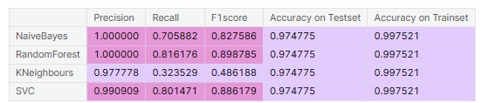

In[8]:

cmap = ListedColormap(["#E1F16B", "#E598D8"])

fig, axes = plt.subplots(nrows=2, ncols=2, figsize=(15,10))

for cls, ax in zip(classifiers, axes.flatten()):

plot_confusion_matrix(cls,

X_test,

y_test,

ax=ax,

cmap= cmap, )

ax.title.set_text(type(cls).__name__)

plt.tight_layout()

plt.show()

Out[8]:

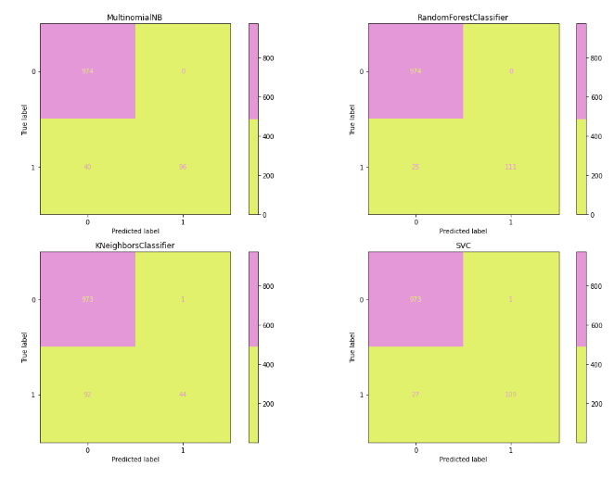

**Explanation:**

Steps in model building:

* Setting up features and target as X and y
* Splitting the testing and training sets
* Build a pipeline of model for four differentclassifiers.
  + Naïve Bayes
  + RandomForestClassifier
  + KNeighborsClassifier
  + Support Vector Machines
* Fit all the models on training data
* Get the cross-validation on the training set for all the models for accuracy

**Testing the models:**

Accuracy Report:

An accuracy report is a document or summary that provides information about the performance of a model, system, or process in terms of accuracy.

Confusion Matrix:

A confusion matrix is a table used in machine learning and statistics to describe the performance of a classification model. It allows you to understand how well a model is classifying instances into different categories, such as "positive" and "negative" for binary classification or multiple classes in multiclass classification.