Chapter 4

Transforming Data with Azure Databricks

Introduction
In today’s data-driven world, the ability to quickly transform and analyze large volumes of data is not just valuable, it is essential. Azure Databricks brings together the scalability of Apache Spark and the seamless integration of Microsoft Azure, empowering data engineers and analysts to unlock insights faster and more efficiently.
This chapter walks you through the essentials of using Azure Databricks for data engineering. Whether you are building scalable Extract, Transform and Load (ETL) pipelines or experimenting with advanced analytics, you will find practical guidance and real-world recipes to help you get the job done.
We will start by setting up your workspace, then move on to writing and managing Notebooks, performing data transformations, optimizing Spark jobs, and integrating with other Azure services. You will also explore best practices that can save you time and resources.
Finally, a set of carefully selected recipes will give you hands-on experience with common tasks, everything from ingesting data from Blob Storage to building real-time streaming pipelines.

Structure
In this chapter, we will cover the following topics:
- Azure Databricks overview
- Creating and managing Notebooks
- Joining multiple data sources with PySpark in Azure Databricks
- Aggregating Data with GroupBy in Azure Databricks
- Creating User-Defined Functions in Azure Databricks
- Saving Data to Azure Data Lake Storage in Azure Databricks
- Building Batch ETL Pipelines in Azure Databricks
- Implementing Streaming ETL with Structured Streaming in Azure Databricks

- Optimizing Spark Jobs
- The Medallion Architecture in Databricks
- Integrating Databricks with other Azure services
- Putting it all together: Integration with the Medallion Architecture

Objectives
The objective of this chapter is to provide a comprehensive and hands-on introduction to Azure Databricks, a powerful data engineering and analytics platform built on Apache Spark. It focuses on how Databricks simplifies large-scale data processing, advanced analytics, and machine learning within the Azure ecosystem. Readers will understand how to set up and work with Databricks workspaces, clusters, and Notebooks to build scalable data pipelines.
The chapter highlights Databricks’ integration with Azure Data Lake Storage (ADLS), Azure Data Factory (ADF), and other services, enabling seamless end-to-end data workflows. It also explains how Delta Lake enhances reliability and performance through ACID transactions and schema enforcement.
Readers will learn techniques for data cleansing, transformation, and enrichment using Spark SQL, PySpark, and user-defined functions. The chapter includes practical scenarios that demonstrate how Databricks can be applied to real-world batch and streaming use cases. By the end, readers will gain confidence in leveraging Databricks for transforming raw data into valuable insights that drive business outcomes.

Azure Databricks overview
Data engineering is the discipline that focuses on making raw data useful. In today's digital world, every action, whether a click on a website, a payment in an app, or a sensor detecting temperature, generates data. However, this raw data is often messy, unstructured, and hard to understand. Data engineering helps collect this data, clean it, store it in organized systems, and prepare it for analysis.
Azure Databricks is a first-party, managed service jointly developed by Microsoft and Databricks. Think of it as a high-performance analytics platform that brings the best of Apache Spark, Delta Lake, and Azure-native integrations under one hood.
Whether you are running complex ETL pipelines, building machine learning models, or performing ad-hoc analysis, Databricks provides a collaborative, scalable, and fully managed workspace for it all.
Key highlights:
- Managed Spark, without the headache: Forget about setting up Spark clusters manually. Databricks handles provisioning, scaling, versioning, and patching behind the scenes.
- Built on Delta Lake: Out of the box, you get ACID transactions, schema enforcement, time travel, and blazing-fast reads and writes via Delta Lake.
- Collaborative Notebooks: Data engineers, analysts, and scientists can work together in real time using Notebooks that support Python, SQL, Scala, and R.
- Secure and compliant: Azure Databricks supports VNet injection, Role-Based Access Control (RBAC), and private link, and is compliant with standards like HIPAA, SOC2, and GDPR.
- Integrated with the Azure ecosystem: Easily connect to ADLS, Azure Synapse, Power BI, Azure Key Vault, Azure Event Hubs, and more.

First-party managed service model
You may come across other Databricks offerings on AWS and GCP, but Azure Databricks is a first-party service. That means:
- It is deeply integrated into the Azure Portal; you manage it like any other Azure resource.
- Billing, identity, RBAC, and policies are all tied directly to your Azure subscription.
- It qualifies for Azure enterprise agreements and Service Level Agreements, making it enterprise-ready from Day 1.
In short, Azure Databricks feels like a native Azure service, but with the power of the world’s leading analytics engine under the hood.

Azure Databricks as game-changer for data engineering
Think of data engineering as building the roads and bridges in a city. These roads help people and goods move from one place to another smoothly. Similarly, data engineers build systems that move data from where it is generated to where it can be used for decision-making. Without these systems, data would be stuck in silos, hard to reach, and nearly impossible to use in a meaningful way.
If you have ever worked with fragmented data platforms, one tool for ingestion, another for transformation, a third for machine learning, and yet another for visualization, you know how quickly things can spiral into complexity. Integrations become fragile, data quality degrades, and projects stall under operational overhead.
Azure Databricks changes that narrative. It brings together the power of Apache Spark, the reliability of Delta Lake, and the enterprise-grade security and scalability of Azure into a single, unified analytics platform. This is not just a managed Spark service; it is a modern data platform built for agility, performance, and collaboration.
Azure Databricks reference architecture
To appreciate the full capabilities of Azure Databricks, the following diagram illustrates its role across the modern data ecosystem. It captures how ingestion, processing, analytics, governance, and AI seamlessly flow within a single platform.
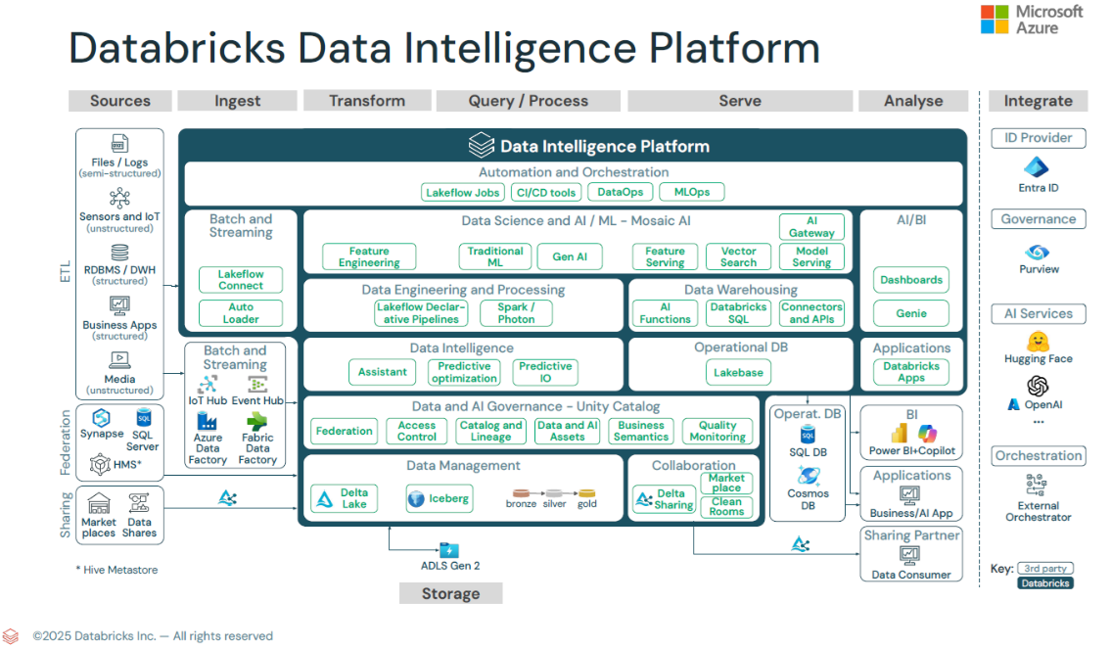
Figure 4.1: Azure Databricks reference architecture (Source: Microsoft/Databricks)

This architecture reinforces the Lakehouse vision, bringing together the scale of a data lake, the reliability of a data warehouse, and the flexibility of modern AI into a single, governed platform.

Built for the entire data lifecycle
Azure Databricks supports every phase of the data lifecycle, from raw ingestion to interactive dashboards and machine learning model serving. Here is how:
- Data ingestion: Easily bring in structured, semi-structured, or unstructured data from virtually any source. Features like Auto Loader allow near-real-time ingestion with schema evolution, ideal for streaming and large-scale data lakes.
- Scalable transformation: Powered by Apache Spark and enhanced by the high-performance Photon engine, Databricks can process massive datasets with impressive speed. Whether you are writing SQL, Python, or Scala, transformations are highly optimized for parallelism.
- Reliable storage with Delta Lake: Delta Lake adds transactional guarantees, schema enforcement, and time travel to your data lakes. You can safely update, merge, or delete data without compromising reliability or performance.
- Analytics and visualization: Analysts can query data using Databricks SQL or connect directly to Power BI for real-time dashboarding. Tables promoted to the gold layer become accessible for business users without needing duplication or extra tooling.
- Security and governance: With Unity Catalog, you gain centralized control over data access, lineage tracking, and metadata management across all workspaces. Integration with Entra ID and Purview ensures that enterprise security and compliance standards are upheld.
- Machine Learning and AI: Whether you are training traditional Machine Learning (ML) models or experimenting with generative AI, Databricks provides an end-to-end environment for feature engineering, model development, tracking, and deployment.

Designed for the modern data team
What makes Azure Databricks truly unique is its ability to support diverse personas on a single platform:
- Data engineers automate pipelines and optimize dataflows.
- Data scientists experiment with models and train at scale.
- Data analysts query and visualize insights using SQL.
- Architects enforce governance and cost controls using enterprise tools.
- All of this takes place within a shared, collaborative environment where Notebooks, jobs, and data assets are versioned, documented, and easily discoverable.

Extending Spark with other native services
While many platforms offer Apache Spark, Azure Databricks stands apart as a first-party service co-developed by Microsoft and Databricks. This means:
- Seamless deployment through the Azure Portal.
- Integrated billing and access controls tied to your Azure tenant.
- Deep native integration with services like ADF, Synapse Analytics, Azure Event Hubs, ADLS Gen2, and Power BI.
It also benefits from continuous innovation, such as Unity Catalog, Delta Live Tables, Lakehouse Federation, and generative AI tooling, all delivered as part of the managed experience.

Importance of Azure Databricks
In an era where data complexity is increasing and delivery timelines are shrinking, Azure Databricks provides a powerful way to simplify the pipeline, accelerate outcomes, and ensure trust in data. Whether your goal is to build robust ETL pipelines, enable self-service analytics, or operationalize machine learning, Databricks gives you the tools to deliver with confidence.
This chapter will help you navigate the platform step-by-step. From workspace setup to production-grade data pipelines, you will gain practical experience and build confidence in using Databricks effectively.
Let us begin by setting up your Azure Databricks workspace.

Setting up Azure Databricks Workspace
The role of a data engineer includes many activities. First, they collect data from various sources such as databases, mobile apps, web services, sensors, and files. This process is called data ingestion. Once the data is collected, it often contains missing values, duplicates, or inconsistent formats. Therefore, the next task is to clean and standardize the data, which is referred to as data cleaning. After that, the data might need to be changed into a different format or structure to be useful. This is called data transformation.
Before diving into data transformation, you need a solid foundation. In this section, you will learn how to create and configure an Azure Databricks workspace, the central hub for your data workflows.
The first step is to create an Azure Databricks workspace and access the Databricks environment through the Azure Portal, as follows:
- Create the Azure Databricks workspace and launch:
  - Go to the Azure portal: Navigate to portal.azure.com.
  - Search for Databricks: In the search bar, type Azure Databricks and select the service. Once selected, you will see the following screen:
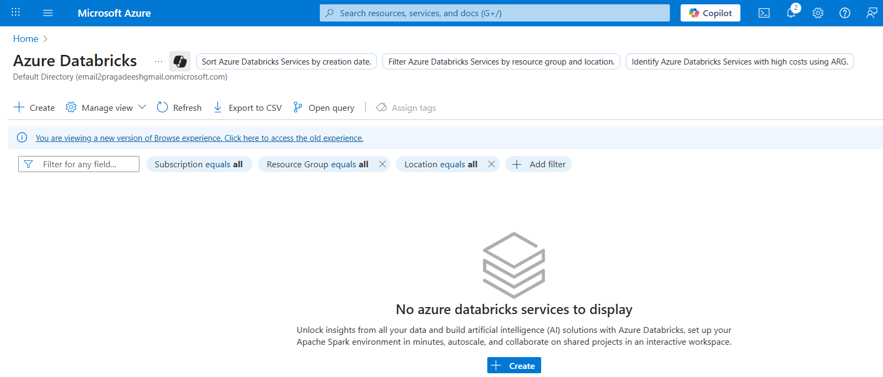
Figure 4.2: Azure Databricks service creation screen

  - Click on Create: On the Create page, specify the required workspace configuration settings, as outlined below.
    - Subscription: Choose the appropriate Azure subscription.
    - Resource group: Either select an existing group or create a new one.
    - Workspace name: Use a consistent naming convention (e.g., dbxw-azde-dev-ci).
    - Region: Select a region close to your data or users.
    - Pricing tier: Start with Standard or Premium, depending on your use case. Premium is often preferred for job execution and security features.
Figure 4.3 shows the required workspace configuration settings in the create page:

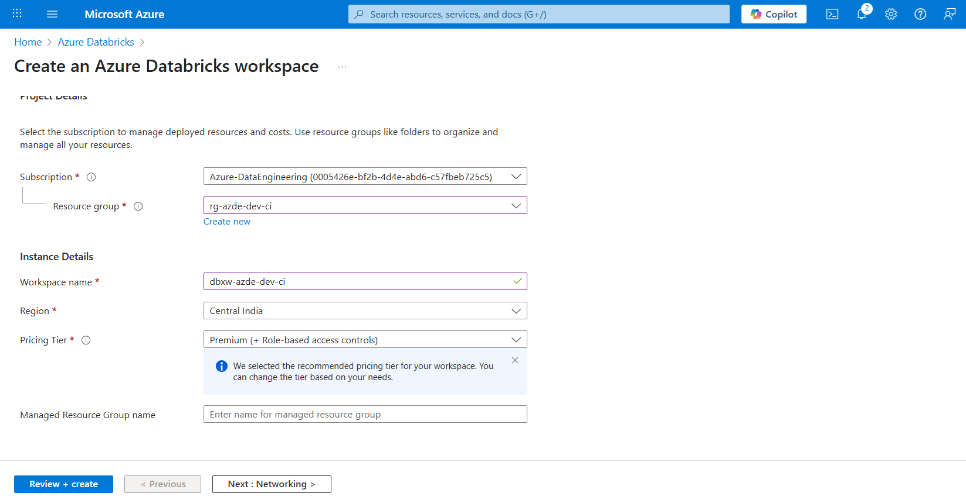
Figure 4.3: Azure Databricks workspace creation screen

  - Click Review + Create and then Create:
  - The workspace deployment process typically takes a few minutes to complete. Once done, you will see a Launch Workspace button (as shown in Figure 4.4), which is your gateway to the Databricks UI.
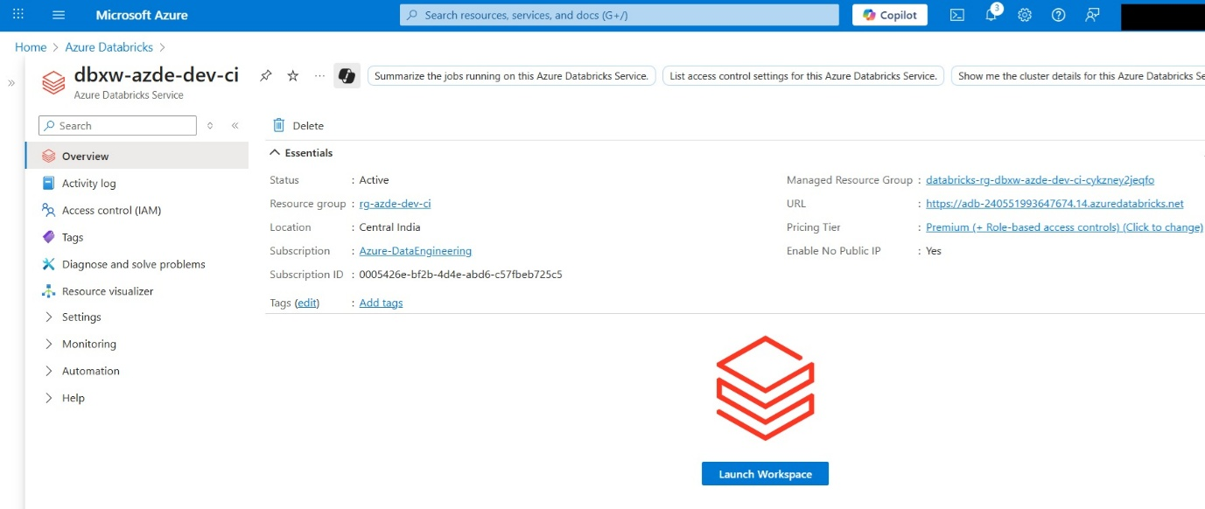
Figure 4.4: Launch Azure Databricks Workspace

  - Click on Launch Workspace: This will create a Workspace within Databricks and take you to the following screen:
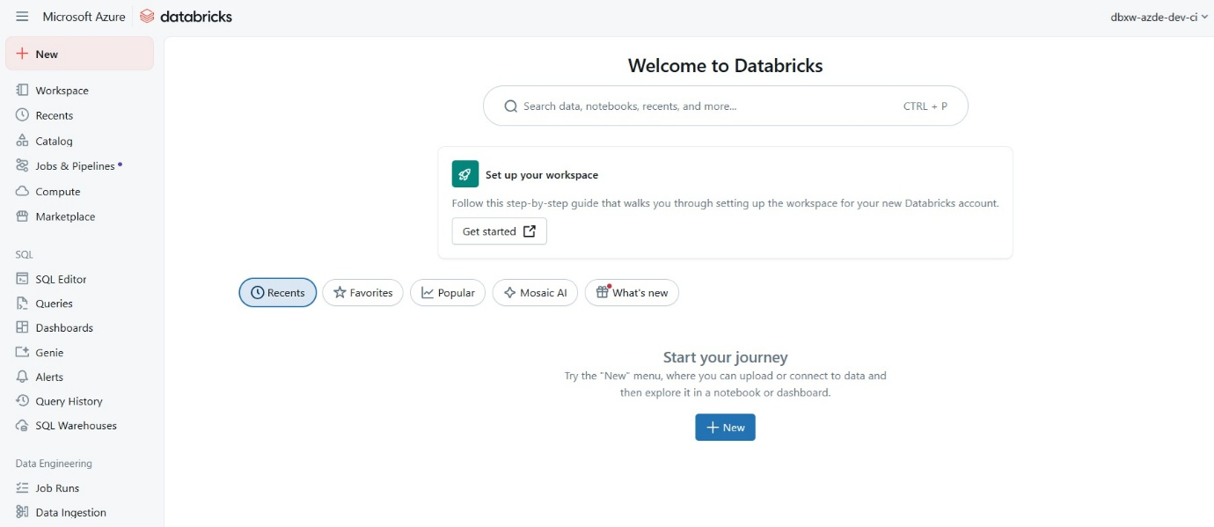
Figure 4.5: Databricks UI

- Configure access control and permissions: Databricks supports RBAC. It is important to set the right permissions for developers, admins, and data scientists. The following configuration patterns are commonly used to manage access in Azure Databricks.
- Use Microsoft Entra ID (formerly Azure AD) to manage user roles.
- Within Databricks, define:
- Workspace admins: Full control.
- Users: Can create Notebooks and run jobs.
- Clusters access: Restrict who can create or restart clusters.
- Set up a cluster: A Databricks cluster is the compute engine behind the scenes. You will need at least one cluster to run Notebooks and jobs.
To create a cluster:
- From the left navigation pane, select Compute, then choose All-purpose compute and click Create compute, as shown in the following figure:
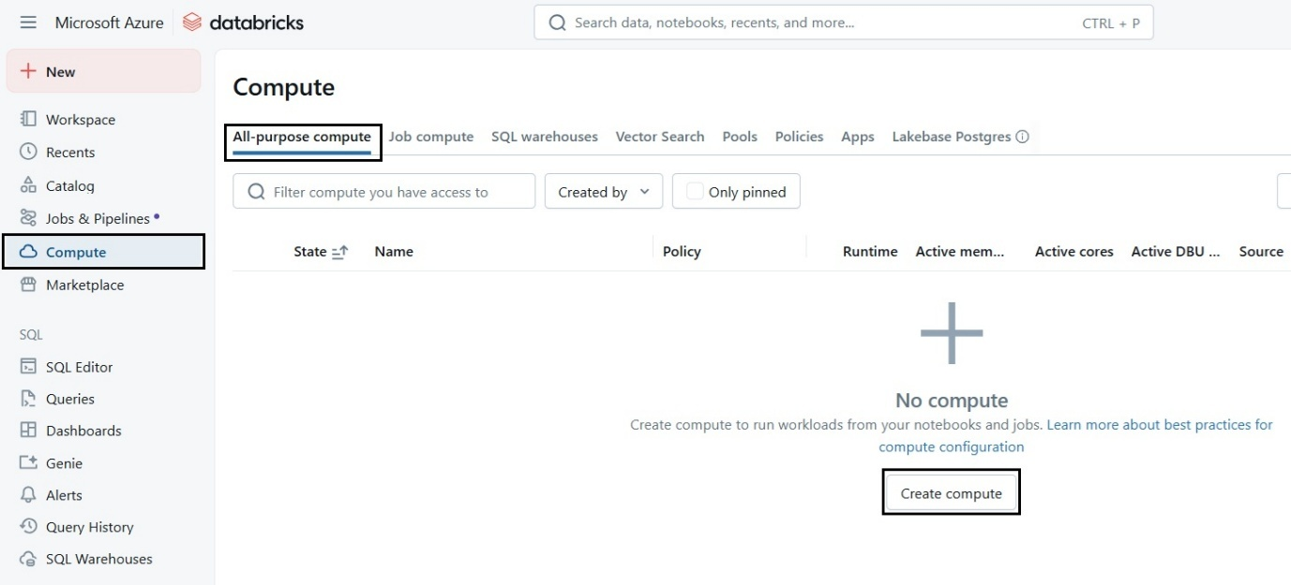
Figure 4.6: Creating an all-purpose compute

- Set a Compute name.
- Choose the Databricks runtime (latest DBR with Scala/Python/SQL).
- Configure Autoscaling to handle varying workloads.
- Enable Terminating idle clusters (e.g., after 20 minutes) to reduce costs.
Clusters can be interactive (for Notebooks) or job-based (for production ETL). Figure 4.7 illustrates the Create new Compute page, where cluster configuration settings are defined:
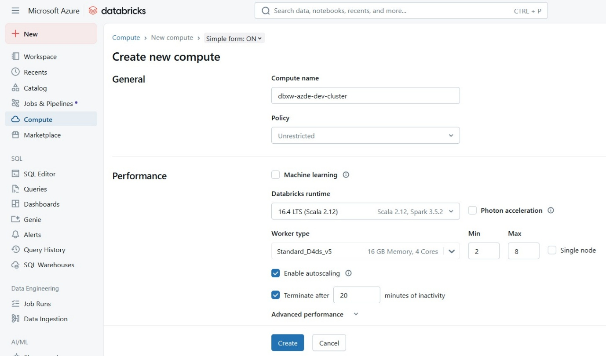
Figure 4.7: Compute creation screen

Creating and managing Notebooks
In Azure Databricks, Notebooks are more than just a place to write code. They are your main workbench for exploring data, building pipelines, running jobs, and collaborating with your team. Think of them as digital Notebooks where you can write in multiple languages, execute code interactively, visualize results, and document your thinking, all in one place.
To get started, you will head into your Databricks workspace and create a Notebook from the sidebar. You will be asked to name your Notebook, choose a default language (Python, SQL, Scala, or R), and attach it to a running cluster. Just like that, you are ready to go.
Each Notebook is made up of individual cells. In these cells, you write and execute your code in small, testable chunks. You can also add text cells using Markdown to explain what your code does, show titles, or include rich formatting like tables and images. This makes your Notebooks not only functional but also easy to read and share. Figure 4.8 illustrates how to navigate to a Notebook within the workspace:

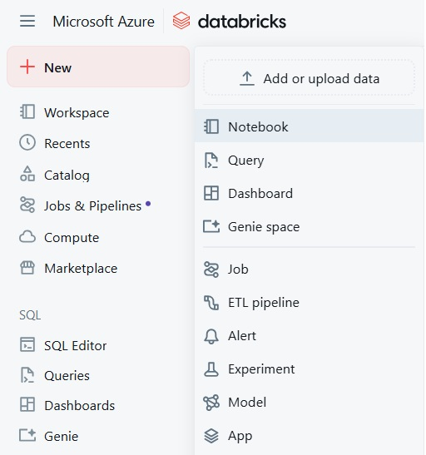
Figure 4.8: Navigate to Notebook creation

One powerful feature of Databricks Notebooks is the ability to mix languages using magic commands. For instance, if your default language is Python but you want to run a SQL query, simply type %sql at the top of a cell. It is a flexible setup that allows data engineers, analysts, and scientists to work in their language of choice without switching tools.
As your project grows, organizing your Notebooks becomes important. You might create folders named bronze, silver, and gold to align with the Medallion Architecture. Naming Notebooks in a logical sequence, like 01_load_data, 02_clean_data, and 03_aggregate, helps keep things clean and easy to follow. Adding a short markdown summary at the top of each Notebook, such as what the Notebook does, what data it touches, and any dependencies, is a great habit to form early. The following is the screenshot of an empty Notebook named Sample Notebook:
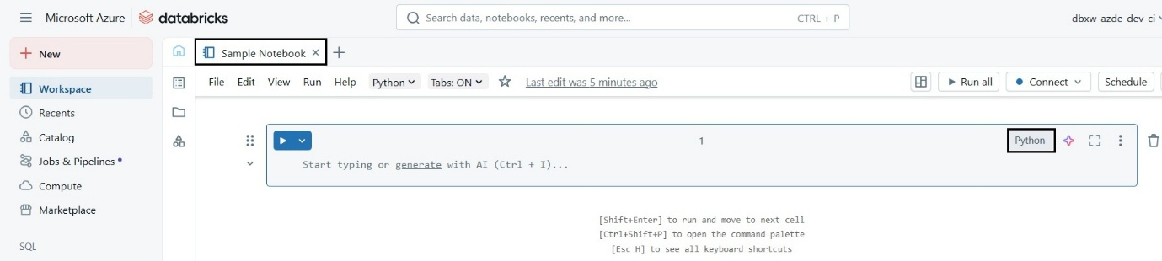
Figure 4.9: Empty Notebook

Databricks also shines when it comes to collaboration. Multiple team members can work on the same Notebook in real time, much like a shared Google Doc. You can leave comments on specific code cells, making it easy to review, explain, or request changes. Every Notebook has built-in revision history, so if something breaks, you can always go back to a previous version.
If your team uses Git, Databricks makes it easy to link Notebooks to a repository. This allows you to version control your Notebooks, integrate with CI/CD pipelines, and maintain a clear audit trail of changes.
Over time, as your Notebooks become more complex, you will want to follow some best practices. Keep Notebooks focused; one purpose per Notebook is a good rule of thumb. Use configuration files or widgets instead of hardcoding paths and values. Move reusable logic into separate modules or libraries, especially if you are repeating code across Notebooks. When you are ready to publish your work or push it into production, clear outputs to keep things clean and make your Notebooks easier to review.
In short, Notebooks in Azure Databricks are where the real work happens. They are flexible, powerful, and built for both solo development and team collaboration. Now that you are familiar with how they work, it is time to start exploring what you can do with them, starting with transforming your data.

Recipe: Ingesting data from Azure Blob Storage
Think of data engineering as building the roads and bridges in a city. These roads help people and goods move from one place to another smoothly. Similarly, data engineers build systems that move data from where it is generated to where it can be used for decision-making. Without these systems, data would be stuck in silos, hard to reach, and nearly impossible to use in a meaningful way. One of the first steps in any data engineering project is loading raw data into your processing environment. In this recipe, you will learn how to ingest data from Azure Blob Storage into Azure Databricks. This is foundational for any transformation, analytics, or machine learning workflow that follows:
- Sign in to the Azure portal: Start by visiting https://portal.azure.com and logging in using your Azure credentials.
- Create a new storage account: To store and manage your raw data, you will need a Blob Storage account, ideally configured with Data Lake Storage Gen2 features enabled. The following steps walk you through creating a Blob Storage account with Data Lake Storage Gen2 enabled using the Azure portal.
  - In the Azure portal, click Create a resource and search for Storage account.
  - Click Create to begin setting up a new storage account.
  - Fill in the following fields:
    - Subscription: Select the active Azure subscription.
    - Resource group: Choose an existing group or create a new one.
    - Storage account name: Must be unique across Azure. Use only lowercase letters and numbers (e.g., datalake123).
    - Region: Pick the region closest to where your Databricks workspace is located.
    - Performance: Stick with Standard for most use cases.
    - Replication: Select Locally-redundant storage (LRS) for cost efficiency
    - Account kind: Ensure this is set to StorageV2 (general-purpose v2).
    - Enable hierarchical namespace: Set this to Enabled to unlock Data Lake Gen2 capabilities.
  - Click Review + Create, and then Create once validation is complete.
- Verify storage account creation: After the deployment finishes, go to the Storage account dashboard. Under the Data Lake Storage section, confirm that the Hierarchical namespace is marked as Enabled. Figure 4.10 shows the storage account screen:
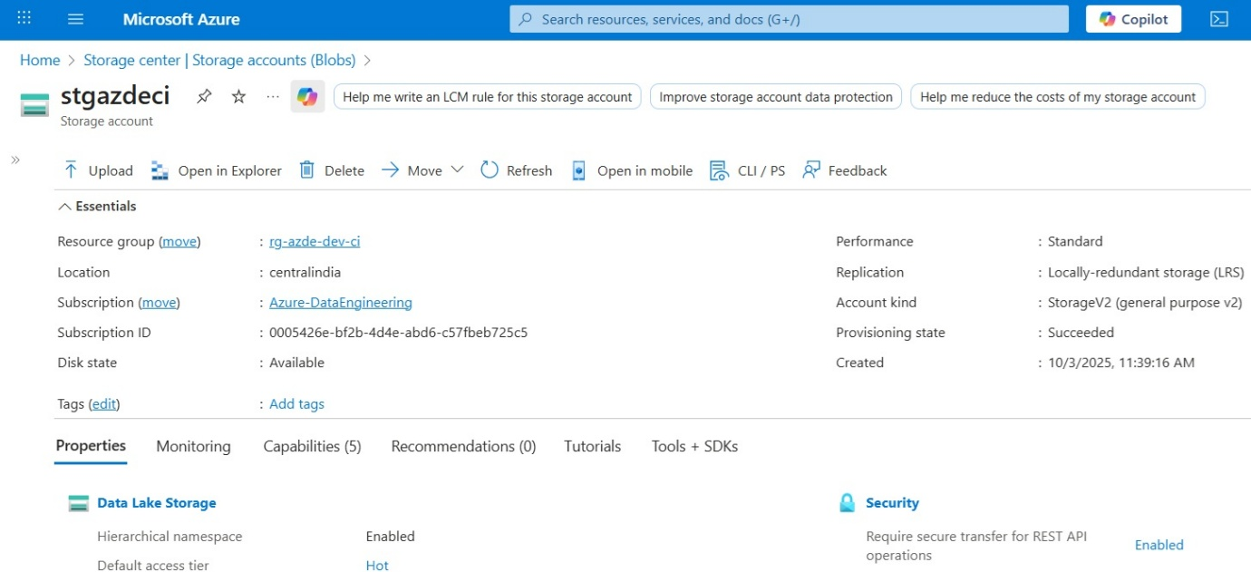
Figure 4.10: Storage account

- Upload sample data: In the storage account, go to Containers and create a new container (e.g., raw).
- Open the container and click Upload to add a CSV or JSON file. You can use your own sample data or download a dataset from sources like Kaggle. Figure 4.11 shows the files in the container:
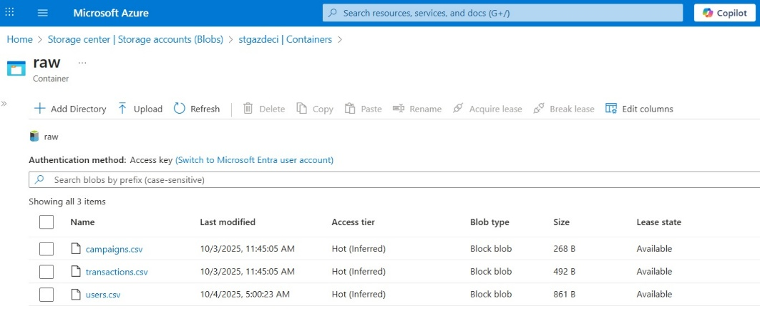
Figure 4.11: Files in the container

Keep a note of the container name and file path; you will need them in Databricks.
- Configure secure storage access in Databricks: Switch to your Databricks workspace and open a Notebook. Configure secure access to the storage account using a service principal or account key, and access files directly through abfss:// paths.
- Option 1: Using Account Key (for simplicity in development), run the following:
# Directly using ABFSS path (preferred)
df = spark.read.csv("abfss://raw@stgazdeci.dfs.core.windows.net/users.csv", header=True)
df.show()
Figure 4.12 shows the records from users.csv after executing the preceding code block:
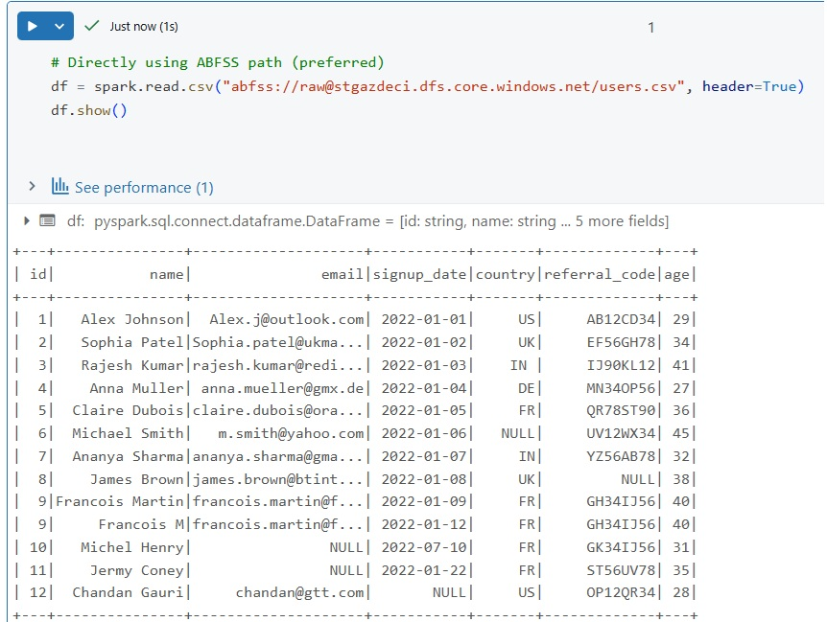
Figure 4.12: Records in users.csv

- Validate the Data Load: Once executed, the Notebook should display a preview of your dataset. This confirms that Databricks is successfully reading from Azure Blob Storage. You have now connected Azure Blob Storage to Databricks and loaded your first dataset. From here, you are ready to start cleansing, transforming, or analyzing the data using PySpark or SQL.

Data transformation techniques
After cleaning and transforming the data, it needs to be stored somewhere safe and accessible. Depending on the size and nature of the data, storage can be in traditional databases, cloud-based storage, or large-scale data lakes. Once stored, data engineers build automated workflows, called data pipelines, that move data from one stage to another at scheduled times or in real time. Raw data is rarely usable as-is. It often comes in with missing values, inconsistent formats, outliers, or unexpected noise. Before you can deliver analytics or power machine learning models, you need to prepare and shape the data, which is where transformation comes in.
In Azure Databricks, you have access to powerful transformation tools through the Apache Spark engine. Whether you are dealing with a few thousand rows or petabytes of streaming data, Spark handles transformations in parallel, across distributed clusters. This means your transformations stay fast, scalable, and memory-efficient, even as your data grows.
There are two primary approaches to transformations in Databricks: Python + Spark (PySpark) and SQL. PySpark gives you programmatic control and flexibility, while SQL provides a familiar declarative interface for data analysts and engineers from traditional database backgrounds. Both are first-class citizens in Databricks and are often used side by side in Notebooks.
Some of the most common transformation tasks include:
- Standardizing column names and formats
- Handling missing or null values
- Filtering and deduplicating records
- Joining datasets from different sources
- Parsing nested JSON or complex types

Aggregating, grouping, and reshaping data
What is especially powerful in Databricks is that you can treat transformations as part of an end-to-end pipeline, read raw data from your Bronze layer, apply business logic in the Silver layer, and produce clean, analytics-ready outputs in the Gold layer. These transformations can be scheduled, versioned, tested, and even audited.
In the next recipe, we will walk through a real-world example of cleansing data using PySpark. You will see how to identify dirty records, apply common fixes, and prepare the dataset for downstream use, all within a Notebook running in Databricks.

Recipe: Data cleansing with PySpark
Before any data can be trusted, it must be cleaned. Dirty data leads to misleading analysis, broken reports, and flawed models. In this recipe, we will explore how to clean a dataset using PySpark, removing nulls, trimming whitespaces, correcting data types, and deduplicating records. These are the essential first steps in any transformation pipeline.
Let us assume you have already ingested a CSV file from Azure Blob Storage or Data Lake into a PySpark DataFrame. We will use a fictional dataset of user signups as an example:

- Load the raw data: First, load the dataset. This example assumes your file is in CSV format and has a header row.
Example code:
df_raw = spark.read.format("csv") \
.option("header", "true") \
.option("inferSchema", "false") \
.load("abfss://raw@stgazdeci.dfs.core.windows.net/users.csv")

df_raw.show(5)
This shows a preview of the raw data. Typical issues at this stage might include:
- Nulls in critical columns like email or signup_date
- Extra whitespaces in string fields
- Inconsistent casing (Active, active, ACTIVE)
- Duplicate user records
- Remove null or empty values: Let us drop records where key fields are missing.
Example code:
df_clean = df_raw.dropna(subset=["email", "signup_date"])
If you want to replace nulls with default values instead:
Example code:
df_clean = df_clean.fillna({
"country": "Unknown",
"referral_code": "N/A"
})
- Trim whitespace and normalize casing: Whitespaces and mixed casing can break joins or groupings. Let us standardize.
Example code:
from pyspark.sql.functions import trim, lower, col
df_clean = df_clean.withColumn("email", trim(lower(col("email")))) \
.withColumn("country", trim(col("country")))
This ensures the email is lowercase and any trailing or leading spaces are removed.
- Convert data types: Sometimes, dates or numbers get interpreted as strings, especially from CSV. Convert them properly.
Example code:
from pyspark.sql.functions import to_date
df_clean = df_clean.withColumn("signup_date", to_date(col("signup_date"), "yyyy-MM-dd"))
You can use cast() if you need to convert numeric columns:
Example code:
df_clean = df_clean.withColumn("age", col("age").cast("int"))
- Drop duplicates: Remove duplicate rows based on one or more business keys (like email).
Example code:
df_clean = df_clean.dropDuplicates(["email"])
- Validate your cleaned data: Always verify your transformations with a quick check:
Example code:
df_clean.printSchema()
df_clean.show(10)

Figure 4.13 illustrates the output produced by the preceding code block. Since the DataFrame consists of only nine records, the complete result set is shown.
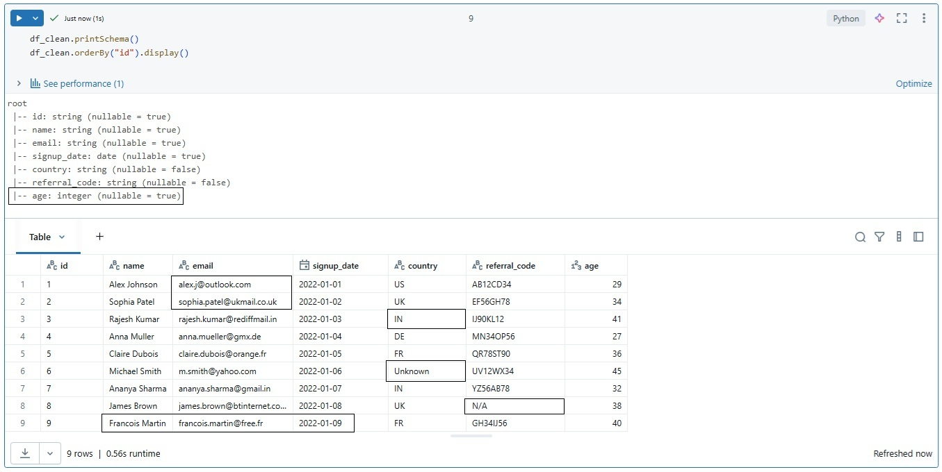
Figure 4.13: Records in DataFrame after processing

- Save the enriched user data:
# coalesce(1) is used here only for demonstration purposes
# to produce a single CSV file. In production environments,
# avoid this pattern for large datasets due to scalability
# and performance considerations.
df_clean.coalesce(1).write.format("csv") \
.option("header", "true") \
.mode("overwrite") \
.save("abfss://silver@stgazdeci.dfs.core.windows.net/cleaned_users/")
Recipe: Data cleansing with SparkSQL and SQL
The same work can also be expressed using SparkSQL inside a Databricks Notebook. We first register each DataFrame as a temporary view and then run SQL queries using spark.sql(). Refer to the following code:
from pyspark.sql.functions import col, trim, lower, coalesce, to_date, lit

df_users_raw = spark.read.format("csv") \
.option("header", "true") \
.option("inferSchema", "false") \
.load("abfss://raw@stgazdeci.dfs.core.windows.net/users.csv")

# Step 1: Remove nulls in critical fields
df_users_step1 = df_users_raw.filter(
col("email").isNotNull() & col("signup_date").isNotNull()
)

# Step 2: Trim/standardize fields and replace nulls with defaults
df_users_step2 = df_users_step1.select(
col("id"),
lower(trim(col("email"))).alias("email"),
to_date(col("signup_date"), "yyyy-MM-dd").alias("signup_date"),
coalesce(trim(col("country")), lit("Unknown")).alias("country"),
coalesce(col("referral_code"), lit("N/A")).alias("referral_code"),
col("age").cast("int").alias("age")
)

# Step 3: Drop duplicates
df_users_clean = df_users_step2.dropDuplicates(["email"])

# Step 4: Validate schema and preview
df_users_clean.printSchema()
display(df_users_clean.orderBy("id"))

Just like we did with PySpark, we can perform data cleansing using SQL inside Databricks. SQL is often easier for analysts and business users who are already comfortable with relational queries. The logic remains the same: remove or replace nulls, trim whitespaces, normalize casing, fix data types, and drop duplicates. By running SQL on top of Spark DataFrames as follows, you get the scalability of Spark with the simplicity of SQL syntax:
%sql
-- Create temp view from the raw DataFrame with header
CREATE OR REPLACE TEMP VIEW users_raw AS
SELECT *
FROM csv.`abfss://raw@stgazdeci.dfs.core.windows.net/users.csv`
WITH (
header = "true"
);

-- Remove nulls in critical fields
CREATE OR REPLACE TEMP VIEW users_step1 AS
SELECT *
FROM users_raw
WHERE email IS NOT NULL
AND signup_date IS NOT NULL;

-- Replace nulls with defaults
CREATE OR REPLACE TEMP VIEW users_step2 AS
SELECT
id,
COALESCE(LOWER(TRIM(email)), '') AS email,
TO_DATE(signup_date, 'yyyy-MM-dd') AS signup_date,
COALESCE(TRIM(country), 'Unknown') AS country,
COALESCE(referral_code, 'N/A') AS referral_code,
CAST(age AS INT) AS age
FROM users_step1;

-- Drop duplicates
CREATE OR REPLACE TEMP VIEW users_clean AS
SELECT id, email, min(signup_date), country, referral_code, age
FROM users_step2
GROUP BY id, email, country, referral_code, age;

-- Preview data
SELECT * FROM users_clean ORDER BY id;

Joining multiple data sources with PySpark
In real-world data pipelines, information usually comes from multiple systems. A single dataset may not provide the full picture. For example, user profile data could be stored in a CSV file, purchase transactions in Parquet, and campaign metadata in Delta format. To create a unified view, we need to join these datasets together.
PySpark in Databricks supports multiple join types such as inner, left, right, full outer, and cross joins. Choosing the correct join type ensures that your enriched dataset contains exactly the records you need without losing or duplicating data.

Recipe: Joining multiple data sources
In this recipe, we will join three different data sources:
- Users
- Transactions
- Campaigns
The following steps walk through loading, aligning, and joining these datasets into a single enriched view:
- Load multiple data sources: Begin by loading each dataset from its respective storage location into Spark DataFrames.
# Cleaned User profile data from CSV
df_users = spark.read.format("csv") \
.option("header", "true") \
.option("inferSchema", "false") \
.load("abfss://silver@stgazdeci.dfs.core.windows.net/cleaned_users")

# Transactions data from CSV
df_txn = spark.read.format("csv") \
.option("header", "true") \
.option("inferSchema", "true") \
.load("abfss://raw@stgazdeci.dfs.core.windows.net/transactions.csv")

# Campaign metadata
df_campaign = spark.read.format("csv") \
.option("header", "true") \
.option("inferSchema", "true") \
.load("abfss://raw@stgazdeci.dfs.core.windows.net/campaigns.csv")

- Standardize column names: Before joining, ensure column names align. If the same concept is labeled differently across datasets (e.g., id vs uid), rename them.
df_users = df_users.withColumnRenamed("id", "user_id")
df_txn = df_txn.withColumnRenamed("uid", "user_id")

- Perform joins: Next, join the DataFrames using appropriate join types based on the business requirement.
- Inner join: It ensures that only users with matching transactions are included. Keep only matching users and transactions:
df_user_txn = df_users.join(df_txn, on="user_id", how="inner")

- Left join: It ensures that all transactions are retained, even if campaign data is missing. Keep all user transactions, enrich with campaign metadata:
df_enriched = df_user_txn.join(df_campaign, on="campaign_id", how="left")

- Validate the Join: After joining, validate the result to confirm schema correctness and expected record counts:
# Check schema
df_enriched.printSchema()
# Preview records
df_enriched.display()
# Count records
print("Total records after join:", df_enriched.count())

If counts balloon unexpectedly, check for duplicate keys or missing join conditions, which can cause Cartesian joins.
- Optimize performance: When one dataset is significantly smaller (e.g., the campaigns table), use a broadcast join to speed things up. For better performance, broadcast smaller lookup tables to avoid unnecessary shuffles:
from pyspark.sql.functions import broadcast
df_enriched = df_user_txn.join(broadcast(df_campaign), on="campaign_id", how="left")
- Save to Silver Layer: Finally, persist the enriched dataset to the silver layer for downstream consumption:
df_enriched.write.format("delta") \
.mode("overwrite") \
.save("abfss://silver@stgazdeci.dfs.core.windows.net/enriched_users_data")

df_enriched.display()
# Count records
print("Total records after join:", df_enriched.count())

The following output confirms the successful creation of the enriched dataset:
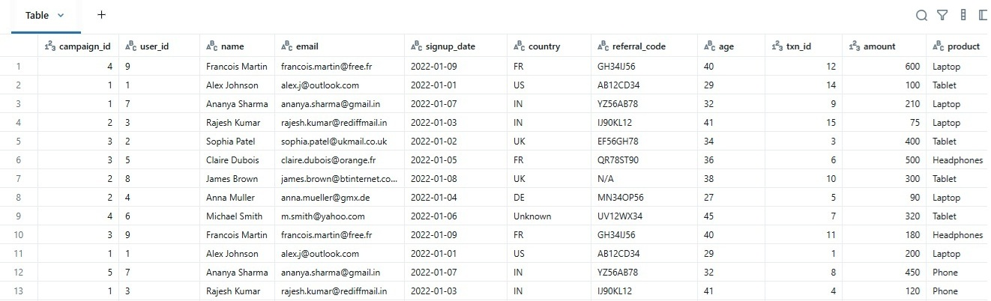
Figure 4.14: Records in DataFrame after enriching

SparkSQL Equivalent -Embedded in PySpark
The same joins can also be expressed using SparkSQL inside a Databricks Notebook. We first register each DataFrame as a temporary view and then run SQL queries using spark.sql(). Refer to the following code:

# Load DataFrames from CSVs with headers
df_users = spark.read.format("csv").option("header", True).load(
"abfss://silver@stgazdeci.dfs.core.windows.net/cleaned_users"
)
df_txn = spark.read.format("csv").option("header", True).load(
"abfss://raw@stgazdeci.dfs.core.windows.net/transactions.csv"
)
df_campaign = spark.read.format("csv").option("header", True).load(
"abfss://raw@stgazdeci.dfs.core.windows.net/campaigns.csv"
)

# Register DataFrames as Temp Views
df_users.createOrReplaceTempView("users")
df_txn.createOrReplaceTempView("transactions")
df_campaign.createOrReplaceTempView("campaigns")

# SparkSQL query: join users and transactions, enrich with campaigns
df_enriched = spark.sql("""
SELECT u.id as user_id, u.name, u.email, u.country,
t.txn_id, t.amount, t.campaign_id,
c.campaign_name, c.start_date, c.end_date
FROM users u
INNER JOIN transactions t
ON u.id = t.uid
LEFT JOIN campaigns c
ON t.campaign_id = c.campaign_id
""")

# Validate the results
df_enriched.printSchema()
df_enriched.show()

Equivalent in SQL
The same joins can be expressed in SQL inside Databricks. The following is the SQL equivalent of the PySpark recipe:
%sql
-- Create temp views for each dataset with header option
CREATE OR REPLACE TEMP VIEW users AS
SELECT * FROM csv.`abfss://silver@stgazdeci.dfs.core.windows.net/cleaned_users`
WITH (
header = "true"
);

CREATE OR REPLACE TEMP VIEW transactions AS
SELECT * FROM csv.`abfss://raw@stgazdeci.dfs.core.windows.net/transactions.csv`
WITH (
header = "true"
);

CREATE OR REPLACE TEMP VIEW campaigns AS
SELECT * FROM csv.`abfss://raw@stgazdeci.dfs.core.windows.net/campaigns.csv`
WITH (
header = "true"
);

-- Standardize column names (example: id → user_id, uid → user_id)
CREATE OR REPLACE TEMP VIEW users_std AS
SELECT id AS user_id, name, email, country
FROM users;

CREATE OR REPLACE TEMP VIEW transactions_std AS
SELECT uid AS user_id, txn_id, amount, campaign_id
FROM transactions;

-- Inner join: Users with transactions
CREATE OR REPLACE TEMP VIEW user_txn AS
SELECT u.user_id, u.name, u.email, u.country,
t.txn_id, t.amount, t.campaign_id
FROM users_std u
INNER JOIN transactions_std t
ON u.user_id = t.user_id;

-- Left join: Enrich with campaign metadata
CREATE OR REPLACE TABLE silver_enriched_users_data
USING delta
AS
SELECT ut.*, c.campaign_name, c.start_date, c.end_date
FROM user_txn ut
LEFT JOIN campaigns c
ON ut.campaign_id = c.campaign_id;

-- Select enriched_users_data
SELECT * FROM silver_enriched_users_data

Aggregating data with GroupBy in Azure Databricks
In real-world analytics, raw joined data is not enough. Business teams need summarized insights such as revenue per campaign, number of users reached, or average transaction value.
Aggregation helps condense millions of rows into meaningful metrics that drive decision-making.
PySpark in Databricks provides the groupBy() method and SQL GROUP BY clause to compute metrics like SUM, AVG, COUNT, MAX, and MIN efficiently on distributed data.

Recipe: Aggregating data with GroupBy
In this recipe, we will continue with the enriched dataset created earlier (Users + Transactions + Campaigns) and generate campaign performance metrics. A step-by-step is as follows:
- Load enriched dataset: The enriched dataset from the previous recipe is stored in the Silver Layer as a Delta table. For loading the enriched dataset:
# Load enriched dataset
df_enriched = spark.read.format("delta") \
.load("abfss://silver@stgazdeci.dfs.core.windows.net/enriched_users_data")

df_enriched.display()
Example schema:
| user_id | name | age | region | txn_id | amount | campaign_id | campaign_name |

- Group and aggregate: Aggregate the dataset to calculate campaign performance metrics. Use GroupBy and aggregation functions to calculate key campaign performance metrics:
from pyspark.sql.functions import sum, avg, countDistinct, max, min

campaign_metrics = (df_enriched
.groupBy("campaign_id", "campaign_name")
.agg(
countDistinct("user_id").alias("UniqueUsers"),
countDistinct("txn_id").alias("TotalTransactions"),
sum("amount").alias("TotalRevenue"),
avg("amount").alias("AvgTransaction"),
max("amount").alias("MaxTransaction"),
min("amount").alias("MinTransaction")
))

- Preview results: Preview the aggregated results to verify the computed metrics:
campaign_metrics.display()

Figure 4.15 shows the output of the aggregation operation:
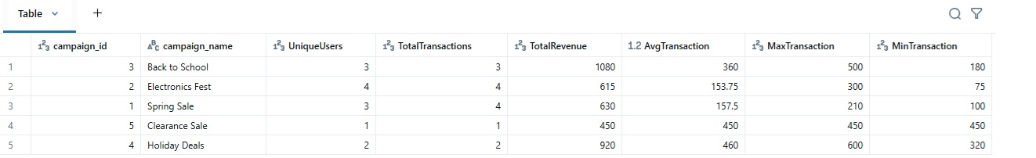
Figure 4.15: Records in DataFrame after aggregation

- SQL equivalent: The same aggregation logic can also be expressed using SQL:
%sql

-- Create temp views for each dataset with header option
CREATE OR REPLACE TEMP VIEW enriched_users_data AS
SELECT * FROM delta.`abfss://silver@stgazdeci.dfs.core.windows.net/enriched_users_data`;

SELECT
campaign_id,
campaign_name,
COUNT(DISTINCT user_id) AS UniqueUsers,
COUNT(DISTINCT txn_id) AS TotalTransactions,
SUM(amount) AS TotalRevenue,
AVG(amount) AS AvgTransaction,
MAX(amount) AS MaxTransaction,
MIN(amount) AS MinTransaction
FROM enriched_users_data
GROUP BY campaign_id, campaign_name;

- Save to Gold Layer: Campaign performance metrics can be saved as a Gold Layer table for business reporting and dashboards:

campaign_metrics.write.format("delta") \
.mode("overwrite") \
.save("abfss://gold@stgazdeci.dfs.core.windows.net/campaign_metrics")

Let us look at some of the best practices:
- Use countDistinct() carefully; for very large datasets, use approx_count_distinct() for performance.
- Repartition by campaign_id before aggregating if campaigns are numerous and data is skewed.
- Cache results if multiple aggregations are needed downstream.

Creating user-defined functions in Azure Databricks
Sometimes, built-in PySpark functions are not enough for complex business logic.
For example, you may want to categorize transactions as High Value or Low Value based on thresholds, or apply custom text processing rules.
PySpark allows you to register User-Defined Functions (UDFs) that extend Spark’s capabilities using Python code.

Recipe: Creating user-defined functions
This recipe explains how to extend Spark processing using custom user-defined logic.
- Load enriched dataset: Begin by loading the enriched dataset from the Silver layer:
# Load enriched dataset
df_enriched = spark.read.format("delta") \
.load("abfss://silver@stgazdeci.dfs.core.windows.net/enriched_users_data")

df_enriched.display()
- Define a Python function: First, define a Python function that implements the required business logic.
Example: Classify transactions as High, Medium, or Low value:
def categorize_transaction(amount):
if amount >= 500:
return "High"
elif amount >= 300:
return "Medium"
else:
return "Low"
- Register UDF in Spark: Next, register the Python function as a Spark UDF so it can be used in DataFrame operations:
from pyspark.sql.functions import udf
from pyspark.sql.types import StringType

categorize_txn_udf = udf(categorize_transaction, StringType())
- Apply UDF to DataFrame: Apply the registered UDF to derive a new column based on transaction values:
df_with_category = df_enriched.withColumn(
"TransactionCategory", categorize_txn_udf(df_enriched["amount"])
)
df_with_category.select("txn_id", "amount", "TransactionCategory").display()

The following output shows the result after applying the UDF:
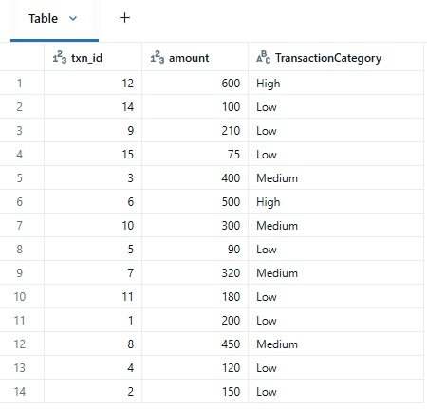
Figure 4.16: Records in DataFrame after applying UDF(categorize_transaction)

- Use SQL equivalent: Register UDF as SQL function:
spark.udf.register("categorize_txn", categorize_transaction, StringType())

df_enriched.createOrReplaceTempView("enriched_users_data")

spark.sql("""
SELECT txn_id, amount, categorize_txn(amount) AS TransactionCategory
FROM enriched_users_data
""").show()
- Save Results: Finally, save the transformed dataset to the Gold layer for downstream use:
df_with_category.write.format("delta") \
.mode("overwrite") \
.save("abfss://gold@stgazdeci.dfs.core.windows.net/transactions_with_category")

Let us look at some of the best practices:
- UDFs can be slower than built-in functions. Always check if a Spark SQL function already exists.
- Consider Pandas UDFs (Vectorized UDFs) for performance on large datasets.
- Use UDFs mainly when business logic cannot be expressed with native Spark functions.
Working with JSON data in Azure Databricks
In many real-world pipelines, data is stored in semi-structured formats such as JSON. For example, user profiles may include nested attributes like preferences, device details, or location data.
PySpark provides functions such as from_json() and get_json_object() to parse and extract JSON fields, making it easier to transform semi-structured data into tabular form for analytics.

Recipe: Working with JSON data
This recipe demonstrates how to parse and flatten JSON data stored within a column using PySpark. The steps are as follows:
- Sample JSON data: In this example, assume the users dataset contains a column named preferences that stores user preferences as a JSON string.
{"language": "English", "notifications": {"email": true, "sms": false}, "theme": "dark"}
- Load dataset: Load the users dataset containing the JSON column from the raw storage layer:
df_users = spark.read.format("csv") \
.option("header", "true") \
.option("inferSchema", "true") \
.load("abfss://raw@stgazdeci.dfs.core.windows.net/users_with_json.csv")

df_users.show(5, truncate=False)
- Define JSON schema: Before parsing the JSON column, define an explicit schema that represents the expected structure of the JSON data:
from pyspark.sql.types import StructType, StructField, StringType, BooleanType

preferences_schema = StructType([
StructField("language", StringType(), True),
StructField("theme", StringType(), True),
StructField("notifications", StructType([
StructField("email", BooleanType(), True),
StructField("sms", BooleanType(), True)
]))
])

- Parse JSON column: Use the from_json() function to convert the JSON string into a structured column based on the defined schema:

from pyspark.sql.functions import from_json, col

df_parsed = df_users.withColumn(
"preferences_parsed",
from_json(col("preferences"), preferences_schema)
)

df_parsed.select("user_id", "name", "email", "signup_date", "country", "preferences_parsed.*").display()

- Extract fields: After parsing the JSON, extract nested attributes and flatten them into individual columns:
df_flattened = df_parsed.select(
"user_id", "name", "email", "signup_date", "country",
col("preferences_parsed.language").alias("language"),
col("preferences_parsed.theme").alias("theme"),
col("preferences_parsed.notifications.email").alias("email_opt_in"),
col("preferences_parsed.notifications.sms").alias("sms_opt_in")
)

df_flattened.display()

The following output shows the flattened view of the parsed JSON data:
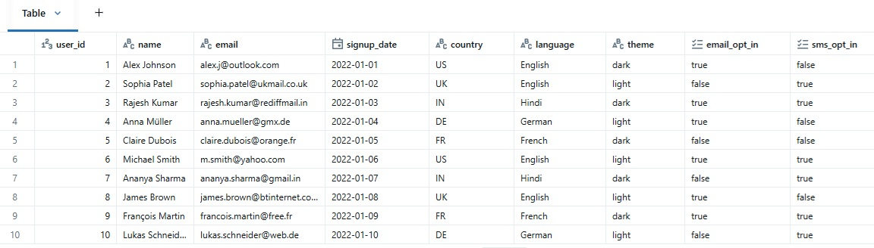
Figure 4.17: Records in DataFrame after flattening

- Save flattened data: Persist the flattened dataset to the Silver layer for downstream transformations and analytics:
df_flattened.write.format("delta") \
.mode("overwrite") \
.save("abfss://silver@stgazdeci.dfs.core.windows.net/users_flattened")

Consider the following:
- Ensure JSON strings in CSV files are properly quoted and escaped; otherwise, rows may break during parsing.
- In production pipelines, prefer providing an explicit CSV schema instead of using inferSchema.
- Use get_json_object() only for simple, single-field extraction scenarios.

Let us look at some of the best practices:
- Use schemas (from_json) instead of get_json_object() when working with complex/nested JSON. It is easier to maintain.
- For very large nested JSON datasets, consider saving them as Delta with StructType columns instead of raw JSON strings.
- Reuse schemas across multiple pipelines for consistency.

Persisting Data to Azure Data Lake
Persisting data is more than just writing files. It is a critical design decision that impacts query performance, pipeline reusability, and downstream analytics.
In modern data engineering, datasets need to be stored durably, consistently, and efficiently, so that business teams and applications can trust and consume the data reliably. ADLS with Delta format provides ACID compliance, schema enforcement, and time travel, making it ideal for production pipelines.

Recipe: Saving data to Azure Data Lake
In this recipe, you will learn how to write processed data from Azure Databricks to Azure Data Lake Storage using best practices such as Delta format selection, partitioning, and table registration. Follow the steps:
  - Load dataset: We will use the flattened user dataset from the previous JSON recipe or the enriched dataset from earlier joins. The following code writes the prepared dataset to the Silver Layer:
df_flattened.write.format("delta") \
.mode("overwrite") \
.save("abfss://silver@stgazdeci.dfs.core.windows.net/users_flattened")
This approach ensures that only curated data is persisted, rather than raw or partially processed files.
  - Choose storage format strategically: Selecting the right storage format is essential for reliability, performance, and long-term maintainability.
- Delta: Recommended for reliability, schema evolution, and time travel.
- Parquet: Fast, compatible with multiple tools, but lacks ACID support.
- CSV: Only for simple exports; not ideal for production pipelines.
Define the output location where the dataset will be stored.
# Recommended Delta format
output_path = "abfss://silver@stgazdeci.dfs.core.windows.net/users_flattened_by_country"

  - Write the dataset with best practices: Write the dataset to Azure Data Lake Storage using Delta format and an appropriate write mode:
df_flattened.write.format("delta") \
.mode("overwrite") \ # Options: overwrite, append, ignore
.save(output_path)

  - Partitioning for large datasets: Partition the dataset on frequently filtered columns to improve query performance.

# Helps improve query performance on filtered columns
df_flattened.write.format("delta") \
.mode("overwrite") \
.partitionBy("country") \
.save(output_path)

  - Verify and register: After writing the data, verify that it was saved correctly and, optionally, register it as a table for SQL and BI access:
df_saved = spark.read.format("delta").load(output_path)
df_saved.show(5, truncate=False)
df_saved.printSchema()

# Optional: register as Delta table for SQL/BI consumption
spark.sql("CREATE TABLE IF NOT EXISTS main.silver.users_flattened USING DELTA LOCATION '{}'".format(output_path))

Note: The above example assumes a Unity Catalog-enabled workspace using the standard catalog.schema.table naming convention.
Key strategic takeaways:
- Persisting datasets is not just a formality. It ensures reliability, discoverability, and performance.
- Delta format + partitioning = production-grade, analytics-ready storage.
- Layered approach (Raw | Silver | Gold) reinforces data governance, reusability, and auditability.
- Explicitly saving and registering datasets makes your pipeline modular and maintainable, ready for batch or streaming ETL workflows.

Building batch ETL pipelines in Azure Databricks
Batch ETL pipelines enable the scheduled extraction, transformation, and loading of data from multiple sources into analytics-ready layers. They form the backbone of most enterprise data platforms by ensuring consistency, repeatability, and reliability in data processing.
In Azure Databricks, batch ETL pipelines are commonly implemented using Spark DataFrames, Delta Lake, and cloud storage such as Azure Data Lake Storage. These pipelines typically ingest raw data, apply standardization and enrichment logic, aggregate metrics, and persist results to curated layers.

Recipe: Building batch ETL pipelines
In this recipe, you will build a complete batch ETL pipeline using user, transaction, and campaign datasets. The pipeline follows a structured flow from ingestion to transformation and finally persistence into Silver and Gold layers.
This recipe demonstrates how individual processing steps come together to form a complete batch ETL pipeline:
- Ingest raw data: The first step in a batch ETL pipeline is ingesting raw or cleaned source data from Azure Data Lake Storage into Spark DataFrames.
# Cleaned User profile data from CSV
df_users = spark.read.format("csv") \
.option("header", "true") \
.option("inferSchema", "false") \
.load("abfss://silver@stgazdeci.dfs.core.windows.net/cleaned_users")

# Transactions data from CSV
df_txn = spark.read.format("csv") \
.option("header", "true") \
.option("inferSchema", "true") \
.load("abfss://raw@stgazdeci.dfs.core.windows.net/transactions.csv")

# Campaign metadata
df_campaign = spark.read.format("csv") \
.option("header", "true") \
.option("inferSchema", "true") \
.load("abfss://raw@stgazdeci.dfs.core.windows.net/campaigns.csv")

- Data standardization: Before joining datasets, standardize column names and data formats to ensure consistency across sources.
# Standardize column names
df_users = df_users.withColumnRenamed("id", "user_id")
df_txn = df_txn.withColumnRenamed("uid", "user_id")

- Join data: Next, join the datasets to create an enriched view combining users, transactions, and campaign details.
# Inner join users & transactions
df_user_txn = df_users.join(df_txn, on="user_id", how="inner")

# Left join with campaigns (broadcast for performance)
from pyspark.sql.functions import broadcast
df_enriched = df_user_txn.join(broadcast(df_campaign), on="campaign_id", how="left")

- Apply transformations / UDFs: Apply business logic transformations to enrich the data further, such as categorizing transactions based on value.
from pyspark.sql.functions import udf
from pyspark.sql.types import StringType

def categorize_transaction(amount):
if amount >= 500:
return "High"
elif amount >= 300:
return "Medium"
else:
return "Low"

categorize_txn_udf = udf(categorize_transaction, StringType())

df_enriched = df_enriched.withColumn("TransactionCategory", categorize_txn_udf(df_enriched["amount"]))

- Aggregate metrics: Once the data is enriched, compute aggregated metrics required for reporting and analytics.
from pyspark.sql.functions import sum, avg, countDistinct, max, min

campaign_metrics = (df_enriched
.groupBy("campaign_id", "campaign_name")
.agg(
countDistinct("user_id").alias("UniqueUsers"),
countDistinct("txn_id").alias("TotalTransactions"),
sum("amount").alias("TotalRevenue"),
avg("amount").alias("AvgTransaction"),
max("amount").alias("MaxTransaction"),
min("amount").alias("MinTransaction")
))

- Save results to ADLS: Persist the processed datasets to the appropriate layers in Azure Data Lake Storage.
# Enriched dataset (Silver layer)
df_enriched.write.format("delta").mode("overwrite").save("abfss://silver@stgazdeci.dfs.core.windows.net/enriched_user_data")

# Aggregated metrics (Gold layer)
campaign_metrics.write.format("delta").mode("overwrite").save("abfss://gold@stgazdeci.dfs.core.windows.net/campaign_metrics")

- Optional table registration: Register the saved datasets as Delta tables to enable SQL and BI access.
# Register as Delta tables
spark.sql("""
CREATE TABLE IF NOT EXISTS main.silver.enriched_user_data
USING DELTA
LOCATION 'abfss://silver@stgazdeci.dfs.core.windows.net/enriched_user_data'
""")

spark.sql("""
CREATE TABLE IF NOT EXISTS main.gold.campaign_metrics
USING DELTA
LOCATION 'abfss://gold@stgazdeci.dfs.core.windows.net/campaign_metrics'
""")

In real-world deployments, this batch ETL pipeline is typically automated and enhanced to meet production requirements. The pipeline can be scheduled to run at regular intervals using Databricks Jobs, or orchestrated as part of a broader workflow using tools such as Azure Data Factory, Apache Airflow, or Prefect.
To make the pipeline fully automated and scalable, parameters such as processing date ranges or incremental load logic can be introduced, allowing the pipeline to process only new or changed data on each run.
Let us look at some of the best practices:
- Modularize your code: Separate ingestion, cleansing, transformation, aggregation, and saving steps.
- Use Delta tables for reliable writes and time travel.
- Broadcast smaller tables to optimize joins.
- Add logging and monitoring for job success/failure.
- Use partitioning for large datasets to improve query performance.

Building Streaming ETL in Azure Databricks
In many real-world scenarios, data arrives continuously from sources such as Internet of Things (IoT) devices, clickstreams, or APIs. Batch processing alone may not be sufficient.
Structured Streaming in PySpark allows you to process data in real-time while keeping the same DataFrame/Dataset API you use in batch ETL. It supports event-time handling, watermarking, and output sinks like Delta Lake.

Recipe: Implementing Streaming ETL with Structured Streaming
Streaming ETL pipelines process continuously arriving data such as IoT events, clickstreams, or transactions in near real time. Using Azure Databricks Structured Streaming, this recipe demonstrates how to ingest streaming data, apply transformations and business logic, and persist the results to Delta Lake for analytics.
In production environments, streaming data is often ingested from sources such as Azure Event Hubs, Kafka, or Auto Loader. For simplicity and reproducibility, this recipe uses a Delta folder as the streaming source, allowing Structured Streaming to process newly arriving transaction records incrementally without requiring external messaging infrastructure.
- Define streaming source: The first step is to define the schema and source for the incoming streaming data. In this example, transaction data is continuously written to a Delta folder in the Raw layer.
from pyspark.sql.types import StructType, StructField, StringType, DoubleType, TimestampType

txn_schema = StructType([
StructField("txn_id", StringType(), True),
StructField("user_id", StringType(), True),
StructField("amount", DoubleType(), True),
StructField("campaign_id", StringType(), True),
StructField("txn_time", TimestampType(), True)
])

streaming_txn = (spark.readStream.format("delta")
.schema(txn_schema)
.load("abfss://raw@stgazdeci.dfs.core.windows.net/streaming_transactions"))

- Apply transformations: Streaming data is often enriched with static or slowly changing reference datasets such as users and campaigns.
# Enrich with users and campaigns (static datasets)
df_users = spark.read.format("delta").load("abfss://silver@stgazdeci.dfs.core.windows.net /users_flattened")
df_campaign = spark.read.format("delta").load("abfss://raw@stgazdeci.dfs.core.windows.net /campaigns")

from pyspark.sql.functions import broadcast

# Join streaming transactions with static data
df_enriched_stream = streaming_txn.join(broadcast(df_users), on="user_id", how="inner") \
.join(broadcast(df_campaign), on="campaign_id", how="left")

- Apply UDF / categorization: After enrichment, apply custom business logic to classify transactions based on their value.
from pyspark.sql.functions import udf
from pyspark.sql.types import StringType

def categorize_transaction(amount):
if amount >= 500:
return "High"
elif amount >= 300:
return "Medium"
else:
return "Low"

categorize_txn_udf = udf(categorize_transaction, StringType())

df_enriched_stream = df_enriched_stream.withColumn("TransactionCategory", categorize_txn_udf("amount"))

- Write streaming output: The enriched streaming data is written to Delta Lake in the Silver layer for downstream processing.
query = (df_enriched_stream.writeStream
.format("delta")
.outputMode("append") # Options: append, update, complete
.option("checkpointLocation", "abfss://silver@stgazdeci.dfs.core.windows.net/ checkpoints/enriched_txn_stream")
.start("abfss://silver@stgazdeci.dfs.core.windows.net/enriched_txn_stream"))

Consider the following
  - checkpointLocation ensures fault tolerance and exactly-once processing.
  - Delta format enables seamless integration between batch and streaming workloads.

- Aggregation in streaming: Streaming ETL pipelines often compute rolling or window-based metrics, such as hourly campaign performance:
from pyspark.sql.functions import window, sum, countDistinct

campaign_metrics_stream = (df_enriched_stream
.withWatermark("txn_time", "10 minutes")
.groupBy("campaign_id", "campaign_name", window("txn_time", "1 hour"))
.agg(
countDistinct("user_id").alias("UniqueUsers"),
sum("amount").alias("TotalRevenue")
))

campaign_metrics_stream.writeStream \
.format("delta") \
.outputMode("update") \
.option("checkpointLocation", " abfss://gold@stgazdeci.dfs.core.windows.net/checkpoints/streaming_campaign_metrics") \
.start("abfss://gold@stgazdeci.dfs.core.windows.net/streaming_campaign_metrics")

- Monitoring and management: Once deployed, streaming pipelines require continuous monitoring and operational management. Note the following:
- Use Databricks Jobs to schedule and manage streaming queries.
- Monitor latency, throughput, and failures via Spark UI or Databricks dashboards.
- Ensure proper watermarking to handle late data.
Let us look at some of the best practices:
- Use Delta Lake for both batch and streaming for seamless integration.
- Use broadcast joins for small reference datasets.
- Partition streaming outputs to improve read performance.
- Always define checkpoint locations for fault-tolerant pipelines.
- Configure appropriate trigger intervals based on business latency and throughput requirements.
- Monitor and gracefully terminate or restart streaming queries during deployments and maintenance activities.
- Combine batch and streaming queries for hybrid ETL approaches (Lambda or Delta Live Tables architecture).

Optimizing Spark jobs
Running Spark jobs in Databricks is often straightforward. You write transformations, joins, and aggregations, and Spark handles the parallel execution. However, as data grows into terabytes or petabytes, and workloads scale to thousands of queries, the way jobs are executed begins to matter as much as the transformations themselves. A query that runs in a few seconds on gigabytes of data may take hours, or fail entirely, on larger volumes if it is not optimized.
Optimization in Databricks is not about making things run fast once; it is about building pipelines that are predictable, cost-efficient, and scalable. The techniques we will cover are not isolated tips. They form a toolkit that data engineers and architects can strategically apply depending on their workload. In this section, we will explore optimization strategies across three layers: data layout, query execution, and lifecycle management.

Broadcast join
When a large fact table needs to be joined with a small dimension table, Spark normally shuffles both across the cluster, which is expensive. Broadcast joins avoid this shuffle by sending the small dataset to every executor. This makes joins significantly faster and is especially powerful in star-schema-like workloads. In Databricks, it is as simple as wrapping the smaller DataFrame in broadcast(). The following example shows how to use a broadcast join to avoid shuffle during a Spark join:
df_enriched = df_transactions.join(broadcast(df_campaigns), "campaign_id")
This works beautifully for dimension tables that are only a few MBs in size. However, attempting to broadcast very large tables can overwhelm the executor's memory. So, it is a precision tool, not a hammer.

Adaptive query execution
Traditionally, Spark built an execution plan before running a job, relying on static estimates that often turned out wrong. With Adaptive Query Execution (AQE), available in Spark 3 and natively enabled in Databricks, Spark can re-optimize queries while they are running. This means if partitions turn out skewed, or if a shuffle produces too many tiny tasks, Spark can adjust automatically. A typical configuration to enable AQE is shown:
SET spark.sql.adaptive.enabled = true;
The beauty of AQE is that it requires little effort from the user. You enable it once, and Spark dynamically chooses better join strategies, merges shuffle partitions, and handles skew. It represents the shift from static tuning to self-optimizing pipelines.

Partitioning
Partitioning is one of the oldest and most powerful optimization strategies in big data. By physically dividing data into folders (for example, by region or date), Spark only scans what is needed. For example, if your dataset has 10 years of sales history but the analyst only queries the last month, partitioning ensures Spark touches just that subset. The following snippet illustrates how partitioning is applied during Delta table writes:
df_sales.write.format("delta") \
.partitionBy("region", "year") \
.mode("overwrite") \
.save("abfss://silver@stgazdeci.dfs.core.windows.net/sales_partitioned")
The catch is balance: too few partitions mean large scans, while too many mean excessively small files. A rule of thumb is to avoid going beyond tens of thousands of partitions in a single table.

OPTIMIZE and Z-ORDER
In Delta Lake, large-scale ingestion often produces thousands of small parquet files, which slows down queries. The OPTIMIZE command compacts these into fewer, larger files, making scans more efficient. A typical OPTIMIZE operation for small-file compaction is shown as follows:
OPTIMIZE delta.`abfss://silver@stgazdeci.dfs.core.windows.net/transactions`
Taking this further, Z-Ordering sorts data on disk by a chosen column (or set of columns), clustering related rows together. This allows Spark to skip irrelevant blocks entirely. A common example is Z-Ordering by user_id or product_id, which accelerates queries where these columns are used as filters. The following example shows how to apply Z-Ordering to improve selective query performance:
OPTIMIZE delta.`abfss://silver@stgazdeci.dfs.core.windows.net/transactions` ZORDER BY (user_id)
Z-Ordering is particularly effective when you cannot partition by a high-cardinality column but still want fast lookups.

Liquid clustering
Traditional partitioning struggles with high-cardinality columns like customer_id. Liquid clustering, introduced by Databricks, is a more flexible approach. Instead of rigid partitions, data is dynamically clustered, and Databricks manages the file layout internally. This reduces partition skew, simplifies schema evolution, and works especially well for streaming data. The following example shows how liquid clustering can be applied when creating a Delta table:
CREATE TABLE sales_data
USING DELTA
LOCATION ‘abfss://silver@stgazdeci.dfs.core.windows.net/sales_data'
CLUSTER BY (region, product_id);
Unlike partitioning, you do not need to guess the right column upfront. Clustering evolves as the table grows, making it a future-proof choice for many workloads.

Caching and persistence
Sometimes optimization is not about changing the data layout but about avoiding redundant computation. If the same DataFrame is queried multiple times, caching it in memory can save huge amounts of re-computation. This is invaluable for interactive analytics or iterative machine learning workloads. A simple caching pattern in Spark is shown as follows:
df_sales.cache()
df_sales.count() # triggers caching
However, caching comes with a memory cost. Engineers should unpersist DataFrames when no longer needed to free resources. Caching is best viewed as a tactical optimization for hot datasets.

VACUUM
Delta Lake tables keep old data files for time travel and rollback. Over months or years, this can accumulate into a storage burden. The VACUUM command removes obsolete files, reducing costs and keeping tables lean. A typical VACUUM operation is shown as follows:
VACUUM delta.`abfss://silver@stgazdeci.dfs.core.windows.net/transactions` RETAIN 168 HOURS

Most organizations retain data for seven days (168 hours), which aligns with the default safety threshold in Delta Lake. Retention periods below this threshold require disabling the retention safety check through configuration and should be used cautiously, as aggressive vacuuming can impact time travel, rollback operations, and active streaming queries.
Bucketing
Although modern Delta Lake optimization techniques such as liquid clustering, OPTIMIZE, Z-ORDER, and predictive optimization are commonly preferred in Azure Databricks, bucketing can still be useful in specialized scenarios involving repeated large-scale joins on stable keys.
When two large datasets need to be joined repeatedly on the same column, bucketing offers a middle ground between partitioning and full shuffles. Data is hashed into a fixed number of buckets, which ensures Spark can perform efficient joins by avoiding a full shuffle. The following snippet illustrates a bucketed table design for predictable batch joins:

CREATE TABLE bucketed_sales
USING DELTA
CLUSTERED BY (user_id) INTO 8 BUCKETS;

Bucketing is most effective in stable batch-processing pipelines where join patterns and schemas remain consistent over time. The downside is reduced flexibility, since changing the bucket count typically requires rewriting the dataset.
Data Skipping, Schema Pruning, and Photon
Databricks adds further layers of optimization. Data skipping indexes automatically maintain min/max statistics, so irrelevant files are skipped during queries. Schema and column pruning ensure Spark only reads the fields requested, which is a simple but often overlooked performance boost. The Photon execution engine, built in C++, accelerates SQL and DataFrame workloads by orders of magnitude without requiring code changes.

Medallion Architecture overview in Databricks
One of the most widely adopted design patterns in Databricks is the Medallion Architecture, sometimes also referred to as the multi-hop architecture. It provides a structured way to organize data pipelines into progressively refined layers, ensuring data quality, usability, and governance at scale.
At its core, the Medallion Architecture divides the data lakehouse into three main layers:
- Bronze layer (raw ingestion): This is the landing zone for all raw, unprocessed data — often ingested directly from source systems, event streams, or external files. Data in this layer may contain duplicates, schema drifts, or incomplete records. The purpose of Bronze is to preserve the original data in its native form, acting as a single source of truth.
- Silver layer (cleansed and enriched): In this layer, data is standardized, cleaned, and enriched with business rules. Duplicate records are removed, nulls are handled, schemas are enforced, and reference data may be joined. Silver serves as the analytics-ready foundation for most downstream processes.
- Gold layer (curated and business-level): The Gold layer contains highly curated, aggregated, and business-specific data. These datasets are often optimized for consumption by BI tools, machine learning models, or external applications. Think of Gold as trusted, presentation-ready data aligned with KPIs and metrics.
The following figure depicts the Medallion Architecture:
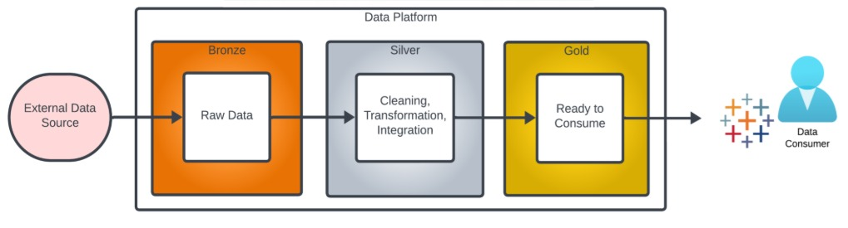
Figure 4.18: Medallion Architecture

Importance of Medallion Architecture
Enterprises face a common challenge: how to manage raw data ingestion, apply transformations consistently, and ensure analysts and data scientists work on reliable, governed datasets. The Medallion pattern solves this by:
- Providing clarity and modularity: each layer has a distinct purpose.
- Allowing incremental refinement instead of one massive ETL job.
- Enabling reusability: Silver can serve multiple Gold datasets.
- Improving trust and governance: business teams know Gold is curated and certified.

Strategic fit in Databricks
The Medallion Architecture fits naturally into Databricks because:
- Delta Lake provides ACID transactions and schema evolution across all layers.
- Structured Streaming enables real-time ingestion into Bronze and propagation to Silver/Gold.
- Databricks Workflows (or ADF) orchestrate the flow across layers.
- Optimizations like Z-Ordering, Partitioning, and Caching are applied at different stages depending on query patterns.

Example flow
In practice, a common Medallion-based pipeline follows this flow:
- Raw clickstream logs land in Bronze.
- Deduplicated, schema-aligned, and enriched user activity data is written to Silver.
- Aggregated KPIs like daily active users or conversion rates are modeled in Gold and exposed to Power BI.
The Medallion Architecture is more than just a technical pattern. It is the operating model of the Databricks Lakehouse. By layering data into Bronze, Silver, and Gold, organizations strike a balance between flexibility and governance, ensuring that data remains both accessible to engineers and trustworthy for business teams.

Integrating Databricks with other Azure services
Azure Databricks is rarely deployed in isolation. In most enterprise architectures, it functions as the data and AI engine that must integrate seamlessly with other Azure services across storage, analytics, governance, machine learning, and visualization. This interoperability transforms Databricks from a powerful Spark-based compute platform into the central hub of a modern data ecosystem. Integration is not only about connectivity; it is about enabling end-to-end workflows that deliver business value, from ingestion and transformation to insights and decision-making.
In the following section, we will explore how Databricks integrates with key Azure services, why those integrations matter, and the strategic benefits they deliver.

Azure Data Factory
While Databricks is the engine for large-scale data processing, most enterprises also need a way to orchestrate and manage data pipelines across multiple systems. This is where ADF fits in. ADF provides a low-code environment for designing, scheduling, and monitoring data workflows, making it the control plane for pipelines that span cloud and on-premises environments.
Let us look at how ADF and Databricks work together:
- Triggering Notebooks: ADF can call Databricks Notebooks or jobs as activities within a pipeline. This allows transformations written in PySpark, SQL, or Scala to be embedded inside larger workflows.
- Hybrid Pipelines: ADF can handle data movement (e.g., from on-premises SQL Server to ADLS), then trigger Databricks for transformation, and finally load data into Synapse or Power BI.
- Monitoring: ADF provides operational visibility through monitoring dashboards, retries, and alerts, ensuring pipelines are resilient.
Strategic value is as follows:
- ADF + Databricks provides the best of both worlds: low-code orchestration with high-performance transformations.
- This separation of concerns is crucial in large organizations where integration engineers, data engineers, and analysts all collaborate.
- It also ensures that Databricks is not overburdened with orchestration logic, focusing instead on what it does best, data processing and analytics.
Example snippet (calling a Databricks Notebook from ADF):
{
"name": "DatabricksNotebookActivity",
"type": "DatabricksNotebook",
"dependsOn": [],
"policy": {
"timeout": "7.00:00:00",
"retry": 1
},
"typeProperties": {
"NotebookPath": "/Shared/transform_users",
"baseParameters": {
"inputPath": "abfss://raw@stgazdeci.dfs.core.windows.net/users/",
"outputPath": "abfss://silver@stgazdeci.dfs.core.windows.net/cleaned_users/"
}
},
"linkedServiceName": {
"referenceName": "AzureDatabricksLS",
"type": "LinkedServiceReference"
}
}

This JSON fragment illustrates how ADF pipelines can pass parameters to a Databricks Notebook, making the orchestration dynamic and reusable.
Bottom line: With ADF orchestrating and Databricks transforming, organizations can design end-to-end, cloud-native data pipelines that are both powerful and manageable.

Azure Synapse analytics
Databricks excels at large-scale transformations and advanced processing, while Synapse is designed for serving relational queries at scale. The integration allows organizations to prepare data in Databricks and deliver it to Synapse for BI consumption, reporting, or downstream applications.
- Typical flow: Curated Delta tables in Databricks are written into Synapse using the native connector (.write.synapsesql). Synapse then exposes these tables to business analysts via SQL queries.
- Reverse flow: Synapse datasets can also be ingested into Databricks for complex transformations that go beyond T-SQL.
Strategic value: This combination bridges the big data and relational analytics worlds, ensuring each persona, data engineers, SQL developers, and BI analysts, works in their comfort zone without data silos.

Power BI
Power BI is the natural front-end for most Azure-based analytics ecosystems. When connected to Databricks, it becomes the visualization layer for the lakehouse. Power BI connects to Databricks through multiple consumption modes, as follows:
- Connection modes:
  - DirectQuery: real-time queries against Databricks SQL Warehouses.
  - Import: cached models for faster reporting.
  - Hybrid: mix of both for performance and freshness.
- Best practice: Always use Databricks SQL Warehouses instead of pointing Power BI directly at interactive clusters, as SQL Warehouses are optimized for BI traffic.
Strategic value: This integration democratizes access, giving business teams self-service analytics on top of the lakehouse without needing Spark knowledge.

Event Hubs and IoT Hub
Modern enterprises often deal with data in motion, such as telemetry from connected devices, application logs, or user activity streams. Azure Event Hubs and IoT Hub act as ingestion services for such streaming data, and Databricks provides the stream processing engine. This integration establishes a streaming ingestion and processing layer for data in motion.
- How it works: Spark Structured Streaming or Delta Live Tables can consume messages from Event Hubs or IoT Hub in near real time.
- Use cases: Fraud detection, anomaly monitoring, personalization engines, connected vehicle analytics.
- Strategic value: This unlocks real-time intelligence instead of relying purely on batch pipelines, enabling faster decision-making and responsive applications.

Azure Machine Learning
Databricks is often the feature engineering workbench, while Azure Machine Learning (Azure ML) specializes in model training, deployment, and governance. Together, they create an end-to-end machine learning lifecycle. The integration can be understood through the following workflow:
- Databricks prepares and curates features in Delta tables or a feature store.
- Azure ML consumes these features for training experiments, model tuning, and deployment to managed endpoints.
- Predictions can flow back into Databricks for scoring or downstream analytics.
Strategic value: By combining Databricks’ data capabilities with Azure ML’s operationalization features, enterprises achieve scalable AI pipelines with proper governance and reproducibility.

Azure Key Vault
Security is at the heart of enterprise adoption. Instead of hardcoding credentials in Notebooks, Databricks integrates natively with Azure Key Vault to retrieve secrets at runtime. The following points outline the practical usage and strategic value of integrating Azure Key Vault with Databricks:
- Practical use: Create a Databricks secrets scope backed by Key Vault, and reference secrets securely when connecting to databases or APIs.
- Strategic value: This enables secure, compliant pipelines while maintaining developer productivity, crucial for regulated industries like finance and healthcare.

Microsoft Purview
While Unity Catalog provides fine-grained governance and access control within Databricks, Microsoft Purview extends governance beyond the workspace by enabling enterprise-wide discovery, lineage, and compliance visibility. The following points summarize how Purview complements Unity Catalog across capabilities, enterprise impact, and strategic value:
- Capabilities: Searchable catalog of assets, data lineage across pipelines, automated classification of sensitive data.
- Enterprise impact: Makes it easier for compliance teams to monitor usage, and for analysts to discover and trust the right datasets.
- Strategic value: This transforms the lakehouse from a potential data swamp into a governed, discoverable ecosystem, aligning with data privacy and compliance mandates.

Unified integrations with Medallion Architecture
The real strength of Databricks lies not only in its own capabilities but in how it interoperates across the Azure ecosystem. By connecting with Synapse, Power BI, Event Hubs, Azure ML, Key Vault, and Purview, Databricks becomes the central nervous system of modern data and AI. These integrations ensure that data is processed efficiently, secured, governed, analyzed, and operationalized to drive business outcomes.
To operationalize these integrations in a scalable and structured way, many organizations adopt the Medallion Architecture. This layered approach organizes data pipelines into bronze, silver, and gold tiers, aligning Azure services and Databricks capabilities across ingestion, transformation, and consumption. Each layer not only serves a technical function but also delivers strategic value, from raw data capture to business-ready insights.

Tools typically used across Medallion layers
The tools commonly used across the Medallion layers are summarized in the following table:
Layer | Purpose | Common data sources | Primary tools or services | Output or consumers | Value proposition
Bronze (Raw) | Land raw, unprocessed data exactly as it arrives | Operational DBs, APIs, IoT devices, event streams, flat files | ADF / Synapse Pipelines (batch ingestion)  Event Hubs / IoT Hub (streaming ingestion)  Databricks Auto Loader  Delta Lake | Data Engineers for raw exploration, audit trails | Flexibility and Completeness: Source-of-truth preserved for reprocessing or audit
Silver (Cleansed and Enriched) | Cleanse, standardize, deduplicate, enrich with reference data | Bronze data | Databricks (PySpark, SQL, Delta Live Tables)  Delta Lake  Azure Key Vault | Analysts, ML engineers, and downstream Gold pipelines | Reliability and Consistency: Trusted, accurate, structured data
Gold (Curated / Business-Level) | Business-ready, aggregated, KPI-driven datasets | Silver data | Databricks SQL  Synapse Analytics  Power BI  Azure ML | Business users, executives, data scientists | Trust and Usability: Directly usable for decision-making, reporting, and advanced analytics
Table 4.2: Tools and consumers across Medallion architecture layers

The Medallion architecture organizes data into progressive layers, moving from raw ingestion to business-ready analytics. The following walkthrough shows how data evolves across the Bronze, Silver, and Gold layers to support downstream consumption:
- Bronze layer: Raw data lands with minimal transformation, preserving source fidelity for auditing or reprocessing.
- Silver layer: Data is cleaned, enriched, and made analytics-ready, forming the foundation of trust.
- Gold layer: Curated, KPI-focused datasets are ready for dashboards, reports, and machine learning. For example:
  - Power BI consumes Gold for self-service analytics and executive dashboards.
  - Synapse Analytics allows large-scale relational querying and reporting on curated datasets.
  - Azure ML leverages Gold datasets as feature-rich inputs for model training and scoring.

Conclusion
In this chapter, you have developed a solid understanding of Azure Databricks and its essential components for modern data engineering. You explored the workspace, Notebooks, and collaborative development practices, and learned how to ingest, cleanse, and transform data effectively using Spark and Delta Lake. You also gained insights into optimizing performance and integrating Databricks with other Azure services for end-to-end data solutions. With this knowledge, you are now equipped to build efficient, scalable, and well-governed data pipelines within Azure Databricks.
In the next chapter, you will design and build analytical data models using Azure Synapse Analytics. You will see how these models power enterprise reporting and semantic layers in Power BI, while also serving as structured, high-performance datasets for advanced analytics and machine learning workloads.

