Chapter 7

Monitoring and Managing Data Pipelines with Azure Monitor

Introduction
Azure Monitor is a comprehensive monitoring solution designed for collecting, analyzing, and acting on telemetry from your cloud and on-premises environments. Its relevance to data pipelines lies in its ability to provide deep visibility into pipeline health, performance, and issues, empowering data engineers and IT professionals to ensure reliable, high-performing data flows.
In today’s data-driven landscape, organizations increasingly rely on intricate data pipelines to fuel business intelligence, analytics, and operational workflows. As these pipelines grow in complexity and scale, the need for robust monitoring tools becomes paramount. Azure Monitor steps into this role by offering an integrated platform that not only tracks the health and efficiency of your data infrastructure but also provides proactive insights to help teams prevent disruptions before they impact critical operations.
This chapter is crafted to serve both newcomers and seasoned professionals seeking to enhance their data pipeline management capabilities. Through real-world scenarios and practical guidance, you will learn how to harness the full capabilities of Azure Monitor, ranging from setting up essential alerts to leveraging advanced diagnostic tools. By the end of this chapter, you will be equipped with the knowledge required to improve pipeline reliability, swiftly troubleshoot issues, and optimize performance across your Azure-based data solutions.

Structure
In this chapter, we will cover the following topics:
- Azure Monitor
- Monitoring data pipelines
- Configuring notifications
- Analyzing pipeline performance
- Troubleshooting issues
- Diagnosing failed pipeline runs
- Monitoring for root cause analysis
- Integrating with other Azure services
- Visualizing metrics in Power BI
- Performance metrics and dashboards
- Automating responses to metric thresholds
- Best practices for monitoring
- Continuous improvement

Objectives
The primary aim of this chapter is to equip readers with the expertise needed to effectively monitor and manage data pipelines within the Azure environment. By the end of this chapter, you will understand how to set up and customize alerts that promptly notify you of potential issues, thereby minimizing downtime and enhancing data reliability. You will learn to analyze pipeline performance metrics, diagnose bottlenecks, and implement solutions for optimal throughput and efficiency.
Another key objective is to foster proficiency in troubleshooting common pipeline problems, utilizing Azure Monitor's diagnostic tools to identify root causes and resolve issues swiftly. The chapter also seeks to demonstrate how seamless integration with Azure services can extend monitoring capabilities and automate responses, streamlining operational workflows. Ultimately, this chapter aims to empower data engineers and IT professionals to not only maintain high-performing data pipelines but also to proactively anticipate and mitigate risks, ensuring the integrity and continuity of critical business processes.
This chapter will guide you through practical recipes for setting up and leveraging Azure Monitor to manage and optimize data pipelines, focusing on Azure Data Factory (ADF) and other Azure data services. We will cover alert configuration, performance analysis, troubleshooting, service integrations, metric visualization, and best practices, all with step-by-step instructions, code samples, and visuals.

Azure Monitor
Azure Monitor is a comprehensive monitoring solution designed to provide deep visibility into your cloud resources and services. Collecting and analyzing data from a wide range of Azure resources empowers organizations to track performance, monitor system health, and identify emerging issues before they escalate. Azure Monitor goes beyond basic oversight, offering a suite of diagnostic tools and analytics that enable users to drill down into logs, metrics, and traces. This level of oversight allows teams to pinpoint the root causes of operational problems quickly, facilitating swift and effective troubleshooting.
One of the standout benefits of Azure Monitor is its ability to unify monitoring across diverse cloud services, bringing together information from ADF, Logic Apps, Power BI, and more into a centralized platform. This integration simplifies the management of complex cloud environments, making it easier to spot trends, detect anomalies, and respond proactively to incidents. Custom dashboards and rich visualizations help translate technical data into actionable insights, aiding both technical and business stakeholders in making informed decisions.
When it comes to troubleshooting, Azure Monitor excels by providing real-time alerts and automated notifications. These features enable teams to react immediately to potential threats or performance degradations, reducing downtime and minimizing the impact on business operations. By leveraging built-in analytics and customizable alerting rules, organizations can tailor their monitoring strategies to fit specific workloads and operational needs. Overall, Azure Monitor plays a pivotal role in maintaining the reliability, efficiency, and security of cloud services, enabling IT professionals to manage their environments with greater confidence and control.
Key features of Azure Monitor include:
- Centralized monitoring for Azure resources and services.
- Custom and built-in metrics collection and analysis.
- Alerting and notification mechanisms.
- Integration with Azure services like Data Factory, Logic Apps, and Power BI.
- Log Analytics for in-depth diagnostics.
- Dashboarding and visualization tools.

Monitoring data pipelines
Azure Monitor offers a comprehensive solution for overseeing data pipelines, ensuring that every step in the process is tracked and optimized for performance and reliability. With its centralized approach, teams can monitor activity across various Azure services, such as Data Factory, and gain visibility into how data is moving, transformed, and loaded throughout their cloud environment.
For instance, consider an organization running nightly Extract, Transform, and Load (ETL) jobs using ADF. By configuring Azure Monitor to track pipeline execution metrics, the team receives instant alerts if a pipeline fails or takes longer than expected to complete. This enables the operations staff to investigate issues, such as data source unavailability or transformation errors, before they affect downstream reporting or analytics.
Another practical scenario involves using custom dashboards to visualize pipeline throughput and latency over time. Suppose a business analyst notices a sudden drop in processed data for a critical sales report. Azure Monitor’s integration with Log Analytics allows them to drill into pipeline logs, pinpoint the bottleneck, perhaps a slow database query or an overloaded compute resource, and coordinate a fix with IT. These insights not only help maintain data integrity but also support continuous improvement in pipeline design and resource allocation. This is shown in a sample custom dashboard in the following recipe, with a screenshot.

Visualize metrics with dashboards
To visualize technical metrics in Azure Monitor, we need to follow the steps given here:
- Create custom dashboards in Azure Monitor.
- Add Data Factory metrics and log queries as visual tiles.
- Share dashboards with stakeholders.
A sample dashboard from Azure Monitor is shown in the following screenshot:
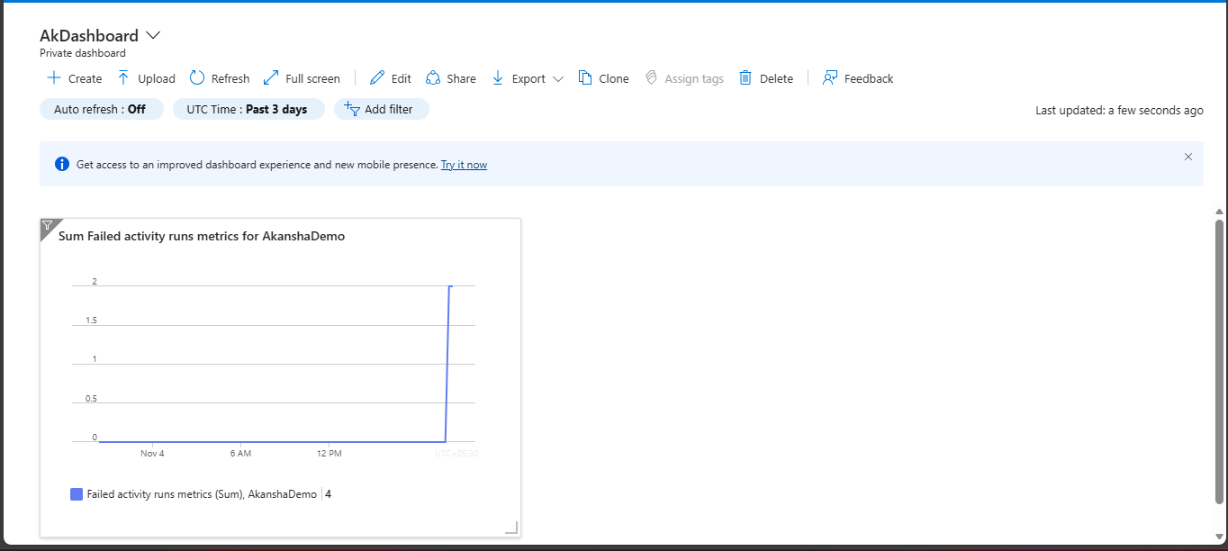
Figure 7.1: Screenshot showing a custom dashboard for metrics in Azure Monitor

By automating alerts and responses, organizations can proactively address common issues, such as missing files or schema mismatches, ensuring that data pipelines run smoothly. Azure Monitor’s flexibility empowers teams to set up tailored monitoring rules and notifications, adapting to evolving business requirements and regulatory standards.
To simplify, monitoring data pipelines with Azure Monitor is not just about catching errors—it is about fostering a culture of resilience, efficiency, and transparency in data operations. Through real-time visibility, actionable insights, and proactive management, Azure Monitor becomes an indispensable tool for modern data-driven enterprises. Some key objectives for using Azure Monitor in data pipelines are:
- Ensure data reliability and integrity.
- Proactively detect and resolve performance bottlenecks.
- Automate responses to common issues.
- Optimize resource utilization and costs.
- Comply with Service Level Agreement (SLAs) and regulatory requirements.
Here is the step-by-step process for setting up Azure Monitor for data pipelines
- Navigate to the Azure Portal and select the Azure Monitor service.
- Click Diagnostic settings on your Data Factory resource.
- Add diagnostic setting, select log categories (PipelineRuns, ActivityRuns), and route to Log Analytics.
- Validate data flow by running a test pipeline and querying logs in Log Analytics.

Configuring alerts
Alerts in Azure Monitor are a critical component for maintaining the health and reliability of cloud-based data operations. Essentially, these alerts act as an early warning system, notifying teams when something deviates from the expected performance or behavior in their Azure resources. With Azure Monitor, organizations can set up alerts for a broad spectrum of signals, including metrics, log data, and activity logs, allowing for real-time detection and response to incidents.
Using alerts is most beneficial when you need to ensure continuous service availability and data accuracy. For example, in a scenario where a company relies on ADF to run nightly ETL jobs, configuring alerts for pipeline failures or delays can help the operations team react quickly to disruptions. If a pipeline fails to complete on time, Azure Monitor can send instant notifications through channels such as email, SMS, or even trigger automated workflows using services like Logic Apps. This immediate feedback loop enables teams to investigate root causes, such as unavailable data sources or transformation errors, before they escalate into more significant issues that affect business reporting or analytics.
Alerts are not limited to error detection; they can also be used to monitor performance thresholds and resource utilization. For instance, a business might set up alerts for unusually high pipeline latency, sudden drops in data throughput, or unexpected spikes in compute usage. These alerts help analysts and engineers quickly identify bottlenecks, like a slow-running query or an overloaded compute node, and take corrective action to maintain smooth data flow. Over time, the trends revealed by these alerts can guide improvements in pipeline design and resource allocation, supporting both efficiency and cost optimization.
To illustrate, imagine a business analyst observing a sharp decline in the data processed for a key sales report. By leveraging Azure Monitor alerts and its integration with Log Analytics, the analyst can quickly pinpoint the issue, collaborate with IT, and resolve the problem, all before it impacts decision-making processes. This proactive alerting approach not only safeguards data reliability but also fosters a culture of resilience and transparency within the organization.
Azure Monitor alerts are indispensable for any organization looking to ensure the health, performance, and compliance of its data pipelines and cloud resources. By providing real-time visibility and automated responses, alerts empower teams to address issues promptly, optimize operations, and meet regulatory or service-level obligations.
Azure Monitor’s alerting system allows you to detect and respond to issues in real time. Alerts can be configured for a wide range of metrics, logs, and activity signals, and can trigger notifications or automated actions.

Setting up an alert for Data Factory
Now we can see how to set up an alert for ADF in the Azure portal:
- Navigate to Azure Monitor: In the Azure Portal, search for Azure Monitor and select it.
- Select Alerts and New Alert Rule: Click on Alerts in the left panel, then New Alert Rule.
- Choose the resource: Select your Data Factory instance.
- Set the condition: Click Add condition, search for Pipeline failed runs, and select the appropriate signal.
- Configure the alert logic: Set the threshold (e.g., Greater than 0 for failures).
- Define the Action Group: Create or select an Action Group for notifications (email, SMS, webhook, Logic App).
- Set alert details: Name your alert rule and provide a description.
- Review and create: Review your settings and click Create.
We can also create Azure Resource Manager (ARM) template code that can be reused for different environments or different services for configuring Azure Monitor alerts tailored to ADF. This requires a systematic approach to defining the alert logic and automating the deployment process. The goal is to ensure that pipeline failures or other key metrics are promptly detected, and relevant stakeholders are notified through the preferred channels.
To begin, your ARM template should specify the resource type as Microsoft.Insights/metricAlerts, which is responsible for metric-based alerting in Azure. Within the properties section, it is important to clearly outline the alert’s purpose using the description field, such as Alert for Data Factory pipeline failures. Assign an appropriate severity level, enable the alert, and define the scopes by referencing the Data Factory resource using its unique Azure Resource ID. This ensures the alert is targeted precisely at the intended Data Factory instance.
The template should also set the evaluationFrequency, which determines how often Azure Monitor checks for the specified condition (for example, every five minutes). Next, the criteria section must specify the metric signal to monitor, such as pipeline failed runs, and set the threshold logic (for instance, triggering the alert when the count of failed runs exceeds zero).
Another crucial step is linking the alert to an Action Group. Action groups define how notifications are sent, whether by email, SMS, webhook, or integration with automation tools like Logic Apps. You can reference an existing Action Group or provision a new one within the same ARM template for seamless deployment.
Finally, provide a meaningful name for the alert rule and a concise description to help with future management and auditing. Once all fields are completed, the ARM template can be deployed, either through the Azure Portal, PowerShell, or Azure CLI, enabling consistent and repeatable alert configuration for your Data Factory environment.
By leveraging ARM templates for alert creation, you enable efficient infrastructure-as-code practices, ensuring that monitoring configurations are versioned, scalable, and easily replicated across environments.
Sample ARM template snippet for this recipe is as follows:
{
"type": "Microsoft.Insights/metricAlerts",
"apiVersion": "2018-03-01",
"properties": {
"description": "Alert for Data Factory pipeline failures",
"severity": 2,
"enabled": true,
"scopes": ["/subscriptions/{subscription-id}/resourceGroups/{resource-group}/providers/Microsoft.DataFactory/factories/{factory-name}"],
"evaluationFrequency": "PT5M",
"windowSize": "PT5M",
"criteria": {
"allOf": [
{
"criterionType": "StaticThresholdCriterion",
"metricName": "FailedPipelineRuns",
"metricNamespace": "Microsoft.DataFactory/factories",
"operator": "GreaterThan",
"threshold": 0,
"timeAggregation": "Total"
}
]
},
"actions": [
{
"actionGroupId": "/subscriptions/{subscription-id}/resourceGroups/{resource-group}/providers/microsoft.insights/actionGroups/{action-group}"
}
]
}
}
Here is the screenshot of the Azure Portal to show alert rule creation for Data Factory pipeline failures:
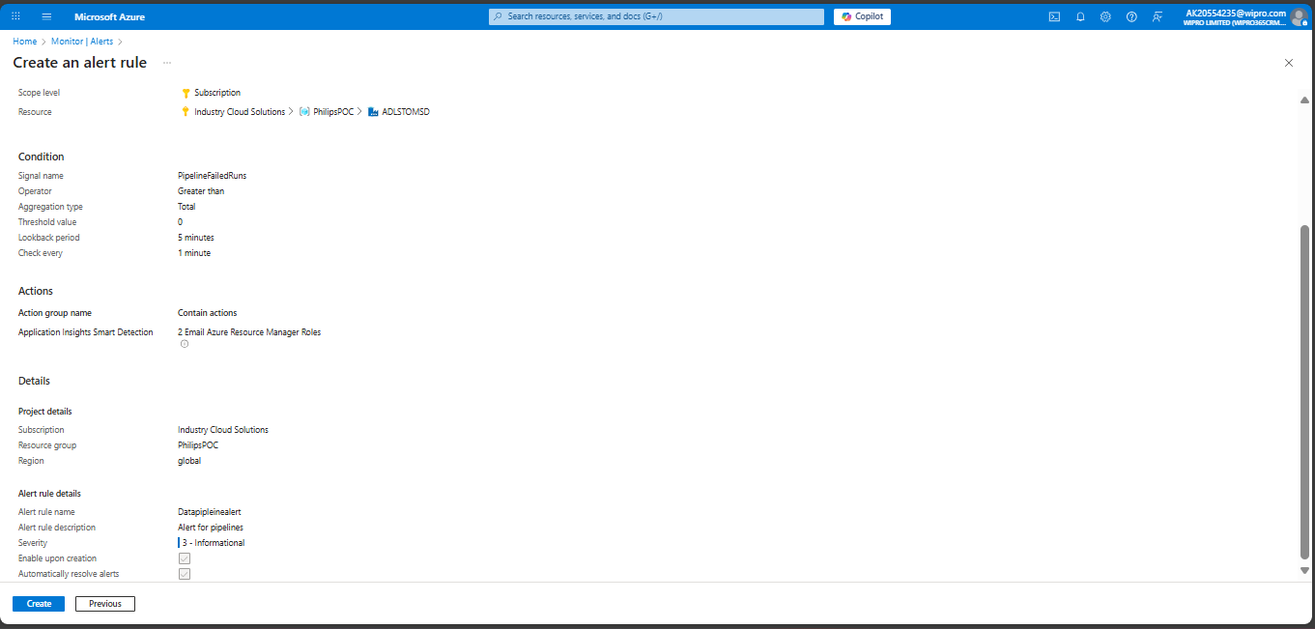
Figure 7.2: Configuring alerts for the data pipeline

Configuring notifications
Configuring notifications in Azure Monitor is an essential step for ensuring that stakeholders are promptly informed of important events or potential issues within your Azure environment. Notifications are primarily delivered through Action Groups, which can be configured to send alerts via several channels, such as email, SMS, push notifications, webhooks, or by integrating with automation solutions like Logic Apps.
Alerts and notifications are designed to work hand-in-hand within Azure Monitor. Alerts are triggered based on specific conditions or metrics you define, such as a pipeline failure in ADF or a spike in resource utilization. Once an alert is activated, the associated Action Group takes over, delivering notifications to the appropriate recipients or systems. This seamless integration ensures that not only are problems detected swiftly, but they are also communicated effectively to those who can take action.
For example, consider a scenario where you want to monitor a Data Factory pipeline for failures, as shown in the following screenshot of a Logic app failure. You would first create an alert rule that monitors the pipeline run status. When a failure is detected, the alert rule triggers an Action Group configured to send an email notification to the operations team. Additionally, you could set up the Action Group to invoke a Logic App, which might automatically create a ticket in your IT service management tool or execute remediation steps. This real-time notification process enables teams to respond quickly, minimizing downtime and maintaining data pipeline health, as shown in the following screenshot:
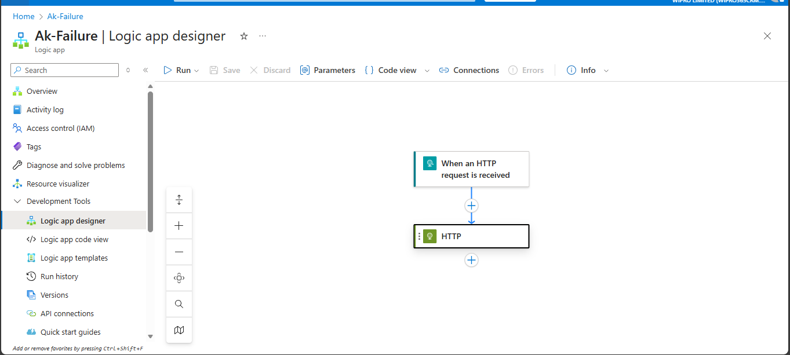
Figure 7.3: Simulating failure in Logic App designer

To configure notifications, navigate to Azure Monitor in the Azure Portal and select Alerts. From there, create a new alert rule by specifying the resource, condition, and threshold. Next, define or select an Action Group and choose the notification methods that best fit your needs. By thoughtfully configuring alerts and notifications, organizations can enhance their responsiveness to incidents and ensure critical systems remain reliable and resilient. The following are the important points to consider when configuring notifications in Azure Monitor:
- Action Groups can be set up for email, SMS, push notifications, webhooks, and Logic Apps.
- For automated remediation, integrate with Logic Apps to trigger workflows upon alert.
Here is the recipe to configure alerts and notifications with step-by-step activities in Azure Portal:
- Go to Azure Monitor and select Alerts and choose the option New Alert Rule.
- Select Data Factory as the resource.
- Add a condition for Pipeline failed runs.
- Create/select an Action Group for notifications (email, SMS, Logic App).
- Save the alert rule.
This is shown in the following screenshot from the Azure portal:
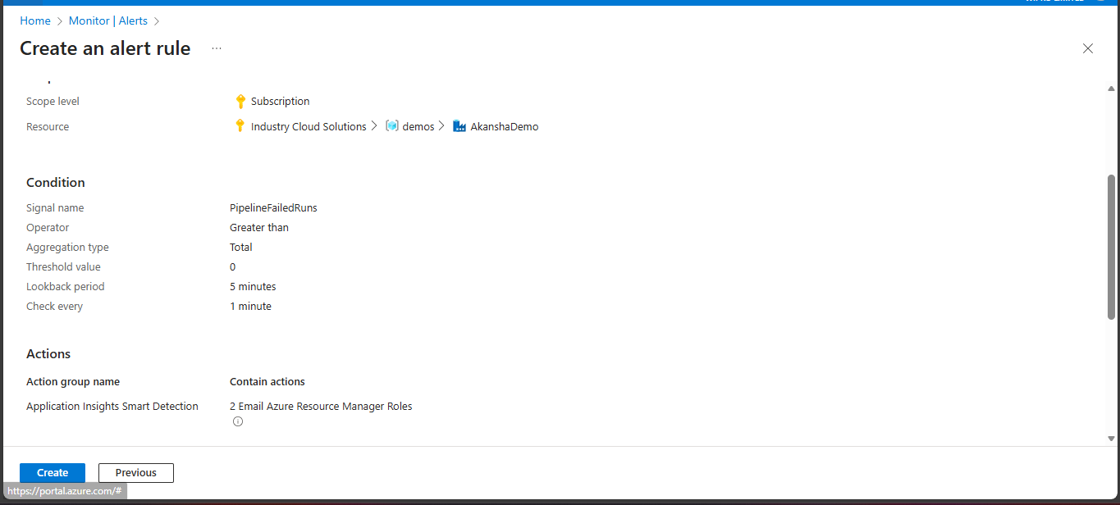
Figure 7.4: Creating an alert and a notification in Azure Monitor

Analyzing pipeline performance
Monitoring ADF pipeline metrics using Log Analytics is pivotal for ensuring efficient data movement and identifying performance bottlenecks. To begin this process, you need to enable diagnostic settings on your Data Factory resource within the Azure Portal. This involves navigating to the resource, selecting Diagnostic settings, and then adding a new diagnostic setting. Here, you can specify which logs, such as PipelineRuns or ActivityRuns, should be sent to your chosen Log Analytics workspace.
Once the logs are streaming into Log Analytics, you gain the ability to perform in-depth analysis using the Kusto Query Language (KQL). With KQL, you can query and visualize various pipeline metrics, such as average activity duration, success and failure rates, and throughput. For example, you might write a query to calculate the average duration of successful pipeline runs for each pipeline, helping you pinpoint areas that may require optimization.
These insights allow teams to proactively address issues, maintain high levels of reliability, and ensure that data pipelines meet organizational performance standards. By leveraging Log Analytics, organizations can transform raw operational data into actionable intelligence, driving continuous improvement for their data integration workflows.
Monitoring pipeline performance is crucial for maintaining data velocity and reliability. Azure Monitor provides metrics such as activity duration, throughput, and failure rates, which can be analyzed using built-in tools or custom queries.

Monitoring Data Factory pipeline metrics
Monitoring Data Factory pipeline metrics is an essential practice for ensuring the smooth and efficient operation of data integration processes within an organization. By actively tracking metrics such as activity durations, data throughput, and failure rates, teams can quickly identify potential bottlenecks or anomalies that may affect performance or reliability.
Leveraging Azure Monitor and Log Analytics allows users to collect diagnostic logs from Data Factory resources, which can then be analyzed in detail using KQL. This approach enables data engineers and administrators to uncover trends, assess the success and failure rates of pipeline activities, and spot areas that may benefit from optimization.
Ultimately, a robust monitoring strategy not only helps in maintaining the required data velocity but also supports proactive troubleshooting, ensuring that data workflows consistently meet the organization’s performance benchmarks.
Here is the recipe for monitoring ADF pipeline metrics using Azure Monitor Log Analytics:
- Enable diagnostic settings: On your Data Factory resource, select Diagnostic settings, then Add diagnostic setting.
- Send logs to Log Analytics: Choose your Log Analytics workspace and select relevant log categories (e.g., PipelineRuns, ActivityRuns).
- Query pipeline runs: In the Log Analytics workspace, use KQL to analyze performance.
KQL sample:
ADFActivityRun
| where Status == "Succeeded"
| summarize avg(DurationMs) by PipelineName
| order by avg(DurationMs) desc
Here is a screenshot showing Log Analytics query results for average pipeline durations in the Azure Portal:
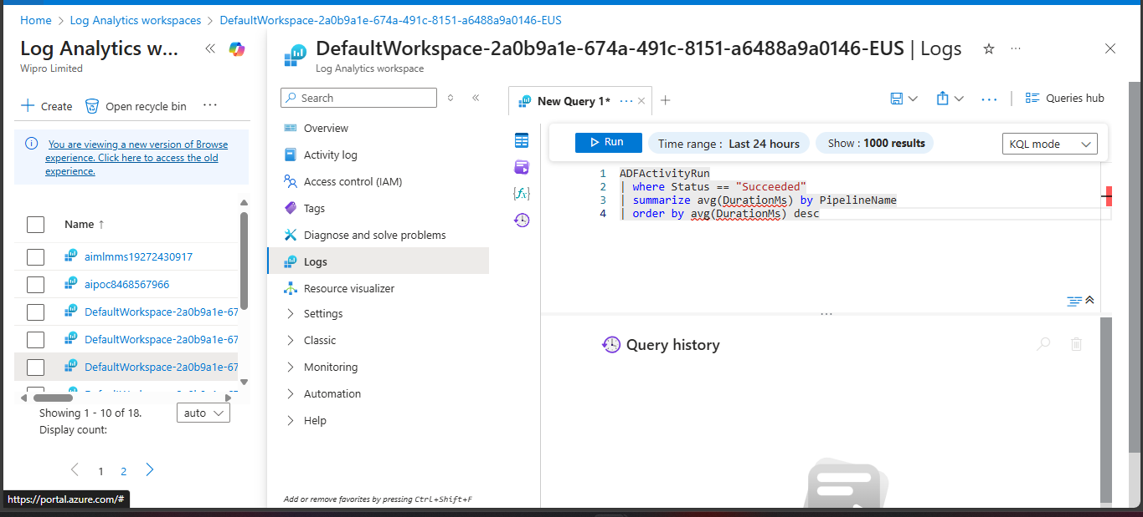
Figure 7.5: Log Analytics query results showing average pipeline durations
Here are the steps in setting up the integration of Azure Monitor with Data Factory:
- Enable diagnostics in Data Factory to send logs to Log Analytics.
- Use Logic Apps for automated remediation based on alerts.
This is shown in the following screenshot in the Azure Monitor diagnostic settings:
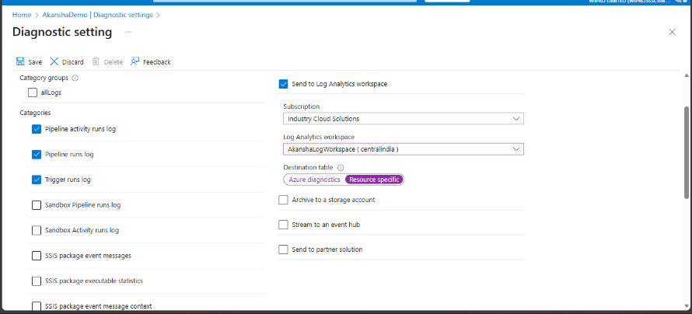
Figure 7.6: Screenshot showing Diagnostic setting in Azure Monitor to integrate the data pipeline

Creating custom metrics
Creating custom metrics in Azure Monitor for ADF allows teams to track specific performance indicators tailored to their unique requirements. By leveraging ADF’s Web Activity, you can trigger an Azure Function to log these custom metrics directly into Azure Monitor. This approach enables you to monitor aspects of your data pipelines that go beyond the standard telemetry, such as tracking the number of processed records or measuring the execution time of particular activities.
Once your metrics are being sent to Azure Monitor, you can visualize trends and patterns by building charts or dashboards within the Azure Portal. This not only helps in identifying potential bottlenecks but also supports proactive decision-making by providing real-time insights into pipeline performance. Integrating custom metrics with Azure Monitor ensures that your data operations are transparent, measurable, and aligned with business objectives. The steps involved in this process are:
- Emit custom metrics: Use ADF’s Web Activity to call an Azure Function that logs custom metrics to Azure Monitor.
- Visualise in Azure Monitor: Create charts or dashboards to display custom metric trends.
Azure Function sample (Python code) tracking metrics from Azure Monitor can be written like this:
import logging
import azure.functions as func
from azure.monitor.opentelemetry.exporter import AzureMonitorMetricExporter
def main(req: func.HttpRequest) -> func.HttpResponse:
metric_exporter = AzureMonitorMetricExporter(
connection_string="InstrumentationKey=your-key"
)
metric_exporter.track_metric(name="CustomDataLatency", value=123)
return func.HttpResponse("Metric logged.", status_code=200)

The following screenshot shows how to visualize custom metrics in Azure Monitor:
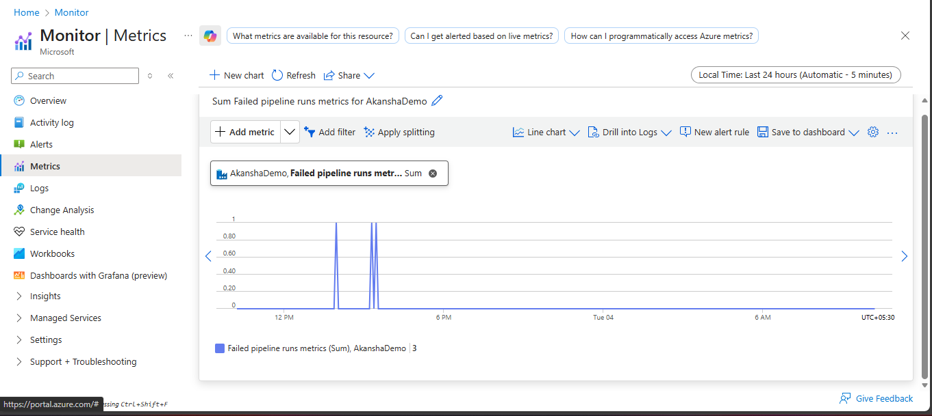
Figure 7.6: Screenshot showing Azure Monitor custom metrics

Troubleshooting issues
Troubleshooting problems in your Azure environment is greatly enhanced with Azure Monitor’s robust diagnostics and metrics features. When it comes to investigating failed pipeline runs, a systematic approach using alert notifications, Log Analytics, activity run details, and resource metrics can be invaluable. First, pay close attention to any alert notifications, as they provide immediate insights into pipeline failures. These alerts allow you to quickly identify which pipelines require attention and often include initial error information.
Next, delve into the diagnostic logs using Log Analytics. By running targeted queries, you can efficiently filter and pinpoint failed pipeline runs. This helps isolate problematic pipelines and provides a clearer picture of their failure patterns over time. Once identified, examining the details of each activity run is crucial. Here, you can determine exactly which activities failed and explore associated error messages to understand the root cause.
Finally, it is important to correlate these failures with resource metrics such as CPU and memory usage. Sometimes, spikes in resource consumption can coincide with pipeline failures, indicating possible performance bottlenecks or capacity issues. By combining these steps, monitoring alerts, analyzing logs, investigating failed activities, and reviewing resource metrics, you can create a comprehensive troubleshooting workflow that leads to faster and more effective resolutions.
Azure Monitor’s diagnostic logs and metrics empower rapid issue identification and resolution.
Here are the steps in monitoring Data Factory pipeline performance using Azure Monitor Log Analytics and diagnostics metrics:
- Query Log Analytics for activity and pipeline run durations.
- Analyze trends and identify bottlenecks.
The following screenshot shows how to query Log Analytics data to understand the data pipeline performance:
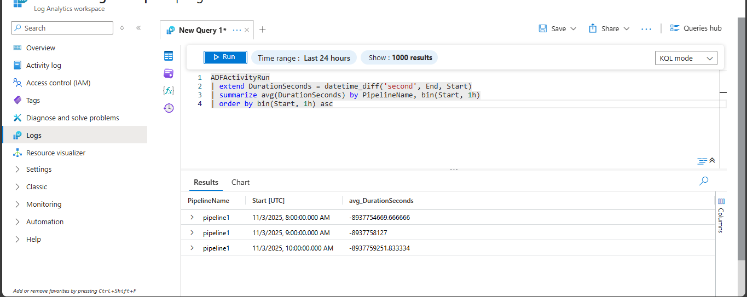
Figure 7.7: Screenshot showing Log Analytics in Azure Monitor to query pipeline performance

Diagnosing failed pipeline runs
When documenting the steps for diagnosing failed pipeline runs with Azure Monitor, it is important to break down the process into clear, actionable instructions. Begin by guiding users to review alert notifications, as these immediately highlight pipelines that have encountered issues.
Next, recommend investigating Log Analytics, where targeted queries can help pinpoint failures across different pipeline runs. Encourage a thorough examination of each activity run, detailing how to identify specific errors and understand their underlying causes.
Finally, advise correlating these failures with resource metrics like CPU and memory usage, which may reveal performance bottlenecks. By presenting these steps in a logical, sequential manner, you make the troubleshooting process both approachable and effective for users. Here are the steps in developing the recipe for the same:
- Check alerts: Review alert notifications for failed pipelines.
- Inspect logs: In Log Analytics, run queries to filter failed pipeline runs.
- Drill into activity runs: Identify which activities failed and examine error messages as shown in the following screenshot:
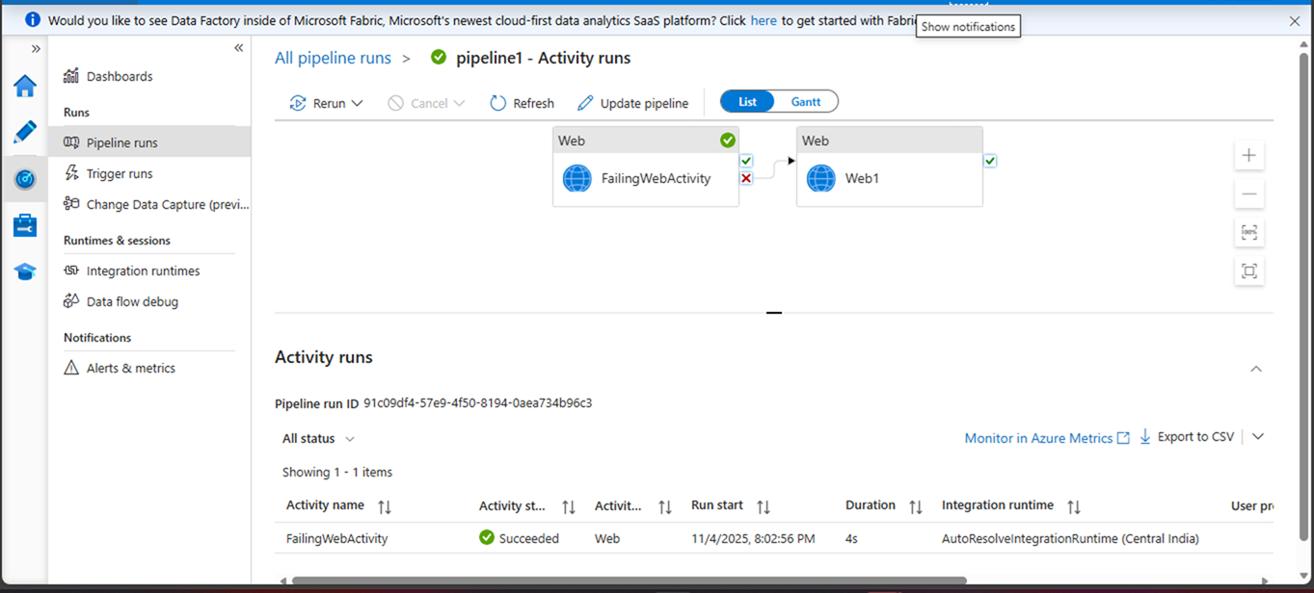
Figure 7.8: Activity runs from the Azure Monitor dashboard

- Correlate with resource metrics: Check if failures align with resource spikes (CPU, memory).
KQL example for querying activity run for failed status is as follows:
ADFActivityRun
| where Status == "Failed"
| project PipelineName, ActivityName, ErrorMessage, Start, End
This can be run in the Log Analytics workspace in Azure Monitor to get KQL results as shown in the following screenshot:

Figure 7.9: Screenshot of error messages and failed activity diagnostics

When addressing issues within ADF pipelines, Azure Monitor provides a comprehensive toolkit for both detection and diagnosis. The troubleshooting process typically begins by inspecting logs in the Log Analytics workspace, where you can run queries to filter for failed pipeline runs. By focusing on these failures, you can quickly narrow down which parts of your workflow need attention.
For example, you might use KQL to identify failed activity runs and retrieve details such as the pipeline name, the specific activity, error messages, and timestamps. This allows for targeted investigation, as shown in diagnostic screenshots where error messages and activity details are surfaced for review. Additionally, drilling into individual activity runs helps clarify root error causes, making it easier to understand whether the problem stems from configuration, data, or connectivity issues.
In this scenario, the best practice is to correlate these failures with resource metrics, such as spikes in CPU or memory usage. By overlaying pipeline diagnostics with resource data, you can determine if performance bottlenecks or resource limitations contributed to the issues. Using Azure Monitor Workbooks, you can visualize this information through interactive dashboards, timelines, and charts, helping to spot patterns and recurring problems over time.
Some key recommendations for effective troubleshooting include:
- Always start by filtering and examining failed runs.
- Pay close attention to error messages for clues.
- Use resource metrics to uncover hidden performance issues.
- Leverage visualizations in Workbooks to identify trends.
- Regularly reviewing pipeline metrics and setting up alerts for anomalous behavior will enable proactive detection and resolution.
Combining these strategies ensures a thorough and efficient approach to maintaining pipeline health and reliability. Now we can see how to troubleshoot Pipeline Issues in Azure Monitor with the following steps:
- Filter failed runs in Log Analytics.
- Drill down into error messages and root causes.
- Correlate with resource metrics for deeper insights.
This is shown in the following screenshot with KQL to troubleshoot and the result from pipeline metrics:
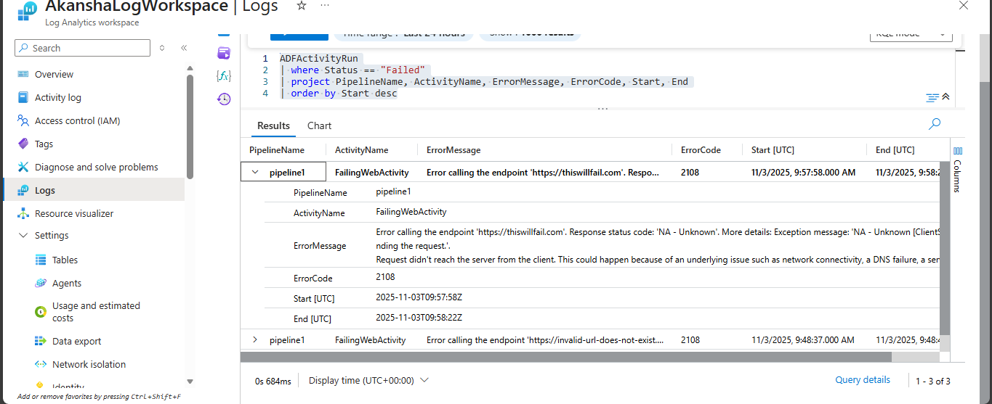
Figure 7.10: Screenshot showing Azure Monitor to troubleshoot pipeline performance

Monitoring for root cause analysis
Azure Monitor Workbooks provide a flexible and interactive environment for conducting root cause analysis of issues within your data pipelines. By leveraging KQL, users can craft queries that pinpoint failed pipeline runs, making it easier to isolate problematic activities and uncover patterns behind failures. For example, you can create a query that specifically filters for runs marked as Failed, displaying details like pipeline name, activity name, error messages, and timestamps. This targeted approach allows you to quickly identify where and when issues occurred.
Additionally, Workbooks enable you to incorporate resource metrics such as CPU and memory usage alongside your pipeline diagnostics. By correlating these metrics with failure events, you gain deeper insights into whether resource constraints contributed to the problems. Timelines and visualizations within the Workbook help you spot trends or recurring issues over time, making it easier to understand the broader context of failures and track their frequency. Overall, Azure Monitor Workbooks streamline the troubleshooting process by bringing together data, queries, and visuals in one unified dashboard.
Here are the steps for this activity:
- Open Workbooks: In Azure Monitor, select Workbooks and create a new workbook.
- Add queries and visuals: Insert KQL queries for failed runs, resource metrics, and timelines.
- Analyze trends: Use visuals to spot patterns or recurring issues.
The following screenshot shows the Azure Monitor workbook for visualizing pipeline failures over time using a visual representation of collected metrics:
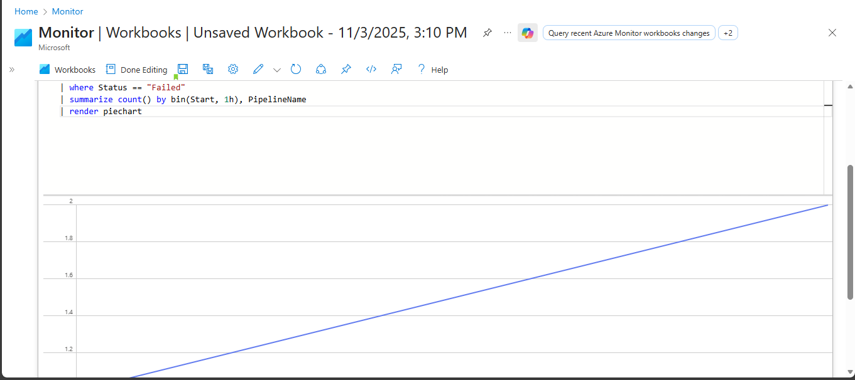
Figure 7.11: Screenshot of a workbook visualizing pipeline failures over time

Integrating with other Azure services
Azure Monitor offers robust integration capabilities with a range of Azure services, including Data Factory, Logic Apps, Power BI, and Event Grid. This seamless connectivity empowers users to automate responses to incidents and gain advanced visualization of operational data.
For instance, by linking Azure Monitor with Data Factory, you can automatically route diagnostic logs to Log Analytics or Event Hub, enabling detailed analysis and the creation of custom alerts. These alerts can then trigger automated workflows in Logic Apps, such as restarting failed pipelines without manual intervention.
Additionally, exporting pipeline metrics to Power BI allows for the development of dynamic dashboards, making it easier to spot trends, evaluate performance, and share insights across teams. Event Grid integration further supports real-time event-driven actions, ensuring that issues are addressed promptly and efficiently.
Altogether, these integrations help organizations streamline monitoring, automate key processes, and enhance their ability to visualize and act on data. Azure Monitor seamlessly integrates with services like ADF, Logic Apps, Power BI, and Event Grid, enabling automated actions and advanced visualization.
Now, let us build the recipe for Integrating Azure Monitor with Data Factory with the following steps:
- Enable diagnostics: Go to Data Factory, select Diagnostic settings, and then choose the Add diagnostic setting option.
- Stream logs: Route logs to Log Analytics, Event Hub, or Storage Account.
- Automate actions: Link alerts to Logic Apps for automated remediation (e.g., restart failed pipelines).
The following screenshot shows how to configure diagnostic settings in Azure Monitor:

Figure 7.12: Screenshot of diagnostic settings with Log Analytics integration

Azure Monitor serves as a central platform for collecting, analyzing, and acting upon telemetry data from various Azure services. By integrating Azure Monitor with key services like Data Factory, Logic Apps, Power BI, and Event Grid, organizations can automate responses to incidents, gain deeper operational insights, and ensure proactive management of their workloads. Such integrations not only reduce manual intervention but also enhance visibility and accelerate decision-making.

Integrating Azure Monitor with Data Factory
ADF is a powerful tool for orchestrating data movement and transformation. When integrated with Azure Monitor, ADF can stream diagnostic logs and metrics for in-depth analysis and automated alerting. For example, by configuring diagnostic settings in ADF, you can send activity logs to Log Analytics, enabling the creation of custom alerts for pipeline failures or performance anomalies. These alerts can then trigger automated notifications or corrective actions, such as restarting a failed pipeline.
Suppose a data pipeline fails due to a connectivity issue. An alert generated by Azure Monitor can automatically invoke a Logic App workflow to restart the pipeline and notify the operations team, thereby minimizing downtime.
Some best practices to consider in this integration are:
- Ensure all relevant diagnostic logs are enabled and routed to a central analytics workspace.
- Define clear alert rules for critical pipeline activities and errors.
- Regularly review and update diagnostic settings to accommodate changes in pipeline configurations.

Integrating Azure Monitor with Logic Apps
Azure Logic Apps enables the automation of business processes and workflows. When integrated with Azure Monitor, it allows for the orchestration of automated responses to monitoring events. For instance, you can set up alerts in Azure Monitor that, when triggered, execute a Logic App to remediate issues or escalate them to relevant stakeholders.
As an example, if a resource’s CPU usage exceeds a predefined threshold, Azure Monitor can fire an alert that triggers a Logic App. This Logic App could scale out the affected service and simultaneously send an email notification to the IT team, ensuring swift action.
Some of the Best Practices in integrating Azure Monitor with Logic Apps are:
- Use Logic Apps for automating routine remediation tasks, reducing manual workload.
- Implement robust error handling within Logic Apps to manage exceptions gracefully.
- Test automated workflows periodically to ensure reliability and effectiveness.

Integrating Azure Monitor with Power BI
Power BI offers advanced data visualization capabilities, making it an ideal companion for Azure Monitor. By exporting monitoring data from Log Analytics to Power BI, users can build interactive dashboards that provide a consolidated view of operational health and trends. This facilitates proactive decision-making and encourages data-driven insights across teams.
A cloud architect can create a Power BI dashboard displaying pipeline performance, error rates, and resource utilization by regularly importing query results from Log Analytics. This dashboard can then be shared with stakeholders, enabling collaborative analysis and timely intervention if issues are detected.
Please consider the following best practices in integrating Azure Monitor with Power BI:
- Automate the export of monitoring data to Power BI for up-to-date visualizations.
- Design dashboards with clear, actionable metrics and intuitive layouts.
- Restrict dashboard access to authorized personnel to maintain data security.

Integrating Azure Monitor with Event Grid
Azure Event Grid provides real-time event-driven capabilities, enabling immediate action in response to critical monitoring events. By integrating Azure Monitor with Event Grid, organizations can ensure that significant events, such as security breaches or system failures, prompt immediate automated workflows or notifications.
Upon detecting a security anomaly, Azure Monitor can emit an event to Event Grid, which in turn triggers a Logic App or Azure Function to isolate the affected resource and alert the security team instantly.
From an integration perspective, here are the Best Practices to be considered:
- Define event subscriptions carefully to avoid unnecessary noise and focus on actionable events.
- Leverage Event Grid’s filtering capabilities to route only relevant events to downstream services.
- Monitor the health of event subscriptions and downstream automation for reliability.

General best practices for seamless integration
Here are some of the best practices in seamless integration of Azure Monitor with Azure Data Factory for real-time and offline monitoring and alerting activities:
- Standardize monitoring configurations across all Azure services to simplify management and reporting.
- Regularly review and refine alert rules and automation workflows to adapt to evolving operational needs.
- Implement access controls and audit logging to safeguard monitoring data and automation processes.
- Foster collaboration between application, operations, and business teams to ensure monitoring objectives align with organizational goals.
- Document integration patterns and automation workflows for easier maintenance and knowledge transfer.
Seamlessly integrating Azure Monitor with Data Factory, Logic Apps, Power BI, and Event Grid empowers organizations to automate responses, visualize operational data, and act on insights in real time. These integrations not only enhance operational efficiency but also enable proactive management, reduce mean time to resolution, and support data-driven decision-making. By following best practices and leveraging the strengths of each service, IT professionals and cloud architects can build resilient, responsive, and well-governed cloud environments.

Visualizing metrics in Power BI
Integrating Azure Monitor’s Log Analytics with Power BI unlocks powerful capabilities for visualizing and interpreting operational metrics. By exporting relevant pipeline and system data from Log Analytics, users can harness Power BI’s interactive dashboards to transform raw log information into actionable insights. For example, you might use a KQL query in Log Analytics to extract pipeline run durations, error rates, or resource consumption statistics over time. Once the data is refined, exporting the results enables seamless import into Power BI Desktop.
After connecting Power BI to these exported datasets, you can design a variety of visuals to represent key performance indicators. For instance, a line chart can track pipeline throughput across several days, while bar graphs can compare error counts by pipeline or by resource group. Additionally, pie charts can segment data to highlight the proportion of successful versus failed runs. These dashboards provide a consolidated, real-time view of pipeline health and operational trends, making it easier for teams to spot anomalies, identify bottlenecks, and respond proactively to emerging issues.
The flexibility of Power BI allows for custom filtering, drill-downs, and interactive features, empowering users to tailor dashboards to specific business or technical needs. For example, operations teams may set up alerts for threshold breaches, while business stakeholders can use slicers to analyze performance by department or region. By integrating Azure Monitor with Power BI, organizations foster a data-driven culture, enabling rapid decision-making based on comprehensive, visually rich metrics.
Now, we can see the recipe on how to create Power BI Dashboards for pipeline performance:
- Export data: Use Log Analytics to query pipeline metrics and export results.
- Connect Power BI: Import query results into Power BI Desktop.
- Create dashboards: Build interactive visuals and publish dashboards.
Effective monitoring of the ADF pipeline performance is vital for ensuring operational excellence and rapid issue resolution. By integrating Azure Monitor’s Log Analytics with Power BI, organizations can visualize pipeline health, track performance metrics, and empower data-driven decisions. The following recipe provides a structured approach to building an interactive Power BI dashboard, catering to both technical and business stakeholders:
- Export pipeline metrics from Log Analytics using KQL: Begin by accessing Log Analytics within the Azure Portal. Craft a KQL statement to extract pipeline performance metrics relevant to your monitoring objectives, such as run durations, error rates, or resource consumption. Once the query has been executed, review the returned dataset to ensure it meets your requirements. Export the results to a .csv file, which will serve as the foundation for your Power BI dashboard.
- Import query results into Power BI Desktop: Open Power BI Desktop and select the option to import data. Navigate to your exported .csv file from Log Analytics. Power BI will prompt you to confirm the data structure and field mappings, allowing you to refine columns and ensure data integrity. This step is crucial as it sets the stage for meaningful visual analysis of your pipeline metrics.
- Design interactive visual dashboards in Power BI: With the data successfully imported, proceed to the dashboard design phase. Utilize Power BI’s suite of visualization tools to construct charts and graphs that best represent your key performance indicators. Line charts may be employed to illustrate pipeline throughput over time, while bar graphs can highlight error counts across different pipelines or resource groups. Consider incorporating pie charts to depict the proportion of successful versus failed runs, thereby offering a holistic view of operational trends.
- Customize visuals and share dashboards: Enhance the dashboard’s interactivity by adding custom filters, drill-down options, and slicers tailored to specific business or technical requirements. Set up conditional formatting and alerts for threshold breaches to enable proactive incident management. Once satisfied with the dashboard configuration, publish the dashboard to the Power BI service and share it with your team, ensuring seamless access and collaboration. Regularly review and update the visuals to reflect evolving monitoring needs and organizational priorities.
By following these steps, IT professionals and cloud architects can establish a robust, visually rich monitoring solution that supports proactive pipeline management and fosters a culture of continuous improvement.
A sample custom Power BI dashboard by pulling Log Analytics data is shown as follows.
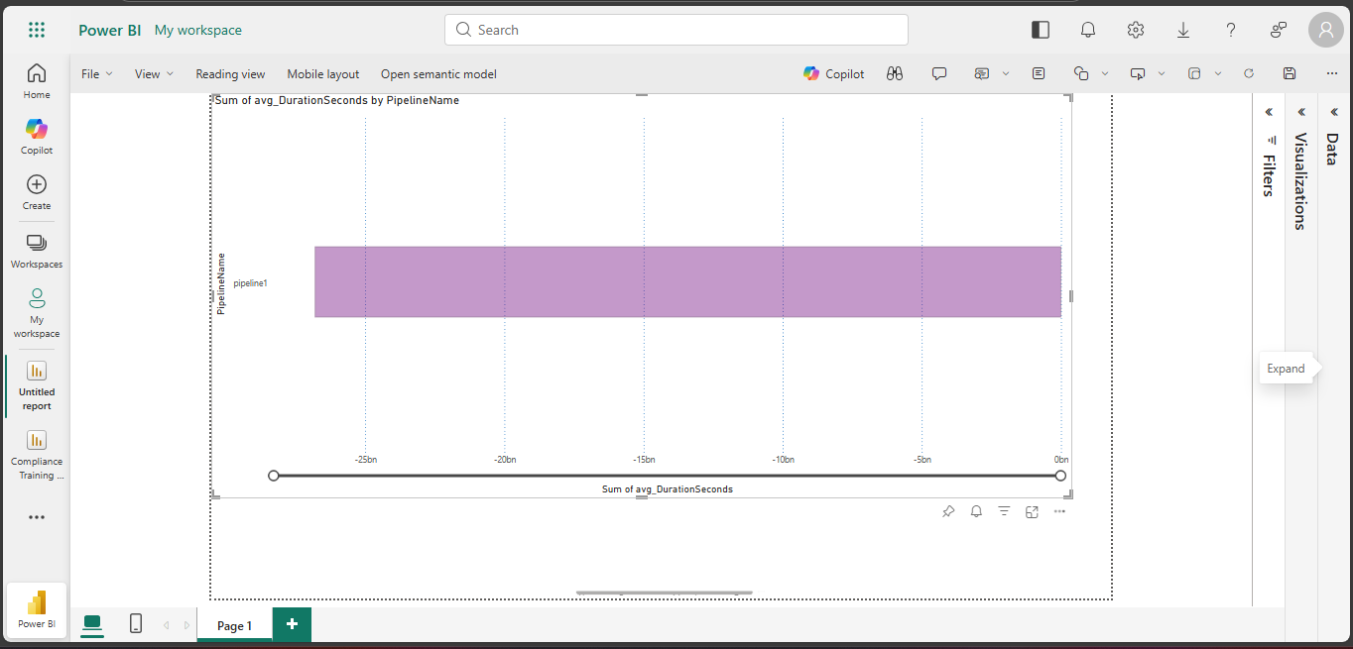
Figure 7.13: Screenshot of Power BI dashboard for pipeline performance

Performance metrics and dashboards
Performance metrics serve as the backbone of any robust monitoring strategy, especially when leveraging custom dashboards within Azure Monitor. These metrics provide real-time insights into the health, efficiency, and reliability of your ADF pipelines or other cloud resources. By visualizing data through interactive dashboards, IT professionals and cloud architects can swiftly identify bottlenecks, spot anomalies, and make informed decisions to optimize operations.
A well-designed Azure Monitor dashboard consolidates essential metrics such as pipeline run duration, throughput, error rates, and resource utilization. For instance, you might include line charts to track the average execution time of pipelines over the past week, bar graphs to compare the frequency of errors across different data sources, or pie charts to illustrate the ratio of successful to failed activities. This multi-faceted visual approach ensures that complex performance data is easily digestible and actionable.
Consider a scenario where a pipeline's average execution time begins to rise unexpectedly. By reviewing the dashboard, you might observe a corresponding spike in data volume or an increase in failed activities during the same period. Such correlations, visible through thoughtfully configured visuals, enable you to pinpoint the root cause—whether it is an inefficient data transformation, a resource constraint, or an external service slowdown. You can then drill down into specific metrics or logs directly from the dashboard to further investigate the issue.
To streamline troubleshooting, Azure Monitor dashboards allow the configuration of metric thresholds and automated alerts. For example, if the error rate for a pipeline exceeds a predefined limit, an alert can trigger an automated workflow, such as sending a notification to the IT team or invoking a Logic App to restart the pipeline. These proactive measures help minimize downtime and improve overall system reliability.
Custom dashboards in Azure Monitor empower organizations to not only visualize performance metrics but also to act swiftly when thresholds are breached. By integrating real-time monitoring with automated responses, teams can maintain high service levels, resolve issues efficiently, and foster a culture of continuous improvement in their cloud environments.
Dashboards offer a consolidated view of pipeline health, performance, and trends, supporting proactive decision-making. Let us see the recipe for building a custom Azure Monitor dashboard.

Building a custom Azure Monitor dashboard
To build a custom Azure Monitor Dashboard, let's follow the following steps in the Azure Portal:
- Open Azure Monitor: Select Dashboards from the Azure Portal menu.
- Add tiles: Click Edit, then Add a resource, and select metrics or logs from Data Factory.
- Configure visuals: Choose chart types (line, bar, pie) and set metric thresholds.
- Share dashboard: Save and share dashboards with your team as shown in the following screenshot:
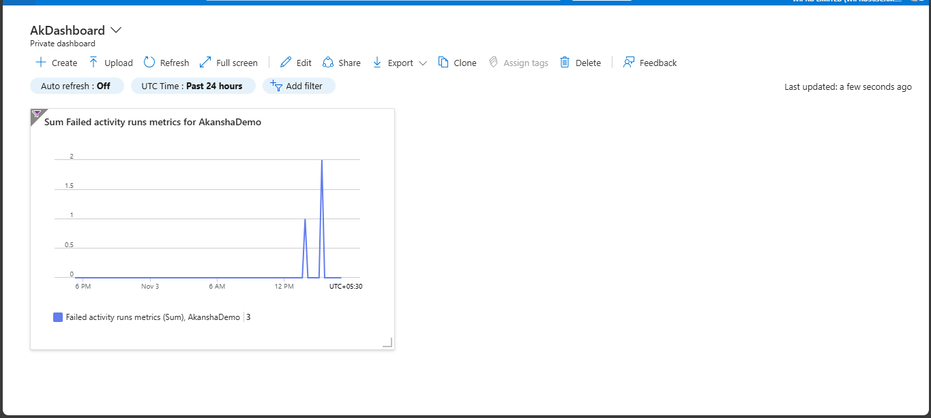
Figure 7.14: Screenshot of a custom Azure Monitor dashboard with Data Factory metrics

Automating responses to metric thresholds
Automating responses to metric thresholds in Azure Monitor is essential for maintaining the health and reliability of cloud-based systems. Rather than relying solely on manual intervention, organizations can configure Azure Monitor to take immediate action when specific metrics cross defined thresholds. This proactive approach not only minimizes downtime but also ensures that issues are addressed as soon as they arise, often before end users are even aware of a problem.
To implement automated responses, users first define alert rules based on critical metrics—such as CPU utilization, error rates, or latency. When these metrics exceed (or fall below an expected Threshold value) the set thresholds, Azure Monitor can trigger a variety of automated actions by leveraging Action Groups. These actions might include sending notifications, running scripts, or invoking workflows in Logic Apps or Azure Functions.
For example, imagine a data pipeline in ADF where the error rate suddenly spikes above an acceptable level/threshold value. An alert rule, configured in Azure Monitor, detects this anomaly. Instantly, an Action Group is activated to send a notification to the IT support team via email or Microsoft Teams. Simultaneously, a Logic App could be triggered to automatically attempt a restart of the problematic pipeline. This orchestration ensures that incidents are not just detected, but also responded to in real time without manual oversight.
Another scenario could involve monitoring virtual machine performance. Suppose CPU usage exceeds 90% for a sustained period; Azure Monitor can automatically scale out additional resources or run a remediation script to optimize performance. These automated responses are invaluable for maintaining service continuity, reducing human error, and enabling IT teams to focus on more strategic initiatives.
So automating responses in Azure Monitor transforms monitoring from a passive activity into an active, intelligent process. By integrating alerts with automated workflows, organizations gain the ability to rapidly address issues, uphold service-level agreements, and foster a resilient cloud environment. Here are the steps in creating such automated responses to trigger alerts in Azure Monitor:
- Set up Action Groups: In alert rules, choose automated actions such as invoking Logic Apps or Azure Functions.
- Configure Logic App: Design workflows to remediate issues (e.g., send a Teams notification, restart a pipeline).
- Test automation: Trigger alerts and validate automated responses.
Logic App sample:
{
"definition": {
"$schema": "[URL]#",
"actions": {
"Send_an_email": {
"type": "ApiConnection",
"inputs": {
"body": {
"To": "data-team@example.com",
"Subject": "Pipeline Failure Alert",
"Body": "A pipeline failure has been detected. Please review."
},
"host": {
"connection": {
"name": "@parameters('$connections')['office365']['connectionId']"
}
},
"method": "post",
"path": "/v2/Mail"
}
}
},
"triggers": {
"When_a_HTTP_request_is_received": {
"type": "Request",
"kind": "Http",
"inputs": {
"schema": {}
}
}
}
}
}

Best practices for monitoring
Azure Monitoring with Alerts, Notification, and automation triggers can look simple, but it consumes a lot of data (Log Analytics and resource usage metrics) behind the scenes, and hence, the following practices should be considered when developing an Azure monitoring solution.
Implementing effective monitoring in Azure is essential for ensuring the reliability, performance, and cost efficiency of your cloud resources. By following a set of best practices, organizations can proactively detect issues, respond swiftly, and maintain operational excellence. Here is a detailed overview of the preceding best practices for monitoring using Azure Monitor, along with real-world examples to understand them better:
- Standardize diagnostic settings: To maintain consistency and centralized visibility, it is important to standardize diagnostic settings across all resources. This involves configuring all data pipeline components, such as Data Factory, Azure Synapse, and Storage Accounts, to forward their diagnostic logs and metrics to a central Log Analytics workspace. For example, an organization managing multiple data pipelines can ensure that every pipeline resource sends its operational and security logs to a single workspace. This unified approach simplifies troubleshooting and enables holistic analysis, especially when investigating incidents spanning multiple services.
- Use descriptive naming: Clear and descriptive naming conventions for alerts, metrics, and dashboards greatly improve the manageability and discoverability of monitoring resources. For instance, instead of naming an alert simply as ErrorAlert, using a name like ADF_Pipeline1_Failure_Alert immediately communicates which data factory and pipeline are affected. This practice becomes invaluable in environments with numerous alerts and dashboards, reducing confusion and speeding up response times during incidents.
- Automate monitoring workflows: Automation is key to efficient monitoring. By leveraging Azure Logic Apps or Automation Runbooks, you can automate responses to specific alerts or thresholds. For example, if a data pipeline job fails, a Logic App can automatically create a ticket in your Information Technology Service Management (ITSM) system, like ServiceNow, and notify the relevant team via email or Teams. This reduces manual intervention, ensures consistency in response, and accelerates issue resolution.
- Regularly review and update alerts: The dynamic nature of cloud workloads means that alert thresholds and notification rules must be reviewed and updated regularly. Suppose a data pipeline that previously processed 10,000 records daily is now handling 1 lakh records due to business growth. The alert thresholds set for performance and failure rates must be adjusted to reflect this new baseline. Periodic reviews help prevent both alert fatigue from unnecessary notifications and missed critical incidents due to outdated settings.
- Leverage workbooks for deep analysis: Azure Monitor Workbooks offer a powerful way to perform ad-hoc and historical analysis of system performance and reliability. For example, a data engineering team can use workbooks to visualize pipeline run durations over the past quarter, identify bottlenecks, and correlate failures with specific changes or deployments. This deep analysis supports continuous improvement and helps in making informed decisions for future optimizations.
- Integrate with DevOps: Connecting monitoring configurations with CI/CD pipelines ensures that alert rules and diagnostic settings are version-controlled and deployed consistently across environments. For instance, as part of the deployment process for a new data pipeline, the required monitoring settings can be automatically applied, ensuring compliance with organizational standards. This integration not only streamlines operations but also reduces the risk of misconfiguration.
- Monitor costs: Monitoring itself can incur high costs, particularly when large volumes of logs and metrics are retained over long periods. It is prudent to track Log Analytics usage and optimize data retention policies. For example, an organization may choose to retain detailed diagnostic logs for only 30 days while keeping summary metrics for a year. Regularly reviewing usage reports helps in identifying opportunities to reduce costs without compromising on monitoring effectiveness.

Continuous improvement
Monitoring is an ongoing process. Regularly review metrics, alerts, and dashboards to adapt to changing business needs and pipeline architectures. Encourage feedback from data engineering teams to refine monitoring strategies and automate more responses.
Embracing continuous improvement is fundamental to getting the most out of Azure Monitor for data pipeline management. Rather than treating monitoring as a static exercise, organizations should view it as an evolving discipline that adapts to the changing landscape of business requirements, technology upgrades, and pipeline enhancements. Routinely examining the collected metrics, alert configurations, and dashboard layouts is crucial to ensure that the monitoring system remains relevant and responsive.
Soliciting feedback from data engineering teams can be invaluable in identifying practical challenges and opportunities for optimization. Their hands-on experience often uncovers gaps or inefficiencies in existing monitoring strategies that may not be evident from automated reports alone. By integrating these insights, teams can refine alerting thresholds, automate incident responses where appropriate, and redesign dashboards for clearer visibility.
Furthermore, continuous improvement involves staying abreast of updates to Azure Monitor’s features and best practices. As new capabilities are introduced, such as enhanced visualization tools or more sophisticated alerting mechanisms, it is prudent to evaluate and incorporate them into the existing monitoring framework. This proactive approach not only boosts operational resilience but also empowers teams to deliver higher business value by anticipating and swiftly addressing emerging issues.
Effective monitoring and management of data pipelines with Azure Monitor are essential for ensuring robust, reliable, and high-performing data solutions. By following the recipes and best practices outlined in this chapter, data engineers and IT professionals can proactively detect issues, automate remediation, optimize performance, and deliver business value with confidence.
For further reading, explore Azure Monitor documentation, Log Analytics KQL tutorials, and the ADF monitoring best practices guide from Microsoft Documentation.

Conclusion
This chapter provided a comprehensive overview of integrating monitoring into data pipeline management using Azure Monitor. Key topics included version-controlling monitoring configurations through CI/CD pipelines, ensuring consistent deployment of alert rules and diagnostic settings, and maintaining compliance with organizational standards. The discussion also highlighted cost management strategies, such as tracking Log Analytics usage and optimizing data retention policies to balance operational efficiency with budgetary constraints.
Furthermore, the chapter emphasized the importance of continuous improvement by regularly reviewing metrics, alerts, and dashboards, and encouraging feedback from data engineering teams to refine monitoring practices. Staying updated with the latest Azure Monitor features and best practices was also recommended to enhance resilience and business value.
In the next chapter, the focus will shift to building robust Azure Data Warehouse solutions. Readers can expect to explore design principles, architectural considerations, and best practices for developing scalable, secure, and high-performance data warehouses on Azure. Topics will likely include data modeling, optimizing query performance, integration with various data sources, and strategies for managing and governing large-scale data environments. This upcoming content will equip professionals with practical guidance to harness Azure’s capabilities for advanced analytics and business intelligence.

