M2P Fintech Solutions

Database Restore Activity

Version 1.0



**M2P Solutions Private Limited**

India’s largest Program Management platform

**Disclaimer**

The information transmitted is intended only for the person or entity to which it is addressed and may contain confidential and/or privileged material. Any review, retransmission, dissemination, or other use of, or taking of any action in reliance upon this information by persons or entities other than the intended recipient is prohibited. This document contains confidential information of M2P Solutions Private Limited and is communicated solely for the intended recipient’s use. Circulation of this document, either internally or externally, is strictly restricted.

**Document Version**

|  |  |  |  |
| --- | --- | --- | --- |
| **Version - 1.0** | | | |
|  | **Version Maker** | **Reviewer** | **Approver** |
| **Name** | Nivas A | Mohan Rao Nk | Sharath Sankar |
| **Date** |  |  |  |
| **Comments** |  |  |  |
| **Summary of Changes in this Version:**   * Quarterly prod database backup validation – Restore activity | | | |

Contents

1.0 Scope: 5

2.0 Backup & Recovery 5

3.0 Recovery Steps 5

STEP 1: Download the corresponding backup from s3 bucket 5

STEP 2: Unzip the backup file 6

STEP 3: Ensure the database is not present in destination server before restoring 6

STEP 4: Restore the database in server 6

STEP 5: Verify the restore process 7

STEP 6: Ensure the database is present in server after the restore 7

STEP 7: Verify the restore log (in case of any error) 7

STEP 8: Cross-verify the count of tables on source and destination servers 8

# 1.0 Scope:

This Document covers the scope of support and tasks performed by the Database admin as part of M2P fintech solutions.

We support Databases like MySQL PostgreSQL & MongoDB on various platforms like Linux and database as a service in AWS and Azure. Below is the updated inventory of the databases we host and support.

<https://teams.microsoft.com/l/file/0180759B-1658-4172-ACB2-0C23BF2066A2?tenantId=3405f089-be04-4322-8340-6550f2deee0a&fileType=xlsm&objectUrl=https%3A%2F%2Fm2psolutions.sharepoint.com%2Fsites%2Finfra%2FShared%20Documents%2FGeneral%2FM2P%20DB%20servers.xlsm&baseUrl=https%3A%2F%2Fm2psolutions.sharepoint.com%2Fsites%2Finfra&serviceName=teams&threadId=19:5f75cddcfdc446de929c0127f85ee10d@thread.tacv2&groupId=216b827c-dba7-4efd-86a2-53666873f548>

# 2.0 Backup & Recovery

* Daily backups are scheduled for production Databases.
* Backup image validation check is performed by doing a restore once in a quarter.
* Backups will be stored on disk and cloud simultaneously.
* In case of recovery, the respective backup image will be restored from S3 bucket and the restore process will be followed.
* To validate the backup image, we perform restore test quarterly on random Prod backup images.

# 3.0 Restore test ticket

* A ticket will be created while performing the restore test.

<https://m2p-fintech.atlassian.net/browse/DBENGG-1387>

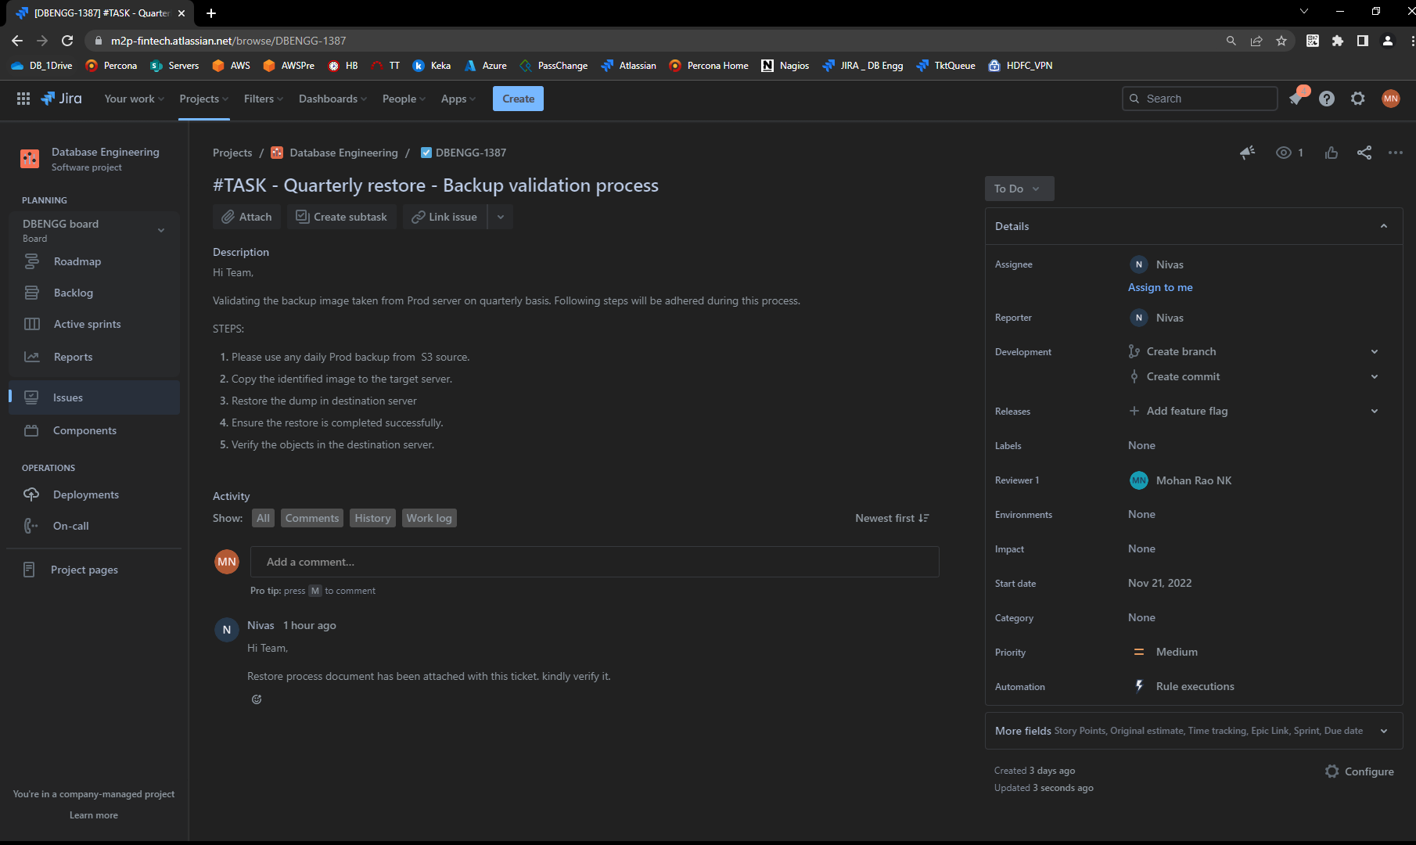

# 4.0 Recovery Steps

## STEP 1: Download the corresponding backup from s3 bucket



## 

## STEP 2: Unzip the backup file

## STEP 3: Ensure the database is not present in destination server before restoring

## STEP 4: Restore the database in server

## STEP 5: Verify the restore process

## STEP 6: Ensure the database is present in server after the restore

## STEP 7: Verify the restore log (in case of any error)

## STEP 8: Cross-verify the count of tables on source and destination servers

