PHASE 8 – PROJECT DEMONSTRATION
PocketSmart AI – Your Smart Budget & Recommendation Assistant

1. Introduction
PocketSmart AI is a smart budget and recommendation assistant developed to help users plan different requirements according to their available budget. The application provides recommendations for Home Interior, Party Planning, and Jewelry Planning.
The project demonstration presents the complete working flow of the application, from user authentication to entering requirements and receiving recommendations.

2. Objective of the Demonstration
The objective of the project demonstration is to show that the developed PocketSmart AI application works according to the planned requirements.
The demonstration covers:
- User registration and login
- Dashboard navigation
- Home Interior Planner
- Party Planner
- Jewelry Planner
- Budget-based recommendations
- Input validation
- Recommendation History
- Final output

3. Project Name
PocketSmart AI – Your Smart Budget & Recommendation Assistant

4. Project Purpose
The purpose of PocketSmart AI is to simplify budget-based planning and recommendation activities.
Instead of manually searching different websites and comparing multiple options, users can enter their requirements and budget into the application and receive organized recommendations.
The application supports three major planning areas:
1. Home Interior Planning
2. Party Planning
3. Jewelry Planning

5. Demonstration of the Application

5.1 Application Home Page
The demonstration begins by opening the PocketSmart AI application.
The home page provides access to the major features of the system. Users can navigate through the application and access the available planners.
Screenshot to add: Home page / landing page screenshot.

5.2 User Registration and Login
The application provides a registration and login mechanism.
A new user can create an account by entering the required details. After registration, the user can log in using the registered credentials.
This feature provides a user-specific experience and allows recommendation activity to be associated with the logged-in user.
Screenshot to add: Login page and/or registration page.

6. Home Interior Planner Demonstration
The Home Interior Planner allows users to create a budget-based interior plan.
For the demonstration, the following inputs were used:
- Room: Living Room
- Style: Modern Contemporary
- Budget: ₹50,000
- Lights: 1
- Fans: 1
- Tables: 1
After submitting the requirements, the system generates a recommendation.

Generated Output
The demonstration produced recommendations for:
- Modern Contemporary Lights
- Modern Contemporary Ceiling Fans
- Modern Contemporary Dining Table
The displayed estimated total cost was:
₹45,999.99
The recommendation was generated within the entered budget.
Screenshot to add: Home Interior Planner input page.
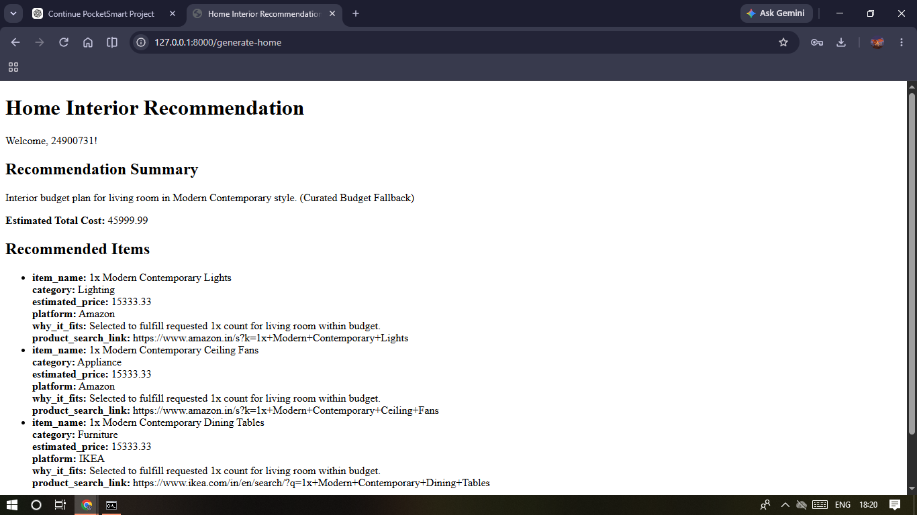
Fig 6.1 – Home Interior Recommendation output.

7. Party Planner Demonstration
The Party Planner helps users plan an event according to their requirements and budget.
For the demonstration, the following details were entered:
- Event: Birthday
- Number of Guests: 20
- Location: Home
- Budget: ₹30,000
The system generated recommendations related to the event.

Generated Recommendation Categories
- Catering
- Venue
- Decoration
- Entertainment
The displayed estimated total cost was:
₹30,000
The result demonstrates that the system can generate an organized event plan based on the user's requirements.
Screenshot to add: Party Planner input page.
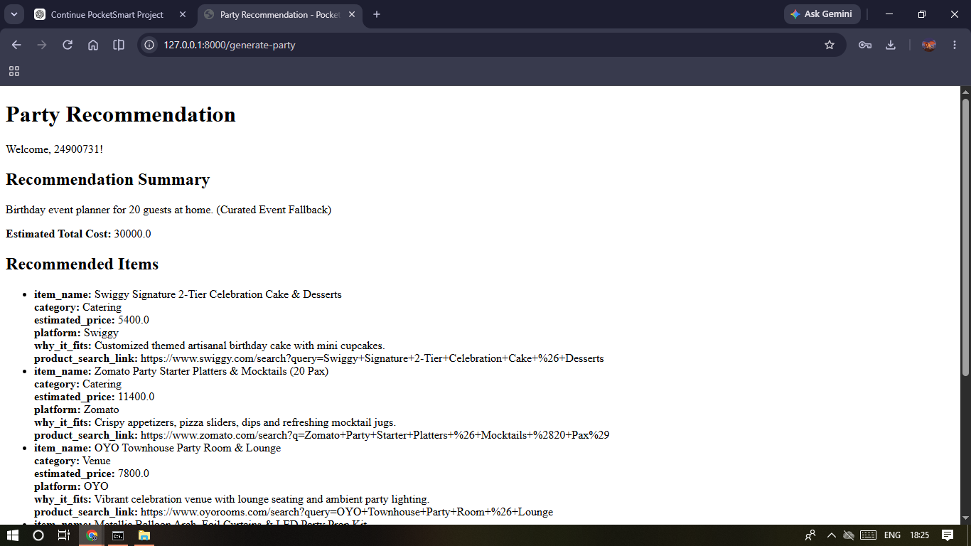
Fig 7.1 – Party Recommendation output.

8. Jewelry Planner Demonstration
The Jewelry Planner provides jewelry recommendations based on the occasion, style, and budget.
For the demonstration, the following inputs were used:
- Occasion: Wedding
- Style: Traditional
- Budget: ₹20,000
The system generated recommendations including:
- Necklace & Earrings
- Bangles
- Ring
- Hair Accessory
The displayed estimated total cost was:
₹20,000
This demonstrates that the application can generate jewelry recommendations according to the selected occasion, style, and budget.
Screenshot to add: Jewelry Planner input page.
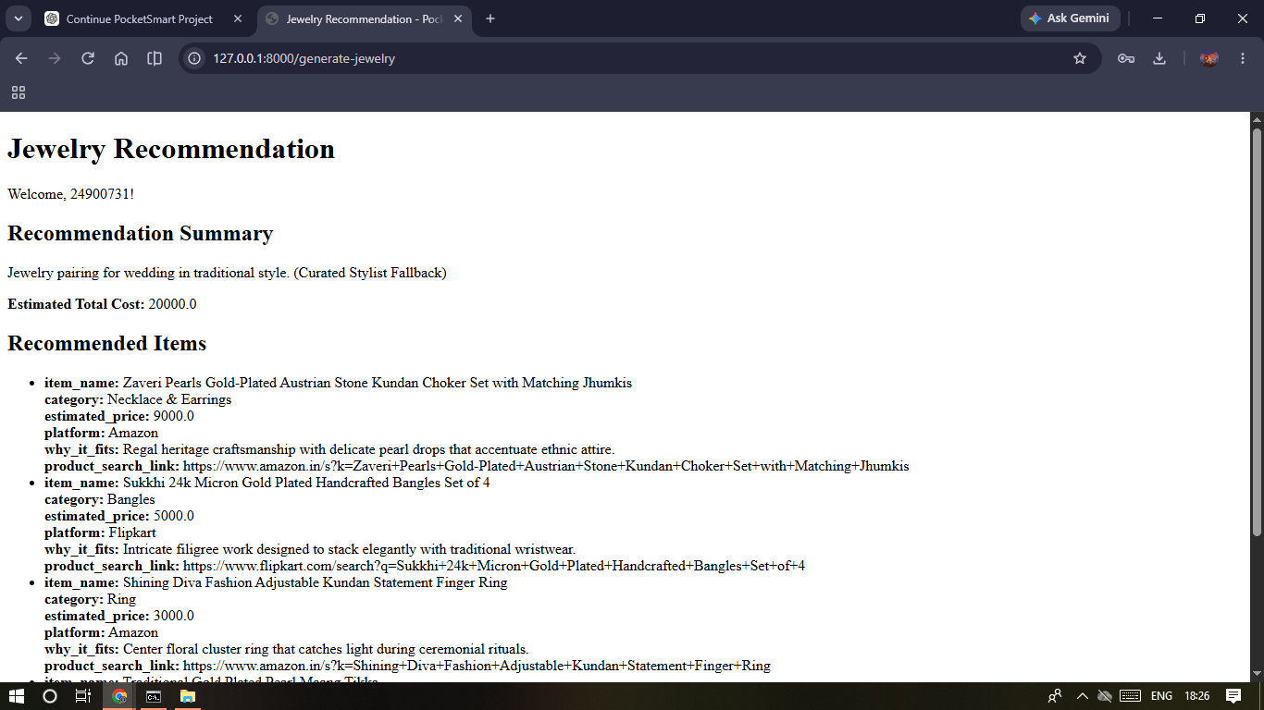
Fig 8.1 – Jewelry Recommendation output.

9. Input Validation Demonstration
The application also handles invalid user inputs.
During testing, an invalid budget value was entered. The application displayed a validation message indicating that the value must satisfy the required minimum.
This validation prevents unsuitable input from being submitted to the planner.
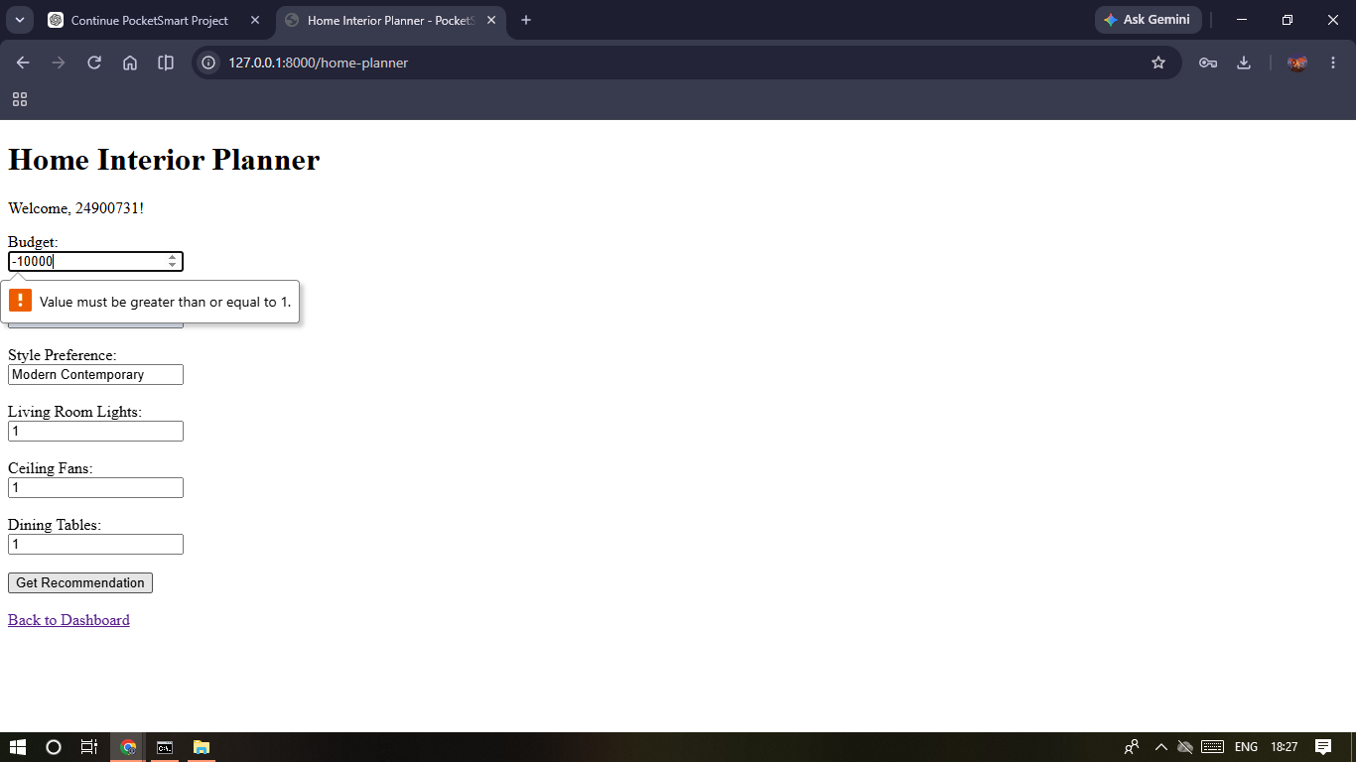
Fig 9.1 – Validation message shown for an invalid budget value on the Home Interior Planner.

10. Recommendation History
The application includes a History feature.
The History page allows the user to review previous recommendation activity generated through the planners.
This helps users refer back to previously generated plans instead of entering the same requirements again.
Screenshot to add: Recommendation History page.

11. Final Output
The final demonstration shows the successful working of the PocketSmart AI application.
The application successfully demonstrates:
- User authentication
- Budget-based planning
- Home Interior recommendations
- Party recommendations
- Jewelry recommendations
- Input validation
- Recommendation History
The final outputs demonstrate the complete flow from user input → processing → recommendation → result.
Screenshot to add: Final output/dashboard screen.

12. Demo Video
A complete project demonstration video has been prepared with screen sharing and voice-over explanation.
The video demonstrates the project name, purpose, benefits, working process, planner features, recommendations, validation, and final output.

Google Drive Demo Video
Demo Video Link: https://drive.google.com/file/d/1Zkn0FbTsW56b2schkGQ-QOrtq_oO524h/view?usp=sharing
Access setting: Anyone with the link → Viewer

13. Voice-Over Demonstration
The demonstration video includes voice-over explaining the application while the screens are being shown.
The explanation covers:
1. Introduction to PocketSmart AI
2. Purpose of the project
3. Main features
4. Login/Register
5. Home Interior Planner
6. Party Planner
7. Jewelry Planner
8. Input validation
9. History
10. Final output

14. Team Members
- Maha Sri
- Narmadha
- Navayuga
- Menaga

15. Technologies Used
The project documentation identifies the following technologies/components:
- Python
- FastAPI
- HTML
- CSS
- JavaScript
- Jinja2
- Uvicorn
- Gemini-based AI recommendation layer
- Authentication and session management
The Phase 5 documentation specifically describes the working application as using a FastAPI backend, HTML/CSS/JavaScript/Jinja2 frontend, Gemini-based recommendation generation, authentication/session management, and three domain-specific planners.

16. Conclusion
The Phase 8 demonstration presents the complete working of PocketSmart AI – Your Smart Budget & Recommendation Assistant.
The demonstration shows how users can enter their requirements and budget and receive recommendations through the Home Interior, Party, and Jewelry planners. It also demonstrates authentication, input validation, recommendation history, and the final outputs.
The completed demonstration video provides visual and voice-over evidence of the project's working process.

