**Abstract**

**Key Requirements**

**X5GON IOS Mobile APP**

**Team 4**

**Patrick Wu | Yinrui HU**

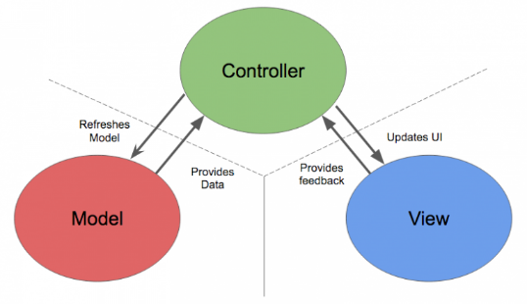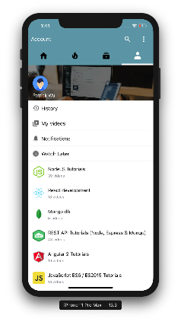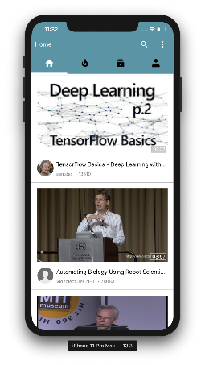

**Our mobile app support view multiple types of OER includes PDF, audio and video.**

**Choosing to use Storyboard instead of Swift UI allows us to write less modification code and make it easier for both ourselves and our client in UI developments.**

**With regards to the performance of the application, we utilized extensive caching and predicting techniques to minimize the lag and increase the responsiveness.**

**Solutions**

**Show** user’s

browsing history

**Add** notes to the OER when they are on display

**Search** X5GON OER

Collections for keywords

**View** all types of OER

**Show** the person or organization who uploads the OER material

**Suggest** and **display** relevant OER

**Rate** an OER by pressing the like and dislike button

**Play** or **pause** an OER video

**X5GON Backend**

**Front End （Swift）**

**Technology Diagram**

Title of OER

**View History**

**User Page**

**Login View**

**Search View**

**View OER**

**Home Page**

**Full Screen Mode**

View this OER

Navigate to different pages

Open Login or Setting window

Search

Progress Bar

Press to rate

Show wiki chunks

Full Screen Mode

Add your notes here

Bookmark this OER

X5GON is an industrial leading Open Education Resource (OER) Provider. In this project, we worked with the UCL X5GON research team to deliver a mobile application that a Mobile Application that provides users with an authentic and mobile-friendly X5GON experience and learning materials catered for their needs.

With this project, the X5Learn system would be able to attract more users from the mobile platform and enable them to learn anything anywhere.