smartEMR
Clinic User Guide
Outpatient (OPD) Workflow — Step by Step for Every Role
Reception → Cashier → Nurse → Doctor → Lab → Radiology → Pharmacy → Discharge
Version 2.0 • May 2026
Tanzanian OPD Pilot
Maintained by iPAB

Contents

About This Guide
This guide shows each member of clinic staff how to use smartEMR for their part of the outpatient (OPD) visit. It is written for everyday users — no computer or medical-records experience is assumed. Find the section for your role and work through the numbered steps.
Every screen picture in this guide has small orange numbers pointing at the exact button or box to use. Under each picture, a list explains what each number means. Match the number on the picture to the number in the list.
smartEMR runs in a web browser, only on the clinic’s own computers. It is not on the internet. Each member of staff has their own username and password — ask the clinic administrator for yours, and never share it.
Swahili: Mwongozo huu unaonyesha kila mfanyakazi jinsi ya kutumia smartEMR. Namba za rangi ya machungwa kwenye picha zinaonyesha kitufe sahihi cha kubonyeza.

The OPD Patient Journey
A patient moves through the clinic in a fixed order. Each station does its part, then passes the patient on by changing the visit Status. smartEMR enforces the order — for example, the nurse only sees a patient after the cashier has taken payment, and the lab can only enter a result after the test has been paid for.
1. Reception | 2. Cashier | 3. Nurse | 4. Doctor | 5–6. Lab / Radiology | 7–8. Pharmacy / Discharge
Find patient, start the visit, bill it | Collect payment, per item | Record vital signs, send to doctor | Examine, diagnose, order tests, prescribe | Run tests / imaging, enter results | Dispense medicine, close the visit

Visit Status Codes
Each visit carries a Status that shows where the patient is in the journey. You will see these codes on the worklists and on the Patient Flow Board. After finishing your step, the system advances the status automatically (or you set it) so the next station knows the patient is ready.
Code | Status | Meaning / set by
RG | Registered | Reception started the visit; awaiting the cashier
PD | Paid | Cashier took payment; awaiting the nurse (triage)
TR | Triaged | Nurse recorded vitals; awaiting the doctor
WD | With Doctor | Doctor has opened the visit
WL | Awaiting Lab | Doctor ordered a lab test / imaging
LB | Lab Complete | Result entered and signed
WP | Awaiting Pharmacy | Medicine to be dispensed
CM | Completed | Visit closed; patient leaves the active board

Getting Started (All Staff)

1. Log in
- Open the web browser (Chrome) on a clinic computer.
- Type the clinic address and press Enter. (Ask your administrator — for example http://localhost:8300.)
- Enter your Username and Password, then click Login.
Swahili: Fungua kivinjari, andika anwani ya kliniki, weka jina la mtumiaji na nenosiri, kisha bonyeza “Login” (Ingia).
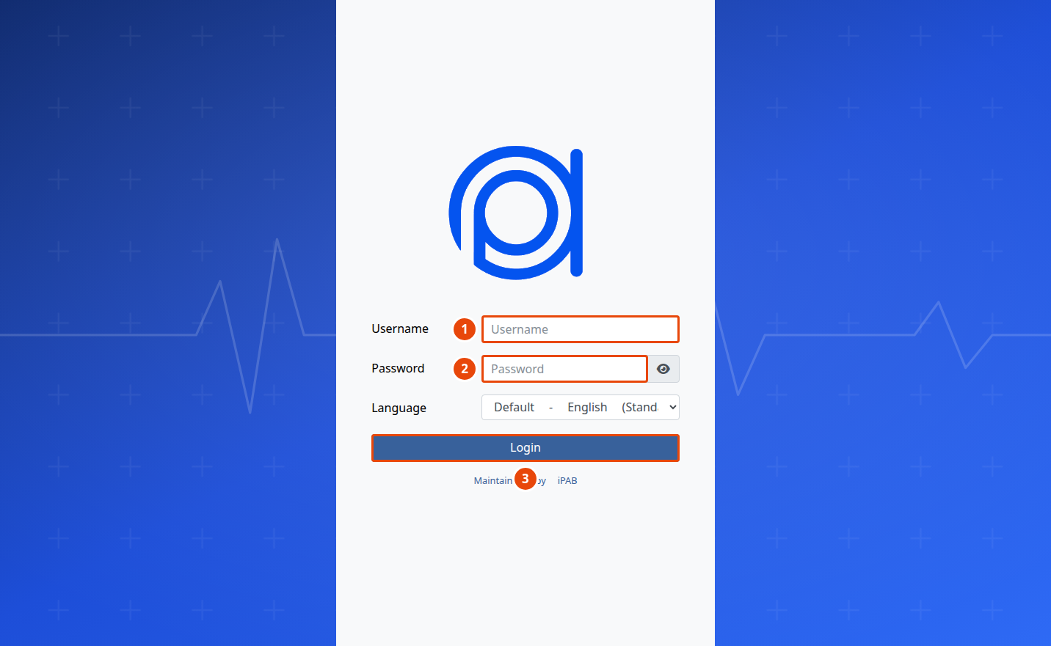
Figure 1 — The smartEMR login screen.
1 | Type your username (for example reception1, doctor1).
2 | Type your password (ask the administrator for yours).
3 | Click Login.

Security: Your password is personal. Never share it. If you forget it, ask the administrator to reset it. Always log out (top-right, click your name → Logout) when you leave the computer.

2. Find your way around
After you log in, the main screen opens. You only ever see the menus for your job — each role has its own short menu and its own first screen (its “worklist”). So a cashier sees the cashier worklist, a nurse sees the triage queue, and so on.
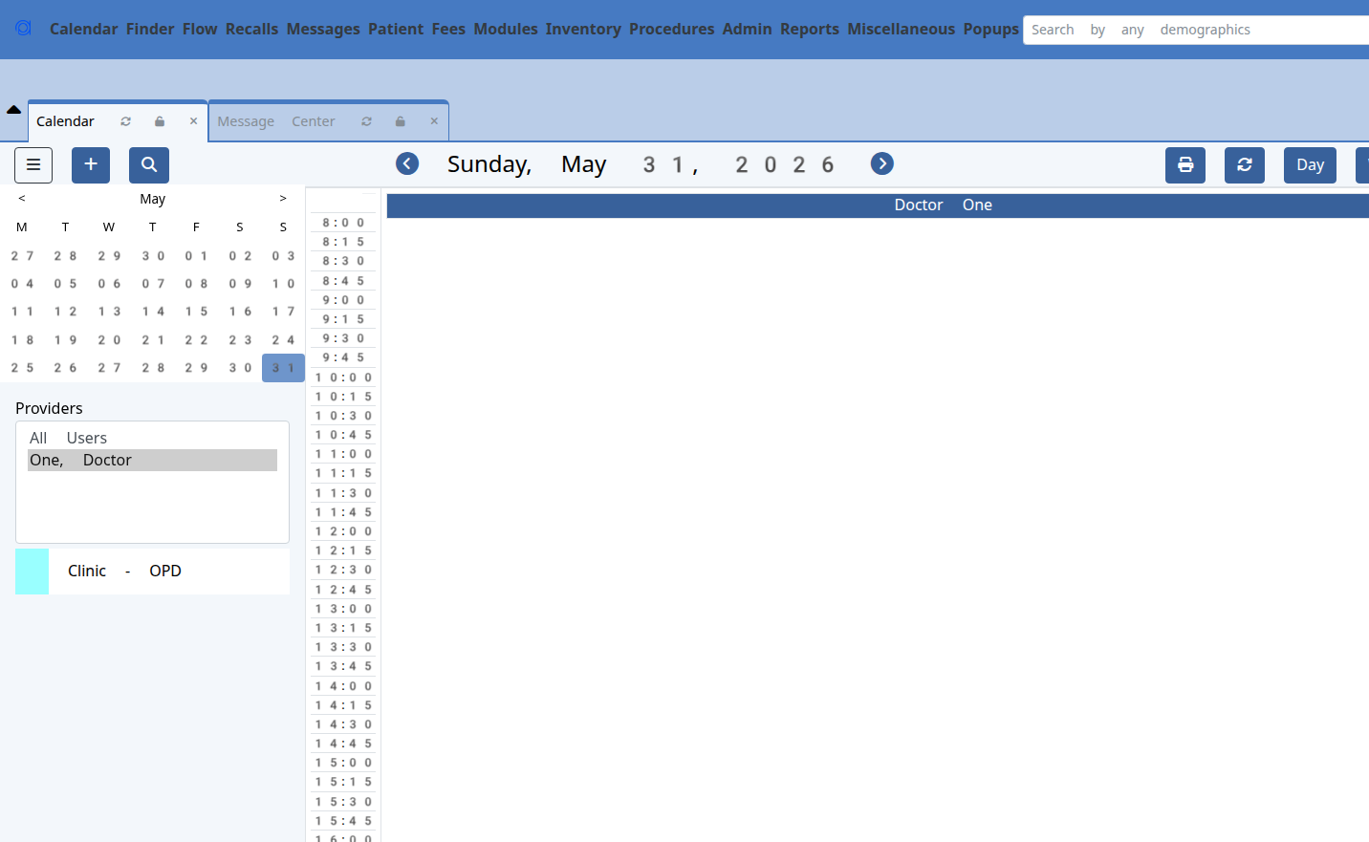
Figure 2 — The main screen after logging in. The blue menu bar runs along the top; your role’s worklist is one click away.

Station 1 — Reception
Login: reception1 • Find the patient, start today’s visit, and send them to the cashier.
Swahili: Mapokezi: mtafute mgonjwa, anza huduma ya leo kwa kuchagua kliniki, kisha mpeleke kwa mhasibu.
From the menu choose Start OPD Visit. (A brand-new patient must first be registered on the New Patient form; then search for them here.)

Find the patient
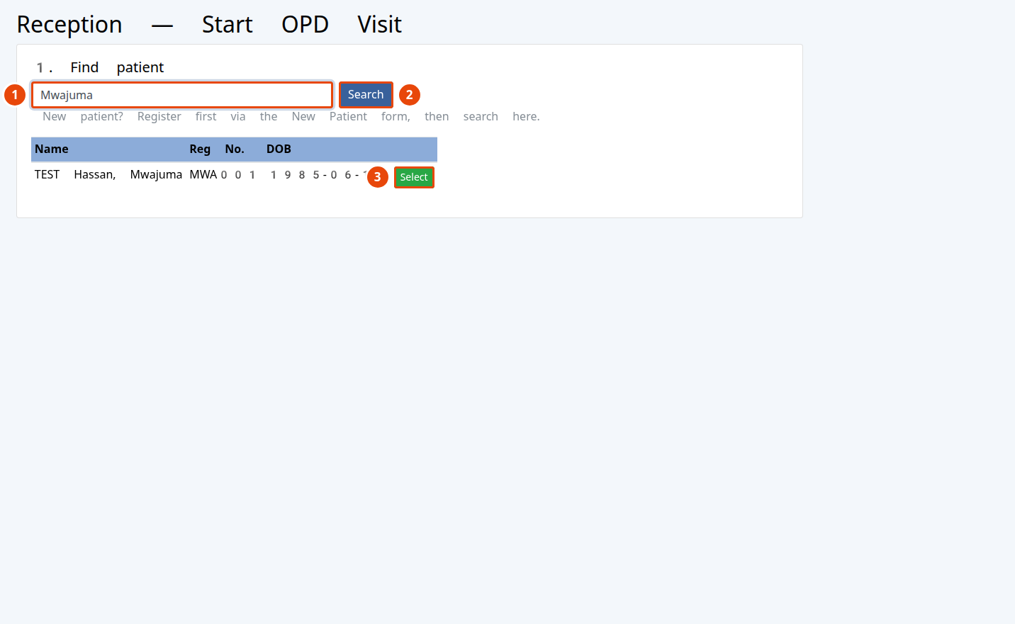
Figure 3 — Reception: find the patient.
1 | Type the patient’s name or Registration No.
2 | Click Search.
3 | Click Select on the correct patient’s row.

Swahili: Jina = Name; Namba ya usajili = Registration No.; Chagua = Select.

Start the visit
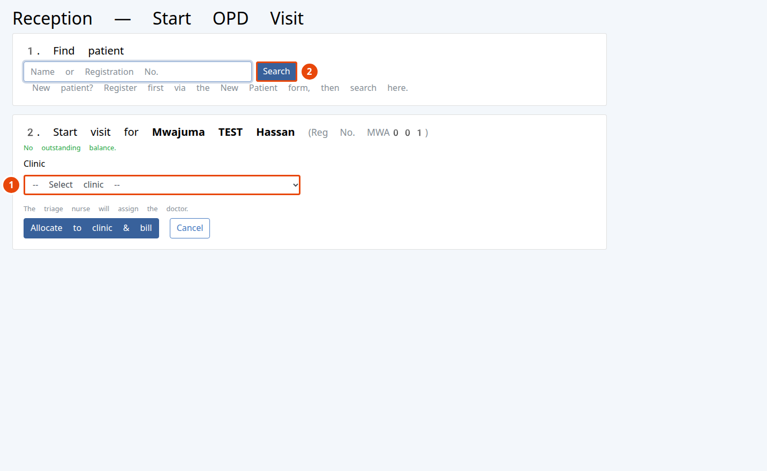
Figure 4 — Reception: choose the clinic and start the visit.
1 | Choose the clinic the patient is attending (General OPD, Gynaecology, Paediatrics, RCH, Dental).
2 | Click Allocate to clinic & bill. smartEMR creates today’s visit, bills the consultation (and registration for a first-ever visit), and sends the patient to the cashier.

Tip: If the patient already has an active visit in that clinic, smartEMR tells you — do not start a second one. Just direct them to the right station.
✔ Done when: the patient appears on the cashier’s worklist with status RG (Registered).

Station 2 — Cashier
Login: cashier1 • Collect payment for each item on the visit.
Swahili: Mhasibu: pokea malipo kwa kila huduma (kuonana na daktari, vipimo, dawa).
Your Worklist shows every patient with money still to collect today — the consultation first, and later any tests, imaging or medicines the doctor adds.
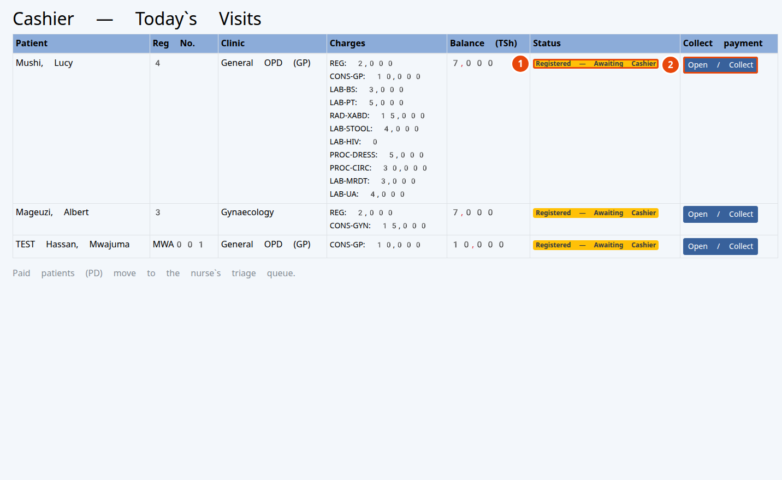
Figure 5 — The cashier worklist.
1 | The visit status (Registered = not yet paid; Paid = done).
2 | Click Open / Collect to take payment for that patient.

Take payment
smartEMR collects per item. Tick the lines the patient is paying for now, choose how they are paying, and collect. Paying for a lab/imaging line is what unlocks that department to enter the result.
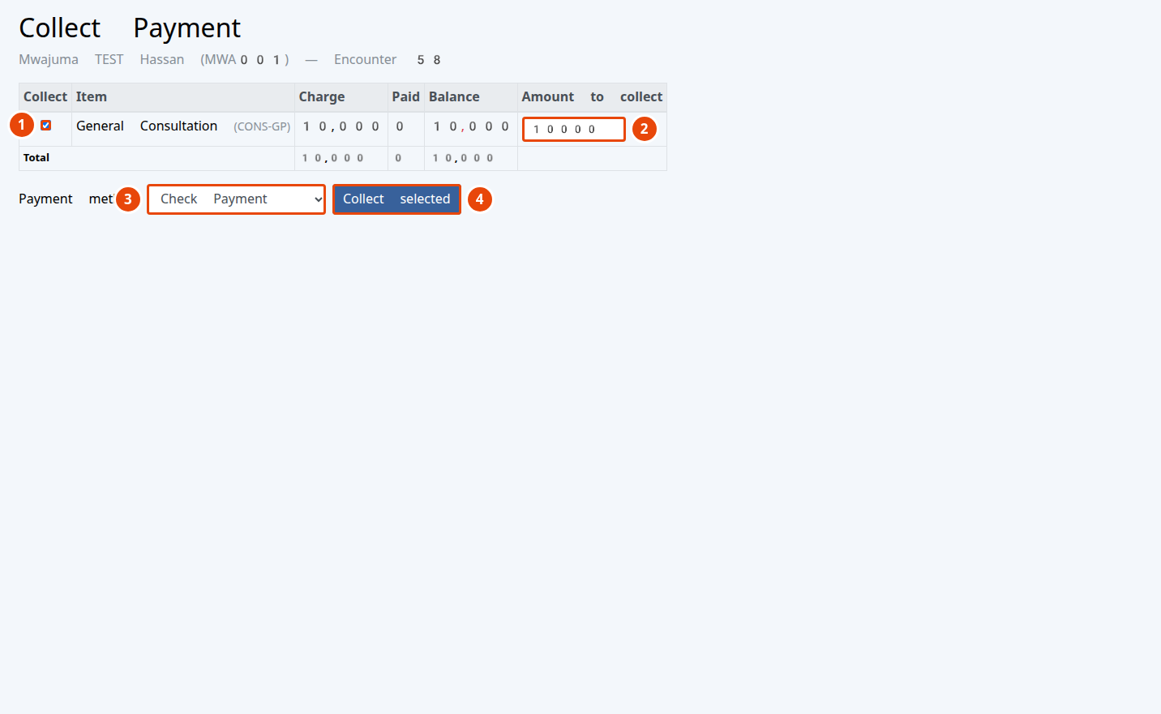
Figure 6 — Collecting payment, line by line.
1 | Tick each line you are collecting now (all are ticked by default).
2 | Change the amount only for a part payment; otherwise leave the full balance.
3 | Choose the payment method: Cash, M-Pesa, Tigo Pesa, Airtel Money, Halopesa, Bank Transfer, NHIF, Other Insurance.
4 | Click Collect selected. A receipt is recorded.

Swahili: Taslimu = Cash; Salio = Balance; Njia ya malipo = Payment method; Kusanya = Collect.
✔ Done when: the consultation is paid and the patient moves to the nurse’s triage queue (status PD).

Station 3 — Nurse (Triage)
Login: nurse1 • Record the patient’s vital signs and send them to the doctor.
Swahili: Muuguzi: pima vipimo vya msingi (uzito, shinikizo la damu, mapigo ya moyo, joto) na mpeleke kwa daktari.
Your Triage Queue lists only paid patients waiting for vitals.
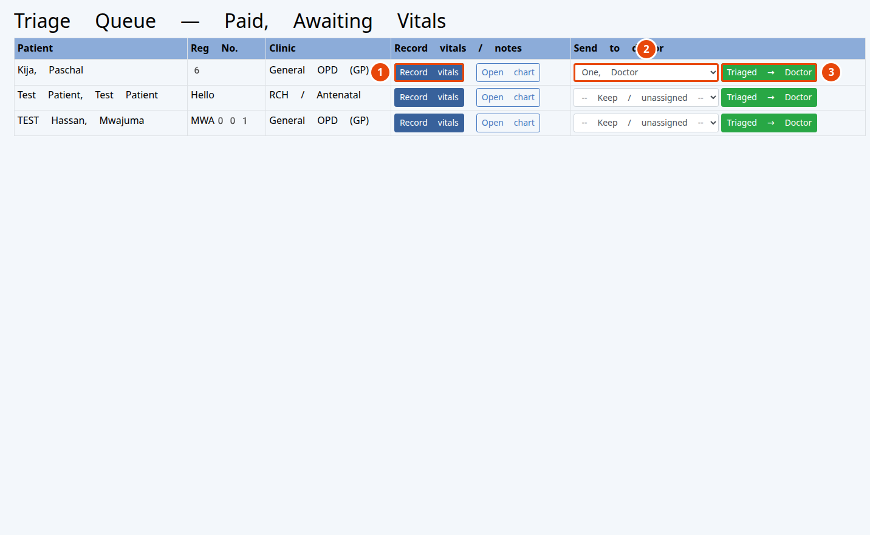
Figure 7 — The nurse’s triage queue.
1 | Click Record vitals to open the vitals form for that patient.
2 | Choose the doctor who will see the patient.
3 | Click Triaged → Doctor to send them on.

Record the vitals
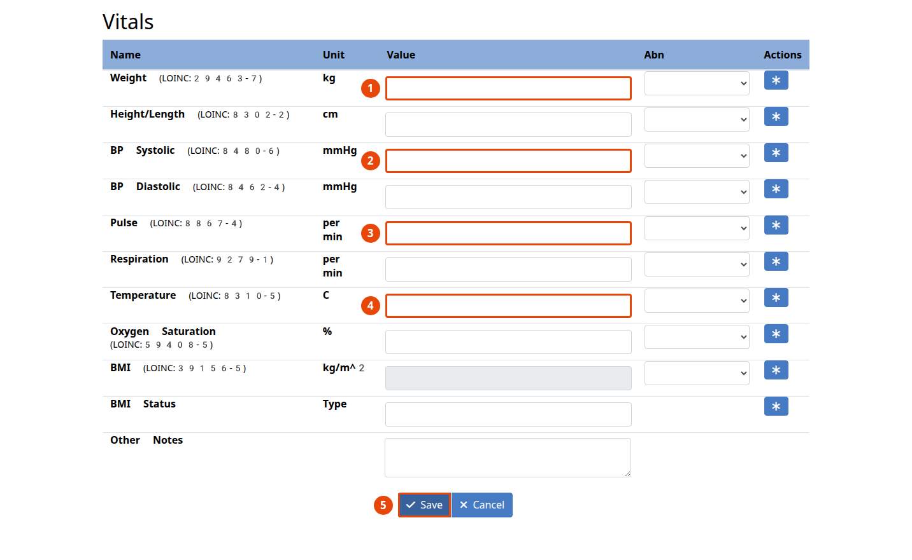
Figure 8 — The vitals form (metric units).
1 | Weight in kilograms (kg).
2 | Blood pressure — systolic (the top number), then diastolic below it.
3 | Pulse (beats per minute).
4 | Temperature in °C.
5 | Click Save. Out-of-range values are highlighted automatically.

Swahili: Uzito = Weight; Shinikizo la damu = Blood Pressure; Mapigo ya moyo = Pulse; Joto = Temperature; Hifadhi = Save.
Note: The nurse cannot open the pharmacy or dispense medicines — that is the pharmacist’s job. This is normal.
✔ Done when: vitals are saved and the patient is sent to the doctor (status TR).

Station 4 — Doctor
Login: doctor1 • Examine the patient, write the note and diagnosis, order tests, and prescribe.
Swahili: Daktari: mchunguze mgonjwa, andika utambuzi, agiza vipimo, na andika dawa.
Your queue shows the patients waiting in your clinic. Open a patient to start, and use the encounter menu to reach the OPD Visit Note, Orders and Prescriptions.
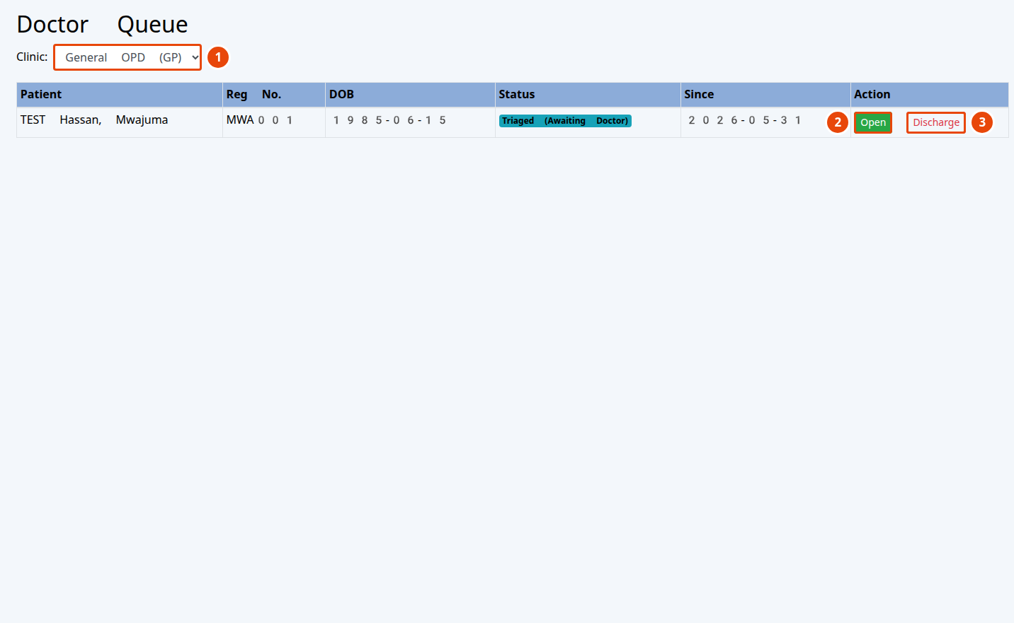
Figure 9 — The doctor’s clinic queue.
1 | Choose which of your clinics’ queues to view.
2 | Click Open to start the consultation (sets the visit to “With Doctor”).
3 | Click Discharge to close a finished visit.

4a. Write the OPD Visit Note
Open Clinical → OPD Visit Note. The note has five sections — Chief Complaint, History, Examination, Diagnosis & Investigations, and Plan. The provider name is locked to you.
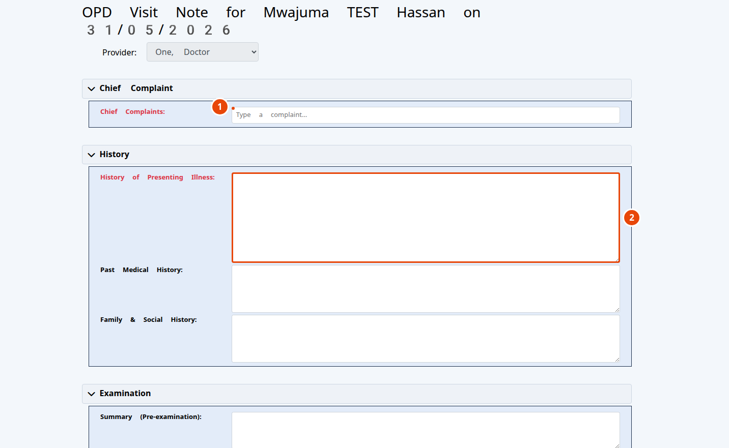
Figure 10 — The OPD Visit Note.
1 | Chief Complaints — click and choose from the list, or type your own.
2 | Type the history and examination findings in each box. Enter the diagnosis lower down, then Save.

Swahili: Malalamiko makuu = Chief Complaints; Historia = History; Uchunguzi = Examination; Utambuzi = Diagnosis.

4b. Order a lab test or X-ray
Open Orders and choose the department: Clinic Laboratory, Clinic Radiology or Clinic Procedures. The same screen is used for each; the cost is added to the bill automatically when you send the order.
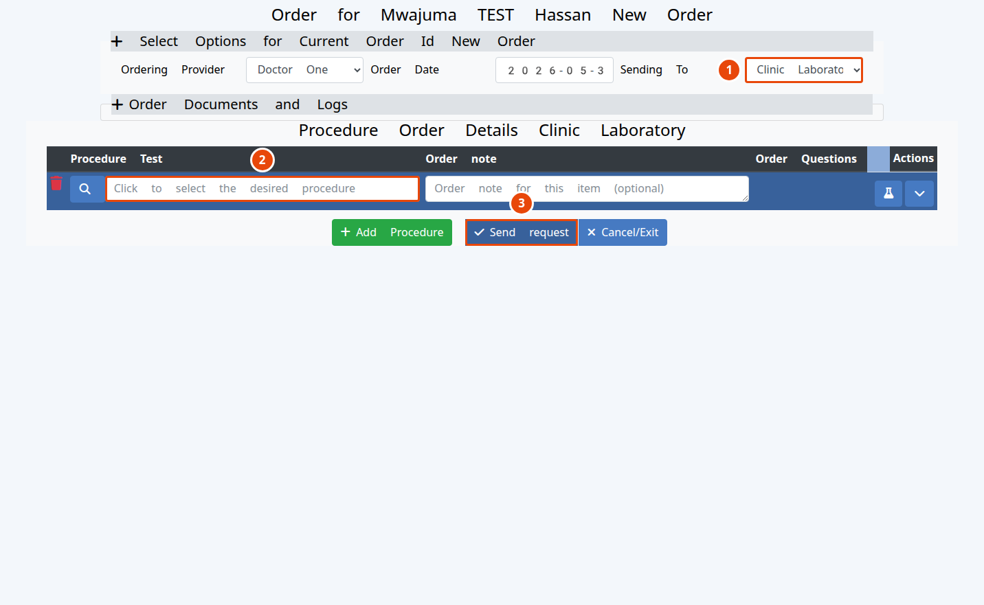
Figure 11 — Ordering a lab test (radiology and procedures work the same way).
1 | The department the order is sent to (here, Clinic Laboratory).
2 | Click to choose the test or procedure (e.g. Malaria Rapid Test, Complete Blood Count; Chest X-ray for radiology).
3 | Click Send request. The charge is added to the cashier’s bill automatically.

Important: The lab or radiology room can only enter the result after the patient has paid for that order at the cashier. Send the patient to the cashier first.

4c. Prescribe medicine
Open Clinical → Prescriptions. Add one row per medicine; the quantity is worked out for you from the dose, frequency and number of days.
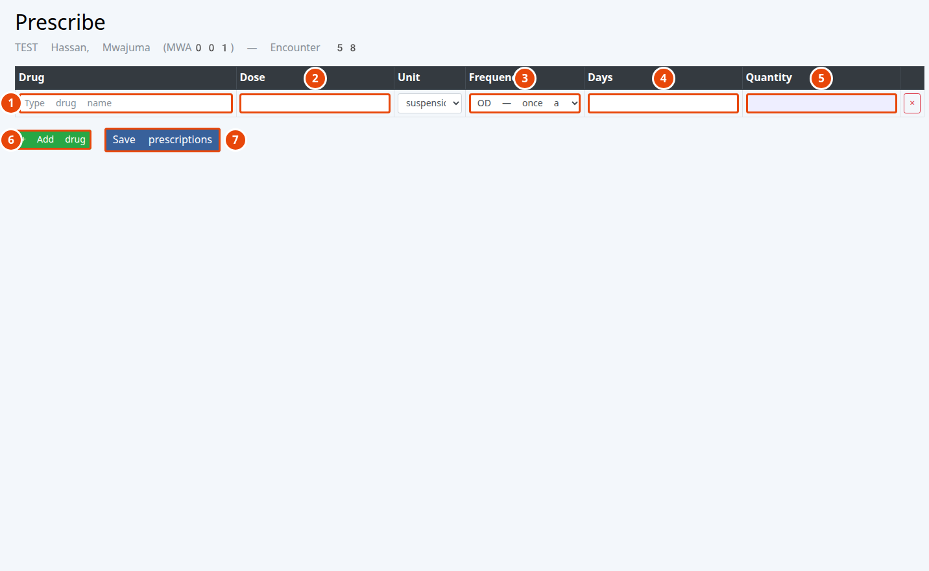
Figure 12 — The prescription grid.
1 | Type the drug name and pick it from the list.
2 | Dose (for example 1 or 2).
3 | How often: OD (once), BD (twice), TDS (three times), QDS, NOCTE, PRN, STAT.
4 | For how many days.
5 | Quantity — calculated for you automatically.
6 | Click + Add drug for another medicine.
7 | Click Save prescriptions. They go to the pharmacy.

Swahili: Dawa = Drug; Kipimo = Dose; Mara ngapi = Frequency; Siku = Days; Kiasi = Quantity; Hifadhi dawa = Save prescriptions.
✔ Done when: the note and diagnosis are saved, tests are ordered, and prescriptions are waiting at the pharmacy.

Back at the Cashier — paying for tests
After the doctor orders tests or imaging, the patient returns to the cashier. The new charges appear on the same Collect Payment screen, line by line.
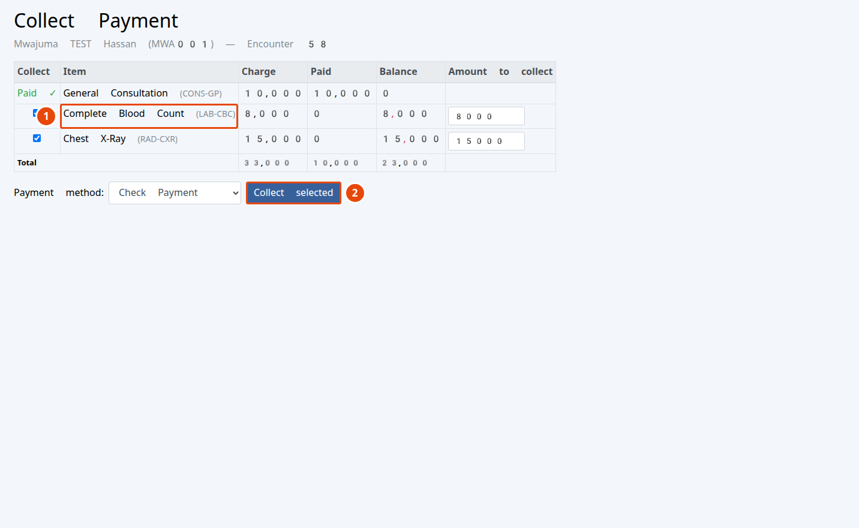
Figure 13 — The cashier collecting the lab and radiology charges.
1 | Each ordered test / X-ray shows as its own line with its own balance.
2 | Tick the lines, choose the method, and click Collect selected. Paying a line unlocks its department.

Station 5 — Laboratory
Login: lab1 • Run the ordered test and enter the result.
Swahili: Maabara: fanya kipimo kilichoagizwa na uweke majibu.
Your Results Worklist shows your department’s orders. You can only enter a result once the order is Paid.
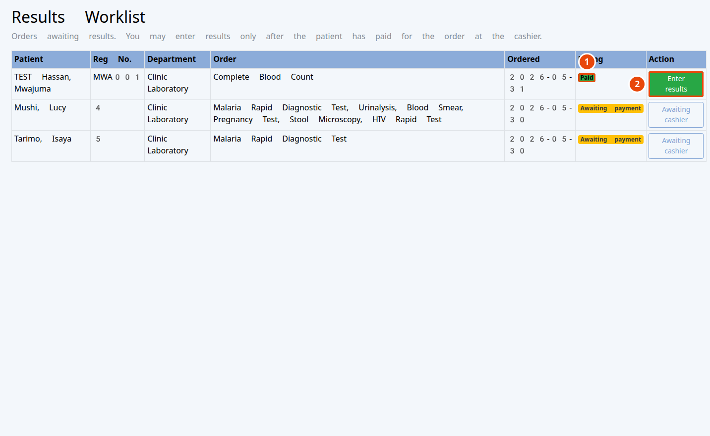
Figure 14 — The laboratory results worklist.
1 | Billing status: a green Paid badge means you may proceed; “Awaiting payment” means the patient must pay first.
2 | Click Enter results to record and sign the result. (Unpaid orders show a greyed-out “Awaiting cashier” button instead.)

Swahili: Majibu ya kipimo = Test Result; Amelipa = Paid; Weka majibu = Enter results.
✔ Done when: the result is entered and signed; the doctor can now see it on the patient’s visit (status LB).

Station 6 — Radiology / Imaging
Login: radiology1 • Perform the imaging and enter the result.
Swahili: Radiolojia (X-ray / Ultrasound): piga picha iliyoagizwa na uweke majibu.
Radiology uses the same Results Worklist as the lab, but it shows only imaging orders (Chest X-ray, Ultrasound, and so on). The same payment rule applies — enter the result only after the order is paid.
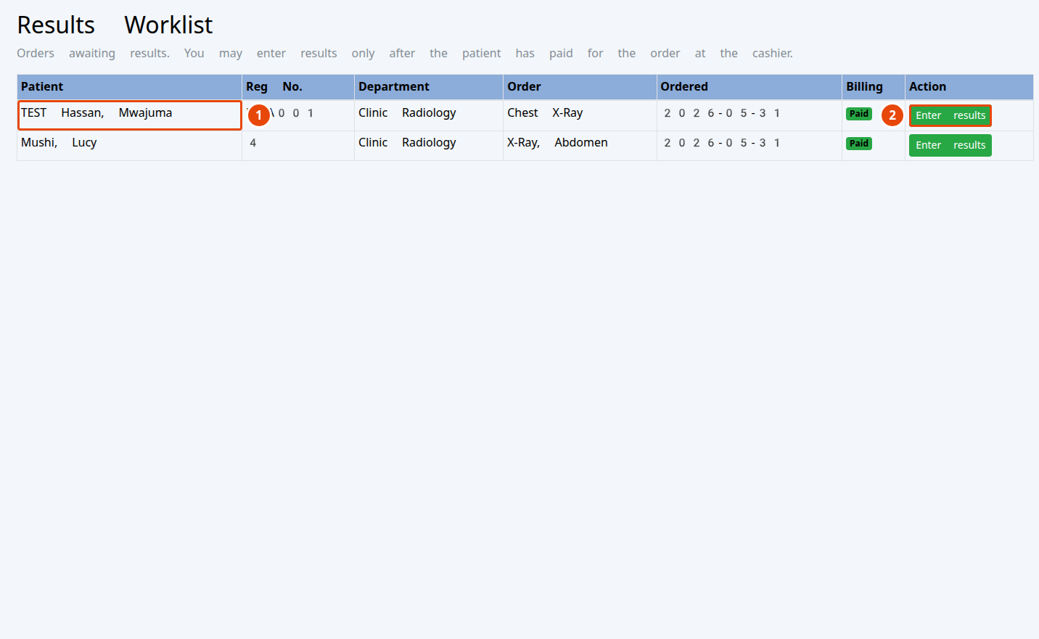
Figure 15 — The radiology results worklist.
1 | Your department’s imaging orders for the day.
2 | Click Enter results once the order shows Paid; otherwise it stays “Awaiting cashier”.

✔ Done when: the imaging result is entered and signed for the doctor to review.

Station 7 — Pharmacy
Login: pharm1 • Confirm and bill the medicine, then dispense it after payment.
Swahili: Famasi: thibitisha dawa na uipeleke kwa malipo, kisha itoe baada ya mgonjwa kulipa.
Dispensing has three steps: Confirm & bill the medicine (this creates the charge and reserves nothing yet), the patient pays at the cashier, then you Dispense it — which reduces the stock count. A medicine can only be dispensed after it is paid for.
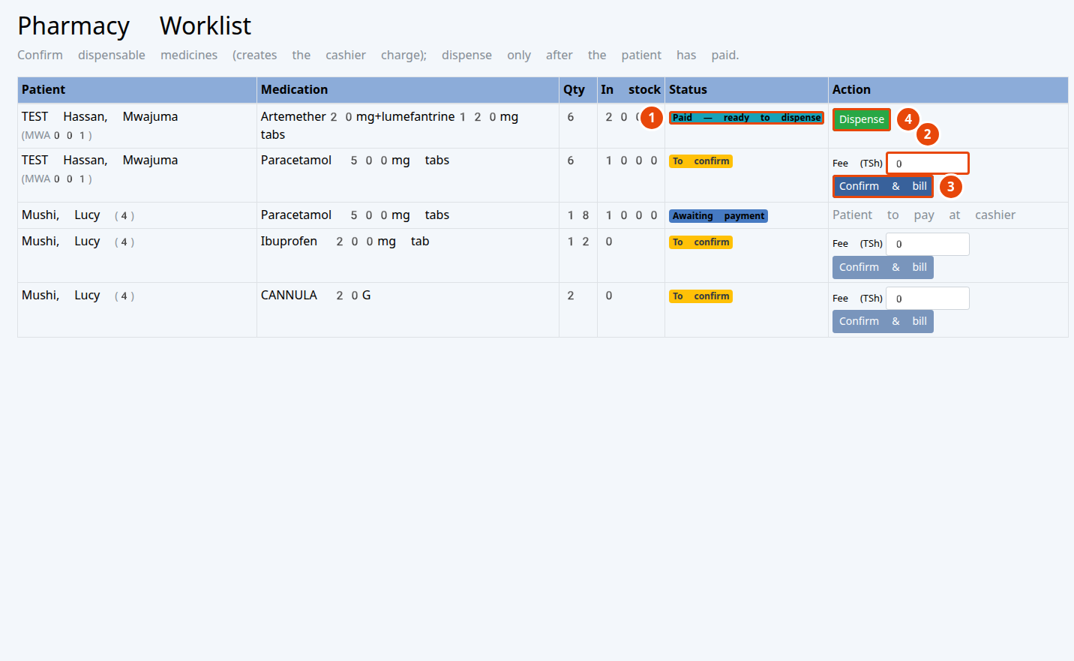
Figure 16 — The pharmacy worklist.
1 | Each medicine’s status (To confirm → Awaiting payment → Paid – ready → Dispensed).
2 | Set or confirm the fee for the medicine.
3 | Click Confirm & bill to send the charge to the cashier.
4 | Click Dispense once it is paid — this hands over the medicine and reduces stock.

Swahili: Idadi = Quantity; Hisa = In stock; Thibitisha = Confirm; Toa dawa = Dispense.

Managing stock
Open Inventory to see every medicine and how much is on hand, to add new medicines, and to record deliveries.
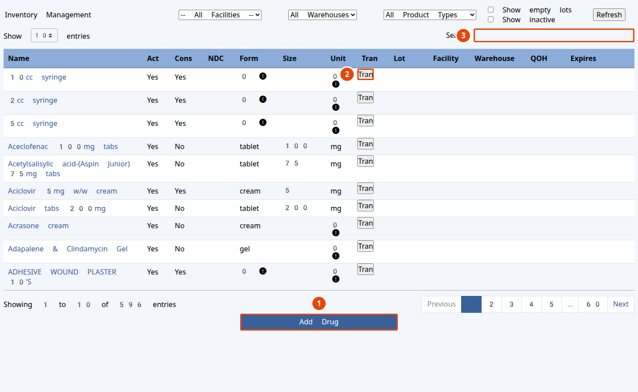
Figure 17 — Inventory management.
1 | Add Drug — add a new medicine to the catalogue.
2 | Tran — record a stock delivery (choose Purchase) so the count goes up.
3 | Search the catalogue by name.

Important: A medicine with zero stock cannot be dispensed. When a delivery arrives, record it with Tran → Purchase so the on-hand count is correct.
✔ Done when: the medicine is handed to the patient and the stock count is reduced.

Station 8 — Discharge & the Patient Flow Board
Login: doctor1 • Close the finished visit so the patient leaves the active board.
Swahili: Kumaliza huduma: funga huduma iliyokamilika ili mgonjwa aondoke kwenye orodha.
When tests, medicines and notes are all done, the doctor clicks Discharge on the clinic queue (see Figure 9). The Patient Flow Board is the shared screen that shows where every patient is right now — useful for the whole clinic to see who is waiting and for what.
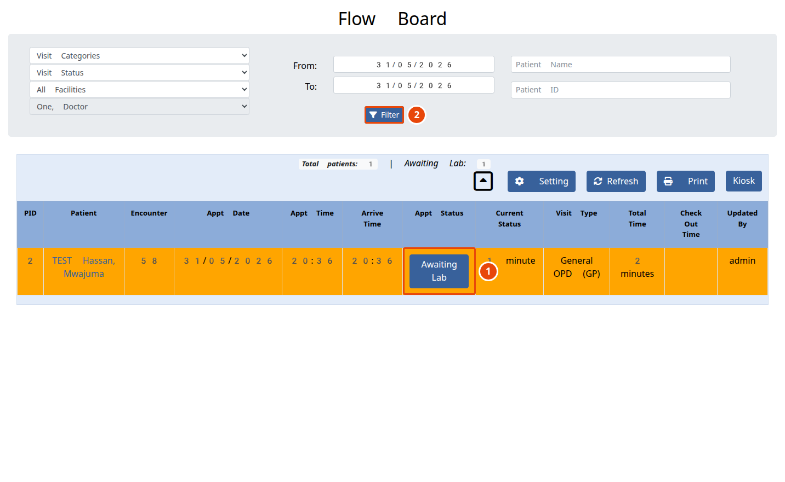
Figure 18 — The Patient Flow Board.
1 | Each patient’s current status (here, “Awaiting Lab”), with the time waiting.
2 | Filter the board by status or date to focus on a group of patients.

✔ Done when: the visit is closed (status CM) and the patient no longer appears on the active board.

Quick Reference
One line per station. Keep this page handy.
Station | Login | What you do | Result status
Reception | reception1 | Start OPD Visit → find patient → choose clinic → Allocate & bill | RG
Cashier | cashier1 | Worklist → Open / Collect → tick lines → Collect selected | PD
Nurse | nurse1 | Triage Queue → Record vitals → Triaged → Doctor | TR
Doctor | doctor1 | Queue → Open → OPD Visit Note → Orders → Prescriptions | WD / WL
Lab | lab1 | Results Worklist → Enter results (after Paid) | LB
Radiology | radiology1 | Results Worklist → Enter results (after Paid) | LB
Pharmacy | pharm1 | Worklist → Confirm & bill → (paid) → Dispense | WP
Discharge | doctor1 | Clinic queue → Discharge | CM

Troubleshooting & FAQ
- “Invalid username or password.” Check Caps Lock and re-type. If it still fails, ask the administrator to reset your password.
- “Access denied” / a menu is missing. Your role only shows the screens for your job — this is by design. Ask the administrator if you believe you need more.
- The patient is not on my worklist. Each station appears only after the previous one finishes. Check the patient’s status: an unpaid patient will not reach the nurse; an unpaid test will not reach the lab.
- I cannot enter a lab/X-ray result. The order must be paid first. Send the patient to the cashier to pay that line.
- I cannot dispense a medicine. Either it has not been paid for yet (Confirm & bill → cashier → Dispense), or it is out of stock (record a delivery with Tran → Purchase).
- Diagnosis search finds nothing. The ICD-10 codes may not be loaded yet — see the Administrator Setup section. You can still type the diagnosis as text.
- Wrong patient open. Always check the patient name at the top of the screen before entering anything.

Appendix — Administrator Setup
These one-time tasks are for the clinic administrator (login admin), not day-to-day staff. Do them before go-live.

1. Load diagnosis (ICD-10) codes
So the doctor’s Diagnosis box can search for diseases: go to Administration → Coding → ICD-10, download the external code set, and import it. (Takes a few minutes.)

2. Enter the real clinic name and details
Go to Administration → Globals → Appearance / Practice and the Facilities screen to set the clinic’s real name, address and phone — these appear on receipts and printouts.

3. Set medicine and service prices
Consultation and lab prices are pre-loaded in Tanzanian Shillings (TSh). Review them, and set prices for radiology, procedures and any medicines you sell, under Administration → Prices / Layouts (or the pharmacist can set a medicine fee at Confirm & bill).

4. Record opening stock
Before dispensing, record what is physically on the shelves: Inventory → Tran → Purchase for each medicine and lot, with the quantity and expiry date.

5. Add staff and assign clinics
Create a login for each member of staff under Administration → Users and give them the right role (Front Office, Accounting, Clinicians, Physicians, Lab Technicians, Radiologists, Pharmacy). Doctors are granted the clinics whose queues they should see.
Backups: smartEMR backs up the database every night automatically. The administrator should keep copies off the computer and test a restore from time to time.

— End of guide — smartEMR v2.0 • Maintained by iPAB

