Ruby Learning
WorkFlow of Ruby apps

Request Response Cycle -: When developing a Rails app, the request/response cycle is a useful guide to see how all the app's files and folders fit together. The request/response cycle traces how a user's request flows through the app. Understanding the request/response cycle is helpful to figure out which files to edit when developing an app (and where to look when things aren't working).

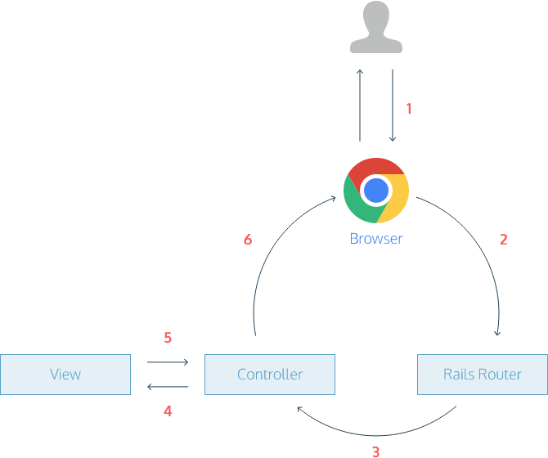

A user opens his browser, types in a URL, and presses Enter.
- When a user presses Enter, the browser makes a request for that URL.
- The request hits the Rails router (config/routes.rb). The router maps the URL to the correct controller and action to handle the request.
- The action receives the request and passes it on to the view.
- The view renders the page as HTML.
- The controller sends the HTML back to the browser. The page loads and the user sees it.

