PROJECT REPORT

Seven Segment Display Counter

Group number: 03
Theory section: 15
Lab section: 15
Group members:
1.Mashiyat Mahjabin Eshita (2210178)
2.Musfika Jahan (2210180)
3.Fardin Jahan Badhon (22101876)
4.Magferah Sultana Samia (22101875)

Proposed Model:
The proposed mode l for our project is seven segment display counter for MOD10, which mainly shows 0 to 9 numerical information. It mainly consists of seven LEDs (hence its name) arranged in a rectangular fashion . Each of the seven LEDs is called a segment because when illuminated the segment forms part of a numerical digit (both Decimal and Hex) to be displayed. It mainly decodes BCD numbers to decimal numbers. Applications of seven segment displays are these displays are commonly used in timers, clock radios, digital clocks, calculators and wristwatches. These devices can also be found in speedometers, motor-vehicle odometers, and radio frequency indicators.

Experimental Setup:
The components we used here are listed below:
- Breadboard v. Display box
- 220 & 330 ohm resistor vi. Battery 9V
- 1K ohm resistor vii. Push button
- Jump wires viii. LED light

Circuit Diagram:

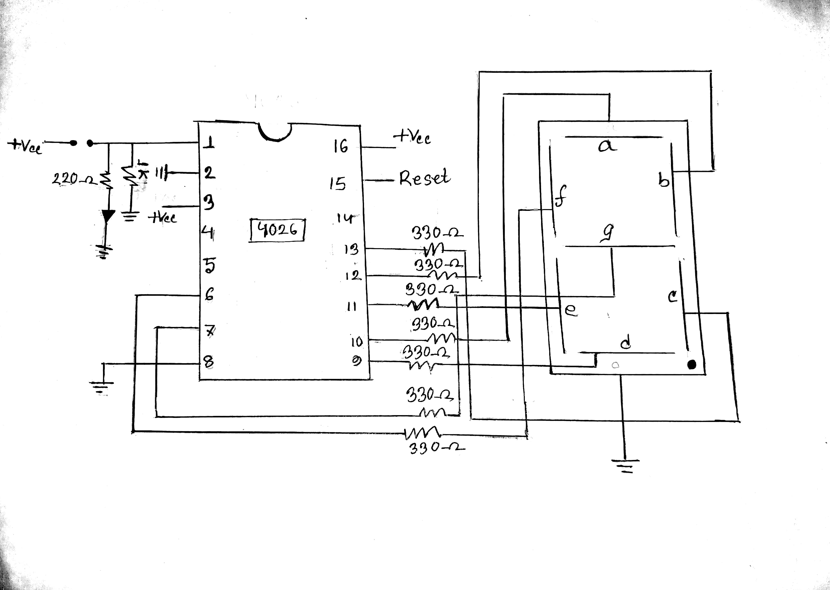

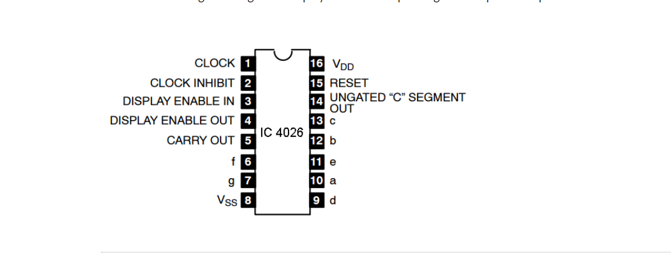

Explanation:
Truth table:
7 segment truth table
Display | B8 | B4 | B2 | B1 | A | B | C | D | E | F | G
0 | 0 | 0 | 0 | 0 | 1 | 1 | 1 | 1 | 1 | 1 | 0
1 | 0 | 0 | 0 | 1 | 0 | 1 | 1 | 0 | 0 | 0 | 0
2 | 0 | 0 | 1 | 0 | 1 | 1 | 0 | 1 | 1 | 0 | 1
3 | 0 | 0 | 1 | 1 | 1 | 1 | 1 | 1 | 0 | 0 | 1
4 | 0 | 1 | 0 | 0 | 0 | 1 | 1 | 0 | 0 | 1 | 1
5 | 0 | 1 | 0 | 1 | 1 | 0 | 1 | 1 | 0 | 1 | 1
6 | 0 | 1 | 1 | 0 | 1 | 0 | 1 | 1 | 1 | 1 | 1
7 | 0 | 1 | 1 | 1 | 1 | 1 | 1 | 0 | 0 | 0 | 0
8 | 1 | 0 | 0 | 0 | 1 | 1 | 1 | 1 | 1 | 1 | 1
9 | 1 | 0 | 0 | 1 | 1 | 1 | 1 | 1 | 0 | 1 | 1
off | 0 | 0 | 0 | 0 | 0 | 0 | 0 | 0 | 0 | 0 | 0
off | 0 | 0 | 0 | 0 | 0 | 0 | 0 | 0 | 0 | 0 | 0
off | 0 | 0 | 0 | 0 | 0 | 0 | 0 | 0 | 0 | 0 | 0

A

F B

G
E C

D

Conclusions:
To conclude,
A seven-segment display (SSD), or seven-segment indicator, is a form of an electronic display device for displaying decimal numerals. A seven-segment display, as its name indicates is composed of seven elements. Individually on or off, they can be combined to produce simplified representations of the numerals. Depending on which elements are turned on, they display decimal numerals 0 through 9. Each element is turned on when a logic input is applied to its corresponding input lead. The over bar above each letter indicates that it is turned on by an active logic input.

