SDI SELF-LEARNING AGENT
Complete Architecture, Requirements, Storage, Validation & Implementation Plan
Service Demand Intelligence (SDI) • Design proposal updated 28 October 2026 • Intent routing revision

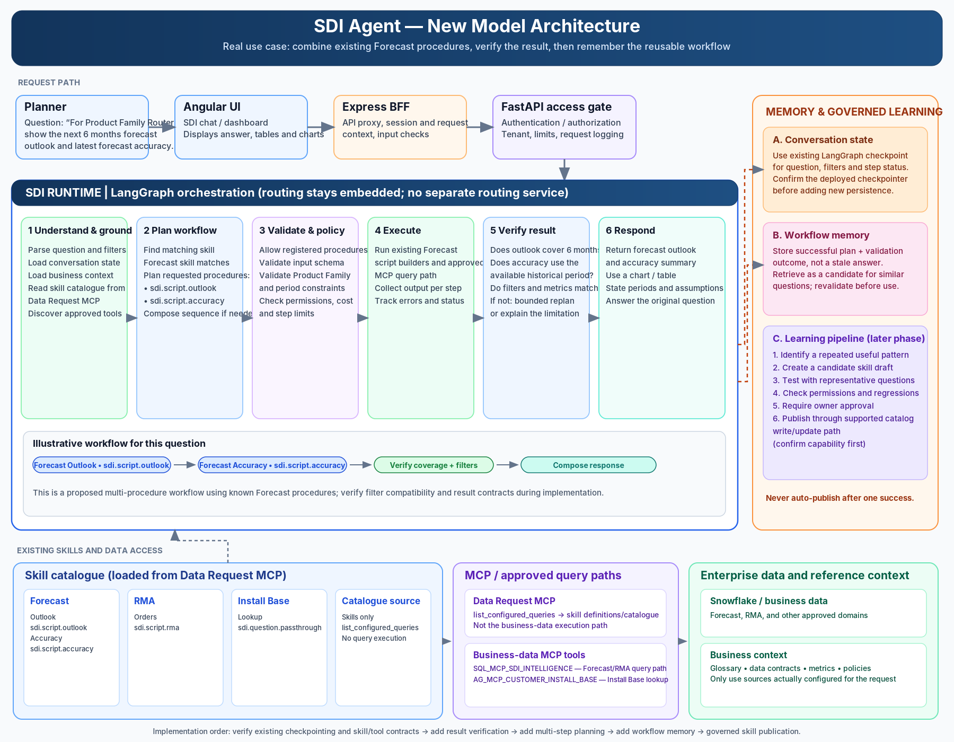
Conceptual end-to-end architecture for the proposed SDI agent model.

Design principle
The model proposes workflows; deterministic controls validate and execute only approved capabilities. Learning is asynchronous, evaluated, and governed.

Document control
Item | Value
Status | Proposed technical design for architecture and engineering review
Scope | Existing SDI request path, workflow planning/execution, result verification, workflow memory, candidate skill lifecycle, governance and rollout
Primary runtime | Existing SDI LangGraph runtime; no separate Intent Routing service in this proposal
Source-of-truth boundary | Existing Data Request MCP skill catalogue remains the approved skill source until the platform team confirms a supported publishing interface
Audience | SDI product owner, planning/business owners, runtime engineering, platform/MCP owners, security/governance, QA/SRE
Important caveat | This document distinguishes known current architecture from proposed additions. All unverified deployment settings and tool availability are marked for confirmation.

Executive summary
The goal is to evolve SDI from an agent that primarily selects one predefined skill into an agent that can reuse existing skills, compose a validated multi-step workflow when needed, verify whether the result answers the original planner question, remember successful workflow patterns, and propose new reusable skills through a controlled lifecycle.
The recommendation is incremental: (1) add result verification to the current path; (2) add restricted read-only multi-step planning; (3) persist reusable workflow templates; and (4) add candidate skill generation, evaluation, owner approval and governed publication. Do not allow the model to write directly to production skill definitions.

Decision summary
Decision | Recommendation | Reason
Routing deployment boundary | Keep routing/planning modular inside the existing SDI runtime for now. | Avoid another service hop and operational dependency; extract later only if reuse/independent deployment justifies it.
Execution authority | LLM proposes; deterministic runtime validates. | Model output is not an authorization grant and cannot invent arbitrary SQL, code or tools.
Workflow memory | Use existing approved PostgreSQL infrastructure if available; verify before designing a new database. | Avoid redundant storage; workflow templates are distinct from LangGraph checkpoints.
Skill catalogue | Keep Data Request MCP as source of approved skills; confirm write/publish API. | Current evidence supports retrieval via list_configured_queries, not necessarily publication.
Learning | Asynchronous and governed. | User answer should not wait for candidate-skill generation; one successful execution is not sufficient proof.
Initial release | Verification first, then restricted planning. | Lowest-risk route to measurable quality improvement.

Contents
- 1. Background and current-state baseline
- 2. Target outcomes and non-goals
- 3. Target architecture
- 4. End-to-end execution sequence
- 5. Workflow plan contract and parameter model
- 6. Context, workflow memory and storage infrastructure
- 7. Result verification and bounded recovery
- 8. Learning pipeline and skill SDLC
- 9. Security, governance and audit
- 10. API and data contracts
- 11. Failure handling and operational requirements
- 12. Test strategy and acceptance criteria
- 13. Implementation roadmap
- 14. Open decisions and risks
- Appendix A. Architecture diagrams
- Appendix B. Example payloads

1. Background and current-state baseline
The current SDI architecture is described as Angular UI with an Express BFF, a FastAPI planning/access layer, and the SDI LangGraph runtime. The runtime loads skill definitions from Data Request MCP, selects a domain/skill and procedure, validates parameters, and executes registered MCP paths. Known skills include Forecast (Outlook and Accuracy), RMA (Orders), and Install Base (Lookup).
The current implementation review in prior project context indicated that a process-local orchestrator cache exists and that production PostgreSQL-backed LangGraph checkpointing was not confirmed. These details must be rechecked against the active branch and deployment manifests before implementation.

1.1 Known skill/procedure examples
Domain / skill | Procedure | Execution identifier described in project context | Notes
Forecast | Outlook | sdi.script.outlook | Existing skill path described in context.
Forecast | Accuracy | sdi.script.accuracy | Existing skill path described in context.
RMA | Orders | sdi.script.rma | Existing skill path described in context.
Install Base | Lookup | sdi.question.passthrough | Execution mapping described in context; verify actual implementation.

A multi-step example that runs Outlook and Accuracy is a proposed orchestration pattern, not a claim that a combined procedure already exists. Inventory and Open Supply were used in earlier illustrative diagrams, but their availability as approved registered MCP tools is not confirmed; they must not be assumed available.

1.2 Current gaps to verify
- Confirm the actual LangGraph graph, node boundaries and checkpointer configuration in the current deployment.
- Confirm whether current conversation context is process-local, persisted, user-bound, and shared across runtime replicas.
- Confirm which registered MCP tools are read-only and which can change business state.
- Confirm whether Data Request MCP exposes only skill retrieval or also supported create/update/publish operations.
- Confirm whether the current response path stores the original user requirements and verifies result completeness.
- Confirm the current timeout, retry, idempotency and concurrent-turn behaviour.

2. Target outcomes and non-goals

2.1 Outcomes
- Answer supported planner questions using one existing skill or a validated workflow composed from approved capabilities.
- Detect missing, mismatched or incomplete data before returning a final answer.
- Retry or replan only within defined limits; otherwise clarify or explain the limitation.
- Persist successful workflow templates and evidence for reuse in later questions.
- Generate candidate skills from repeatable workflow patterns, test them, and publish only after required approval.
- Keep a traceable audit from question to plan, tools, results, verification and any published skill version.

2.2 Non-goals for the first release
- Training or fine-tuning the LLM or changing its model weights.
- Allowing the LLM to generate and execute arbitrary Python, SQL or unregistered tools.
- Automatic production skill publication without review.
- Replacing Data Request MCP, Snowflake, the current UI/BFF/API, or all existing skills.
- Creating a standalone Intent Routing service solely to support this work.
- Treating one successful tool response as proof that a workflow is correct or generally reusable.

3. Target architecture
Keep the existing user-facing path and implement intent routing as a modular part of the existing SDI LangGraph runtime—not as a separate microservice. The router classifies the request and selects a route. Greeting requests are answered directly; knowledge questions retrieve relevant domain information from Drift Cloud RAG; data questions use one shared planning/execution workflow that supports either a single approved skill or a multi-skill plan. The asynchronous learning pipeline starts only after a verified successful workflow and does not delay the user response.
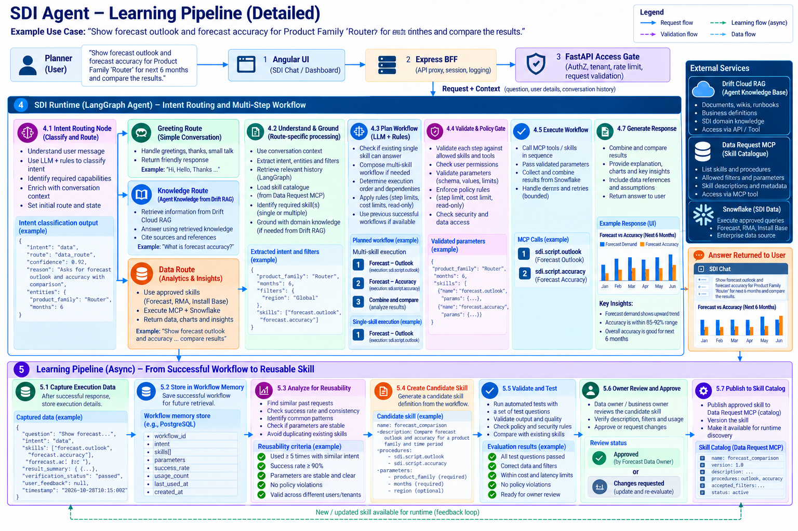
Diagram 1. Updated SDI architecture: intent routing, route-specific grounding, single/multi-skill data workflows, and governed asynchronous learning.

3.1 Runtime responsibilities

3.1.1 Intent routing and route responsibilities
Intent routing is an internal node/module in the existing SDI runtime. It is not a separately deployed service in this proposal. It returns a structured route decision and route-specific context; authorization remains enforced by deterministic server-side controls.
Route | Purpose | Next processing
Greeting | Handle greetings, thanks and simple conversation. | Return a concise response; no skill catalogue or business-data execution required.
Knowledge | Answer domain/concept questions using the agent’s knowledge base. | Retrieve relevant documents and references from Drift Cloud RAG; ground the response in retrieved knowledge.
Data | Retrieve, calculate and analyse SDI business data. | One shared workflow: understand/ground, plan one or multiple approved skills, validate, execute MCP/Snowflake calls, verify and respond.
Important: single-skill and multi-skill are execution strategies inside the Data Route, not separate intent routes. The current design has no separate Action Route. If SDI later adds real write/operation capabilities, enforce their permissions and confirmation policy inside the relevant approved execution path rather than assuming an Action Route already exists.
Component / node | Responsibilities | Must not do
Understand & Ground | Parse intent, entities and requested outcome; load relevant history, glossary, policies, skill catalogue and registered tool metadata. | Treat user-supplied text as trusted policy or tool definitions.
Plan Workflow | Choose an existing skill or propose a sequence of registered capabilities; define dependencies and expected outputs. | Invent a new tool or bypass an unsupported capability.
Validate & Policy Gate | Validate schema, tool registry membership, permissions, filters, dependencies, read/write risk, step limits and budget. | Allow an LLM route/plan to grant access.
Execute Workflow | Invoke approved tools with validated arguments, collect structured step outputs and execution metadata. | Run arbitrary model-generated code or direct database writes outside approved APIs.
Verify Result | Compare actual output against original question requirements, filters, time range, metric coverage and data quality. | Equate successful HTTP/MCP status with answer correctness.
Generate Response | Create a clear answer with caveats, evidence references, tables/charts where appropriate. | Hide missing data or claim unsupported certainty.
Workflow Memory | Store reusable plans, schema, version and verification evidence; retrieve similar candidates. | Store secrets or unnecessarily large sensitive data payloads.
Learning Pipeline | Analyze repeated success, generate candidates, run evaluations, request approval and publish through supported interface. | Write directly to production catalogue without gates.

3.2 Flow at a glance
Planner -> Angular UI -> Express BFF -> FastAPI access gate
-> SDI LangGraph runtime -> Intent Routing node
-> Greeting route: direct conversational response
-> Knowledge route: retrieve grounded domain knowledge from Drift Cloud RAG
-> Data route: Understand/Ground -> Plan (one or multiple skills)
-> Validate/Policy -> Execute -> Verify -> Generate response
-> Shared conversation state and response handling
-> after verified success: emit asynchronous learning event
-> Workflow memory -> Reusability analysis -> Candidate skill
-> Evaluation/tests -> Owner approval
-> Publish approved skill to Data Request MCP catalogue (if supported)
Note: there is no separate Action Route in this target design. Multi-skill execution is a planning choice within the Data Route, not a separate intent.

4. End-to-end execution sequence
- Authenticate the request and establish trusted caller identity, tenant, roles and correlation ID at the existing access boundary.
- Load the conversation checkpoint and current state using the conversation identifier bound to the authenticated user.
- Classify the request into greeting, knowledge, or data intent and preserve the original answer requirements. Extract entities, filters, grain, time window, metrics, output format and constraints. Do not create a separate Action Route: single-skill versus multi-skill is decided by the planner inside the Data Route.
- Load route-specific context. For knowledge requests, retrieve relevant documents and references from Drift Cloud RAG. For data requests, load the lightweight skill catalogue from Data Request MCP, full skill content when needed, registered MCP tool metadata, glossary, data contracts and relevant policy context. Greeting requests may return directly without invoking the data workflow.
- For a greeting, return a direct conversational response. For a knowledge question, answer using relevant Drift Cloud RAG results and references. For a data question, ask the LLM to propose a structured plan: use one existing skill if it satisfies the request, or compose a multi-step plan from registered capabilities if necessary; otherwise clarify or return unsupported.
- Validate the plan deterministically: schema, tool/procedure allowlist, parameter types/ranges, required filters, step dependencies, data classification, authorization, autonomy policy, maximum steps, timeouts and budget.
- Execute steps in dependency order. Pass only validated inputs and trusted identity. Capture each step's status, timing, output schema, source/version references and safe summary.
- Aggregate or transform the step outputs using deterministic code where practical. Avoid relying on the LLM for arithmetic or exact joins that can be done safely in code.
- Verify output against the original answer requirements. If it fails, classify the failure and allow a bounded parameter correction or replan; do not loop indefinitely.
- Generate the user response, including limitations and provenance. Commit the successful state only according to the context update rules.
- Emit a minimal execution event to the asynchronous learning pipeline when eligible. The user response must not wait for skill generation or approval.

5. Workflow plan contract and parameter model
Use a typed, versioned JSON contract between the planner, validator and executor. The model proposes the plan; deterministic code parses and validates it before any tool is called.

5.1 Proposed workflow plan
{
"plan_version": "1.0",
"intent": "compare_forecast_measures",
"strategy": "existing_skills_composed",
"steps": [
{
"step_id": "step_1",
"skill": "forecast",
"procedure": "outlook",
"execution_id": "sdi.script.outlook",
"inputs": {
"product_family": "Router",
"months": 6
},
"depends_on": []
},
{
"step_id": "step_2",
"skill": "forecast",
"procedure": "accuracy",
"execution_id": "sdi.script.accuracy",
"inputs": {
"product_family": "Router",
"months": 6
},
"depends_on": []
}
],
"answer_requirements": {
"product_family": "Router",
"period_months": 6,
"required_measures": ["forecast_outlook", "forecast_accuracy"]
},
"verification_profile": "forecast_comparison_v1"
}

The identifiers above are illustrative contracts based on known skill procedures. Verify actual accepted parameter names, filters and execution IDs against the live skill files and runtime validators before implementation.

5.2 Validation rules
- plan_version is supported and every required field is present.
- Every skill, procedure and execution identifier is registered and enabled.
- Every parameter is allowed by the skill contract, correctly typed, within bounds and consistent with user context.
- No undeclared dependency, cycle, duplicate step ID or unsupported output reference exists.
- Only registered tools may execute; tool arguments are generated from validated values, not copied blindly from model text.
- Plan respects maximum step count, timeout, retry count, cost budget and permitted read/write class.
- User identity and entitlements are enforced at the tool/API boundary even when the tool credential has broader access.

5.3 Planner response categories
Status | Meaning | Runtime action
ready | Valid plan using registered capabilities | Run policy gate then execute.
clarification_required | Essential parameter or intent is ambiguous | Ask the user; do not execute.
unsupported | No approved capability can answer the request | Explain limitation and optionally log a safe gap signal.
invalid_plan | Malformed or unsupported plan | Reject; optionally allow one bounded replan.
policy_denied | Plan violates access or autonomy policy | Stop, audit and return a safe explanation.

6. Context, workflow memory and storage infrastructure

6.1 Keep three data lifecycles separate
Data class | Purpose | Proposed storage | Retention / lifecycle
Conversation / graph state | Resume an active turn and preserve context across turns. | Existing LangGraph checkpointer, if correctly configured; verify backend, schema and deployment first. | Per approved conversation TTL/retention policy; user/tenant scoped.
Workflow memory | Find reusable plans and measure reliability across conversations. | Dedicated PostgreSQL tables in approved existing PostgreSQL infrastructure, if available; otherwise assess platform standard. | Longer-lived, versioned; retention and deletion policy required.
Candidate skill artifacts | Store generated skills and evaluation evidence pending review. | Version-controlled repository or approved artifact/review store. | Retain review history and immutable version lineage.
Approved skills | Authoritative instructions/capabilities discoverable at runtime. | Existing Data Request MCP skill catalogue, subject to confirmed publication API. | Versioned, reviewed, rollback-capable.
Execution logs/metrics | Troubleshooting, audit, cost and reliability measures. | Approved observability platform; metadata only where possible. | Per security and platform policy.

Do not introduce MongoDB simply because it appears in a concept diagram. The original example labels MongoDB as planned, but the implementation recommendation is to first verify existing PostgreSQL/checkpoint and approved platform storage. The choice of workflow memory storage remains an architecture decision until deployment and data-governance constraints are confirmed.

6.2 Workflow memory schema (proposed)
Field | Type / example | Purpose
workflow_id | UUID | Stable identity for a reusable workflow.
version | integer | Immutable workflow revision.
intent_key | text | Canonical intent/capability signature.
workflow_definition | JSONB | Validated ordered steps, dependencies and registered execution IDs.
parameter_schema | JSONB | Required/optional parameters and allowed types; no secrets.
filter_signature | JSONB | Normalized non-sensitive filter pattern, not user-private values unless required.
verification_profile | text/JSONB | Expected output and deterministic/semantic checks.
success_count | integer | Number of verified successful executions.
failure_count | integer | Failures by category, without unnecessary payloads.
last_verified_at | timestamp | Most recent successful verification.
tool_catalogue_version | text | Tool registry/skill version against which the workflow was validated.
status | enum | candidate, evaluated, approved, deprecated, blocked.
created_by | text | System or reviewer identity.
created_at / updated_at | timestamps | Lifecycle and audit timestamps.

6.3 Workflow execution record (proposed)
Field | Purpose
execution_id, request_id, conversation_id | Trace a workflow execution; conversation ID must be access-controlled.
workflow_id/version | Identify the template/version used, if any.
plan_hash | Identify the exact normalized plan without retaining unnecessary prompt content.
step_statuses and durations | Diagnose failed/slow steps.
verification_status and reason codes | Track whether the result met requirements.
tool/catalogue versions | Reproducibility and stale-workflow detection.
safe result summary/reference | Minimal evidence needed for review; avoid storing full sensitive rows by default.
cost/token metrics | Estimate operational cost.

6.4 Persistence rules
- Conversation state is keyed by an opaque conversation ID and bound to authenticated user/tenant. Never trust a client-supplied ID without ownership validation.
- A greeting, clarification or error must not overwrite the last successful result reference.
- Only commit successful result context after verification passes; keep failed attempts separately for diagnostics.
- Protect against concurrent turns overwriting newer state using versions, optimistic concurrency or per-conversation serialization.
- Workflow memory must not store credentials, connection strings, tokens, or full result datasets unless a reviewed use case and policy explicitly require them.
- Use migrations, indexes, retention/expiry, backups and access controls consistent with the approved platform database standard.

7. Result verification and bounded recovery

7.1 Verify against the question, not just the tool status
Verification dimension | Example check | Preferred method
Filter correctness | Product Family equals Router; no unintended widening. | Deterministic.
Time coverage | All six requested months are present or gaps are explicit. | Deterministic.
Metric coverage | Both Outlook and Accuracy results exist when both were requested. | Deterministic schema/coverage checks.
Grain and join integrity | No duplicate multiplication or mismatched PID/product-family grain. | Deterministic/data-quality checks.
Freshness | Source timestamp is within agreed SLA. | Deterministic metadata check.
Numerical correctness | Aggregations, percentages and comparisons are calculated consistently. | Deterministic code/tests where possible.
Question relevance | Narrative actually answers the comparison asked. | LLM evaluator plus rule-based checks, with evidence.
Access compliance | No unauthorized contract/customer data in answer or chart. | Policy enforcement and output checks.

7.2 Recovery loop
Execute
-> Verify
-> pass: generate answer, commit successful state, emit learning event
-> fail: classify failure
-> parameter/input correction (if safe and justified)
-> bounded replan (if workflow is structurally unsuitable)
-> clarification (if user input is missing)
-> stop/escalate (if data/policy/tool issue remains)

Initial recommended default: at most one automatic correction/replan per user turn, configurable by policy. This is a starting recommendation, not a business-approved threshold. Never retry a write operation without idempotency and explicit policy controls.

8. Learning pipeline and skill SDLC
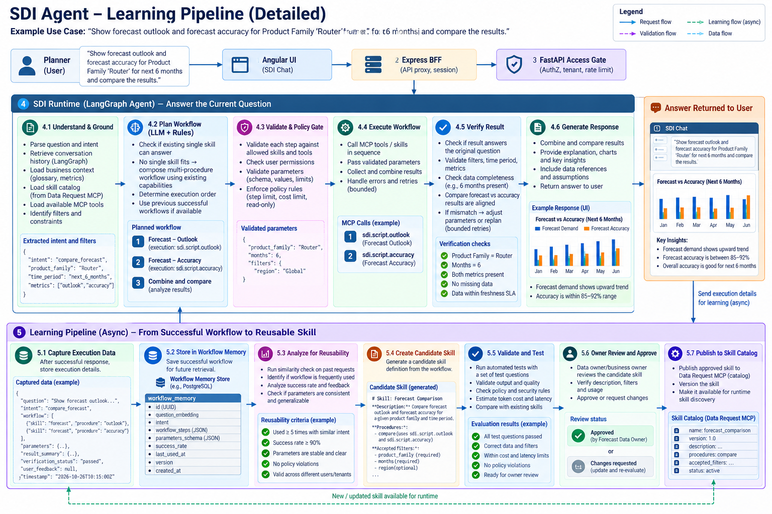
Diagram 2. Learning pipeline concept: capture, memory, reusability, candidate generation, testing, review and publication.

8.1 Event trigger and eligibility
After a verified successful response, the runtime emits a minimal event or enqueues a job. This is asynchronous so user response latency does not depend on learning work.
{
"event_type": "workflow.execution.verified",
"request_id": "req-...",
"workflow_execution_id": "exec-...",
"intent_key": "compare_forecast_measures",
"plan_reference": "plan-hash-or-versioned-reference",
"verification_status": "passed",
"tool_versions": ["..."],
"safe_metrics": {
"step_count": 2,
"latency_ms": 4200,
"retry_count": 0
}
}

Do not send secrets, raw sensitive rows or a complete transcript to the learning worker. The event should reference the persisted execution record and include only fields needed for eligibility and correlation.

8.2 Pipeline stages
Stage | Operation | Output / gate
1. Capture | Record plan, tool versions, parameters schema, step status, verification outcome and safe metrics. | Execution evidence; eligible only if verified and policy permits.
2. Persist | Save normalized workflow template and execution evidence in workflow memory. | Versioned record; idempotent write keyed by execution ID/plan hash.
3. Analyze reuse | Cluster/similarity-match by intent, required outputs and capability sequence; assess repetition and outcomes. | Reuse score and candidate rationale.
4. Generate candidate | Create skill documentation from the plan: purpose, procedure, parameters, allowed capabilities, failure handling and verification profile. | Draft only; cannot execute by virtue of being generated.
5. Evaluate | Run curated golden questions, edge cases, missing filters, authorization tests, data quality tests, regression tests, latency/cost checks. | Machine-generated evaluation report and pass/fail.
6. Owner review | Business/data owner reviews meaning, scope, filters, safety and expected outcome. | Approved, rejected or changes requested.
7. Publish | Use an authorized catalogue API or reviewed deployment process; assign version and audit identity. | Approved skill becomes discoverable after refresh/reload.
8. Monitor/rollback | Monitor production outcomes and disable/revert if failures regress. | Version history and rollback record.

8.3 Candidate skill lifecycle
verified executions
|
v
workflow memory (reusable plan + evidence)
|
v
reusability threshold met?
no -> keep memory; gather more evidence
yes
|
v
generate candidate skill in draft area
|
v
automated tests + policy/security/regression tests
fail -> reject or revise candidate
pass
|
v
business/data owner approval
changes -> revise and re-test
approved
|
v
publish version to approved skill catalogue
|
v
runtime catalogue refresh -> future requests may select skill
|
v
monitor, deprecate or rollback

8.4 Reusability criteria
The exact thresholds must be agreed with owners. Suggested signals include repeated use for similar intents, a high verified-success rate, stable parameter schema, no policy violations, repeatability across representative cases, acceptable cost/latency, and no overlap that would make the new skill confusing or redundant. A single success must not trigger automatic publication.

8.5 Catalogue publication constraint
The project context confirms skill retrieval through Data Request MCP's list_configured_queries and rows where catalogType is Skill. It does not confirm a write/publish API. Therefore, implement a SkillPublisher interface but keep the production implementation disabled until the MCP/platform owner confirms supported create/update, versioning, approval and rollback semantics. A candidate can be reviewed in source control or an approved artifact store meanwhile.

8.6 Does the agent change its LLM?
No. In this design, self-learning is workflow memory, workflow reuse and governed skill creation. It does not fine-tune model weights. Model/provider configuration remains externalized; changing the LLM is a separate model-governance decision.

9. Security, governance and audit
- Carry authenticated planner identity and entitlements into every skill/tool call; do not let a service account's broader access expand the planner's rights.
- Treat tool descriptions, retrieved skill documents and user text as data, not as executable policy overrides.
- Allowlist tool names, execution IDs, procedures and parameter schemas. Deny arbitrary SQL or generated code execution.
- Separate read-only workflow planning from actions that write or change business state. Require approval for high-risk operations and route writeback through secured APIs.
- Apply data classification and RBAC before data is sent to the LLM, included in generated responses, stored in memory, or exposed to learning evaluation.
- Redact sensitive values from prompts/logs/metrics. Use safe reason codes rather than logging chain-of-thought.
- Version skill definitions, workflow plans, evaluation suites and publication records.
- Maintain audit records for candidate creation, evaluation, owner decision, publish, deprecation and rollback.
- Protect candidate skills against prompt injection or unsafe instructions by generating only within a constrained schema and reviewing diffs before publication.

10. API and data contracts

10.1 Runtime graph state (proposed)
{
"request_id": "uuid",
"conversation_id": "opaque-id",
"authenticated_subject": "server-derived-subject",
"question": "...",
"answer_requirements": {
"intent": "...",
"entities": {},
"filters": {},
"time_range": {},
"required_metrics": [],
"output_format": "text|table|chart"
},
"context_version": 12,
"plan": {},
"step_results": [],
"verification": {
"status": "pending|passed|failed",
"issues": []
},
"last_successful_result_ref": null
}

10.2 Verification result contract
{
"status": "passed|failed|needs_clarification",
"checks": [
{
"check_id": "period_coverage",
"status": "passed",
"evidence_ref": "result-ref"
}
],
"issues": [],
"recommended_recovery": "none|correct_parameters|replan|clarify|stop"
}

10.3 Candidate skill metadata
{
"skill_id": "forecast_comparison",
"candidate_version": 1,
"status": "draft",
"purpose": "Compare approved forecast measures for requested scope",
"procedures": [],
"accepted_parameters": {},
"allowed_execution_ids": [],
"verification_profile": "forecast_comparison_v1",
"test_suite_version": "golden-set-v1",
"evaluation_status": "pending",
"owner_approval": "pending"
}

11. Failure handling and operational requirements
Failure | Required behaviour
No matching skill and no composable tools | Return unsupported/clarification; do not invent capability.
Invalid model plan | Reject via schema/registry validation; bounded replan at most per configured policy.
Tool timeout/transient failure | Apply bounded retry only when safe/idempotent; record failure category.
Permission denied | Stop; do not attempt another tool to bypass access; return safe explanation.
Partial data | Mark missing coverage; replan only if a valid alternative exists, otherwise disclose limitation.
Verification failed | Do not store as successful workflow; correct/replan within limit or escalate.
Learning worker unavailable | Return answer normally; queue/retry learning event if infrastructure supports it.
Catalogue publication unavailable | Keep candidate pending; never claim it is published.
Stale workflow memory | Revalidate tool/skill versions; reject or replan when contracts changed.
Concurrent conversation turns | Use versioning/serialization; prevent older turns overwriting newer successful context.

11.1 Observability
- Trace each turn with request ID across BFF, API, runtime, MCP tools, verification and learning worker.
- Capture per-node duration, LLM token/cost metrics, tool latency, retries, plan rejection reasons, verification pass rate and unsupported-request rate.
- Measure candidate generation, evaluation pass/fail, approval lead time, publication failures and rollback rate.
- Use structured logs with redaction. Avoid storing full prompt, transcript or sensitive result rows by default.
- Alert on increased verification failures, tool timeouts, unexpected cost growth, policy denials and catalogue refresh errors.

12. Test strategy and acceptance criteria

12.1 Test layers
Layer | Tests
Unit | Plan schema, parameter validator, dependency graph, result coverage, filter matching, candidate serialization.
Contract | Skill provider/catalogue, MCP tool schemas, checkpointer interface, publisher interface and version compatibility.
Integration | LangGraph graph with mocked MCP, real staging MCP where approved, persistence and learning queue.
Evaluation/golden set | Existing skill questions, follow-ups, multi-step questions, ambiguity, unsupported requests, missing data, permission restrictions.
Security | Cross-user context access, prompt injection, unauthorized data classes, arbitrary tool/SQL attempts, log redaction.
Reliability | Timeouts, retries, partial failures, concurrency, worker downtime, checkpoint restore, catalogue refresh and rollback.
Performance/cost | End-to-end p50/p95 latency, added verification tokens, tool call counts, workflow memory retrieval latency and learning queue lag.

12.2 Acceptance criteria for first milestone: Verify
- The original user requirements are retained as structured state and are available to Verify.
- Tests detect wrong filters, missing requested periods, missing metrics and incomplete result sets.
- Verification failure never results in a falsely labelled successful workflow-memory record.
- Automatic recovery is bounded and unsupported/policy-denied cases stop safely.
- Existing valid single-skill requests continue to work with no regression in access control.

12.3 Acceptance criteria for workflow memory
- Only eligible verified executions can create reusable workflow records.
- A similar future question can retrieve a candidate plan, but the plan is revalidated before execution.
- Workflow records contain no credentials and avoid unnecessary sensitive output payloads.
- Tool/skill version changes cause revalidation or invalidation as designed.
- Memory access is tenant/user-safe and auditable.

12.4 Acceptance criteria for candidate skills
- A candidate is never directly executable or production-discoverable before approval.
- Evaluation results and test-suite version are attached to the candidate.
- Owner approval/rejection is attributable and audited.
- Publishing uses an explicitly supported catalogue interface or approved deployment process.
- New skill versions can be rolled back and are discoverable after a defined refresh mechanism.

13. Implementation roadmap
Phase | Scope | Deliverable | Exit gate
0. Discovery | Inspect current graph, context/checkpointer, MCP registry, skill contracts, deployment and catalogue write support. | As-is inventory and confirmed platform decisions. | No assumptions left hidden for critical infrastructure.
1. Verification | Capture answer requirements; add Verify node and bounded recovery. | Reliable verification for current existing skills. | Golden tests pass; no false-success state updates.
2. Restricted planning | Add structured multi-step plans using registered read-only capabilities. | Planner + deterministic plan validator + sequential executor. | Approved multi-step scenarios work safely.
3. Workflow memory | Persist successful plans/evidence and retrieve similar templates. | Storage schema, retrieval, versioning and revalidation. | Cross-session reuse works without stale/unauthorized execution.
4. Candidate skill SDLC | Generate candidate, evaluate against tests, owner review and audit. | Draft/review lifecycle and evaluation reports. | Candidates cannot bypass approval.
5. Publication and operations | Integrate confirmed publisher; version, refresh, monitor and rollback. | Governed skill publication end-to-end. | Approved skill appears in runtime catalogue; rollback tested.
6. Controlled expansion | Expand capabilities, domains, optional multi-skill composition and feedback loops. | Measured production rollout. | Business acceptance, security sign-off and cost/latency targets met.

13.1 Recommended immediate sprint
- Map the current graph and capture the exact existing single-skill flow in tests.
- Define AnswerRequirements, WorkflowPlan and VerificationResult Pydantic models.
- Implement deterministic checks for required filters, time coverage, metrics and data freshness where metadata exists.
- Add bounded recovery and ensure context updates only after successful verification.
- Create a golden dataset of representative planner questions and expected checks.

14. Open decisions and risks
Open decision | Why it matters | Owner / next action
Is LangGraph checkpointing configured in deployed environments? What backend and retention? | Determines whether conversation persistence can be reused. | Runtime/platform engineering: inspect code, env and deployment.
Which PostgreSQL instance/schema is approved for workflow memory? | Determines storage infrastructure, access, backup and retention. | Platform/data governance: approve or select standard.
Does Data Request MCP support create/update/publish skill operations? | Determines how candidate skills become approved catalogue entries. | MCP owner: confirm API and lifecycle semantics.
Which existing MCP capabilities are approved for multi-step composition? | Prevents diagram examples from implying nonexistent tools. | Capability owners: publish registry and input/output schemas.
What success/reuse thresholds promote a workflow to candidate skill? | Prevents noisy or unsafe skill creation. | Product/business/data owners: agree criteria.
Who owns approval for each skill/domain? | Required governance boundary. | Product/governance: define role and audit trail.
What is the accepted data retention and privacy policy for workflow records? | Controls storage of planner context, filters and execution evidence. | Security/privacy/data governance.
What are latency/cost/retry budgets? | Controls safe bounded autonomy and operating cost. | Product/SRE/finance: set SLOs and thresholds.
How should skill refresh/rollback work at runtime? | Avoids stale catalogues after publication. | MCP/runtime owners: define invalidation and refresh contract.

Risk register
Risk | Impact | Mitigation
False-positive verification | Incorrect business answer returned and potentially learned. | Use deterministic checks for structured facts; golden tests; human-reviewed candidate promotion.
Unsafe plan/tool use | Unauthorized access or unintended business action. | Strict allowlist, schema validation, identity propagation, read-only-first rollout.
Stale workflow memory | Old tool contracts or assumptions reused incorrectly. | Version pinning, revalidation, invalidation and rollback.
Sensitive data persisted | Privacy/compliance breach. | Minimal event payloads, access controls, redaction and retention policy.
Skill catalogue write support missing | Cannot automate publication. | Use draft repository/review path until supported API is confirmed.
Added LLM calls increase latency/cost | Poor user experience and operating cost. | Measure each stage, use deterministic checks first, bounded evaluator calls.

Appendix A. Architecture diagrams
The diagrams below are conceptual design artefacts generated during the architecture discussion. They illustrate different views of the proposal. They are not evidence that all shown capabilities or integrations exist in production.

A1. Original SSC agent-loop reference
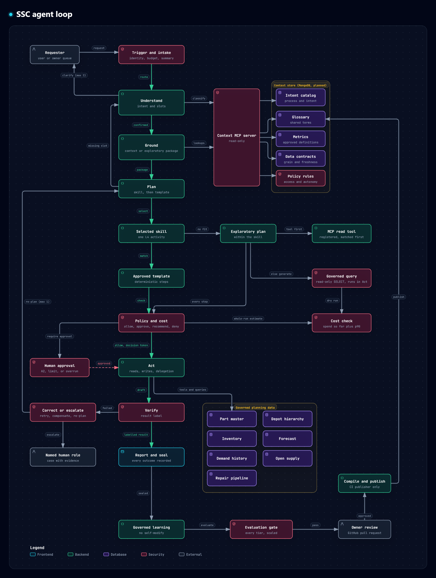
Original reference diagram supplied by the user.

A2. New-model architecture — real-use-case view
Updated intent-routing architecture: greeting and Drift RAG knowledge paths, plus one shared data workflow supporting single-skill and multi-skill execution. No separate Action Route is shown.

A3. Learning pipeline — detailed view
Capture, persist, assess, generate candidate, evaluate, approve and publish.

A4. Earlier detailed architecture concept
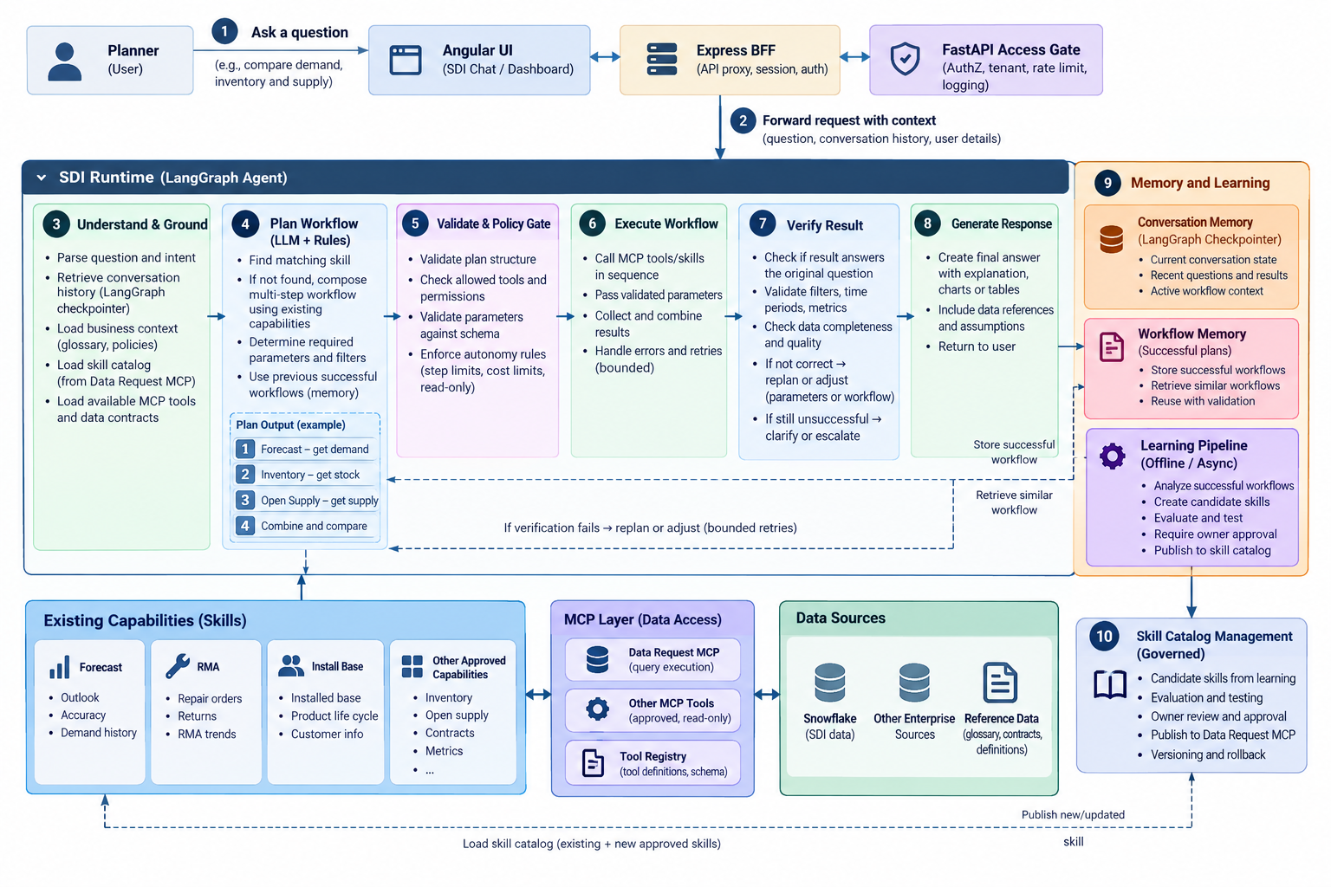
Earlier broad architecture concept; treat capability labels as illustrative pending tool-registry confirmation.

A5. Interactive architecture artefact
An interactive HTML diagram was also generated for click-to-explain block stories and guided navigation. Open the separate file SDI Agent SDLC Loop Interactive HTML. The Word document contains static diagram views because Word does not preserve the HTML click interactions.
Interactive HTML path: /mnt/data/sdi_agent_sdlc_loop_interactive.html

Appendix B. Example user story and trace

B1. Planner request
“Show forecast outlook and forecast accuracy for Product Family Router for the next six months, and compare the results.”

B2. Expected route
- Intent routing: classify the request as a data/analytics question. The Data Route planner selects Forecast Outlook and Forecast Accuracy as two steps in one multi-skill workflow; the requested scope is Product Family Router for six months. This is not an Action Route.
- Plan: compose the two existing Forecast procedures only if the current skill/tool contracts permit both procedures to run for the same scope.
- Validate: check procedure registration, accepted filters, months range, access permissions, read-only status and policy limits.
- Execute: call approved execution IDs and capture structured outputs and source freshness metadata.
- Verify: both measures exist for the same product family and period; missing months or inconsistent grain fail verification.
- Respond: show comparison and state any data limitations.
- Learn: after successful verification, save a normalized plan and outcome metrics for future reuse; do not publish a new skill automatically.

B3. Example failure
If Outlook returns six months but Accuracy returns only four, verification fails the period-coverage check. The runtime may attempt one safe replan/correction if the skill contract supports it. If the gap remains, it must explain the missing coverage and must not record the run as a fully successful workflow.

Appendix C. Source and assumption notes
- Project context and prior architecture discussions: current repos, LangGraph runtime, skill loading from Data Request MCP, Forecast/RMA/Install Base skill examples, and current uncertainty about deployed checkpointing and skill publication.
- SDI-Agent-Context-and-Requirements.docx: routing lexicon and platform requirements including RBAC, super-agent/sub-agent context, skills, and conversational persistence. The present design does not override those requirements.
- SDI_Intent_Routing_Service_Design.md: prior standalone-router proposal. This document intentionally recommends embedded modular planning for the current stage, consistent with the later decision to avoid a separate routing service for latency/cost/configuration-consistency reasons.
- Generated architecture diagrams are conceptual. Tool availability, schema details, actual data sources, database choice, checkpointer backend, publication API, retention, approval roles and numeric thresholds require confirmation.

