UIEP-3745 — Corporate Officer Exclusion
Demo / UAT Document — Reproducible Steps with Screens
Field | Value
Ticket | UIEP-3745
Feature | COE election end messaging & confirmation flow
Route | /manage-account/corporate-office-exclusion
Release | Oct 28 UAT / NNMilestone2
Demo date | ____________________
Tester | ____________________
Environment | Local / UAT ____________________

1. Purpose
Demonstrate that Corporate Officer Exclusion no longer fails silently after Submit, shows clear success/error messaging, blocks a second election attempt on revisit, and matches Figma: Intro → Worksheet → Success → Already elected.

2. Screen map
# | Screen | Capture / Figma
A | Before fix (baseline) | 00-before-initial-worksheet.png
B | Intro | 06-intro-screen.png + Initial.png
C | Must-calculate banner | 01-submit-without-calculate-must-calculate-banner.png
D | Inline missing value | Figma: inline errors.png
E | No-savings warning | 02-no-savings-warning-on-submit.png
F | Eligibility reject | 03-eligibility-rejected-deadline-and-payroll.png
G | Success | Figma: Success.png (needs eligible account)
H | Already elected | Figma: Already visited.png (needs elected account)

3. Accounts required
Scenario | Account type
Happy path (Intro → Success) | Eligible newly subject Corp / LLC-as-Corp (<$500k, in window)
Already elected | Account with COE already in effect
Negative paths | Any COE-openable account (e.g. VANDERLOOP)

Eligible tip (from ticket): Register a Corporation that activates on submit, then take COE before initial report due date OR within 30 days of Initial Determination.

4. Pre-demo checklist
- Office build succeeds (0 errors) with latest COE files
- Logged in with access to test employer account
- Navigate: View & Manage Account → Corporate Officer Exclusion
- Have this Word doc open for screen compare

5. Reproducible demo steps

STEP 0 — Baseline (what was broken)
Goal: Show original defect: Submit did nothing
Account: Any (old behavior / capture)
Reproduce steps:
1. Open baseline capture or old build
2. On worksheet click SUBMIT ELECTION with no end messaging
Expected result:
- Before: no success screen, no error banner (silent)
- Ticket: “Nothing happens after successful COE election submission”
Pass / Fail: ☐ Pass ☐ Fail
Screen reference (actual / demo capture):
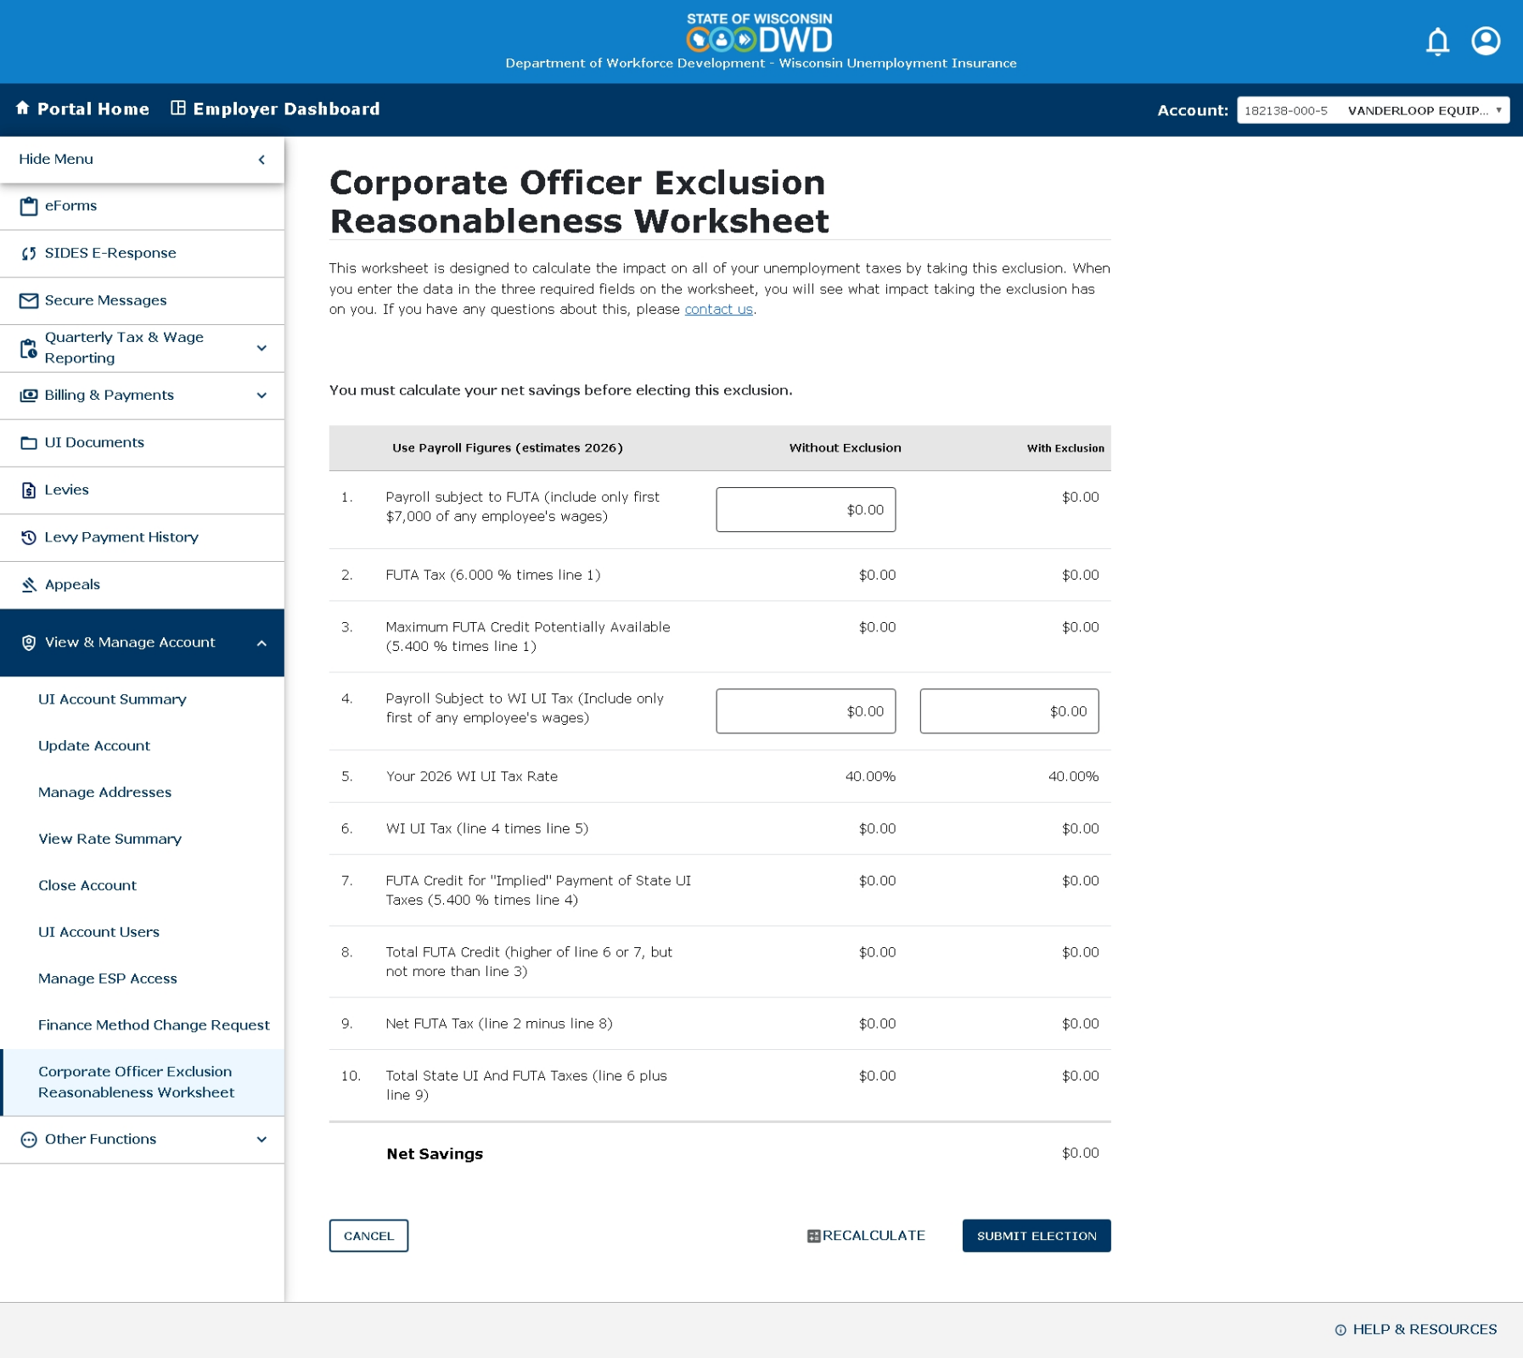
Baseline — worksheet only; Submit appeared to do nothing

STEP 1 — Intro screen
Goal: Landing shows Intro (not worksheet) with eligibility + NEXT
Account: Not-yet-elected account (e.g. 182138-000-5)
Reproduce steps:
1. Select employer account
2. Open Corporate Officer Exclusion
3. Do not click NEXT yet — capture/show Intro
Expected result:
- Title: Corporate Officer Exclusion
- Eligibility copy ($500k / Corp / LLC-as-Corp)
- Grey card: Account Number (######-###-#), Legal Name, effective-as-of date
- NEXT button bottom-right
Pass / Fail: ☐ Pass ☐ Fail
Screen reference (actual / demo capture):
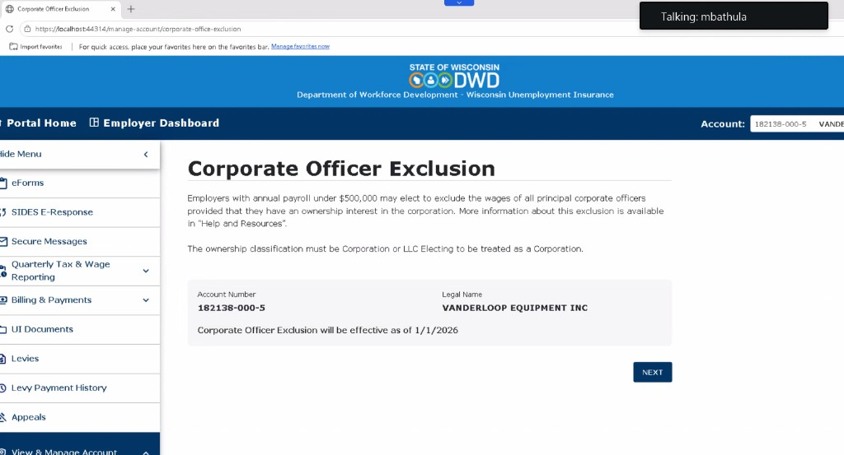
Actual Intro screen (demo capture)
Figma reference:
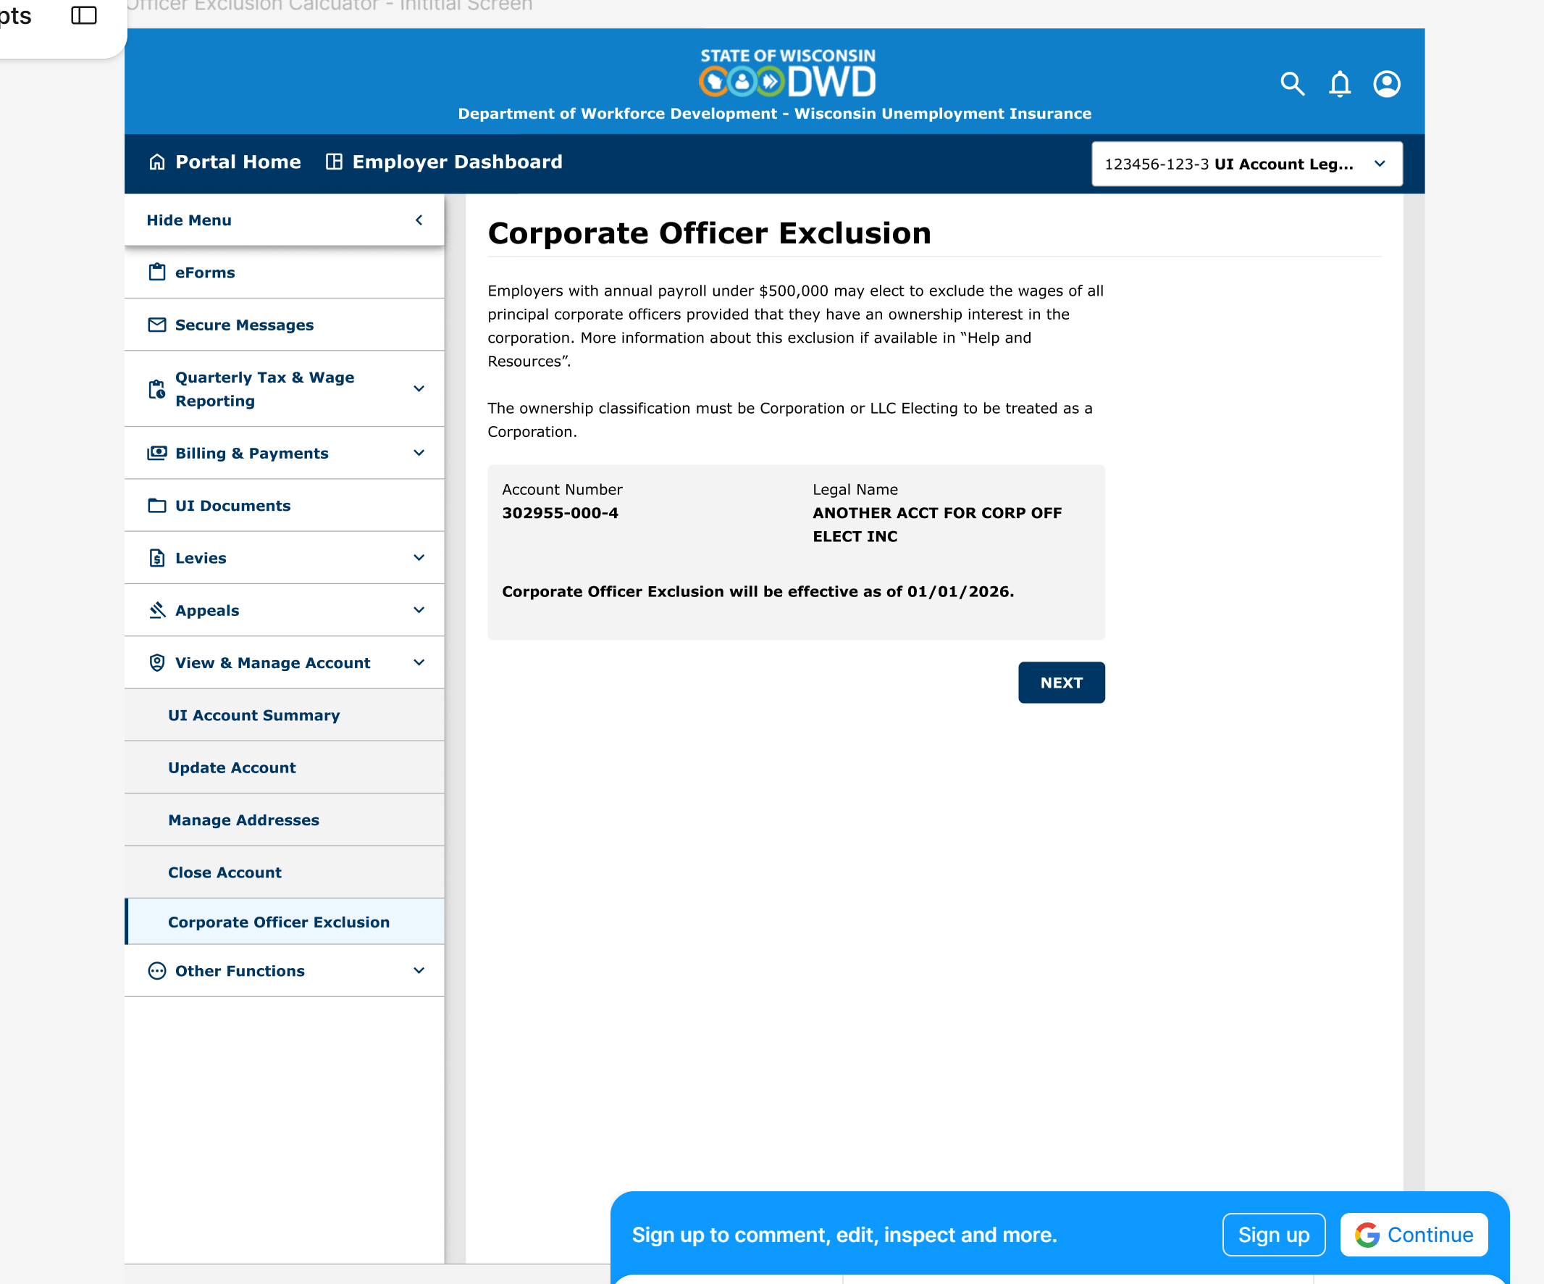
Figma — Initial.png

STEP 2 — Worksheet after NEXT
Goal: NEXT opens reasonableness worksheet
Account: Same as Step 1
Reproduce steps:
1. From Intro click NEXT
Expected result:
- Title: Corporate Officer Exclusion Reasonableness Worksheet
- Table lines 1–10 + Net Savings
- Buttons: CANCEL | CALCULATE | SUBMIT ELECTION
Pass / Fail: ☐ Pass ☐ Fail
Figma reference:
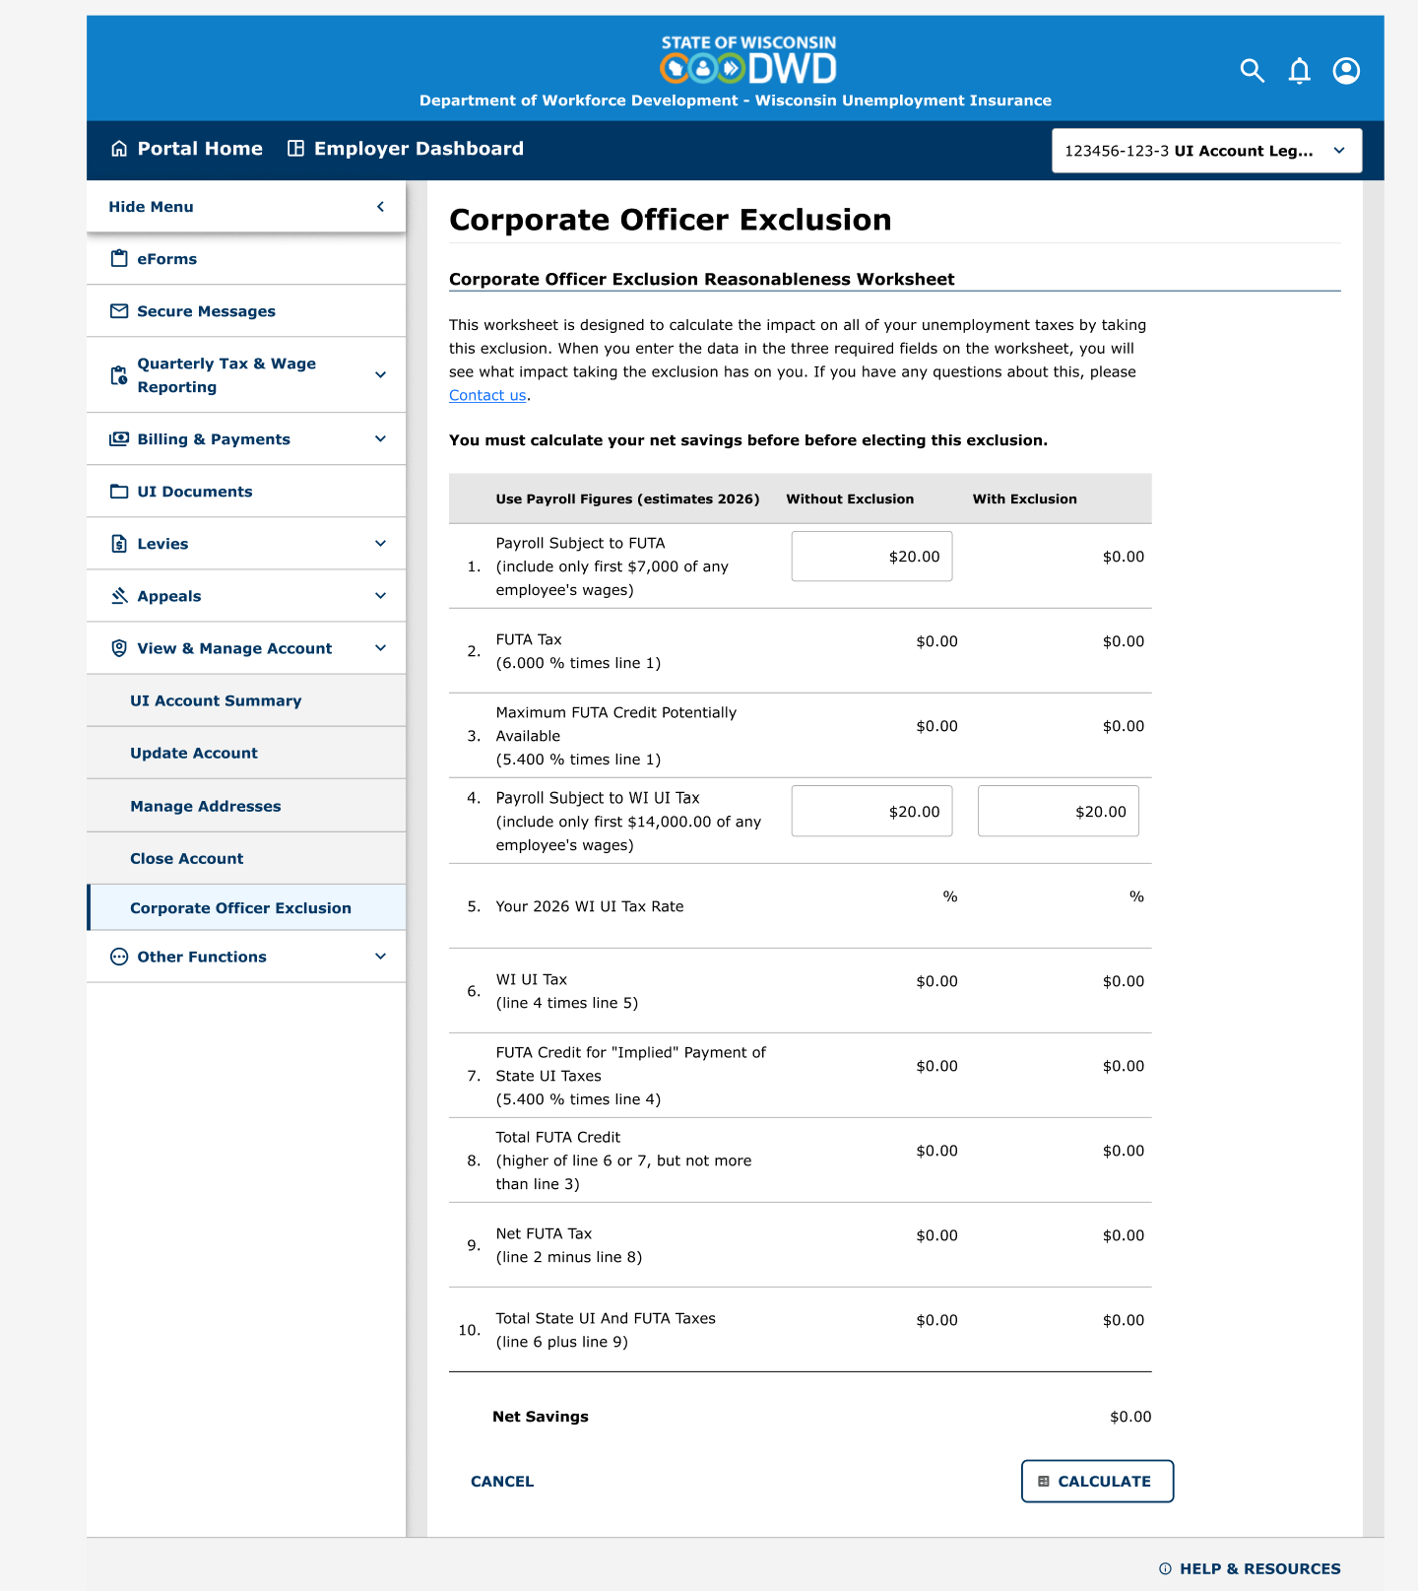
Figma — Officer Exclusion Calculate Worksheet.png

STEP 3 — Submit without Calculate
Goal: Submit is never silent
Account: Same worksheet
Reproduce steps:
1. On worksheet click SUBMIT ELECTION without clicking CALCULATE
Expected result:
- Red Alert: “You must calculate your net savings before electing this exclusion.”
- Stay on worksheet
Pass / Fail: ☐ Pass ☐ Fail
Screen reference (actual / demo capture):
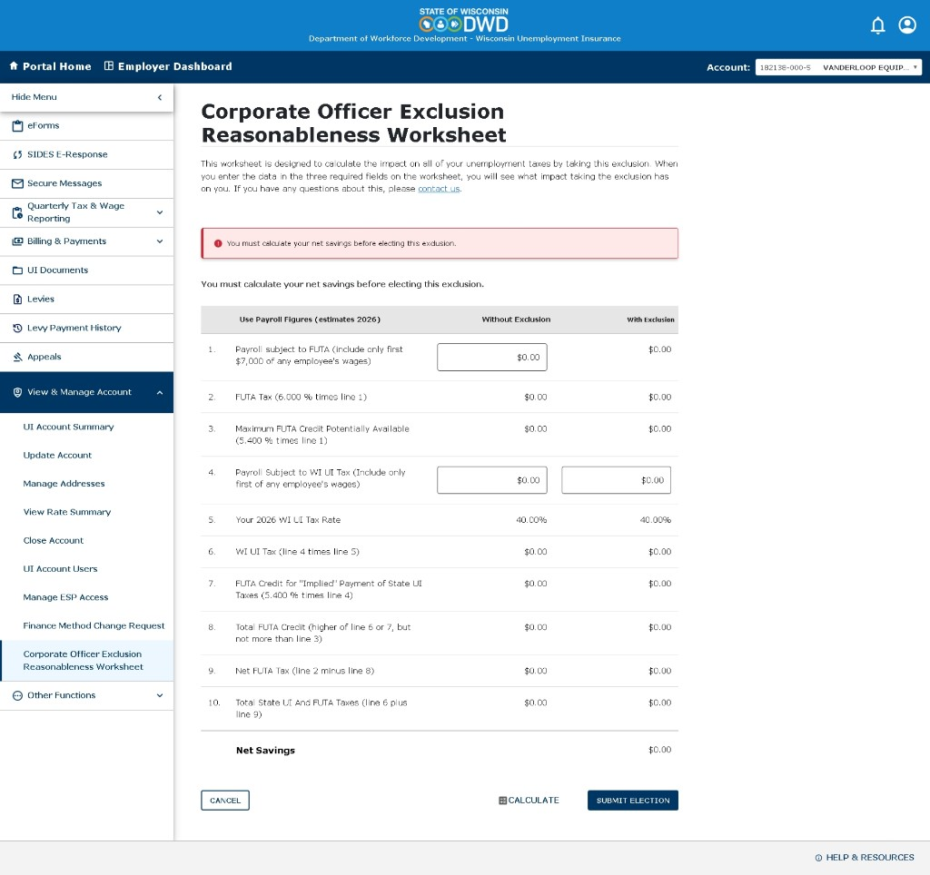
Must-calculate banner after Submit without Calculate

STEP 4 — Inline missing value
Goal: Required $0 fields show Missing value
Account: Same worksheet
Reproduce steps:
1. Leave Line 1 FUTA Without at $0.00 (and/or WI Without at $0)
2. Click CALCULATE
Expected result:
- Top Alert lists missing fields (e.g. Payroll Subject to FUTA missing.)
- Field shows red border + “Missing value”
Pass / Fail: ☐ Pass ☐ Fail
Figma reference:
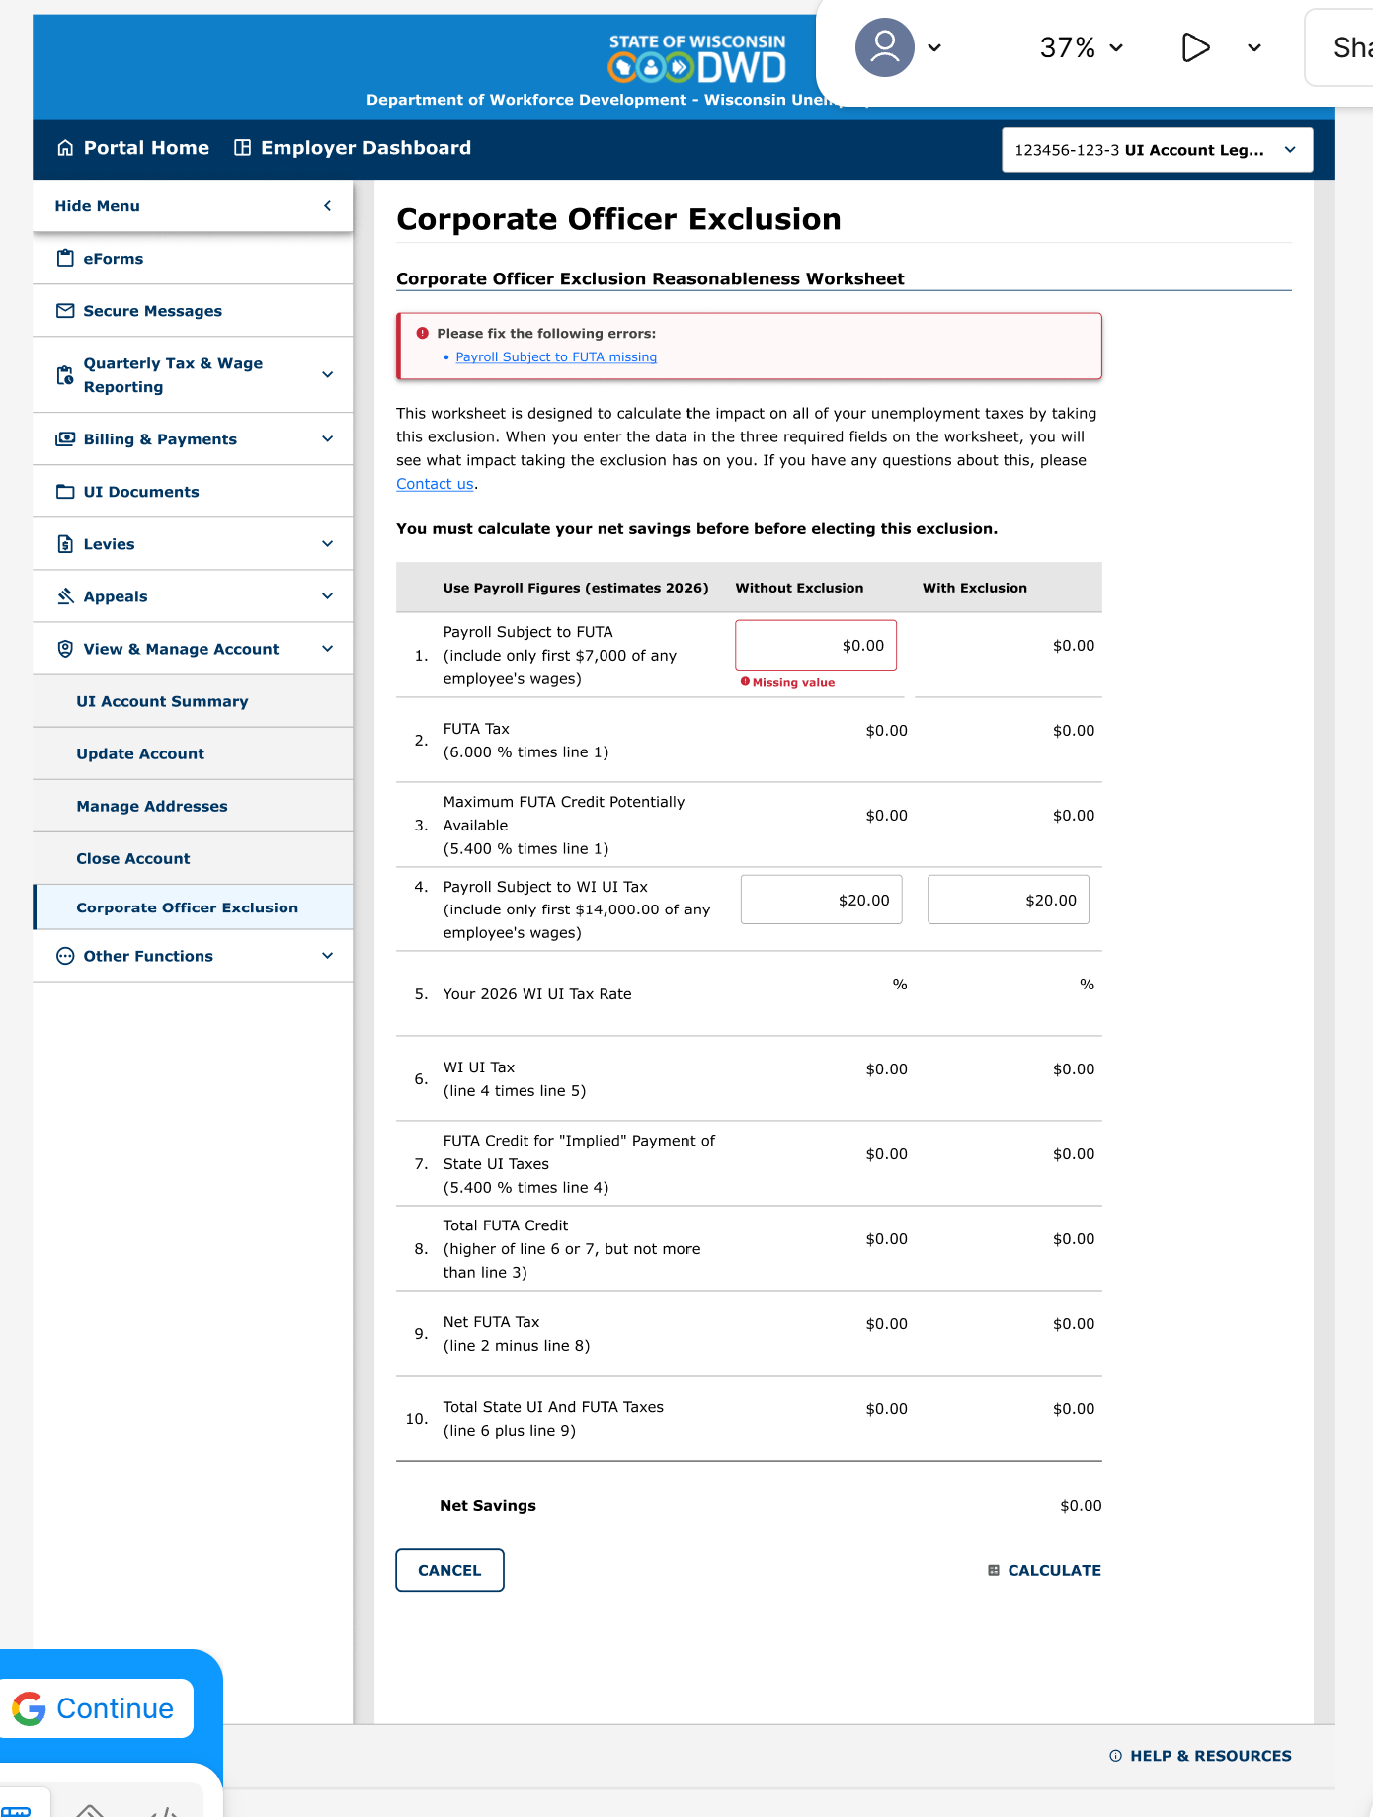
Figma — Officer Exclusion Calculate Worksheet inline errors.png

STEP 5 — Calculate updates values
Goal: CALCULATE refreshes tax rows / Net Savings
Account: Same worksheet
Reproduce steps:
1. Enter FUTA Without > 0 (e.g. 400)
2. Enter WI Without > 0 (e.g. 600)
3. Enter WI With (e.g. 0)
4. Click CALCULATE
Expected result:
- CALCULATING… then values update
- Error banners clear
Pass / Fail: ☐ Pass ☐ Fail
Figma reference:
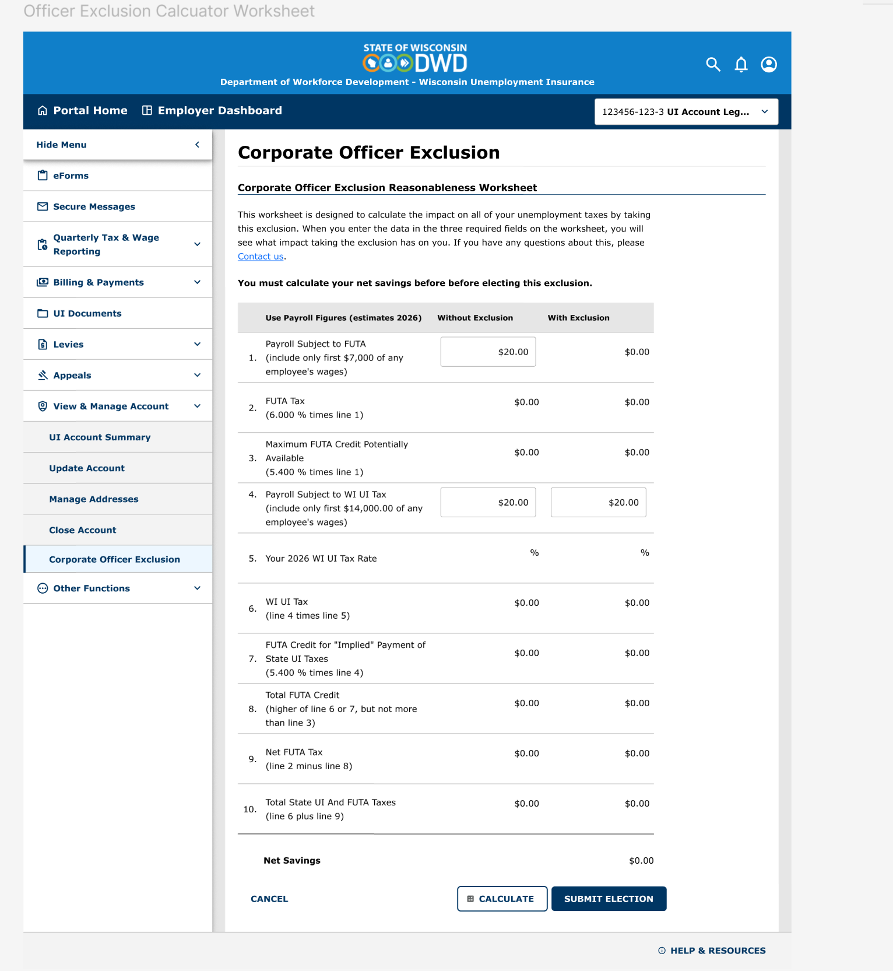
Figma — Officer Exclusion Caluclator Worksheet.png

STEP 6A — Submit success (happy path) ★ eligible account
Goal: End messaging after successful election
Account: Eligible newly subject Corp (required)
Reproduce steps:
1. Complete Step 5
2. Click SUBMIT ELECTION
3. If no-savings warning (6B), click SUBMIT ELECTION again
4. Observe success screen
Expected result:
- Green: “Your election successfully submitted.”
- Links: View Initial Determination letter; Mail a copy…
- Summary card: Account, Legal Name, Confirmation ID (if API), Date Submitted (if API), effective date
- ACCOUNT SUMMARY only (no BACK)
Pass / Fail: ☐ Pass ☐ Fail
Figma reference:
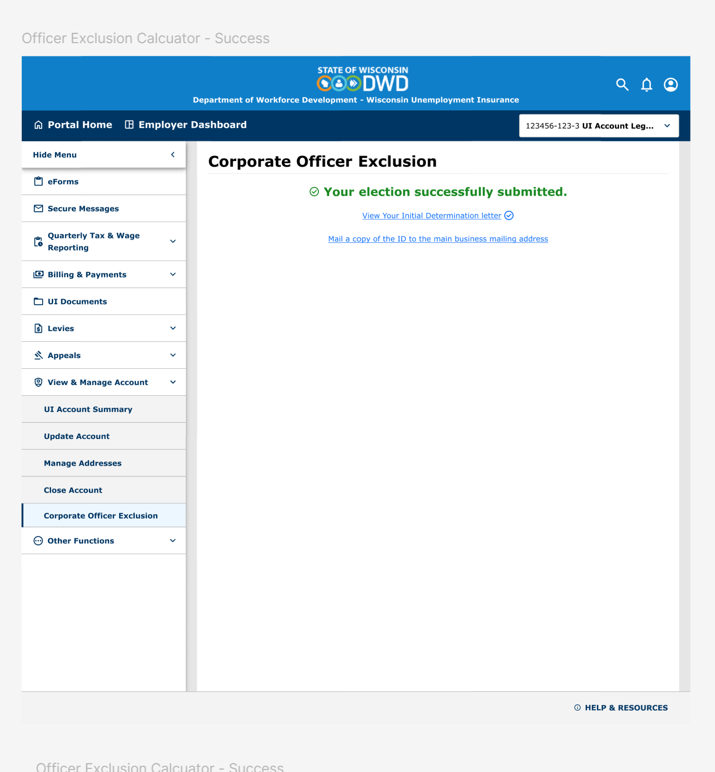
Figma — Officer Exclusion Calculator -Success.png

STEP 6B — No-savings / pay MORE warning (optional)
Goal: Backend warning when estimates show higher tax
Account: Account that can submit with negative net savings
Reproduce steps:
1. Calculate with figures that produce negative Net Savings
2. Click SUBMIT ELECTION once
Expected result:
- Alert warns you will pay MORE unemployment tax…
- Can Submit again to proceed or Cancel
Pass / Fail: ☐ Pass ☐ Fail
Screen reference (actual / demo capture):
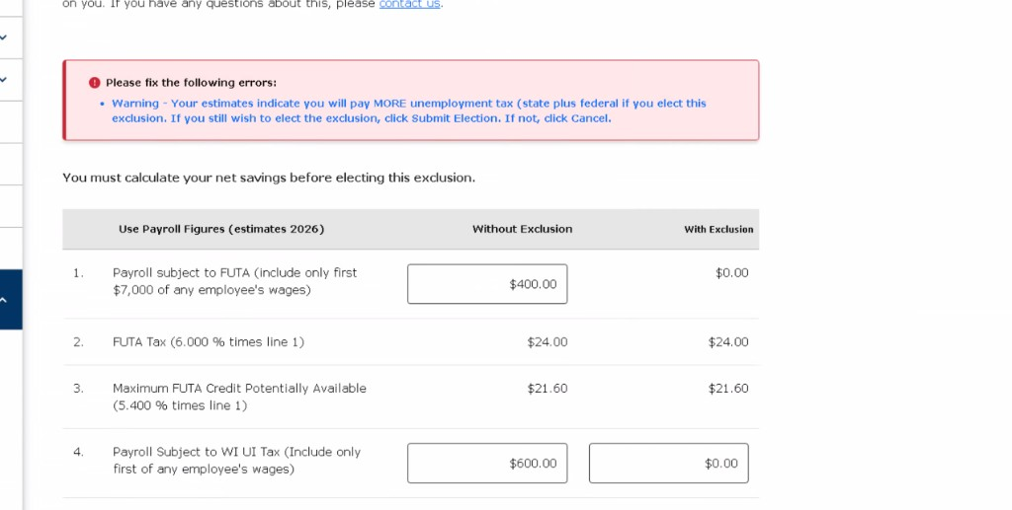
No-savings / pay MORE warning

STEP 6C — Mail copy banner
Goal: Mail-copy link shows Figma banner
Account: After successful submit
Reproduce steps:
1. On success click “Mail a copy of the ID to the main business mailing address”
Expected result:
- Banner: “Initial Determination letter will be mailed to your main business mailing address.”
Pass / Fail: ☐ Pass ☐ Fail
Figma reference:
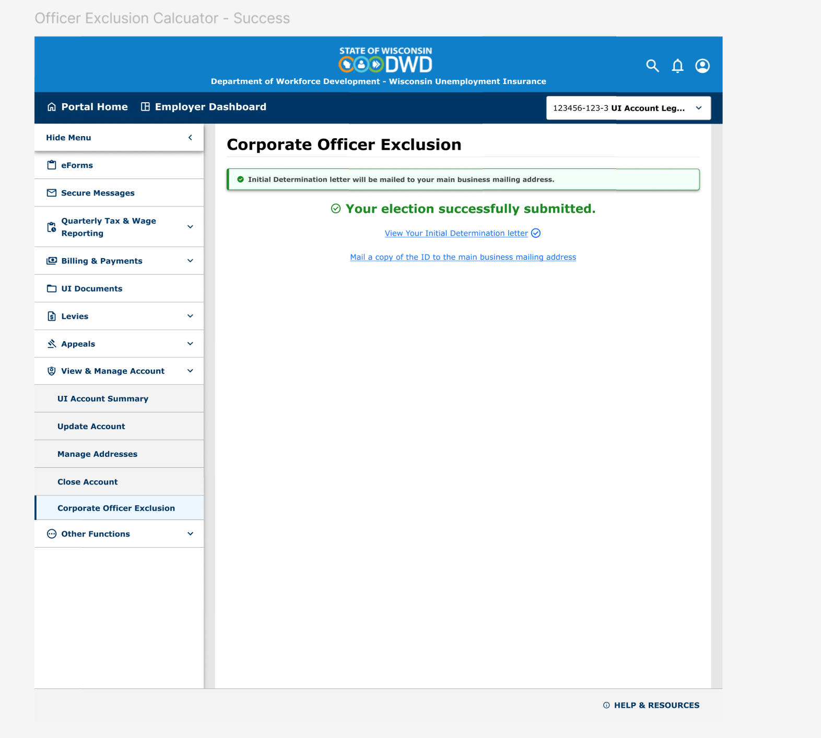
Figma — Officer Exclusion Calculator -Success with banner.png

STEP 6D — Account Summary exit
Goal: End button returns to Account Summary
Account: Success screen
Reproduce steps:
1. Click ACCOUNT SUMMARY
Expected result:
- Navigates to /manage-account/account-summary
- Not account-details; not legacy Complete
Pass / Fail: ☐ Pass ☐ Fail

STEP 7 — Already elected (revisit) ★ elected account
Goal: Cannot take election again; confirmation shown
Account: Same account after Step 6A success, or known elected account
Reproduce steps:
1. From Account Summary open Corporate Officer Exclusion again
Expected result:
- No worksheet / no Submit
- Banner: “Corporate Officer Exclusion submitted.”
- Card with account details + ACCOUNT SUMMARY only
Pass / Fail: ☐ Pass ☐ Fail
Figma reference:
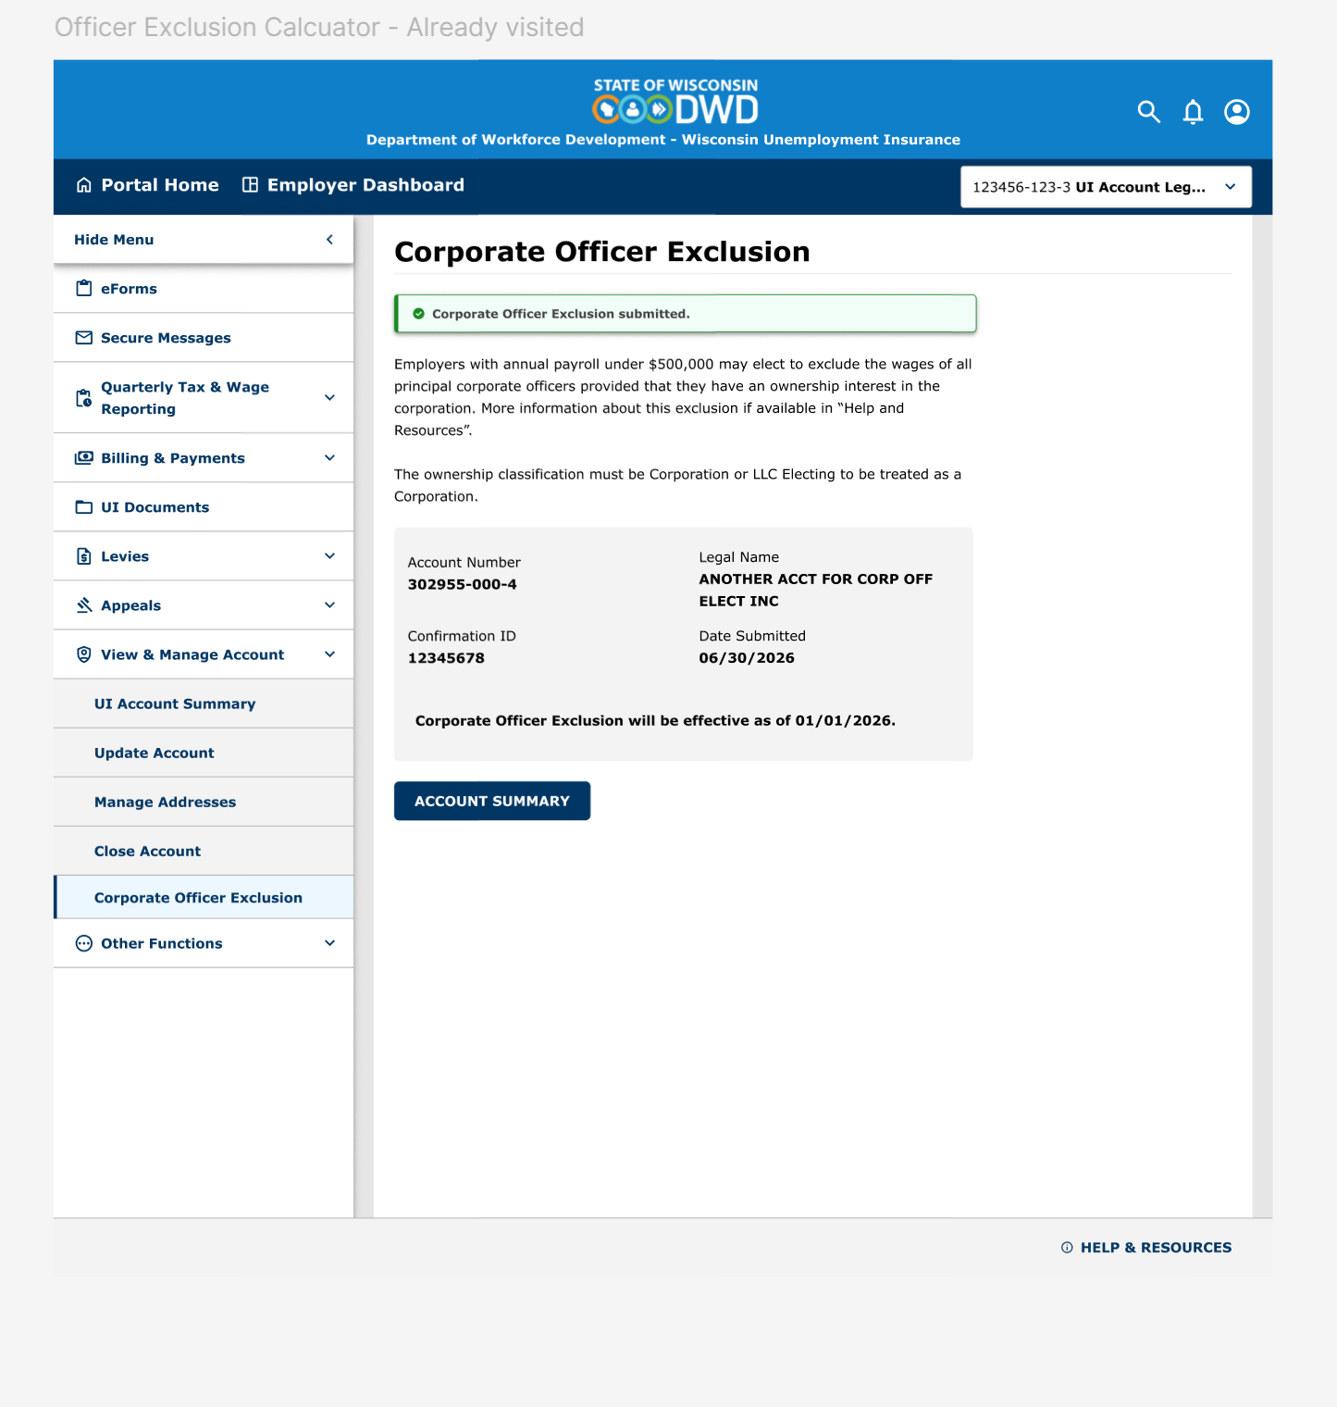
Figma — Officer Exclusion Calculator -Already visited.png

STEP 8 — Eligibility reject (optional)
Goal: Backend rule violations display clearly
Account: Ineligible (deadline / ≥$500k) e.g. VANDERLOOP
Reproduce steps:
1. Intro → NEXT → Calculate → Submit
Expected result:
- Alert shows deadline and/or $500,000 payroll messages
Pass / Fail: ☐ Pass ☐ Fail
Screen reference (actual / demo capture):
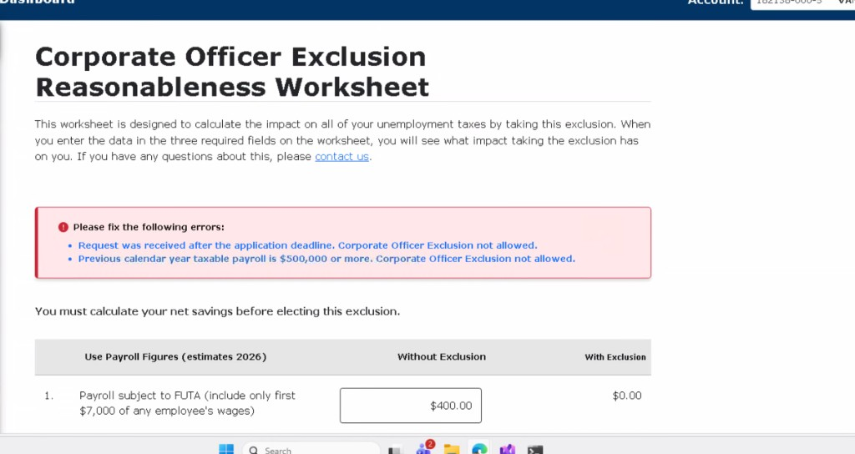
Eligibility rejected — deadline and payroll rules

STEP 9 — Submit failed banner (if forceable)
Goal: Unexpected save failure messaging
Account: Dev-only / N/A in UAT if not practical
Reproduce steps:
1. Force save exception if possible; otherwise mark N/A
Expected result:
- Banner: “Worksheet failed to submit. Please try again.”
Pass / Fail: ☐ Pass ☐ Fail
Figma reference:
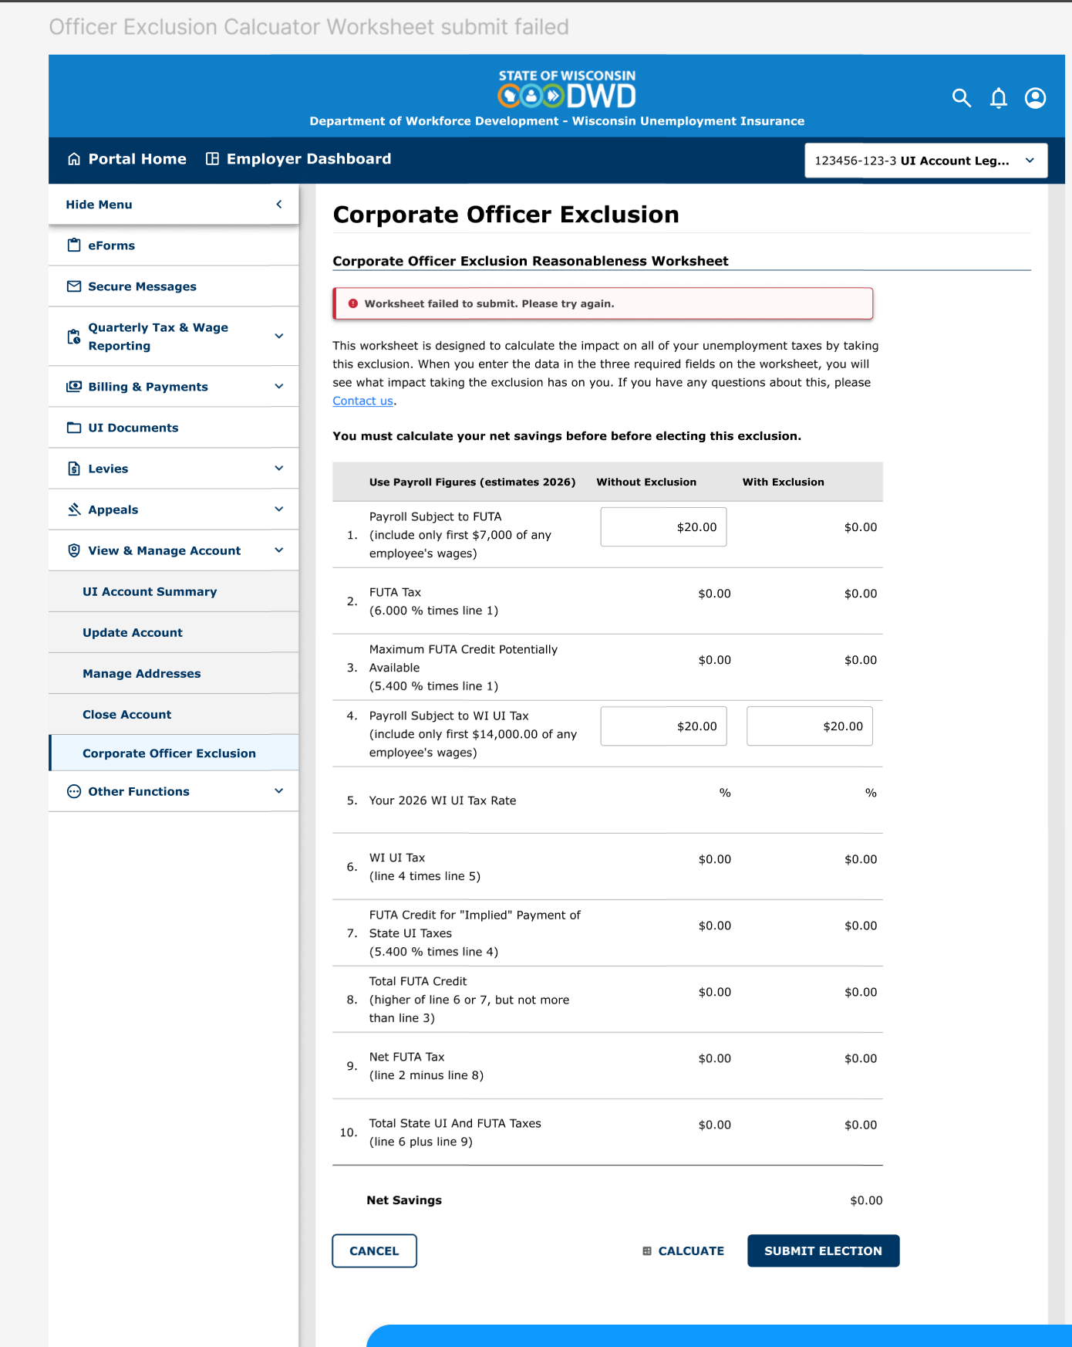
Figma — Officer Exclusion Calculate Worksheet submit failed.png

6. Ticket acceptance mapping
Ticket note | Demo step
Nothing after successful submit | Step 6A
Can Submit again on same page | Steps 6A + 7
No COE effective date | Steps 1, 6A, 7
No Account Summary navigation | Step 6D
No intro screen | Step 1
Already-elected messaging | Step 7
Account Summary (not Complete) | Step 6D
View / mail Initial Determination | Steps 6A + 6C (UI)

7. Out of scope
- Dual already-in-effect + suspended errors → UIEP-3750 (backend)
- Confirmation ID exact contract vs CorporateOfficerExclusionSK → Mendota/product
- Actual mail send of ID letter → backend/product

8. Demo talking points (2 minutes)
- Before: Submit did nothing → employer could retry and get confusing errors
- Now: Intro → Calculate required → clear banners
- Success: green confirmation + letter links + Account Summary
- Revisit: already-elected card — no second Submit on worksheet

9. Sign-off
Role | Name | Date | Result
Developer |  |  | ☐ Pass ☐ Fail
QA / UAT |  |  | ☐ Pass ☐ Fail
Product (optional) |  |  | ☐ Pass ☐ Fail

Notes / defects found during demo:
________________________________________________________________________________
________________________________________________________________________________

