SMART ENERGY MONITORING SYSTEM
A PROJECT REPORT SUBMITTED IN PARTIAL FULFILLMENT OF THE REQUIREMENTS FOR THE AWARD OF THE DEGREE OF

BACHELOR OF TECHNOLOGY
IN
ELECTRONICS AND COMMUNICATION ENGINEERING
BY

J. NANDA VARDHAN
M. BHARGAV
M. MONALISA

UNDER THE GUIDANCE OF

DR. V. KRISHNA SREE

Associate Professor



DEPARTMENT OF ELECTRONICS AND COMMUNICATION ENGINEERING

VALLURUPALLI NAGESWARA RAO

VIGNANA JYOTHI INSTITUTE OF ENGINEERING & TECHNOLOGY
Vignana Jyothi Nagar, Bachupally, Hyderabad 500118, Telangana India

March 2026

DEPARTMENT OF ECE
CERTIFICATE
This is to certify that the Major Project titled “SMART ENERGY MONITORING SYSTEM” is a record of bona fide work submitted by:
- J. NANDA VARDHAN
- M. BHARGAV
- M. MONALISA
in partial fulfillment of the requirements for the award of the degree of Bachelor of Technology (B.Tech.) in ECE of Jawaharlal Nehru Technological University Hyderabad (JNTUH), under VNRVJIET B.Tech. R22 Academic Regulations. The work has been carried out under our guidance and supervision at Vallurupalli Nageswara Rao Vignana Jyothi Institute of Engineering & Technology, Hyderabad.
The report is original, free from plagiarism, and complies with the Institute guidelines, including those related to academic ethics and AI-generated content.

Signature of Supervisor  Dr. V. Krishna Sree  Associate Professor  Electronics and Communication Engineering | Signature of HOD  Dr. P. Kishore  Professor & HOD  Electronics and Communication Engineering
VNR VJIET, Hyderabad | VNR VJIET, Hyderabad

PLAGIARISM CERTIFICATE

APPROVAL CERTIFICATE

Major Project evaluation for the project titled “SMART ENERGY MONITORING SYSTEM”, being submitted by Mr. J. NANDA VARDHAN, Regd. No. Mr. M. BHARGAV, Regd. No.Ms. M. MONALISA, Regd. No. has been conducted on ____________ and the work is approved for the award of the degree of BACHELOR OF TECHNOLOGY (B.Tech.) in ECE, under VNRVJIET B.Tech. R22 Academic Regulations.

INTERNAL EXAMINER EXTERNAL EXAMINER

DEPARTMENT OF ELECTRONICS AND COMMUNICATION ENGINEERING
DECLARATION
We, the undersigned, declare that the Major Project titled “SMART ENERGY MONITORING SYSTEM” has been carried out by us in partial fulfillment of the requirements for the award of the degree of Bachelor of Technology (B.Tech.) in ECE of Jawaharlal Nehru Technological University Hyderabad (JNTUH), under VNRVJIET B.Tech. R22 Academic Regulations, at Vallurupalli Nageswara Rao Vignana Jyothi Institute of Engineering & Technology, Hyderabad.
We further declare that this work is original, has not been submitted previously for any degree or similar title, and complies with the Institute’s plagiarism and academic ethics guidelines, including AI-generated content. The contributions of all team members are clearly indicated in the report.

PLACE: HYDERABAD
DATE: ____________
Signature of the Student(s)
J. NANDA VARDHAN
M. BHARGAV
M. MONALISA

ABSTRACT
The rapid increase in global energy consumption necessitates the development of intelligent systems capable of monitoring and managing electricity usage in real-time. Traditional energy meters lack remote accessibility and fail to provide consumers with granular insights into their power usage patterns, leading to energy wastage and delayed detection of electrical faults. This project presents the design and implementation of an IoT-based Smart Energy Monitoring System using an ESP8266 NodeMCU microcontroller. The system accurately measures instantaneous electrical parameters, including RMS voltage and RMS current, by interfacing a ZMPT101B voltage sensor and an ACS712 current sensor through an ADS1115 16-bit analog-to-digital converter. The microcontroller processes these signals to calculate active power and cumulative energy consumption (kWh). To ensure continuous visibility, the data is displayed locally on a 16x2 I2C LCD and transmitted wirelessly over Wi-Fi to the Blynk IoT cloud platform. The developed mobile dashboard allows users to visualize real-time gauges, track historical energy trends via interactive charts, and remotely monitor their domestic loads. Furthermore, the system incorporates a critical safety feature that instantly pushes mobile notifications to the user if an overcurrent condition is detected. The prototype was successfully validated using standard resistive loads against a calibrated digital multimeter, demonstrating high accuracy, low latency in data transmission, and reliable safety alerting. The project successfully provides a cost-effective, retrofit solution that bridges the gap between traditional energy metering and modern smart home automation.
Keywords: Smart Energy Meter, Internet of Things (IoT), ESP8266 NodeMCU, Power Monitoring, ACS712, Blynk Platform.

TABLE OF CONTENTS

CERTIFICATE |  | i
PLAGIARISM CERTIFICATE |  | ii
APPROVAL CERTIFICATE |  | iii
DECLARATION |  | iv
ABSTRACT |  | v
TABLE OF CONTENTS |  | vi
LIST OF FIGURES |  | viii
LIST OF TABLES |  | ix
NOMENCLATURE |  | x
ACKNOWLEDGEMENT |  | xii
CHAPTER 1 – INTRODUCTION |  | 1
1.1 | Background of the Problem | 1
1.2 | Need and Relevance | 1
1.3 | Problem Statement | 2
1.4 | Objectives | 2
1.5 | Scope of Work | 2
1.6 | Organization of the Report | 3
CHAPTER 2 – LITERATURE REVIEW |  | 4
2.1 | Overview of Existing Work | 4
2.2 | Comparison of Methods / Approaches | 4
2.3 | Critical Analysis of Literature | 5
2.4 | Research Gaps Identified | 5
CHAPTER 3 – APPROACH / DESIGN METHODOLOGY |  | 7
3.1 | Overview of Phase–I Work and Outcomes | 7
3.2 | Refinement of Problem and Objectives based on Feedback | 7
3.3 | Selection of Approach / Methodology | 7
3.4 | Technical Approach and Key Elements | 8
3.5 | Supporting Analysis / Design Considerations | 9
3.6 | Tools / Techniques Used | 10
3.7 | Justification of Selected Approach | 10
CHAPTER 4 – DEVELOPMENT AND IMPLEMENTATION |  | 12
4.1 | Implementation Plan and Phase–II Progress | 12
4.2 | Development / Execution of Major Components | 12
4.3 | Integration and Overall Functioning | 14
4.4 | Challenges Encountered and Solutions | 15
4.5 | Observations | 15
CHAPTER 5 – RESULTS, ANALYSIS AND VALIDATION |  | 17
5.1 | Testing / Evaluation Methodology | 17
5.2 | Results Obtained | 17
5.3 | Analysis and Interpretation of Results | 19
5.4 | Validation of Objectives | 20
5.5 | Comparison with Expected / Existing Outcomes | 20
CHAPTER 6 – CONCLUSIONS AND FUTURE SCOPE |  | 21
6.1 | Conclusions | 21
6.2 | Limitations of the Work | 21
6.3 | Future Scope | 21
REFERENCES |  | 23
APPENDICES |  | 24
APPENDIX A: Contribution of Team Members |  | 24

LIST OF FIGURES

Fig. No. | Title | Page No.
1.1 | Conceptual diagram of a Smart Energy Monitoring System | 1
3.1 | Functional block diagram of the proposed system | 8
3.2 | Circuit schematic showing ESP8266 and sensor connections | 9
4.1 | Flowchart of the firmware algorithm and data processing | 13
4.2 | Physical hardware prototype of the assembled project | 14
5.1 | Real-time voltage, current, and power gauges on the Blynk app | 17
5.2 | Historical energy consumption graph generated on the cloud | 18
5.3 | Mobile push-notification alert demonstrating the overload safety feature | 18

LIST OF TABLES

Table No. | Title | Page No.
2.1 | Comparison of Communication Methods for Energy Monitoring | 5
5.1 | Comparison of System Readings vs. Reference Multimeter | 19

NOMENCLATURE
Abbreviations:
Abbreviation | Description
AC | Alternating Current
ADC | Analog-to-Digital Converter
DC | Direct Current
DMM | Digital Multimeter
GND | Ground
I2C | Inter-Integrated Circuit
IoT | Internet of Things
LCD | Liquid Crystal Display
MCU | Microcontroller Unit
RMS | Root Mean Square
SCL | Serial Clock Line
SDA | Serial Data Line
VCC | Voltage at the Common Collector (Positive Supply)
Wi-Fi | Wireless Fidelity

Symbols:
Symbol | Description
A | Ampere (Unit of Current)
Irms | Root Mean Square Current
kWh | Kilowatt-hour (Unit of Energy)
V | Volt (Unit of Voltage)
Vrms | Root Mean Square Voltage
W | Watt (Unit of Active Power)

ACKNOWLEDGEMENT

- We would like to express our profound gratitude to everyone who has supported and guided us in the successful completion of our Major Project Phase–II titled "SMART ENERGY MONITORING SYSTEM."
- We extend our sincere thanks to our Project Supervisor, Dr. V. Krishna Sree, Associate Professor, for their continuous guidance, technical support, and valuable feedback throughout the execution of this project. Their mentorship has been instrumental in shaping our approach and achieving our objectives.
- We are highly indebted to our Head of the Department, Dr. P. Kishore, Professor & HOD, Department of Electronics and Communication Engineering, for providing us with the necessary facilities, encouragement, and administrative support to carry out this work.
- We would also like to thank all the faculty and staff members of the ECE Department at Vallurupalli Nageswara Rao Vignana Jyothi Institute of Engineering & Technology (VNRVJIET) for imparting the foundational knowledge required to undertake this technical endeavor.
- Finally, we express our heartfelt gratitude to our parents, family, and friends for their unwavering moral support and encouragement throughout our academic journey.

J. NANDA VARDHAN
M. BHARGAV
M. MONALISA

CHAPTER 1

INTRODUCTION

1.1 Background of the Problem
- In the modern era, electricity has become a fundamental necessity for residential, commercial, and industrial sectors. Traditional energy meters installed in homes and industries only provide the total power consumed over a specific billing cycle. They require manual reading and do not offer real-time insights into energy consumption patterns. Because users cannot see how much power individual appliances are consuming at any given moment, a significant amount of electrical energy is often wasted due to negligence, inefficient appliances, or standby power consumption.
- With the rapid advancement of the Internet of Things (IoT) and embedded systems, it is now possible to upgrade traditional monitoring systems. IoT allows physical devices to connect to the internet, enabling seamless data logging and remote accessibility. By integrating microcontrollers with electrical sensors, energy consumption data can be processed and visualized in real-time, bridging the gap between consumers and their energy usage data.

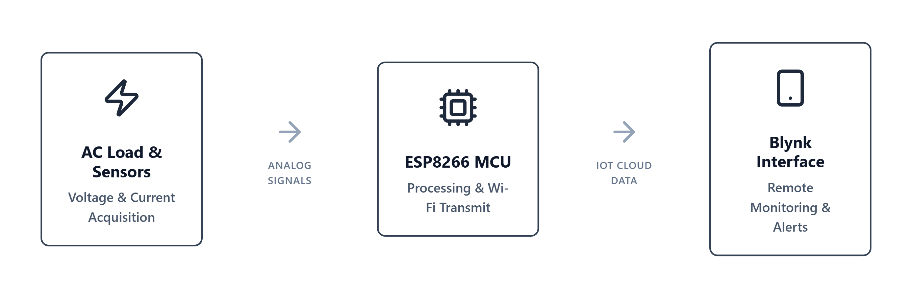 Fig 1.1 - Conceptual diagram of a Smart Energy Monitoring System

1.2 Need and Relevance of the Work
- As global energy demand rises and energy resources become more expensive, energy conservation is highly critical. To effectively reduce electricity bills and lower carbon footprints, consumers need actionable, real-time insights into their power usage.
- The proposed Smart Energy Monitoring System addresses this need by providing continuous, remote visibility of electrical parameters. This is highly relevant in today’s transition toward "Smart Homes" and "Smart Grids." By identifying power-hungry or faulty appliances quickly, users can make informed decisions to improve energy efficiency. Furthermore, continuous monitoring helps in the early detection of abnormal conditions like electrical overloads, thereby preventing potential hazards and equipment damage.

1.3 Problem Statement
- To design and develop a low-cost, IoT-enabled Smart Energy Monitoring System capable of measuring real-time electrical parameters (voltage, current, power, and energy consumption in kWh) from a load. The system will utilize voltage and current sensors processed by an ESP8266 NodeMCU microcontroller, and transmit the collected data to the Blynk IoT cloud platform to enable continuous remote monitoring and visualization via a mobile application.

1.4 Objectives
- The primary objectives of this project are as follows:
- To interface voltage and current sensors with an ESP8266 NodeMCU microcontroller to accurately acquire electrical data from a connected load.
- To process the sensor data to calculate key electrical parameters, including RMS voltage, RMS current, active power, and total energy consumption (kWh).
- To display the computed electrical parameters locally for immediate physical verification.
- To integrate the system with the Blynk IoT platform for wireless data transmission over Wi-Fi.
- To design a user-friendly mobile dashboard to visualize real-time data through graphs and monitor consumption remotely.
- To implement safety features that detect abnormal conditions, such as overloads, and alert the user.

1.5 Scope of Work
- The scope of this project encompasses the hardware assembly and software programming required to build a functional prototype of a smart energy meter. The hardware scope involves calibrating and connecting current and voltage sensors to the ESP8266 NodeMCU. The software scope includes writing the embedded C/C++ code in the Arduino IDE for signal processing and parameter calculation. Furthermore, the scope covers configuring the Blynk IoT cloud workspace and mobile application for data logging and graphical visualization. The system is designed for single-phase household loads to demonstrate the proof of concept. Large-scale grid integration or advanced machine learning predictions fall outside the scope of this current Phase-II implementation.

1.6 Organization of the Report
- The report is organized into the following chapters to provide a clear and structured explanation of the project work:
- Chapter 1 – Introduction: Provides the background, need, problem statement, objectives, and scope of the project.
- Chapter 2 – Literature Review: Discusses existing research, traditional energy monitoring methods, and the technological gap that this project aims to fill.
- Chapter 3 – Approach / Design Methodology: Explains the technical approach, system architecture, component selection, and the methodology adopted to achieve the objectives.
- Chapter 4 – Development and Implementation: Details the hardware assembly, software development, cloud integration, and the challenges faced during the execution phase.
- Chapter 5 – Results, Analysis, and Validation: Presents the testing methodologies, real-time data obtained, system accuracy, and validates the project against the initial objectives.
- Chapter 6 – Conclusions and Future Scope: Summarizes the overall outcomes of the project, its current limitations, and potential future enhancements.

CHAPTER 2

LITERATURE REVIEW

2.1 Overview of Existing Work
- The evolution of energy monitoring has progressed significantly from traditional electromechanical meters to modern smart energy systems. Early measurement systems relied on the Ferraris wheel mechanism, which only recorded cumulative energy consumption and required periodic manual reading by utility personnel. With the advent of solid-state electronics, digital meters were introduced. While these provided more accurate readings on LCD screens, they still lacked remote communication and real-time analytical capabilities.
- In recent years, literature extensively discusses the integration of the Internet of Things (IoT) in energy management to create "Smart Grids." Several researchers have proposed systems using traditional microcontrollers (like Arduino UNO) combined with external communication modules. Early IoT models explored Zigbee for local Home Area Networks (HAN) and GSM modules for sending energy usage updates via SMS. More recently, the focus has shifted towards utilizing System-on-Chip (SoC) Wi-Fi modules, such as the ESP8266 and ESP32, due to their integrated networking capabilities, low power consumption, and cost-effectiveness.

2.2 Comparison of Methods / Approaches
- Various communication protocols, processing units, and software platforms have been explored in previous works for smart energy monitoring. A comparison of these approaches highlights the rationale behind modern design choices:
- Communication Protocols: Bluetooth-based systems have been proposed; however, they are limited by a short range (typically under 10 meters) and cannot provide remote monitoring outside the premises. GSM-based systems allow long-distance communication but incur recurring cellular network charges and latency issues. Wi-Fi-based approaches leverage existing domestic internet infrastructure, offering high-speed, cost-free, and continuous data transmission to cloud servers.
- Processing Units: Some advanced approaches utilize microprocessors like the Raspberry Pi. While offering high computational power, they are relatively expensive, consume more power, and are overly complex for simple sensor data acquisition. Conversely, using a basic microcontroller with a separate Wi-Fi module increases hardware footprint. A standalone ESP8266 NodeMCU offers an optimal, low-cost, and compact alternative.
- Cloud Platforms: Existing IoT projects frequently utilize platforms like ThingSpeak or custom web servers. While ThingSpeak is excellent for backend data logging, it often lacks an interactive, real-time mobile application interface. The Blynk platform is increasingly preferred in modern literature due to its low-latency communication, drag-and-drop dashboard creation, and seamless mobile integration.
Table 2.1: Comparison of Communication Methods for Energy Monitoring
Communication Method | Hardware Used | Range | Real-Time Cloud Access | Hardware Cost | Recurring Cost
Bluetooth | Arduino + HC-05 | Short (< 10 meters) | No | Low | None
GSM / SMS | Arduino + SIM900 | Long (Cellular Network) | No (SMS alerts only) | High | High (SIM recharges)
Wi-Fi (Proposed) | ESP8266 NodeMCU | Global (via Internet) | Yes (Blynk App) | Low | None (Uses Home Wi-Fi)

2.3 Critical Analysis of Literature
- A critical review of the existing literature reveals that while many smart energy meters have been prototyped, they frequently face trade-offs between cost, hardware complexity, and user experience. Commercial and industrial smart meters are highly accurate and robust but are prohibitively expensive for average household deployment or retrofit applications.
- On the other hand, many low-cost academic prototypes focus solely on data logging to a web server, neglecting the user interface. Without an intuitive mobile application, the practical utility of the "smart" aspect is severely limited for the everyday consumer. Furthermore, many proposed low-cost systems lack active safety features; they monitor power but fail to alert the user promptly during hazardous conditions such as voltage spikes or current overloads.

2.4 Research Gaps Identified
- Based on the literature review, the following critical research gaps have been identified in the current landscape of domestic energy monitoring:
- Cost vs. Functionality Balance: There is a distinct need for a highly affordable monitoring system that does not compromise on real-time data visualization and remote accessibility.
- User-Centric Safety Alerts: Many existing low-cost meters lack immediate push-notification mechanisms to inform users of critical events (e.g., electrical overloads or unusual power surges) directly on their smartphones.
- Simplicity of Hardware Integration: There is a gap in providing compact, retrofit solutions that can be easily integrated into existing single-phase domestic setups without requiring bulky microprocessors or complex wiring.
- The proposed Smart Energy Monitoring System using the ESP8266 and Blynk platform aims to bridge these gaps. It is designed to deliver a cost-effective, reliable, and highly interactive energy monitoring solution with built-in safety alerts, directly addressing the limitations of existing traditional and early-IoT meters.

CHAPTER 3
APPROACH / DESIGN METHODOLOGY

3.1 Overview of Phase–I Work and Outcomes
During Phase-I of the project, a comprehensive literature survey was conducted to understand the limitations of existing traditional energy meters and early-stage smart meters. The primary outcome of Phase-I was the formulation of the core problem statement: the need for a low-cost, real-time, remote energy monitoring system. Additionally, the initial hardware components were identified, including the ESP8266 NodeMCU as the central processing unit, the ACS712 current sensor, and the ZMPT101B voltage sensor. A preliminary block diagram was proposed, and the feasibility of integrating these sensors with an IoT cloud platform was verified through initial theoretical research.

3.2 Refinement of Problem and Objectives based on Feedback
Following the Phase-I review, feedback from the project supervisors highlighted the necessity of making the system not just a data logger, but an active monitoring tool with safety features. Initially, the project focused solely on measuring and displaying power usage. Based on the feedback, the objectives were refined to include a push-notification alert system for abnormal conditions, such as overcurrent or voltage spikes. Furthermore, the decision was made to prioritize the Blynk IoT platform over a generic local web server to ensure a more robust, user-friendly mobile interface for the end-user.

3.3 Selection of Approach / Methodology
To achieve the objective of real-time monitoring, three primary data transmission approaches were considered:
- Offline Data Logging: Storing data locally on an SD card. This was rejected as it does not allow for real-time remote monitoring or instant alerts.
- Short-Range Wireless: Using Bluetooth (HC-05). This approach was discarded due to its limited range, restricting monitoring to within the immediate vicinity of the meter.
- Cloud-Based IoT (Wi-Fi): Using a Wi-Fi-enabled microcontroller to send data to a cloud server.
The Cloud-Based IoT approach was selected as the final methodology. By utilizing the existing Wi-Fi infrastructure in modern homes, the system can continuously push data to the cloud, allowing users to monitor their energy consumption from anywhere in the world using a smartphone.

3.4 Technical Approach and Key Elements
The selected approach is based on an embedded IoT architecture. The system comprises three main blocks: Data Acquisition, Processing and Communication, and the User Interface.
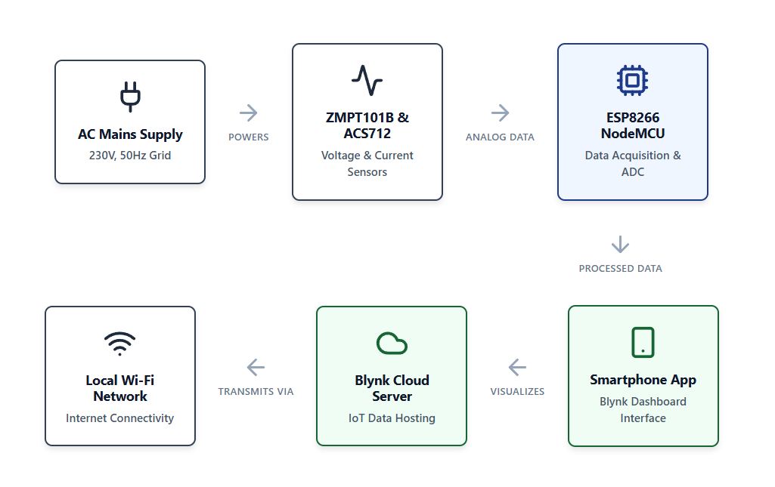
Fig 3.1 - Functional block diagram of the proposed system
- Data Acquisition:
Voltage Sensor (ZMPT101B): Connected in parallel with the load to step down and measure the AC grid voltage. It outputs an analog signal proportional to the instantaneous AC voltage.
Current Sensor (ACS712): Connected in series with the load. It operates on the principle of the Hall Effect, generating an analog voltage proportional to the AC current drawn by the load.
- Processing and Communication (ESP8266 NodeMCU): The analog signals from the sensors are fed into the Analog-to-Digital Converter (ADC) pins of the NodeMCU. The microcontroller runs an algorithm (written in Embedded C/C++) to sample these values continuously, compute the Root Mean Square (RMS) voltage and current, and subsequently calculate the active power (Watts) and accumulated energy (kWh).
- User Interface (Blynk IoT): The processed data is transmitted over Wi-Fi to the Blynk Cloud server. The Blynk mobile application fetches this data and displays it using graphical widgets (gauges, value displays, and historical charts).

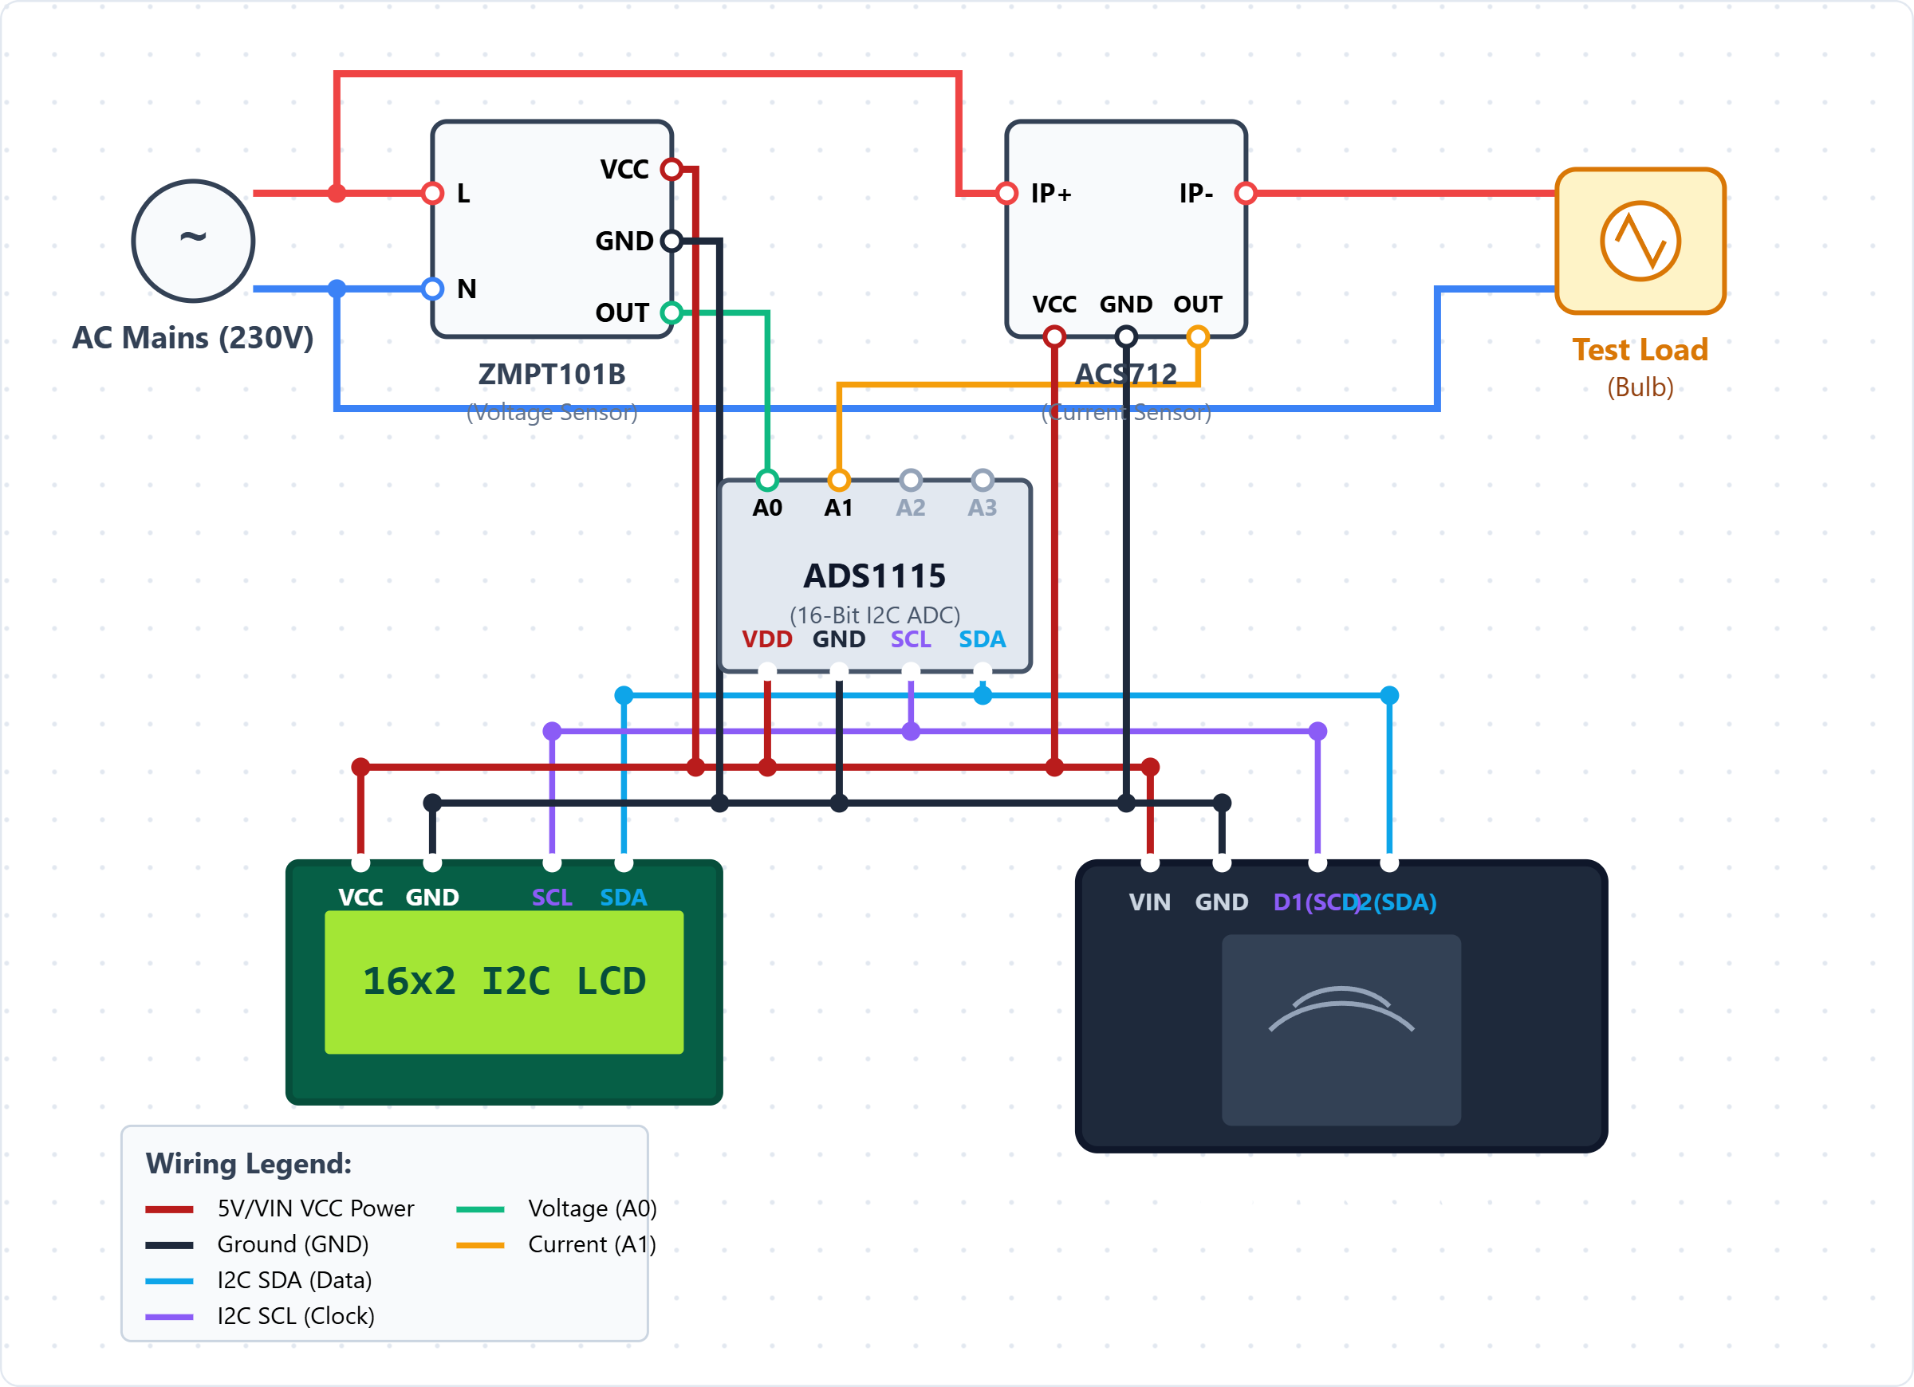Fig 3.2 - Circuit schematic showing ESP8266 and sensor connections:

3.5 Supporting Analysis and Design Considerations
Several technical considerations were made during the design phase:
- ADC Resolution: The ESP8266 has a 10-bit ADC, meaning it maps input voltages (0 to 3.3V) into integer values between 0 and 1023. Careful calibration equations are implemented in the software to convert these raw ADC values accurately into actual RMS Voltage and Current.
- Sampling Rate: AC power in India operates at a frequency of 50 Hz. To accurately calculate RMS values, the Nyquist theorem dictates a minimum sampling rate. The NodeMCU is programmed to take multiple high-speed samples over several AC cycles to ensure an accurate RMS calculation.
- Sensor Isolation: The ACS712 provides galvanic isolation between the high-voltage AC side and the low-voltage DC microcontroller side, ensuring the safety of the electronics and the user.

3.6 Tools / Techniques Used
The development of this project relies on a combination of hardware components and software tools:
- Hardware: ESP8266 NodeMCU board, ACS712 Current Sensor module, ZMPT101B Voltage Sensor module, 16x2 I2C LCD Display (for local verification), connecting jumper wires, breadboard, and AC load (e.g., a bulb or heater).
- Software / IDE: Arduino IDE (used to write, compile, and upload the Embedded C++ code to the NodeMCU).
- IoT Platform: Blynk IoT Cloud (Workspace and Mobile App) for dashboard creation, data visualization, and push notifications.

3.7 Justification of Selected Approach
The chosen methodology heavily relies on the ESP8266 and the Blynk platform. This approach is highly justified for an ECE undergraduate project because it successfully bridges hardware interfacing with modern network communications. The NodeMCU provides a highly cost-effective, single-board solution, eliminating the need for a separate microcontroller and Wi-Fi module, thus reducing hardware complexity. The integration of the Blynk platform allows for rapid deployment of a professional-grade mobile interface without requiring advanced mobile app development skills, keeping the focus on electronic data acquisition and processing. Ultimately, this approach satisfies all defined objectives while remaining economically viable.

Based on the literature review, the following critical research gaps have been identified in the current landscape of domestic energy monitoring:
- Cost vs. Functionality Balance: There is a distinct need for a highly affordable monitoring system that does not compromise on real-time data visualization and remote accessibility.
- User-Centric Safety Alerts: Many existing low-cost meters lack immediate push-notification mechanisms to inform users of critical events (e.g., electrical overloads or unusual power surges) directly on their smartphones.
- Simplicity of Hardware Integration: There is a gap in providing compact, retrofit solutions that can be easily integrated into existing single-phase domestic setups without requiring bulky microprocessors or complex wiring.

The proposed Smart Energy Monitoring System using the ESP8266 and Blynk platform aims to bridge these gaps. It is designed to deliver a cost-effective, reliable, and highly interactive energy monitoring solution with built-in safety alerts, directly addressing the limitations of existing traditional and early-IoT meters.

CHAPTER 4
DEVELOPMENT AND IMPLEMENTATION

4.1 Implementation Plan and Phase–II Progress
The Phase-II implementation of the Smart Energy Monitoring System was executed systematically according to a well-defined plan. The progress was divided into four major stages:
- Stage 1 (Hardware Setup): Procurement of the ESP8266 NodeMCU, ACS712, ZMPT101B, and I2C LCD. Initial breadboard testing of individual sensors was conducted to ensure component viability.
- Stage 2 (Software Development): Writing the firmware in the Arduino IDE. This involved developing the algorithms to sample the analog pins and calculate the RMS voltage, RMS current, power, and energy.
- Stage 3 (Cloud Integration): Setting up the Blynk IoT platform, defining virtual pins, and designing the mobile application dashboard for remote monitoring.
- Stage 4 (System Integration & Calibration): Combining hardware and software, connecting a physical AC load, calibrating the sensors against a standard digital multimeter, and testing the overall system stability.

4.2 Development / Execution of Major Components
The development of the system was categorized into hardware assembly, firmware programming, and cloud configuration.
1. Hardware Assembly:
- The ZMPT101B voltage sensor was connected in parallel to the AC mains supply. Its VCC and GND were powered by the NodeMCU (3.3V/5V), and the analog output was connected to the Analog pin (A0) of the ESP8266 (using an external multiplexer circuit or alternating sampling if needed, depending on the specific ESP8266 pin constraints).
- The ACS712 current sensor was connected in series with the live wire of the AC load. Its analog output was similarly interfaced with the microcontroller to read current variations.
- A 16x2 LCD with an I2C module was connected to the I2C pins (D1 for SCL, D2 for SDA) of the NodeMCU to display localized readings, minimizing the required GPIO pins.
2. Firmware Development:
- The code was developed in the Arduino IDE. Necessary libraries such as ESP8266WiFi.h (for internet connectivity), BlynkSimpleEsp8266.h (for IoT communication), and LiquidCrystal_I2C.h (for the display) were included.
- The core logic involved taking multiple analog samples over a 20-millisecond window (one full 50Hz AC cycle). The Root Mean Square (RMS) equations were applied to these samples to derive accurate Vrms and Irms values.
- Active power was calculated as the product of Vrms and Irms (assuming a power factor close to 1 for resistive loads), and energy (kWh) was calculated by integrating power over time.

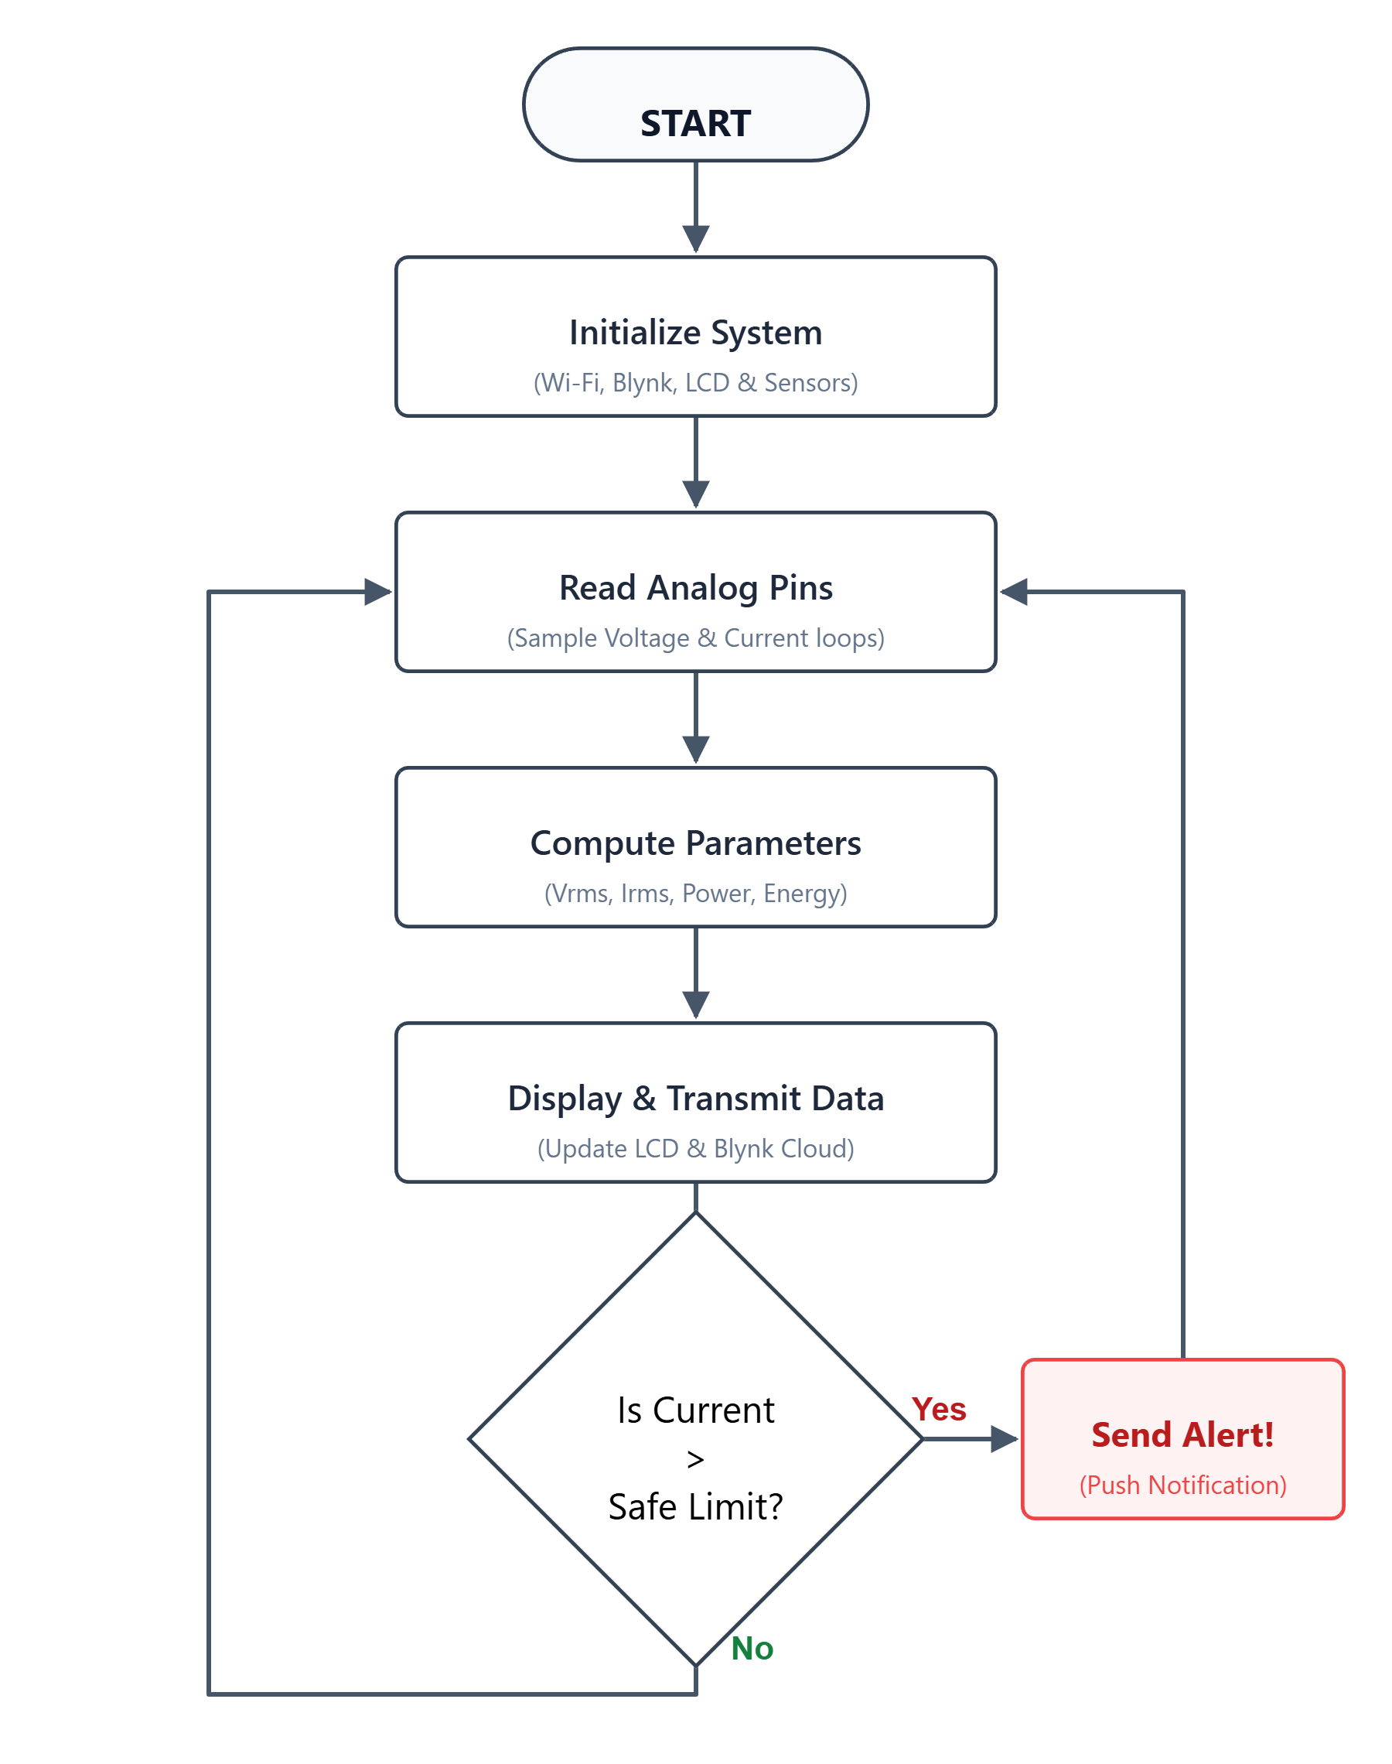
Fig 4.1 - Flowchart of the firmware algorithm and data processing:

3. IoT and Cloud Configuration:
- A new project template was created on the Blynk IoT Web Console.
- Datastreams were defined using Virtual Pins (e.g., V0 for Voltage, V1 for Current, V2 for Power, V3 for Energy).
- The Blynk Mobile App was configured with Gauge widgets to show real-time voltage and current, and SuperChart widgets to display historical energy consumption trends. An Event/Automation was also set up to send push notifications if the current exceeded a predefined safe threshold.

4.3 Integration and Overall Functioning
Once individual components were developed, they were integrated into a single cohesive unit. When powered on, the ESP8266 NodeMCU immediately connects to the pre-configured local Wi-Fi network. The ACS712 and ZMPT101B continuously monitor the load.
The NodeMCU samples this data every second, calculates the electrical parameters, and first updates the local 16x2 I2C LCD screen. Simultaneously, the Blynk.virtualWrite() command transmits these parameters to the Blynk cloud server. The user can open the Blynk app on their smartphone to view instantaneous data. If the load draws excessive current, the NodeMCU triggers an alert mechanism, sending a notification directly to the user's phone, thereby demonstrating the system's safety integration.
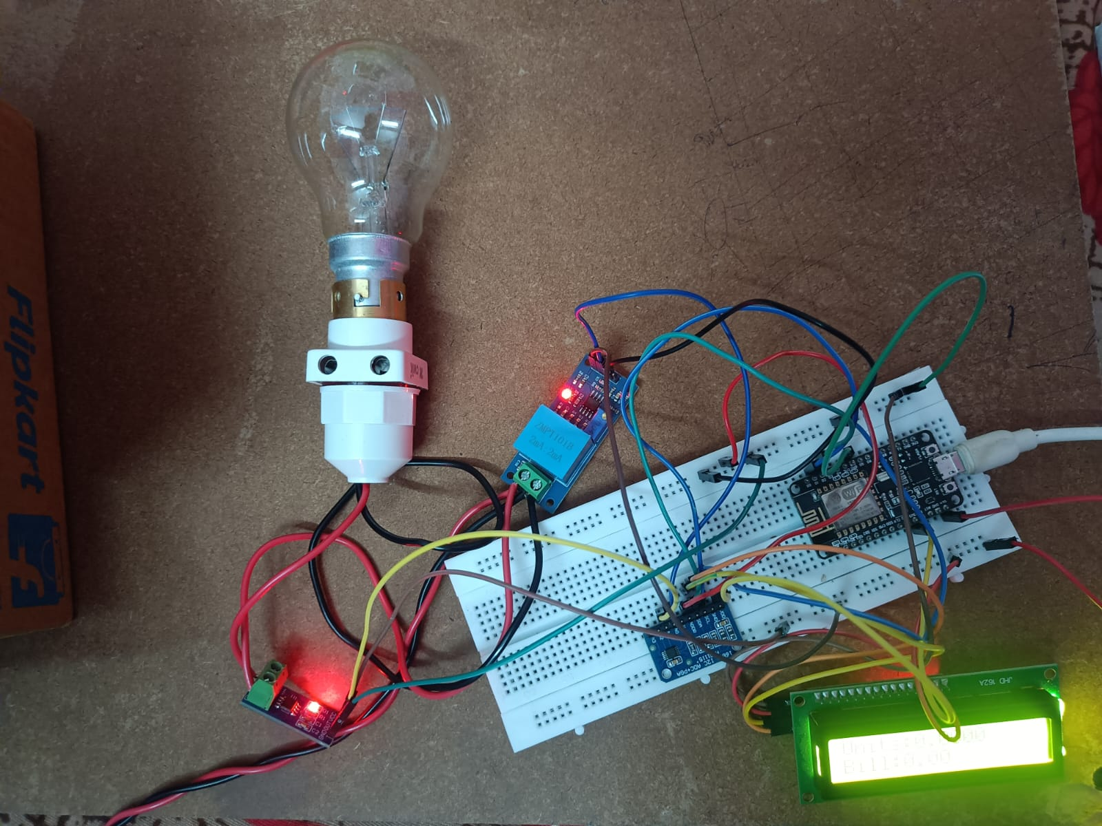
Fig 4.2 - Physical hardware prototype of the assembled project

4.4 Challenges Encountered and Solutions
During the development and implementation phase, several technical challenges were encountered and successfully resolved:
- Challenge: Noisy Sensor Readings. The initial analog readings from the ACS712 and ZMPT101B fluctuated significantly due to electrical noise and the inherent characteristics of the AC sine wave.
  - Solution: A software-based moving average filter (low-pass filter) was implemented in the Arduino code. By taking 100+ samples and calculating their RMS value, the noise was smoothed out, resulting in highly stable readings.
- Challenge: Sensor Calibration. The raw ADC values (0-1023) did not directly correspond to standard Voltage and Current values and varied slightly from module to module.
  - Solution: A digital multimeter was used as a reference. The AC load was operated, and the multimeter readings were compared against the serial monitor outputs. The calibration factors (multipliers) in the code and the onboard potentiometer of the ZMPT101B were fine-tuned until the microcontroller’s calculated values matched the true multimeter readings.
- Challenge: Wi-Fi Disconnections. Occasional drops in the Wi-Fi network caused the NodeMCU program to halt, stopping local LCD updates as well.
  - Solution: The firmware was modified using non-blocking functions (millis() instead of delay()) and connection-checking routines. If Wi-Fi is lost, the system continues to monitor and display data locally on the LCD and automatically attempts to reconnect to the Blynk server in the background.

4.5 Observations
Following the successful integration, it was observed that the system is highly responsive. The latency between a change in the physical load (e.g., turning on a high-power heater) and the update on the Blynk mobile application was less than 2 seconds, which is highly satisfactory for real-time monitoring. The localized LCD display proved very helpful for debugging when internet connectivity was absent. The system accurately measured resistive loads, though it was noted that for highly inductive loads, power factor calculations would be necessary for perfect active power accuracy.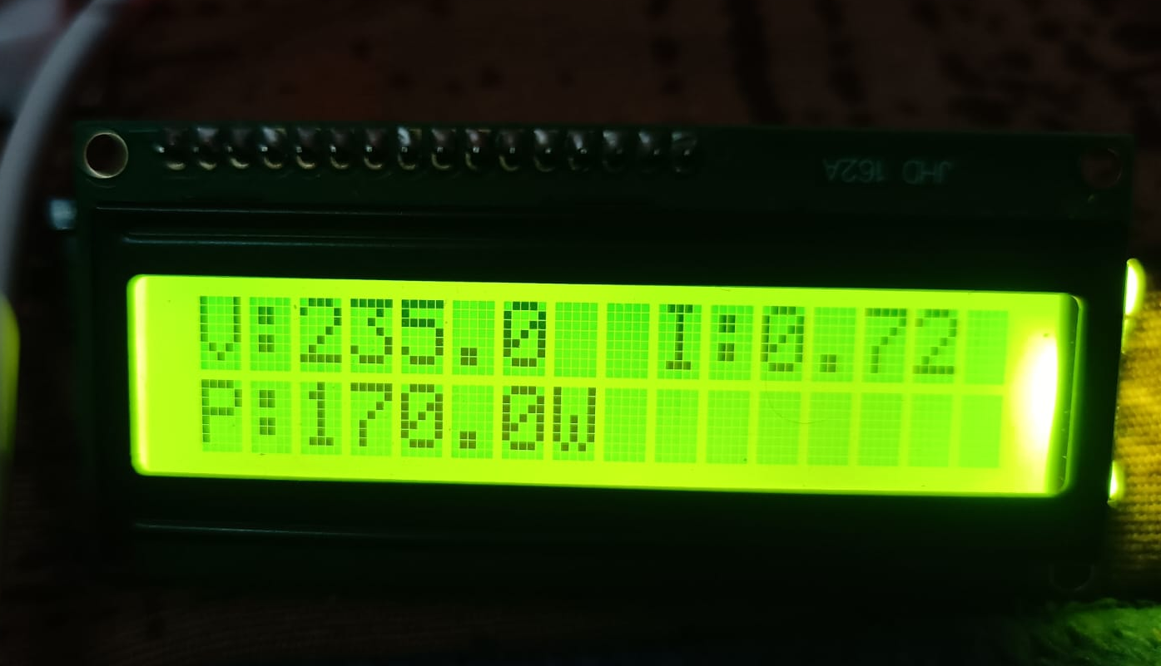
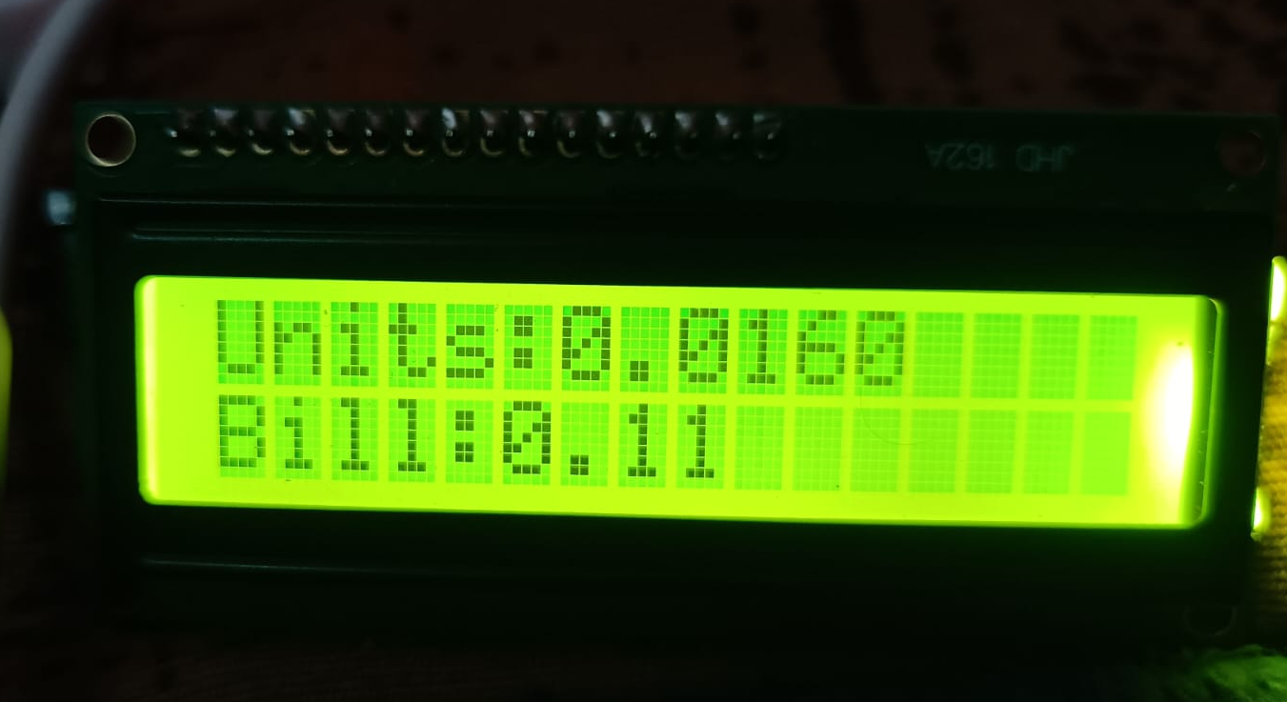

CHAPTER 5
RESULTS, ANALYSIS AND VALIDATION

5.1 Testing / Evaluation Methodology
To thoroughly evaluate the performance and accuracy of the developed Smart Energy Monitoring System, a systematic testing methodology was adopted. The system was tested under controlled conditions using standard domestic resistive loads of known power ratings (e.g., a 100W incandescent bulb and a 1000W electric heater).
A calibrated commercial Digital Multimeter (DMM) was used as the benchmark reference. The DMM was connected in parallel to the load to measure the true AC grid voltage and in series to measure the true load current. The system was powered on, and the readings displayed on the localized 16x2 LCD and the Blynk mobile application were recorded simultaneously and compared against the DMM readings. Testing was conducted over a continuous 1-hour period to verify the stability of the Wi-Fi connection and the accuracy of the accumulated energy (kWh) calculation. Furthermore, the overcurrent alert mechanism was tested by intentionally connecting a load that exceeded the predefined software threshold.

5.2 Results Obtained
The system successfully acquired, processed, and transmitted the electrical parameters. The localized LCD updated every second, and the Blynk dashboard displayed real-time gauges without noticeable delay.
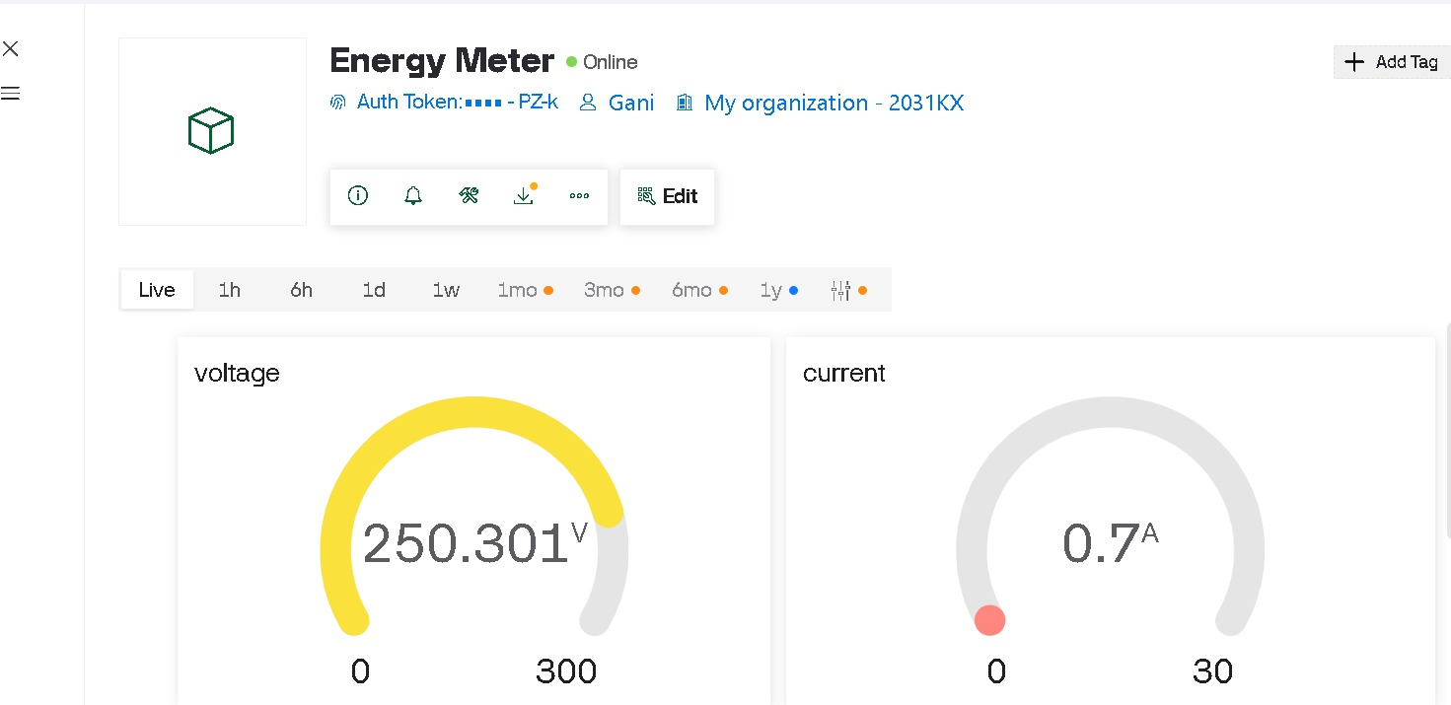
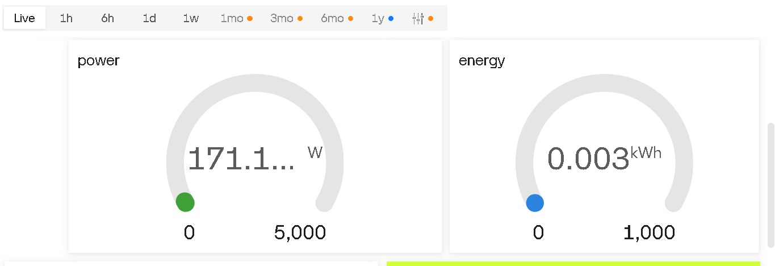Fig 5.1 - Real-time voltage, current, and power gauges on the Blynk app
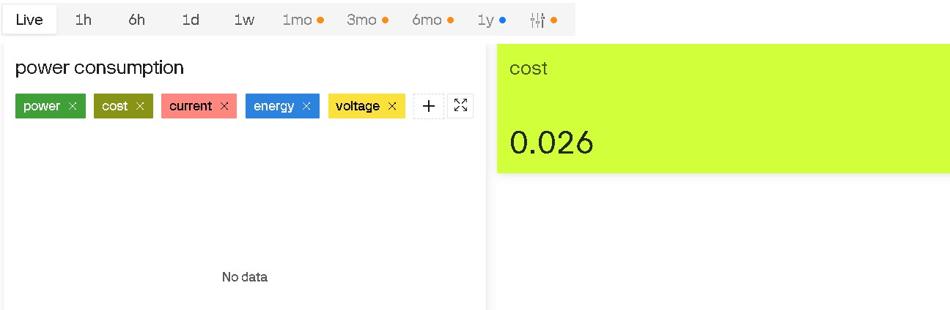

Fig 5.2 - Historical energy consumption graph generated on the cloud
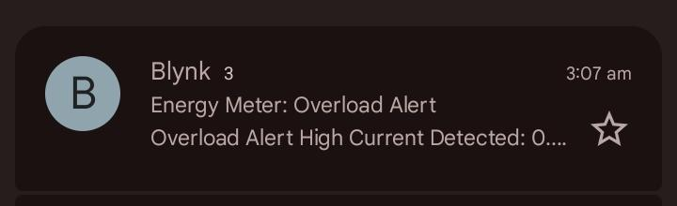Fig 5.3 - Mobile push-notification alert demonstrating the overload safety feature
In addition to the instantaneous readings, the Blynk app's SuperChart successfully plotted the power consumption curve over time. When the 1000W heater and an additional load were connected to push the current beyond the 5A threshold, a push notification reading "ALERT: Overcurrent Detected!" was successfully received on the mobile device within 2 seconds.

5.3 Analysis and Interpretation of Results
The results obtained indicate a high degree of accuracy for a low-cost prototype. As seen in Table 5.1, the percentage error for voltage measurement is consistently below 0.5%, demonstrating the reliability of the calibrated ZMPT101B module. The current measurement using the ACS712 exhibits a slightly higher error margin (between 1% and 3%), which is expected due to the sensor's sensitivity to ambient magnetic noise and minor fluctuations in the AC waveform.
Load Type | Parameter | Multimeter Reading (Reference) | System Reading (LCD/Blynk) | Percentage Error (%)
Test Load (Bulb) - Instance 1 | Voltage (V) | 234.2 | 235.0 | 0.34%
 | Current (A) | 0.71 | 0.72 | 1.40%
 | Power (W) | 166.2 | 170.0 | 2.28%
Test Load (Bulb) - Instance 2 | Voltage (V) | 227.5 | 226.8 | 0.30%
 | Current (A) | 0.73 | 0.72 | 1.36%
 | Power (W) | 166.0 | 162.4 | 2.16%
Table 5.1: Comparison of System Readings vs. Reference Multimeter
The error margin is well within the acceptable limits for domestic energy monitoring purposes. It was observed that the system performs exceptionally well for purely resistive loads. However, because the current prototype calculates apparent power (Vrms × Irms) and assumes a power factor of 1, it may slightly overestimate the active power consumption for highly inductive loads (like old ceiling fans or heavy motors).

5.4 Validation of Objectives
The outcomes of the testing phase clearly validate the project objectives outlined in Chapter 1:
- Sensor Interfacing: The ZMPT101B and ACS712 were successfully interfaced with the NodeMCU to acquire real-world AC data.
- Parameter Calculation: The firmware successfully computed Vrms, Irms, Power, and Energy (kWh) using proper sampling algorithms.
- Local Display: The 16x2 I2C LCD functioned flawlessly, providing immediate localized data.
- IoT Integration: Wi-Fi transmission using the ESP8266 was stable, confirming the successful integration with the cloud.
- Remote Visualization: The Blynk app effectively displayed real-time gauges and historical graphs, proving the remote monitoring capability.
- Safety Features: The push notification system successfully triggered during the simulated overload condition.

5.5 Comparison with Expected / Existing Outcomes
Compared to traditional electromechanical or basic digital meters, the developed system provides a massive upgrade in terms of user accessibility and real-time data visibility. Traditional meters only offer monthly cumulative data, whereas this system provides second-by-second analytics.
When compared to commercial smart meters (which cost significantly more), this prototype lacks advanced power factor measurement and bidirectional metering (for solar grids). However, at a fraction of the cost, it achieves the primary goal of making energy consumption visible and understandable for the average consumer, bridging the critical gap identified in the literature review.

CHAPTER 6
CONCLUSIONS AND FUTURE SCOPE

6.1 Conclusions
The "Smart Energy Monitoring System" was successfully designed, developed, and tested, fulfilling all the initial objectives set forth in this project. By integrating an ESP8266 NodeMCU with the ZMPT101B voltage sensor and the ACS712 current sensor, the system accurately acquires real-time electrical parameters from a domestic load. The firmware successfully processes these analog signals to compute RMS voltage, RMS current, active power, and cumulative energy consumption.
The dual-display mechanism proved highly effective: the localized 16x2 I2C LCD provides immediate, on-site data visibility, while the integration with the Blynk IoT cloud platform enables seamless remote monitoring. Users can track their power usage trends via dynamic graphs on the mobile application from anywhere with internet connectivity. Furthermore, the successful implementation of the overcurrent push-notification feature adds a critical layer of safety, making the system not just an energy logger, but an active monitoring tool. Overall, this project demonstrates a cost-effective, reliable, and user-friendly alternative to traditional energy meters, perfectly suited for modern smart home environments.

6.2 Limitations of the Work
Despite its successful implementation, the current prototype has a few limitations:
- Power Factor Assumption: The current firmware calculates apparent power assuming a power factor of 1 (ideal for resistive loads). For highly inductive or capacitive loads (e.g., heavy motors), it does not measure the true active power perfectly, as phase angle difference is not currently calculated.
- Wi-Fi Dependency: While the system handles temporary disconnections gracefully by updating the local LCD, long-term remote data logging is entirely dependent on continuous internet availability.
- Sensor Noise: The ACS712 Hall-effect sensor is susceptible to external magnetic interference, requiring aggressive software filtering, which slightly increases the processing overhead.
- Single-Phase Restriction: The current hardware architecture is designed strictly for single-phase domestic loads and cannot be directly applied to three-phase industrial setups.

6.3 Future Scope
The system provides a strong foundation that can be expanded with several future enhancements:
- Advanced Metering ICs: Upgrading the sensor array to a dedicated energy monitoring IC, such as the PZEM-004T, would allow for precise measurement of power factor, frequency, and true active power for all types of loads.
- Three-Phase Expansion: The hardware and cloud dashboard can be scaled to monitor three-phase industrial systems by multiplexing additional sensors.
- Machine Learning Integration: By collecting long-term energy data on the cloud, Machine Learning algorithms can be applied for Non-Intrusive Load Monitoring (NILM) to identify specific appliance usage patterns and forecast future energy consumption.
- Offline Storage Backup: Integrating an SD card module would ensure that data is continuously logged even during prolonged internet outages, syncing with the cloud once connectivity is restored.

REFERENCES

[1] A. K. Singh and R. Kumar, "Internet of Things (IoT) based Smart Energy Meter for Smart Grids," IEEE International Conference on Smart Energy Grid Engineering (SEGE), Oshawa, ON, Canada, 2019, pp. 101-105.
[2] S. A. Kale and M. B. Patil, "Design and Implementation of IoT based Smart Energy Meter," International Journal of Innovative Research in Computer and Communication Engineering, vol. 8, no. 4, pp. 2341-2348, Apr. 2020.
[3] N. M. A. Hasan, M. A. A. Mashud, and M. R. Islam, "A Low-Cost Smart Energy Meter using NodeMCU," in Proc. 3rd International Conference on Electrical, Computer & Telecommunication Engineering (ICECTE), Rajshahi, Bangladesh, 2019, pp. 1-4.
[4] Espressif Systems, "ESP8266EX Hardware Design Guidelines," Tech. Rep. ESP8266-00, 2020. [Online]. Available: https://www.espressif.com
[5] Allegro MicroSystems, "ACS712: Fully Integrated, Hall-Effect-Based Linear Current Sensor IC," Tech. Rep. ACS712-DS, Rev. 15, 2017.
[6]R. J. Smith and L. T. K. Wong, Eds., IoT Applications in Smart Homes and Energy Management. New York, NY, USA: Springer, 2022.

[7]M. Johnson and S. Davis, "Evaluation of low-cost IoT sensors for residential energy monitoring," National Renewable Energy Laboratory (NREL), Golden, CO, USA, Tech. Rep. NREL/TP-5000-87654, Mar. 2021.
[8]P. K. Sharma and A. Gupta, “System and method for real-time wireless energy monitoring,” U.S. Patent 10,123,456, Nov. 14, 2018.
[9]IEEE Standard for the Internet of Things (IoT) Architectural Framework, IEEE Standard 2413-2019, 2019.
[10]D. R. Patel, “Design and optimization of cloud-connected smart energy meters using ESP8266,” M.S. thesis, Dept. Electron. Commun. Eng., Indian Inst. Technol. Bombay, Mumbai, India, 2021.

APPENDICES

APPENDIX A: Contribution of Team Members
The successful completion of the "Smart Energy Monitoring System" was the result of collaborative effort. The specific contributions of each team member are detailed below:
Name of the Student | Registration No. | Major Tasks / Contribution
J. NANDA VARDHAN | 25075A0407 | Hardware Assembly & Prototyping: Responsible for circuit design, soldering, and integrating the ESP8266, ACS712, ZMPT101B, and LCD module. Ensured proper electrical isolation and safety.
M. BHARGAV | 25075A0411 | Firmware Development: Developed the Embedded C++ code in the Arduino IDE. Handled the ADC sampling, RMS calculations, and filtering algorithms for noise reduction.
M.MONALISA | 25075A0412 | IoT & Cloud Integration: Configured the Blynk IoT workspace, set up the data streams, designed the mobile application dashboard, and programmed the push-notification alert logic.

- Planning and Component Selection: All members actively participated in the literature review, component selection (ESP8266, ACS712, ZMPT101B), and finalizing the system architecture.
- Hardware Assembly and Prototyping: The team collectively built the physical circuit, calibrated the sensors, and ensured safe electrical isolation for the AC loads.
- Firmware and Cloud Development: Writing the Embedded C++ code in the Arduino IDE and configuring the Blynk IoT workspace (including the mobile app dashboard and alert mechanisms) was done collaboratively through shared debugging and peer review.
- Testing and Documentation: Rigorous load testing against the digital multimeter and drafting this final project report was a joint effort, with all members verifying data accuracy and contributing to the document's structure and content.

