***In the Northeast, Spring Breaks Are Becoming Snow Breaks***

The March 13 winter storm that bombarded Southern New England set new snowfall records in Boston, Worcester, and Providence.

[Maggie Wang](https://github.com/wxiaonanw/storms), March 19, 2018

Colleges in the Northeastern states have begun their Spring breaks one after another, even though Spring has not yet sprung. [The third major nor’easter in March](https://www.washingtonpost.com/news/capital-weather-gang/wp/2018/03/14/tuesdays-blizzard-dumped-as-much-as-2-feet-of-snow-in-eastern-massachusetts/?utm_term=.7741d191a254) hit New England on March 13, dropping nearly 30 inches of snow in Massachusetts alone. Boston’s Logan International Airport tolled an almost 15-inch snow accumulation, causing the [cancellation](http://time.com/5197161/third-noreaster-cripples-boston-airport-forces-hundreds-of-other-flight-cancelations/) of more than 80 percent of its departing flights.

The storm broke single-day snowfall records in Boston and Worcester, Massachusetts that were last set in the 1950s. It also renewed March 13 snowfall records previously held by America’s “[Storm of the Century](https://www.ncei.noaa.gov/news/1993-snow-storm-of-the-century),”[1] which cost the country more than $1 billion in damages when it blasted the East Coast and the South on March 11-14, 1993.

The 1993 storm was registered as Extreme, or a Category 5, based on the Regional Snowfall Index ([RSI](https://www.ncdc.noaa.gov/snow-and-ice/rsi/)) produced by the National Oceanic and Atmospheric Administration ([NOAA](http://www.noaa.gov/)). The indices account for each snowfall’s impact area and population, and are further divided into five categories, with Category 1 representing “Notable” storms and Category 5 denoting “Extreme” snow events.

Although the NOAA has not published the RSI calculation for the most recent storm, one can clearly observe its severity when comparing it to the more recent major [mid-March storm in 2017](https://twitter.com/NWSBoston/status/973922065442115584). With the later rated as a Category 4 Crippling storm, it in total dropped about 15 inches of snow in Worcester, while the most recent nor’easter roared Worcester with nearly 22 inches in a single day.

These storms, along with other winter extremes, serve as the Exhibit A of the bitter fruits of global warming. According to [a study](https://www.nature.com/articles/s41467-018-02992-9#MOESM1) authored by MIT climatologist [Dr. Judah Cohen](http://www.judahcohen.org/) and his colleges, in recent decades, “severe winter weather—including both cold spells and heavy snows—became more frequent in the eastern United States” when the annual Arctic warming trend peaks in mid- to late-winter. Therefore, the counterintuitively brutal winters do not serve as evidence against global warming – no matter how many capitalized letters President Donald Trump can type into [his tweet](https://twitter.com/realDonaldTrump/status/946531657229701120?ref_src=twsrc%5Etfw&ref_url=https%3A%2F%2Fwww.washingtonpost.com%2Fnews%2Fenergy-environment%2Fwp%2F2018%2F01%2F04%2Fhow-climate-change-could-counterintuitively-feed-some-winter-storms%2F&tfw_creator=chriscmooney&tfw_site=WashingtonPost).

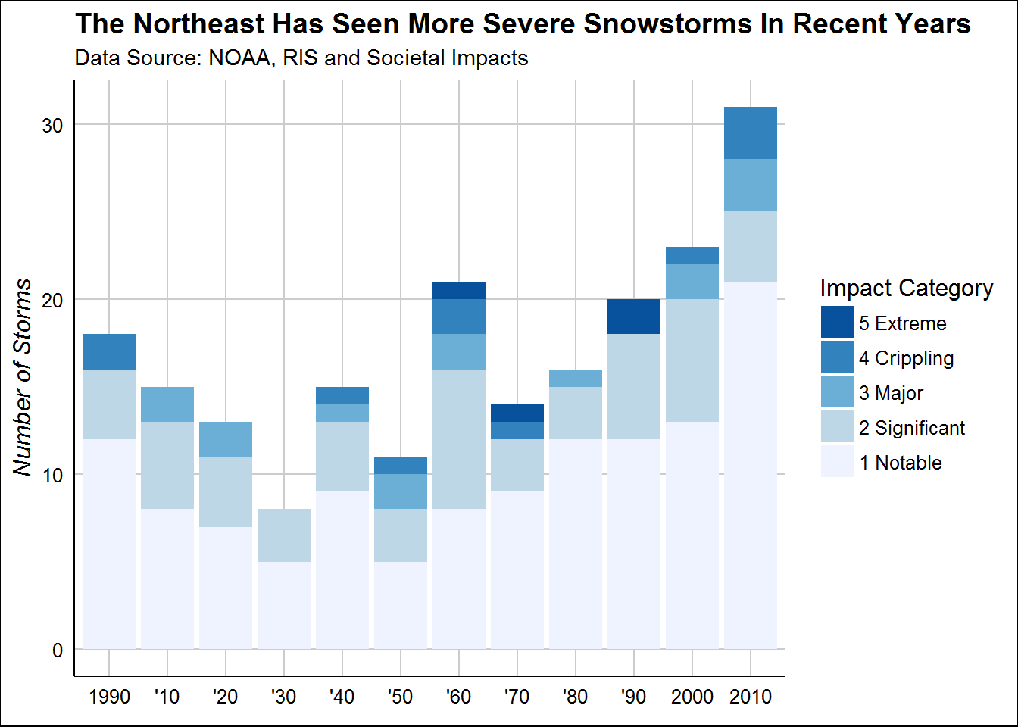

Historical storm data documented by the NOAA confirms Dr. Cohen’s findings. This graph above illustrates the increased frequency of major snowstorms through time. The growth is especially present in Category 1 storms.[2] Although the mildest type recorded, these “Notable” storms are no less formidable: the storm on [March 7-8, 2018](http://boston.cbslocal.com/2018/03/07/snow-totals-who-has-the-most-from-march-7-noreaster/), for example, unloaded 30 inches of snow on North Adams, Massachusetts.

And as yet another nor’easter, [winter storm Toby](https://weather.com/storms/winter/news/2018-03-19-winter-storm-toby-fourth-march-noreaster-northeast-snow), approaches, threatening not only the East Coast but also the Ohio Valley, New England residents can only ready their duck boots, mutter “Winter is Coming,” and ponder on [the merits of ordering food delivery in snowstorms](https://motherboard.vice.com/en_us/article/4x35gq/are-you-an-asshole-for-ordering-food-in-a-blizzard-we-asked-an-ethicist?utm_source=vicefbus).

Word Count: 515

1. The 1993 storm is actually the historically second worst snow storm in the Northeast: the 1969 “[100-Hour Snowstorm](https://www.climate.gov/news-features/blogs/beyond-data/100-hour-snowstorm-february-1969)” rated 34 on the RSI scale.
2. The increase is statistically significant. Please refer to [the author’s GitHub repository](https://github.com/wxiaonanw/storms) for detailed modelling output.