Web Output Screens

To run web code install below package

pip install Flask==2.1.0

Now double click on ‘runWeb.bat’ file to start python server and get below age

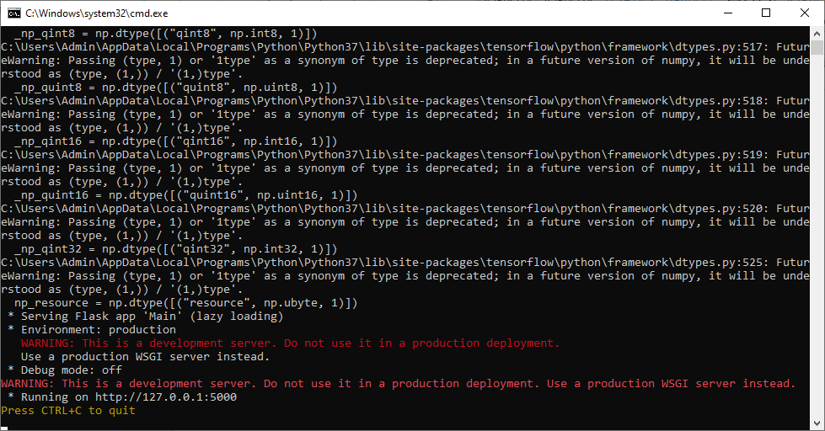

In above screen python web server started and now open browser and enter URL as <http://127.0.0.1:5000/index> and then press enter key to get below page

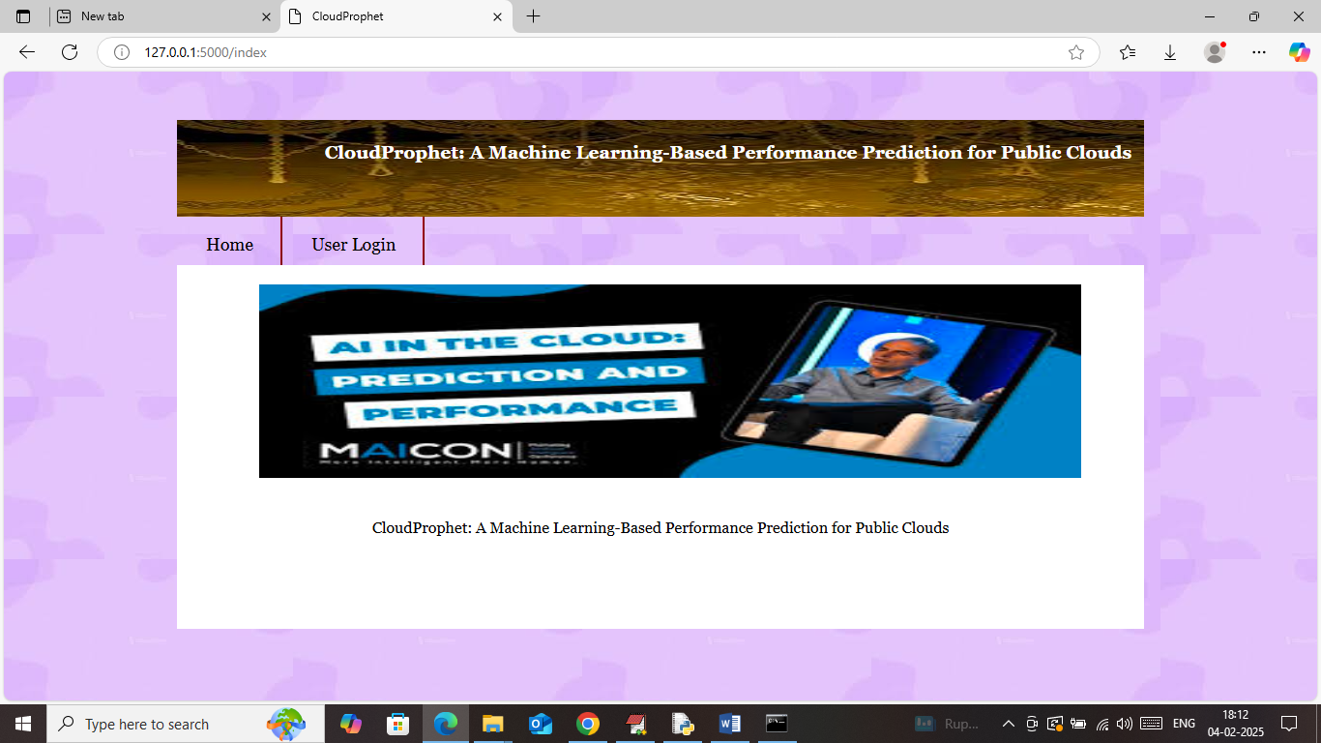

In above screen click on ‘User Login’ link to get below page

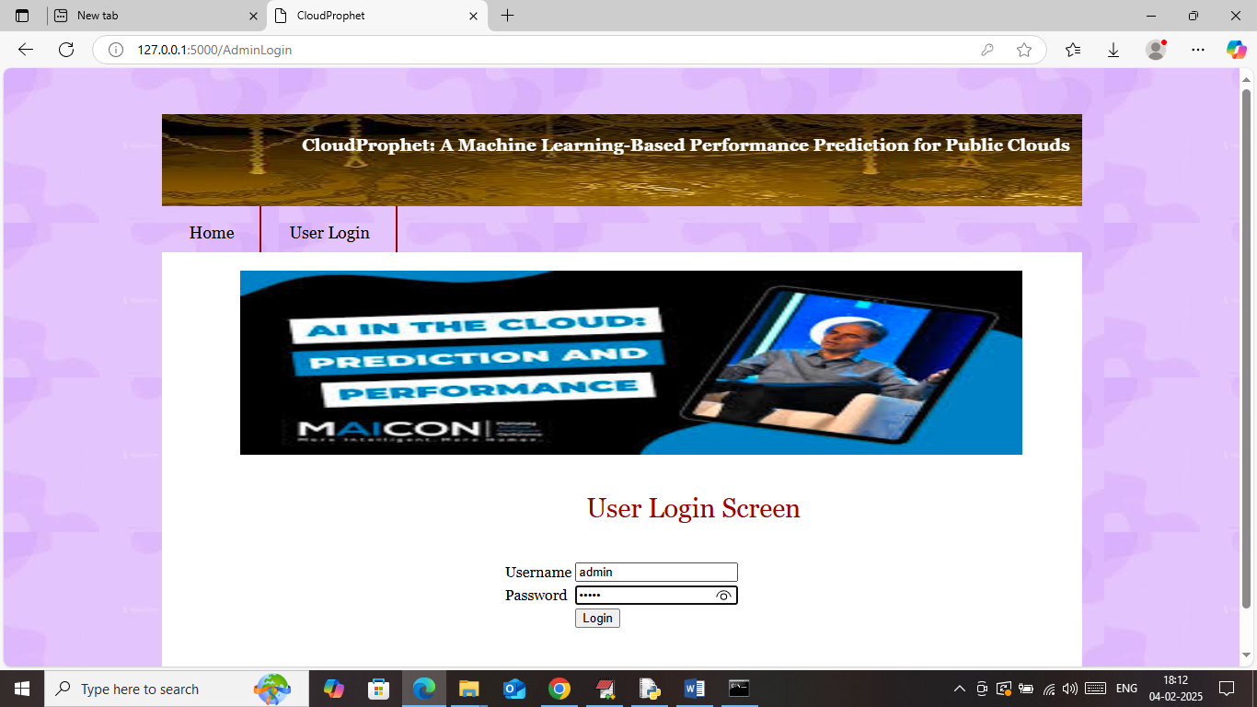

In above screen user can login by using username and password ‘admin and admin’ and then press enter key to get below page

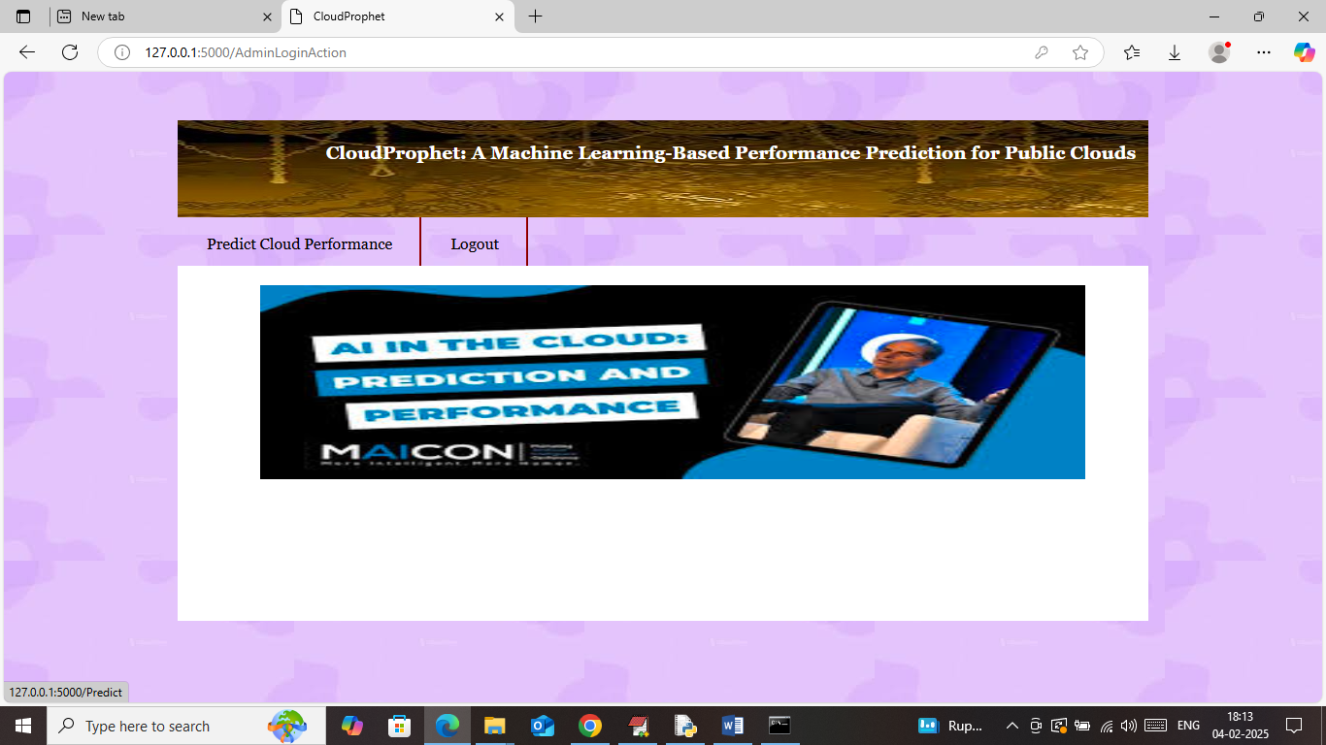

In above screen click on ‘Predict Cloud Performance’ link to get below page

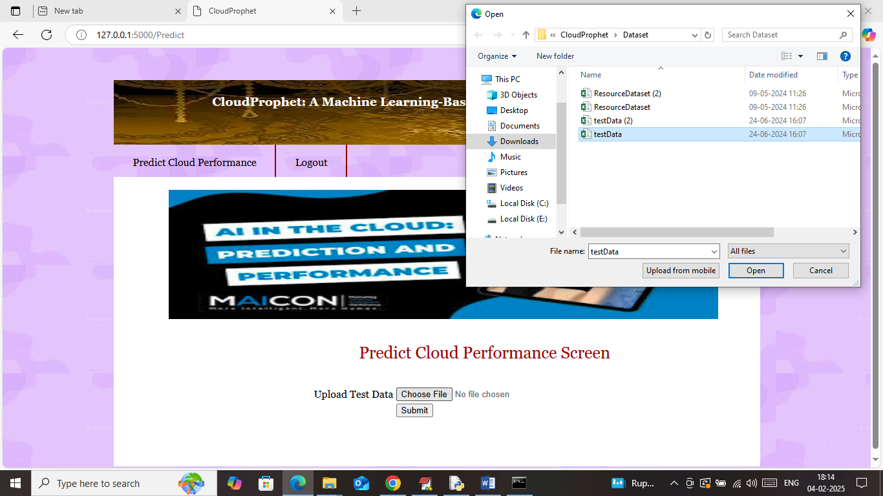

In above screen select and upload testData.csv file and then click on ‘Open and Submit’ button to get below output

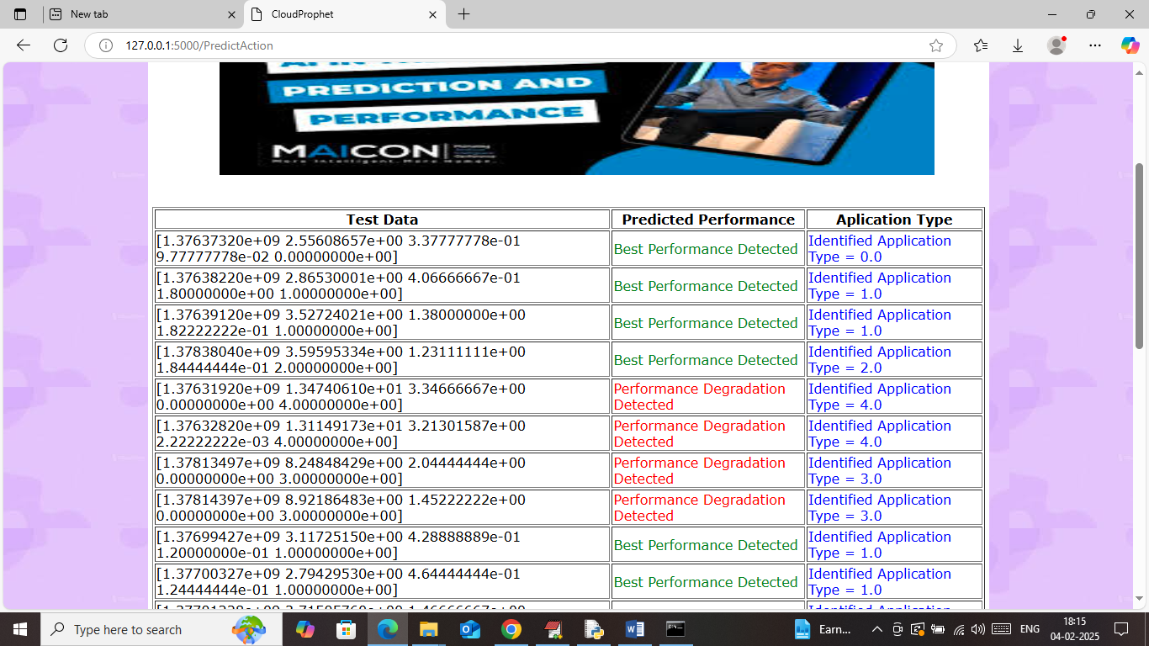

In above screen in first column can see Test Data values and then can see predicted performance along with identified Application type.

Similarly by following above screens you can run web code.