SOFTWARE BASICS TOPICS

- WHAT IS SOFTWARE?
- TYPES OF SOFTWARE?
WHAT S PROGRAM?
- WHAT IS SOURCE CODE?
PROGRMAING LANGUAGES
- COMPILER VS INTERPRETER
- APPLICATION
- FRONTEND BS BACKEND
- DATBASE-BASIC IDEA
- API-BASIC IDEA
- CLIENT SERVER MODEL
- SLDC CYCLE
- AGILE METHOD
- WATERFALL METHOD

What is Software ?
- Set of instructions which on executed delivers the desired outcome
- It is a service that is cost and time effective to achieve desired outcome
- Without software hardware is of no use
- User access hardware like phone to watch movie but user cannot access it because of multiple users privacy so to solve that introduced something called application.
- User ApplicationOSH/w
Types of Software
- System software :
manages only system – operating system , system utilities and device drivers eg: rebooting ,external driver management
- Application Software-General Purpose and customized software

Software vs Program Vs Application :
Software: Inside -programs and data structures and documentations , eg: MS Office the entire package is software
Program: Inside Software- A specific set of instructions written in programming language to perform a task. Developer write it to perform a specific task.
“ EVERY PROGRAM IS A SOFTWARE BUT NOT EVERY SOFTWARE IS JUST A PROGRAM.”
Application: The user’s tool . Software designed for end users to hepl them accomplish real world tasks. APP is completely user centric. Example-Chrome ,Spotify and Instagram.
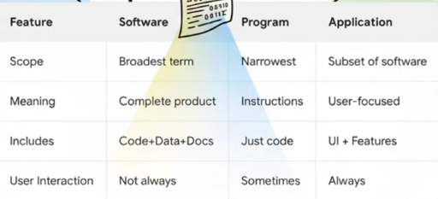
Resource: https://youtu.be/d1JH4-RnPhQ?si=FOB7Z_1OfopHISSg

SOURCE CODE :
- Fundamental components of computer program.
- It is just plain text.
- Open source software makes its source code available to everyone. Eg: React (GitHub)
- Source code generally high level code or assembly code but not machine code-0’s and 1’s
- High levelAssemblyMachine
PROGRAMMING LAN GUAGES:
Programming languages are the foundation of software development, allowing developers to create applications, websites, and systems through computer-understandable instructions.
- Python: Known for simplicity and readability, used in data science, machine learning, and web development.
- Java: Platform-independent, popular for enterprise applications and Android development.
- JavaScript: Essential for web development, enabling interactive websites.
- C++: High-performance language for system programming, games, and real-time applications.
- C#: Used for Windows applications and game development with Unity.
- Swift: Apple’s language for iOS and macOS apps.
- Go: Designed for scalability and cloud computing.
- Ruby: Known for web frameworks like Ruby on Rails.
Source: Introduction to Programming Languages - GeeksforGeeks

COMPILER Vs INTERPRETER:
COMPILER:
- Takes the high level code and translate to machine learning and generate output to users at one go.
- If suppose there is error in line 4 there will be not output of previous line shown to users and in end produced Error with no output.
INTERPRETER:
- Takes the high level code line by line ,process line by line generate machine code and output and then goes to next line.
- If suppose there is an error at line 4 the output till line 3 will be shown.
Resource: https://youtu.be/E3TDMVETp08?si=glI2ogHemWLL3nT8 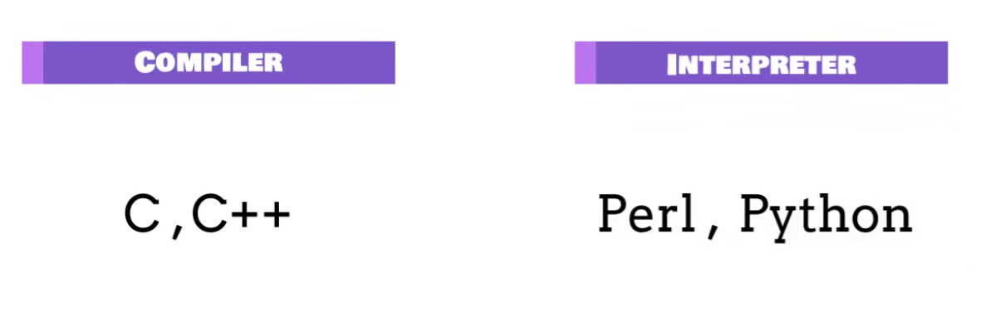
FRONTEND AND BACKEND:
FRONTEND:
The frontend is the part of a website or app users directly interact with. It includes the layout, design, and interactive elements, creating a smooth and user-friendly experience. It’s called the client-side because it runs in the user’s browser.
- User Interface Design
- Responsiveness
- Interactivity
- Cross-Browser Compatibility.
- Tools-HTML, CSS, JavaScript, React , Angular
BACKEND:
The backend is the server side of web development. It handles and processes data, manages storage and retrieval, and ensures the frontend gets the information it needs. While users interact with the frontend, the backend works behind the scenes to manage business logic and data operations.
- Server Side logic
- Database Management
- API Development
- Security
- Tools-php, node.js, PostgreSQL
Resource: Frontend Vs Backend Development - GeeksforGeeks
Database:
A database is a structured system used to store, manage, and retrieve data efficiently for multiple users and applications. It's important due to following features:
- Scalability: Handles large volumes of data efficiently.
- Data Integrity: Maintains accuracy using rules and constraints.
- Security: Protects data through controlled access and permissions.
- Analytics: Helps analyze data to support better decision-making.
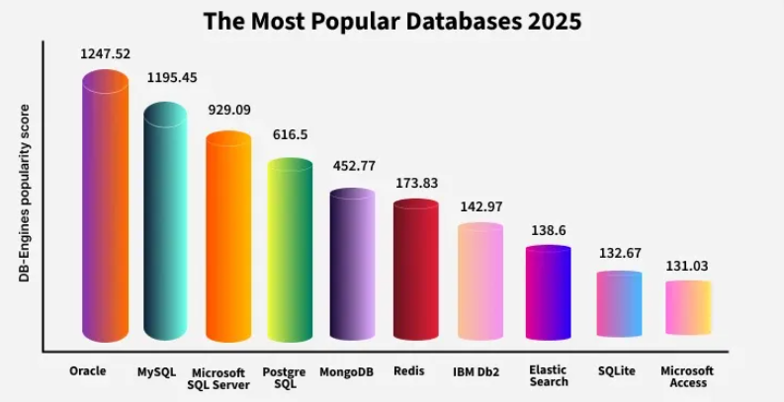

At the core of every database system is the Database Management System (DBMS)- a software layer that acts as an intermediary between users and the raw data
Resource: Introduction to Database - GeeksforGeeks

API(APPLICATION PROGRAM INTERFACE):
- Invisible connection between applications
- Request and response mechanism
- An API acts as an interface between a client and a server, allowing them to communicate and exchange data.
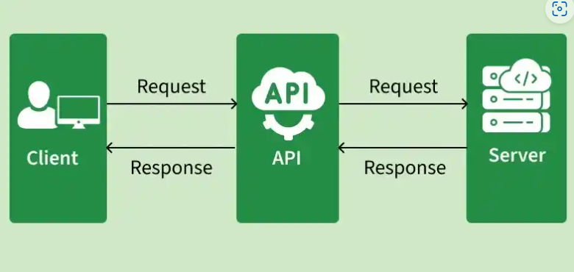
- API Endpoint: A specific URL through which clients access a particular resource or service.
- HTTP Methods: Define the operation performed by a request, such as retrieving, creating, updating, or deleting data.
- Headers: Provide additional information about a request or response, such as content type and authentication details.
- Parameters: Provide additional information required to process a request, such as resource identifiers or filtering criteria.
- Request Body: Contains data sent by the client to the server, commonly in JSON or XML format.
- Response: Contains the result returned by the server after processing the request.
- HTTP Status Codes: Indicate the outcome of a request, such as success, client error, or server error.
- GET-to request data, POST- to send data, PUT-To update existing data, DELETE- to delete data from server.
- REST,SOAP,GRAPHQL,JSON-RPC and XML-RPC are different protocols used within API.
- Web API, Local API, Program API are major types of API.
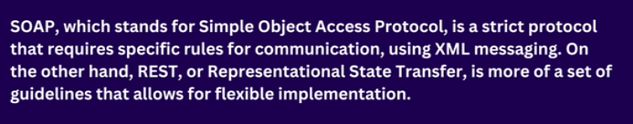
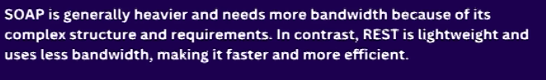




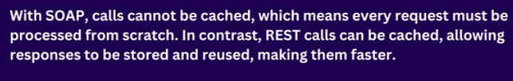

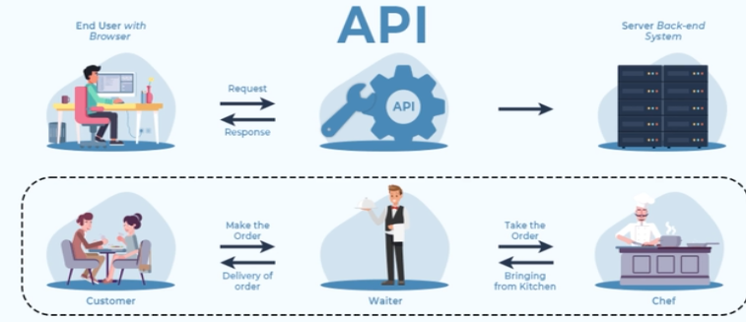

Resource: Introduction to API (Application Programming Interface) - GeeksforGeeks

CLIENT SERVER model:
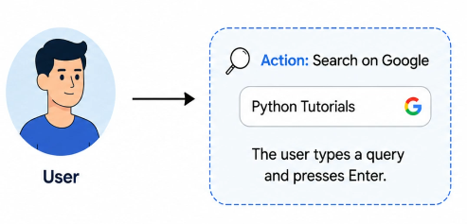
A client is an application that we used to communicate with the server.
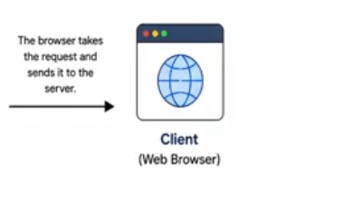
Example: Instagram. WhatsApp, Amazon, Chrome, Microsoft edge. These are some examples of client appplications
The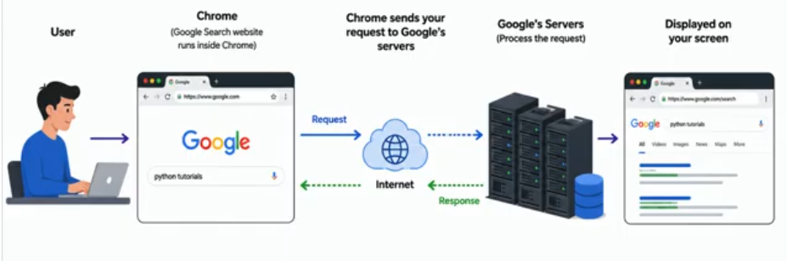
The request response happen to HTTP/HTTPS Protocol.
Server: Receives request, process it by asking questions and then respond with appropriate answers. If additional information required it communicates with databases.
Along with response server send HTTP Status code.
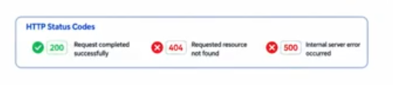
RESOURCE: https://youtu.be/-dSXvLAwXO0?si=FBIZ6x5HXLXWsGOo

SLDC:
SOFTWARE DEVELOPMENT LIFE CYCLE
PLANNING DEFINING/ANALYSIS DESIGNING CODING/IMPLEMENTATION TESTINGDEPLOY/MAINTENANCE
An important document is drafted in analysis stage called SRS document. SRS-Requirement Specification.
Resource: https://youtu.be/kSU2MPeptpM?si=-GhpM06GBJbX0XxZ
STAGE 1: PLANNING:
- Activities: Feasibility analysis, cost estimation, scheduling, resource planning
- Output: Project Plan, Feasibility Report
- Key Roles: Project Managers, Senior Engineers, Stakeholders

STAGE 2: Requirement Specification (SRS)
- Activities: Requirement gathering, validation, documentation
- Output: Software Requirement Specification (SRS)
- Key Roles: Business Analysts, Product Owners

STAGE 3: System Design
- High-Level Design (HLD): Defines system architecture, technology stack, database design, and major modules.
- Low-Level Design (LLD): Specifies component logic, APIs, data structures, and workflows.
- Output: Design Document Specification (DDS)
STAGE 4: Development (Coding)
- Activities: Coding, code reviews, unit testing, version control management
- Tools: IDEs, version control systems, debuggers
- Output: Source code, executable application
- Key Roles: Frontend, Backend, Full Stack Developers
STAGE 5: Testing
- Unit Testing: Verifies individual components
- Integration Testing: Ensures modules work together
- System Testing: Validates the complete system
- User Acceptance Testing (UAT): Confirms business requirements are met
STAGE 6: Deployment
- Activities: Production setup, deployment, smoke testing
- Modern Approach: Continuous Integration and Continuous Deployment (CI/CD) pipelines for faster and reliable releases
- Output: Live application
- Key Roles: DevOps Engineers, Release Managers
STAGE 7 : Maintenance
- Activities: Bug fixes, performance tuning, updates, feature enhancements
- Output: Patches, updates, new versions
- Key Roles: Support Engineers, Developers

AGILE MODEL:
The Agile Model is an iterative and incremental software development approach designed to deliver software quickly while adapting to changing customer requirements through continuous collaboration and feedback.
Major companies uses AGILE MODEL OF SLDC LIFECYCLE
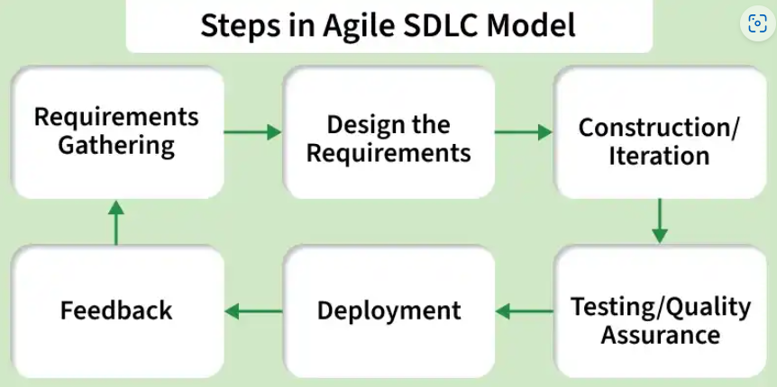
Agile means – Move Quickly
Large project are broken down into smaller chunks called iterations , then released ,feed back is gathered , the project is enhanced and then re-released.
ADVANTAGES:
- Frequent delivery
- Face to Face communication with client
- Changes updated done fast
- Time taken is less
DISADVANTAGES:
- Less Documentation
- Maintenance Problem
RESOURCE: https://youtu.be/Xs6E-MAJbfE?si=AsDUubulYfJKJ3cD

