Officials’ Guidance

2017-2020 Cycle

Horizontal Displacement

New for this cycle, gymnasts will receive a separate score for their horizontal displacement (H score). A deduction is awarded for each element based on the zone they land it in, and the total of these deductions is subtracted from the maximum mark (usually 10.0). The zones are shown as follows:

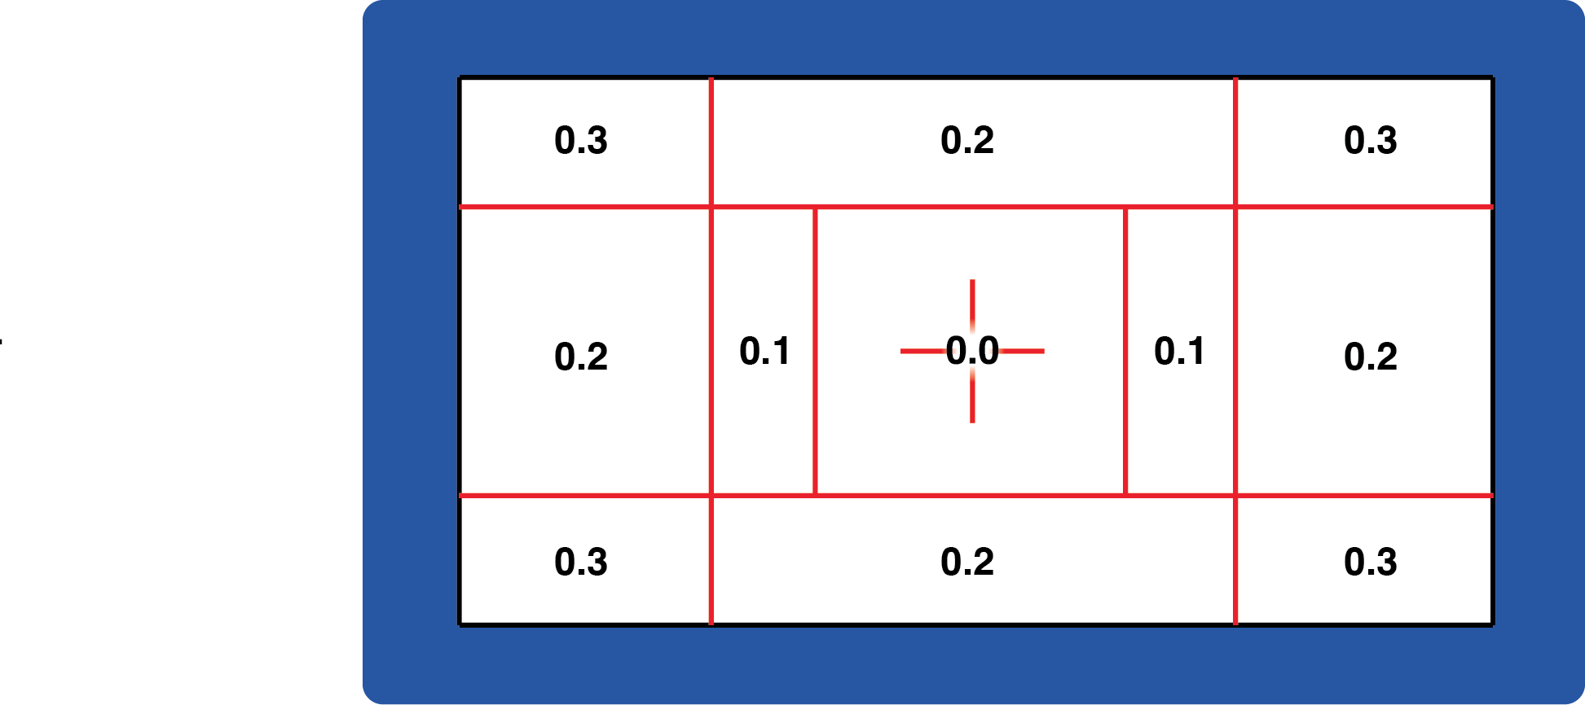

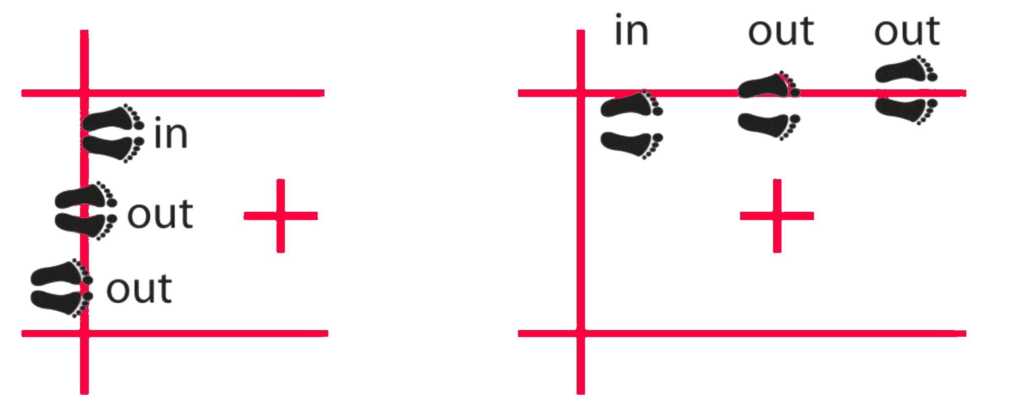The gymnast must obviously be over the line and into a zone for that deduction to be given. Benefit should therefore be given to the gymnast if there is uncertainty.

For elements performed to feet, the

following diagram shows how to assess the zonal deduction:

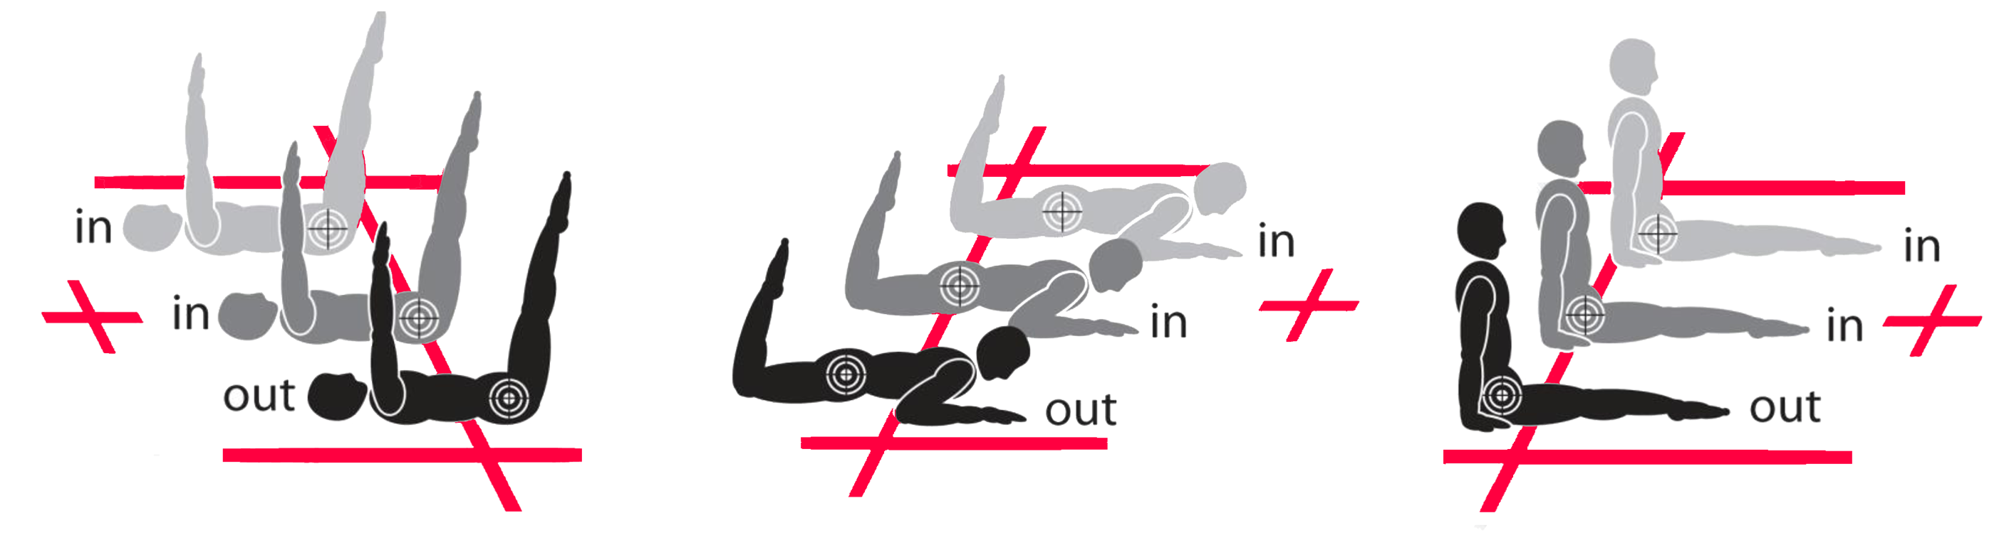For elements performed to seat, front, or back, reference should be made to the hip to determine the landing zone: