

ClimatePros
Unified Architecture
A Auto Dispatch B Closeout Copilot C Parts Finder
Version 1.0 — Draft for Client Review

PREPARED FOR ClimatePros
PREPARED BY techjays
ISSUED July 28, 2026
COMPANION TO ClimatePros Stream 1 Scope Document v2.0 (July 21, 2026)

Document Control
Item | Detail
Document | Stream 1 — Unified Architecture
Version | 1.0 — Draft for Client Review
Issued | July 28, 2026
Prepared by | techjays
Classification | Confidential — ClimatePros / techjays
Companion to | Stream 1 Scope Document v2.0 (July 21, 2026) — that document defines what is in scope; this one defines how it is built.
Source | Generated from the stream1-unified-architecture design set (sections 1–12)

How to Read This Document
● Sections are numbered 1–12 and match the live architecture document one-to-one. Cross-references appear as §N — for example §6 Core Logic.
● Cloud placement rule, applied throughout: anything AI-specific runs on Azure — the FastAPI AI server, its MongoDB, and the vector store. Everything else runs on AWS: the .NET APIs on EC2, SQL Server, the ElastiCache for Redis dispatch queue, the ECS Fargate workers, and Amazon SNS push. Models stay on-prem on ClimatePros hardware. The single cross-cloud hop is the AI request itself (AWS → Azure).
● Use Case A involves no LLM. It is a deterministic weighted-sum ranking and must stay explainable. Use Cases B and C are AI-assisted, and in both the technician can always override the output.
● Diagrams appear as Figure N placeholders for screenshots from the live HTML document; each carries a caption describing what the figure shows, so the text stands alone without it.
● Formulas, schemas, scoring constants, API parameters and cost line items are reproduced at full fidelity from the source design, not summarised.
● Terminology corrected during conversion is listed in Appendix A; open items needing ClimatePros confirmation are listed in Appendix B.
Approval
Approved for ClimatePros: ________________________ Date: ____________
Approved for techjays: ___________________________ Date: ____________
Contents
01 Stream 1 Overview 4
Auto-Dispatch — finding the right technician 4
Job Summarisation Copilot — changing the job status 4
Technician Parts Finder — finding the part that isn't on the truck 5
02 High-Level Architecture 6
2a · Unified system diagram 6
2b · Detailed architecture per use case 9
03 Technology Stack 12
Dispatch Worker Stack A 14
Central AI Service Stack B C 14
04 Infrastructure 16
FieldJetX Platform 16
Auto-Dispatch tier + central AI server 16
Environments 17
Compute sizing 17
Network topology 18
05 Operational Flows 20
Auto-Dispatch — Assignment Loop 20
Job Summarisation — Technician Flow 23
Parts Finder — Find & Allocate 28
06 Core Logic (per use case) 31
Auto-Dispatch — Ranking Algorithm 31
Job Summarisation — Summarise Pipeline & Retrieval 32
Parts Finder — Matching & Sourcing Logic 34
07 Data & Schema 36
Auto-Dispatch — Amazon ElastiCache for Redis Data Structures 36
Job Summarisation — the AI MongoDB Collections 36
Parts Finder — Data Model 37
08 API Reference 39
Auto-Dispatch — API Reference 39
Job Summarisation — API Reference 40
Technician Parts Finder — API Reference 41
09 Observability & Evals 46
Unified Observability — OpenTelemetry Tracing + CloudWatch / Azure Monitor Logs 46
Evals — the Feedback Loop 47
10 Cost Projection 48
Compute Sizing 48
Cost Formulas 49
Unified Monthly Cost by Scenario 49
Database & Cross-Cloud Egress 50
11 Onboarding & Fault Tolerance 51
How every rollout runs 51
Auto-Dispatch 51
Job Summarisation 53
Parts Finder 54
Environments 17
12 Non-goals & PII 56
Non-goals 56
PII inventory & data handling 57
Appendix A — Corrections applied during conversion 59
Appendix B — Open items 62

01 Stream 1 Overview
ClimatePros runs commercial refrigeration & HVAC field service: ~900–1,000 technicians, 46 branches, 10,000+ sites. Work orders arrive automatically. Everything after that still runs on a phone call and a technician's memory. Three use cases, three bottlenecks, one job.
Where AI sits: Use Case A is a deterministic algorithm — no LLM. It replaces a decision a dispatcher already makes by hand, so it must be explainable and repeatable. Use Cases B and C use AI, and in both the technician can always override it.
~900–1,000  Technicians | 46  Branches | 10,000+  Sites

A Algorithm · no LLM

Auto-Dispatch — finding the right technician
Web portal · Dispatcher
A dispatcher has a job ready and ~40 candidate techs in the region. The four things that decide the right one — how far, how familiar with the site, how soon free, how urgent — are each buried behind separate clicks or held in the dispatcher's head. Confirming one means dialling candidates one at a time, ~2–3 min each; no answer → call the next.
Why it hurts: two dispatchers per branch are the throughput ceiling — more job volume means more headcount, not faster dispatch.
We solve: rank on those same four factors; push an accept/decline offer that cascades automatically. No LLM — every assignment explainable.
B AI · tech overrides

Job Summarisation Copilot — changing the job status
Mobile · Technician at end of job
Every job ends with a mandatory status change, and behind it sits a wall of forms plus two free-text notes — one for the customer, one for the office. Done properly it takes 10–15 min, often in a machine room with no signal where voice dictation is only ~30% accurate.
Why it hurts: so the tech skimps — ~40% of 16.3M notes are ≤40 chars, the most common note is literally "checked history". Downstream the office can't bill or route ("Replaced motor" — but no motor in the parts list).
We solve: restructure rough words into a clean customer/office note and suggest form values from similar jobs; flag what's missing. Never fabricates, never blocks Save. Target: 10–15 min → ~15 s.
C AI · tech overrides

Technician Parts Finder — finding the part that isn't on the truck
Mobile · Technician on-site
On site the tech needs a part. Three sources the app already answers — truck, nearby techs, warehouse. The fourth, a third-party supplier, is a phone call: Google search, 1–3 calls, hope they answer.
Why it hurts: the same physical part carries a different number at every vendor, and the supplier API matches exact part number only — no fuzzy logic. A human bridges that gap by phone under emergency pressure; miss it and it's a return dispatch — a second truck roll, job can't finish today.
We solve: AI suggests the likely part; one search shows where it is across all four sources with location and distance. No price ranking, no ordering.
Work order in → (A) the right tech is offered the job on the web portal → tech arrives on site → (C) the missing part is found on mobile without a phone call → (B) the closeout note writes itself. Full step-by-step diagrams for all three: see §5 Operational Flows.

02 High-Level Architecture

2a · Unified system diagram
Figure 1
Unified system diagram · ClimatePros Stream 1
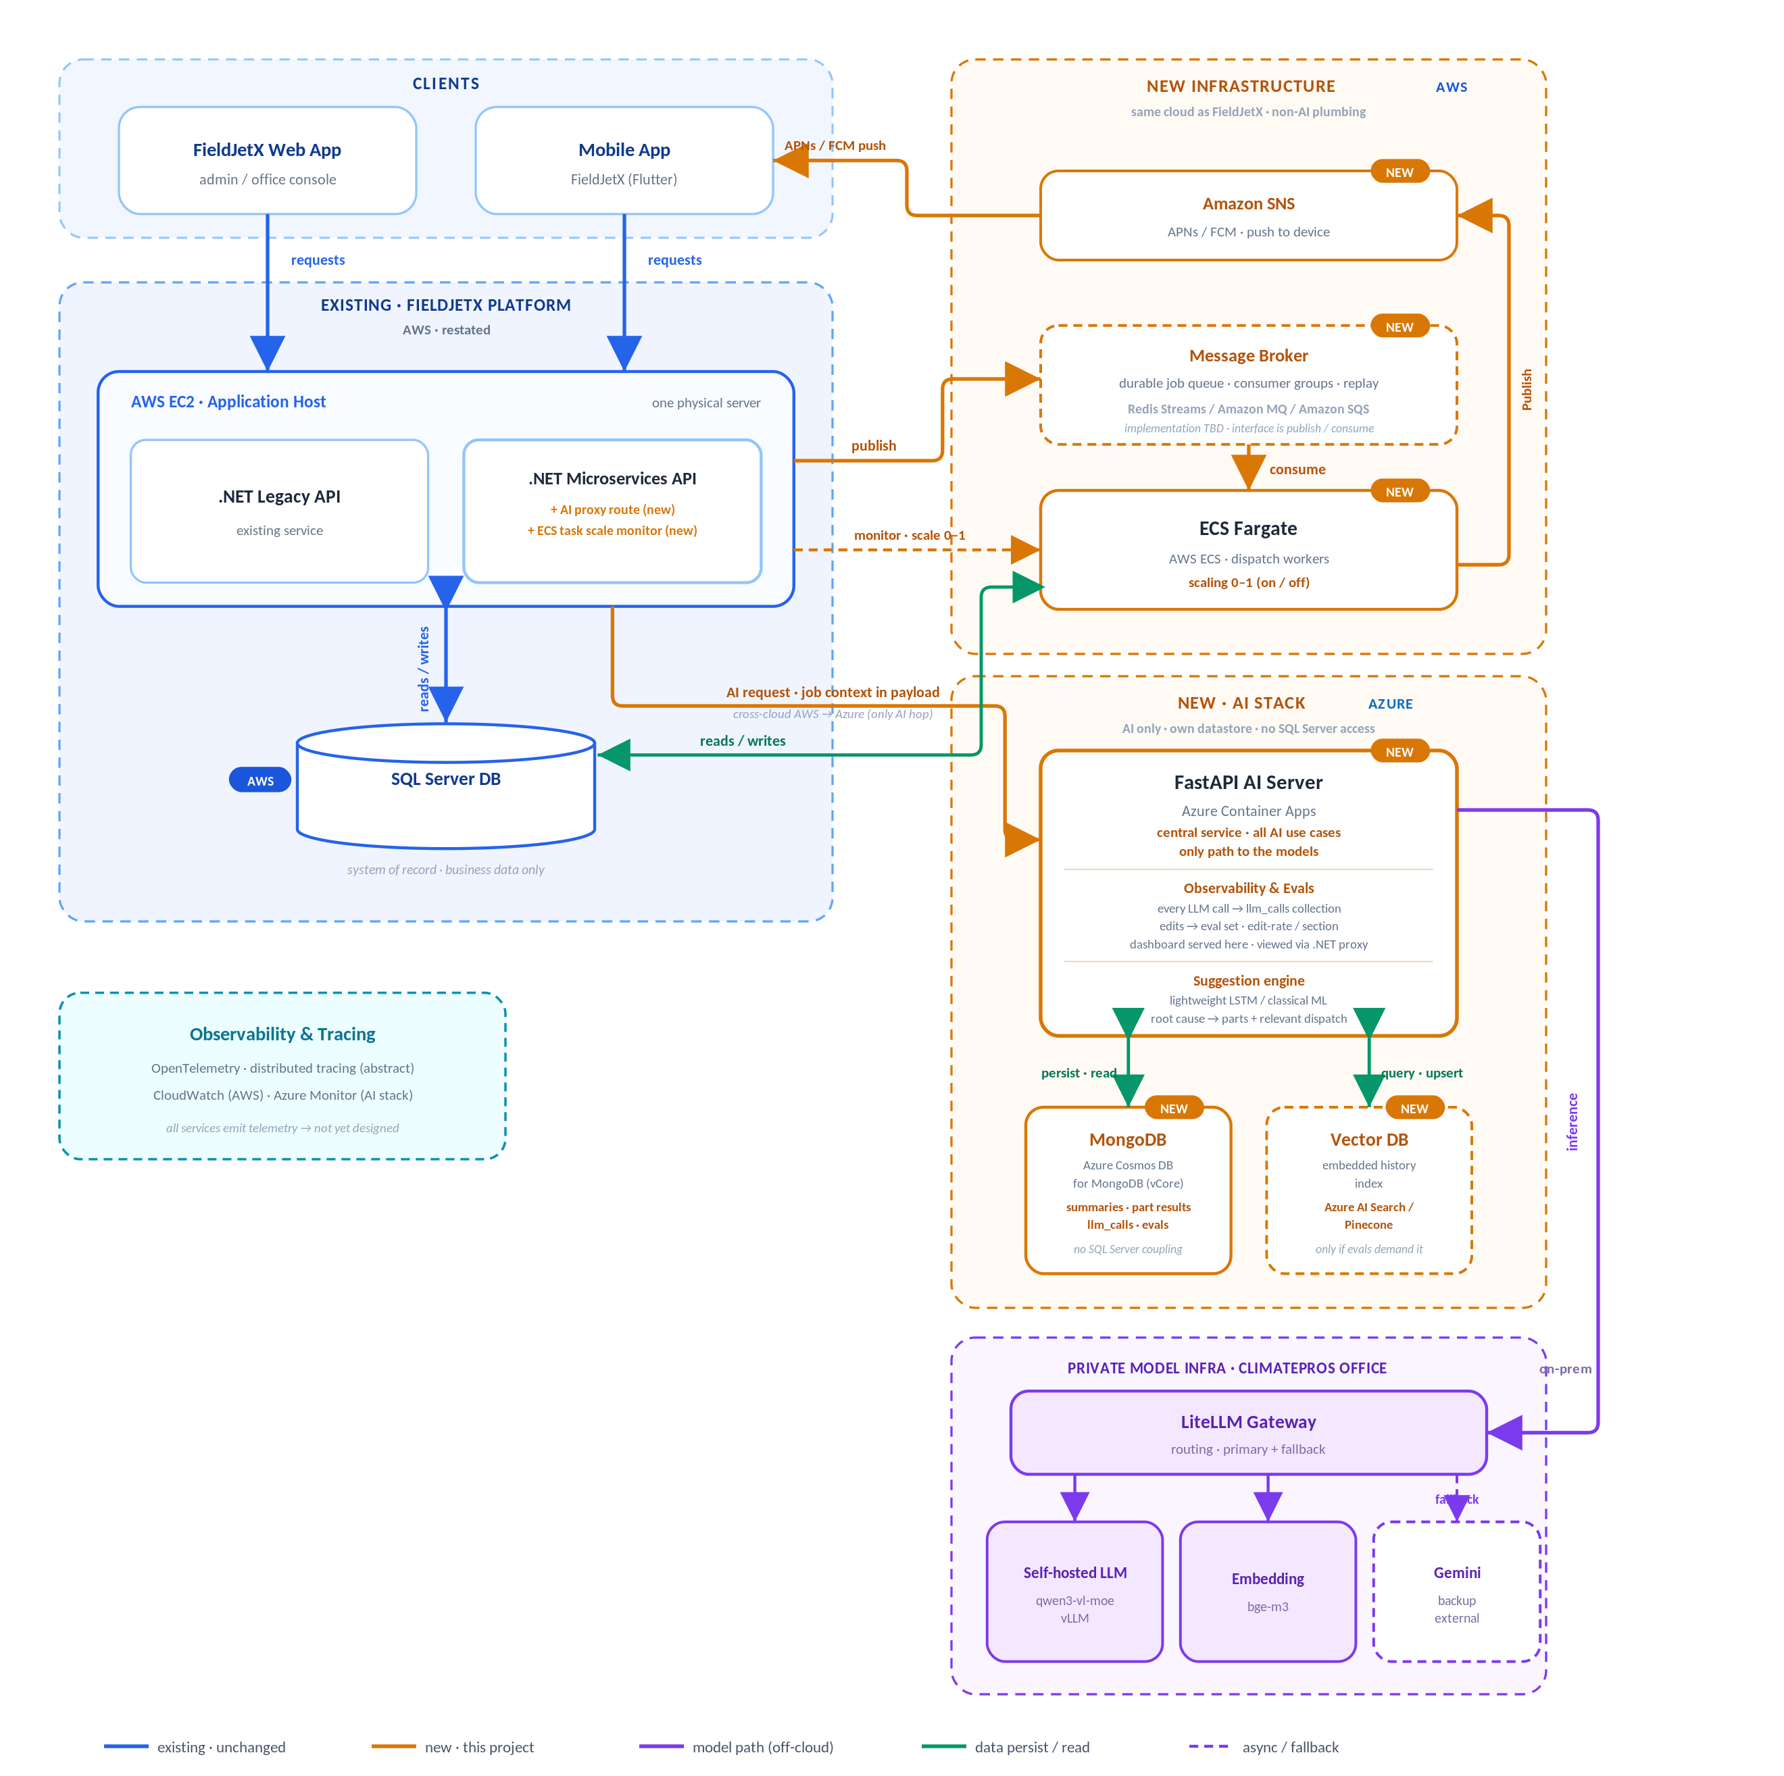
Six zones: clients; the existing FieldJetX platform on AWS; new AWS infrastructure (queue, workers, push); the new Azure AI stack (FastAPI AI server, MongoDB, vector store); the private on-prem model infra; and the cross-cutting observability layer. Live version: stream1-unified-architecture.html.
Everything runs on AWS alongside the existing FieldJetX platform — except the AI stack (FastAPI AI server, its own MongoDB, vector DB), which runs on Azure. The AI server is the single cross-cloud hop, and it holds no SQL Server connection: it owns its own datastore.
The diagram groups the system into six zones — clients, the existing FieldJetX platform (AWS), the new AWS infrastructure (queue, workers, push), the new Azure AI stack (AI server + its own datastore + vector DB), the private on-prem models, and a cross-cutting observability layer. What follows is the overall flow: which entity talks to which, and why. Per-use-case wiring (queues, locks, schemas, ranking, scoring) is detailed in §2b — this section stays deliberately high-level.

Entry · single front door
Web App + Mobile App → AWS EC2 (.NET APIs)
Both clients speak only to the existing .NET APIs on the EC2 application host over HTTPS. Neither the new infrastructure nor the models are ever reached directly — the legacy platform stays the single entry point and gains just two new additions: an AI proxy route and an ECS task-scale controller (spins workers up/down).

Data · two stores, cleanly split
EC2 ↔ SQL Server (AWS) ↔ ECS workers | FastAPI ↔ MongoDB (Azure)
SQL Server stays the system of record for business data — the EC2 .NET APIs and the new ECS dispatch workers read/write it directly, all inside AWS. The FastAPI AI server never connects to SQL Server: it owns a separate MongoDB (Azure Cosmos DB for MongoDB) for summaries, part-search results, llm_calls traces and eval data. Any business context it needs arrives in the request payload from the .NET AI proxy.

Dispatch · Use Case A · no LLM
.NET → ElastiCache → ECS Fargate → SNS → Mobile
When auto-dispatch is on, the .NET API publishes the job to ElastiCache for Redis and the scale monitor spins ECS Fargate workers 0→1. Workers consume the stream, rank technicians, and push accept/decline offers out through Amazon SNS (APNs/FCM) to the technician's phone. Entirely on AWS — no cross-cloud hop. The reply path returns via the .NET API. Deterministic — no model involved.

AI · Use Cases B & C
.NET (AWS) → FastAPI AI Server (Azure) → Vector DB / MongoDB
For summarisation (B) and parts finding (C), the .NET AI proxy forwards the request — with the job context in the payload — across to the FastAPI AI Server on Azure, the single central AI service and the only path to the models. It queries/upserts the Vector DB for historical retrieval and persists its outputs to its own MongoDB. This AWS→Azure call is the sole cross-cloud dependency; the AI stack is self-contained behind it.

Models · private, on-prem
FastAPI → LiteLLM Gateway → self-hosted LLM / embedding / Gemini
All inference goes through the on-prem LiteLLM Gateway, which routes to the self-hosted qwen3-vl-moe (vLLM) and bge-m3 embedding, with Gemini as external fallback. No service calls a model directly — LiteLLM is the sole gate, keeping data inside ClimatePros infra.

Observability · cross-cutting
all services → OpenTelemetry / CloudWatch + Azure Monitor
Every service emits traces and logs to a shared observability layer (OpenTelemetry) — CloudWatch on the AWS side, Azure Monitor for the AI stack.

2b · Detailed architecture per use case
Figure 2
Use Case A — detailed architecture (Auto-Dispatch)
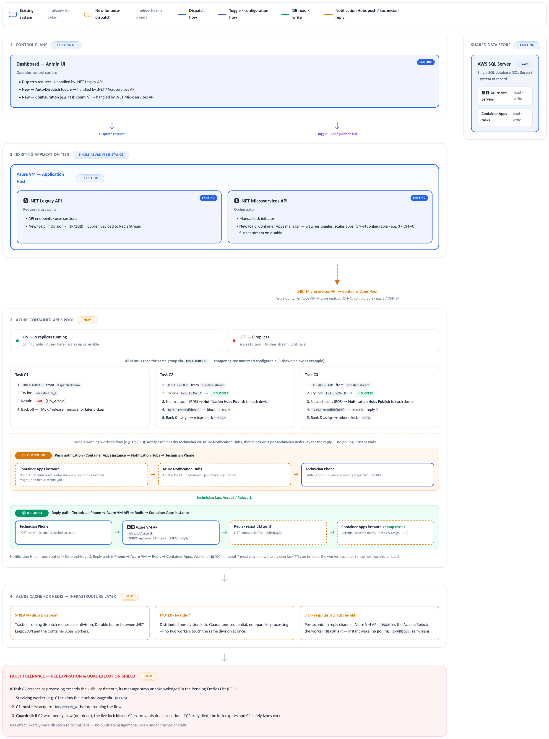
Blue = existing · unchanged; amber dashed = new · this project; purple = toggle/config flow; green = DB read/write. Entirely within AWS. Live version: stream1-unified-architecture.html.

Figure 3
Use Cases B & C — detailed architecture (shared AI service)
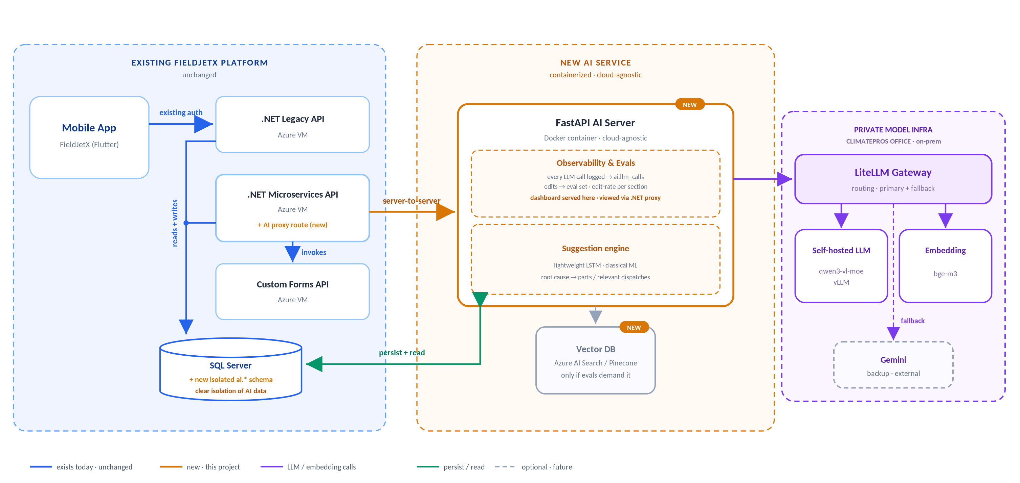
Blue = existing · unchanged; amber dashed = new · this project; purple = LLM/embedding calls (client-hosted, off-cloud); green = persist/read. Grey dashed = optional vector index. Live version: stream1-unified-architecture.html.

A A adds: durable dispatch queue + ECS Fargate worker + push-offer cascade.
Use Case A architecture: blue = existing · unchanged, amber dashed = new · this project, purple = toggle/config flow, green = DB read/write. All of Use Case A runs on AWS: the .NET Legacy and Microservices APIs on AWS EC2, the dispatch workers on AWS ECS Fargate, the durable queue on Amazon ElastiCache for Redis, push through Amazon SNS, and AWS SQL Server as the system of record. No part of A touches Azure — there is no LLM in this use case.
B C B & C add: central FastAPI AI server + vector history index. B runs the summarise pipeline; C the four-source part search + fuzzy matching — same wiring, different pipeline.
One diagram serves both B and C — they share the same detailed architecture (central FastAPI AI server + vector history index, same Azure/on-prem model path). Only the pipeline differs, detailed in §6. Blue = existing · unchanged, amber dashed = new · this project, purple = LLM/embedding calls (client-hosted, off-cloud), green = persist/read. The vector history index is an optional future add-on (grey dashed), added only if evals demand it. The AI service is a portable Docker container; the existing platform is restated on AWS EC2. The FastAPI AI server and its datastores are the only Azure components in this diagram.
AI data is self-contained. The FastAPI AI server owns its own MongoDB (Azure Cosmos DB for MongoDB, vCore) and holds no SQL Server connection at all — it persists its own outputs (summaries, part-search results, LLM-call traces and eval data) in its own collections. Any business context it needs arrives in the request payload from the .NET AI proxy, so the AI datastore is never coupled to the legacy relational schema.

03 Technology Stack
Ten layers, three use cases. The existing platform pieces — client apps, the .NET API host, SQL Server, observability — are shared: reused as-is, not rebuilt. A's new tier — durable dispatch queue, worker pool, push — stays on AWS alongside the existing platform; B and C's new tier — a central AI service and vector store — is the one part of Stream 1 that runs on Azure, reached by a single cross-cloud hop from the AWS side.
Layer | A Auto-Dispatch | B Job Summarisation | C Parts Finder
Client | FieldJetX Web App (Angular) existing + Mobile App (Flutter) existing Dispatcher console (web) + technician accept/decline offers (mobile) | FieldJetX Mobile App (Flutter) existing Technician close-out wizard | FieldJetX Mobile App (Flutter) existing Technician on-site search
App / API host | .NET Legacy API + .NET Microservices API on AWS EC2 existing One shared application host across all three use cases. The Microservices API gains a new AI-proxy route (B, C) and a new ECS Fargate scale-monitor route (A).
Central AI service | N/A deterministic — no LLM | FastAPI on Azure Container Apps new Single entry point for both B and C; stateless, horizontally scalable containers; the only path to the models.
Workers | AWS ECS Fargate new Async worker pool · scales 0–1 on toggle · 20 concurrent dispatches per task | N/A | N/A
Message Broker | Amazon ElastiCache for Redis new Redis Streams (XREADGROUP / XACK / XCLAIM) · division locks · per-technician reply BLPOP · decided implementation for the durable dispatch queue | N/A | N/A
Vector store | N/A | Azure-hosted vector store experimental Cross-site similar-incident retrieval. Built only if the dataset proves it beats the deterministic baseline — decided from the data. | Azure-hosted vector store experimental Fuzzy part-number matching via embedded dispatch-parts history + cosine similarity. Built only if the dataset proves it beats exact/keyword lookup — decided from the data.
Push | Amazon SNS new APNs (iOS) + FCM (Android) · one Publish call per device endpoint | N/A | N/A
Database | AWS SQL Server AWS System of record. A reads/writes dispatch & assignment tables directly from AWS EC2 and AWS ECS Fargate — no cross-cloud hop for this data. B and C add no tables to SQL Server at all: they persist their AI output to the AI server's own MongoDB on Azure, and read business context only via the payload the .NET AI proxy sends. Stream 1's one cross-cloud hop is the AI request itself (AWS → Azure), not this database (see §2 cloud placement).
Models | N/A no LLM in this use case | LiteLLM gateway (routing · primary + fallback) · self-hosted qwen3-vl-moe (vLLM) generation · bge-m3 embedding · Gemini fallback on-prem · unchanged Client's private hardware; dispatch/job text and images never leave client infrastructure. Any model or provider change must pass the eval set first.
Observability | OpenTelemetry + CloudWatch (AWS) + Azure Monitor (AI stack) new Every service — AWS EC2 host, ElastiCache-fed workers, ECS Fargate, the Azure AI server, vector store calls — emits traces and logs via OpenTelemetry, viewed through CloudWatch on the AWS side and Azure Monitor for the AI stack.

New non-AI infrastructure — the message broker, the worker pool, and push — stays on AWS, matching the existing FieldJetX platform. Only the AI stack (the central AI service, its MongoDB, and the vector store) runs on Azure; that AI-request hop is Stream 1's sole cross-cloud dependency. AWS SQL Server is unaffected either way — it was always AWS and is read only by AWS-side compute.

Dispatch Worker Stack A
Library-level detail for the Auto-Dispatch async worker (the Workers / Message Broker / Push rows above). Fully async top-to-bottom — no thread pools, no blocking calls in the event loop.
1 Core Runtime
● Python 3.11+
● asyncio event loop drives all worker tasks
● asyncio.Semaphore for concurrency control
2 Push — Amazon SNS
● aioboto3 async client against the SNS Publish API
● IAM role credentials — no manual token handling
● One Publish call per platform endpoint ARN (APNs / FCM)
3 Messaging & Sync — Amazon ElastiCache for Redis
● redis.asyncio client against the ElastiCache endpoint
● Input: consumes job tasks via Redis Streams (XREADGROUP)
● Wait-state: unblocked via Pub/Sub or a secondary stream when the mobile app's HTTP reply reaches the API host
4 External Requests
● httpx with built-in async connection pooling for 3rd-party API calls

Central AI Service Stack B C
Library-level detail for the shared FastAPI AI service (the Central AI service row above) — the single entry point for both B and C, and the only path to the models.
1 Core Runtime
● Python 3.11+
● FastAPI async framework · Uvicorn ASGI server
● pydantic request/response schemas
2 Model Access
● httpx async client to the LiteLLM gateway
● Generation via qwen3-vl-moe (vLLM) · embeddings via bge-m3
● Gateway handles primary + fallback routing (Gemini fallback)
3 Retrieval experimental
● Async client to the Azure-hosted vector store
● Cosine-similarity search over bge-m3 embeddings
● Built only if it beats the deterministic baseline — decided from the data

04 Infrastructure
What Stream 1 already has vs. what it introduces — the same §3 layers, regrouped by existing-platform vs. new-build. The existing platform and all new non-AI plumbing stay on AWS, aligned with FieldJetX; only the AI stack (FastAPI AI server + its own datastores) runs on Azure, with the models on-prem. See the callout below.
Existing · reused as-is

FieldJetX Platform
Mobile App — FieldJetX (Flutter) · technician-facing (B, C)
● FieldJetX Web App — admin / dispatcher console (A)
● AWS EC2 — one host running both .NET services AWS
● .NET Legacy API — existing service on the EC2 host AWS EC2
● .NET Microservices API — existing service on the EC2 host; gains new routes for A/B/C AWS EC2
AWS SQL Server — system of record · business data only AWS
New · introduced by this project

Auto-Dispatch tier + central AI server
● Message Broker — Amazon ElastiCache for Redis, using Redis Streams (consumer groups + replay) as the durable dispatch queue for Auto-Dispatch (A) AWS
● ECS Fargate — Auto-Dispatch workers — scale 0–1 on toggle; consume queued dispatches, read/write SQL Server AWS ECS
Amazon SNS — outbound push to technician phones (APNs / FCM); worker → SNS → Mobile App AWS
● Azure Container Apps — AI Server (FastAPI) — central AI service for B & C; the only component that reaches the models. Two subsystems ride inside it: Observability & Evals — every LLM call → llm_calls · technician edits → eval set · dashboard served here, viewed via the .NET proxy Suggestion engine — lightweight LSTM / classical ML · root cause → parts + relevant dispatch Azure
● MongoDB — AI-owned datastore: summaries · part results · llm_calls · evals. No SQL Server coupling. Azure Cosmos DB (vCore)
● Vector store — embedded dispatch-parts history index (C) · optional future similar-incident index (B) · only if evals demand it Azure AI Search / Pinecone
● .NET additions — AI-proxy route (B, C) + ECS task scale-monitor route (A) on the existing Microservices API AWS EC2
● LiteLLM Gateway + self-hosted LLM (qwen3-vl-moe / vLLM) + embedding (bge-m3) — private model infra, client hardware on-prem
● Google Gemini — managed fallback only, not primary external
Observability & Tracing — OpenTelemetry traces + logs → CloudWatch (AWS) + Azure Monitor (AI stack) abstract
2 | new compute tiers | ECS Fargate workers (0–1) + Container Apps AI server
1 | new message broker | Amazon ElastiCache for Redis (Redis Streams)
2 | new data stores | MongoDB + vector store (conditional)
3 | off-cloud model entities | LiteLLM + self-hosted LLM + embedding
1 | external backup | Google Gemini (fallback only)

Environments
ClimatePros already runs Dev / Staging / Prod. Stream 1 mirrors all three. New AWS tiers (message broker, dispatch workers, push) and new Azure tiers (the AI server, its MongoDB, and the vector store) — plus the on-prem model link — are stood up per environment; the AWS SQL Server system of record is shared — lower environments point at a snapshot or a restricted replica, never live prod data (see §12 PII).
Environment | Purpose | What differs from Prod
Dev | Integration & feature work provisioned alongside Staging + Prod | Lowest replica caps; Gemini-only models (no on-prem link); points at a SQL snapshot
Staging | Pre-prod validation & evals mirrors Prod topology | Smaller replica ranges; restricted SQL replica; full model stack for eval fidelity
Prod | Live — 900–1,000 technicians, 46 branches full scale + HA | —

Compute sizing
New compute tiers — AWS ECS Fargate for dispatch workers, Azure Container Apps for the AI server — run small and scale horizontally, not vertically. Baseline instance size is 0.5 vCPU / 1 GB RAM across both, which handles 60+ concurrent dispatch operations per instance comfortably; load is met by adding replicas/tasks, not bigger boxes.
Component | Instance size | Scaling | Notes
Dispatch workers (ECS Fargate) AWS | 0.5 vCPU / 1 GB | Scale 0–1 on Auto-Dispatch toggle | 60+ concurrent dispatches per instance; one instance covers current volume
AI server (FastAPI) Azure | 0.5 vCPU / 1 GB | Scale 1–N on request concurrency | Central B & C service; min 1 replica avoids cold-start on the model path
Amazon ElastiCache for Redis AWS | Managed tier | Fixed; sized to queue depth | Dispatch queue must not evict — persistence on, no-eviction policy
Vector store Azure | Managed / index-sized | Grows with parts-history corpus | Embedded dispatch-parts index (C); optional similar-incident index (B)

Network topology
The existing platform and all new non-AI infrastructure sit inside a single AWS VPC, matching FieldJetX: EC2 (the .NET hosts) and ECS Fargate (dispatch workers) in an apps subnet, and ElastiCache for Redis and SQL Server reached over private subnets — neither exposes a public IP, so all worker↔broker and worker↔database traffic stays inside the VPC. The only public entry point is the .NET API, fronted by an AWS load balancer / API gateway where WAF filtering and TLS termination happen; the mobile app (B, C) and web console (A) reach the API there.
A separate Azure VNet holds only the AI stack: Container Apps (the FastAPI AI server) in an apps subnet, with MongoDB and the vector store reached over private endpoints in a data subnet. The one cross-cloud path in Stream 1 is the .NET AI-proxy route on AWS calling the FastAPI AI server on Azure — technician phones never reach either side directly, and the AI server never reaches AWS SQL Server. From there, the AI server has two private egress paths of its own: the on-prem model stack (LiteLLM + self-hosted models) over a VPN / private link to the ClimatePros datacenter, and a fallback to Google Gemini over outbound HTTPS. That gives three trust boundaries to enforce: Internet→AWS (load balancer / WAF), AWS→Azure (the single AI-request hop — VPN/peering target state, public endpoint + IP allow-list as fallback), and Azure→on-prem (VPN / private link).
Cross-cloud dependency:
the seam isn't the database — · AWS SQL Server
is read and written only by AWS-side compute (EC2 and ECS Fargate), so Auto-Dispatch (A) never leaves AWS. The one cross-cloud hop is the AI request itself: when a technician triggers a summarisation (B) or parts search (C), the .NET AI-proxy route on AWS EC2 calls the FastAPI AI Server on Azure Container Apps, carrying the job context in its payload, and gets a response back.
● Network path: target state is a site-to-site VPN or VPC-to-VNet private peering between the AWS account and the Azure subscription; until that's provisioned, the fallback is a public HTTPS endpoint on the AI server, locked down by IP allow-listing / mTLS.
● Added latency: only the B/C request path pays inter-cloud round-trip time — once per summarisation or parts search, not per SQL call — and this has to be budgeted into the P95 targets in §9 Observability & Evals.
● Cost: AWS bills egress on the .NET proxy's outbound call to Azure; this is one request/response pair per B/C call, not a per-row data-transfer cost, and belongs in §10 Cost Projection.
● Single seam: this AI-request hop is the only place Stream 1 crosses clouds — SQL Server, the message broker, the dispatch workers, and push all stay inside AWS. If the link goes down, B and C fall back to their existing manual path (forms without AI assist, no parts search); Auto-Dispatch (A) is entirely unaffected since it never touches Azure.

05 Operational Flows
The request/response mechanics for each use case, trigger to outcome. A is a closed-loop dispatch cascade with a hard timeout and human escalation; B is a technician-facing UX flow, shown both before and after the copilot, plus the background flywheel that feeds each visit's data into the next; C is the ordered, multi-source parts search that backs the mobile app's "source & allocate" step. Companion to §2 Architecture and §3 Technology Stack — component-level detail (Redis Streams, division locks, ECS Fargate task walkthroughs) lives there; this section is the process view.

A Auto-Dispatch — Assignment Loop
One dispatch, start to finish: a new job only enters the queue for divisions with auto-dispatch turned on, then works down a ranked shortlist until a technician accepts or the shortlist runs out. The admin Enable/Disable toggle is covered by the scale ON/OFF walkthrough in §2.

Figure 4
Use Case A — assignment loop (trigger to outcome)
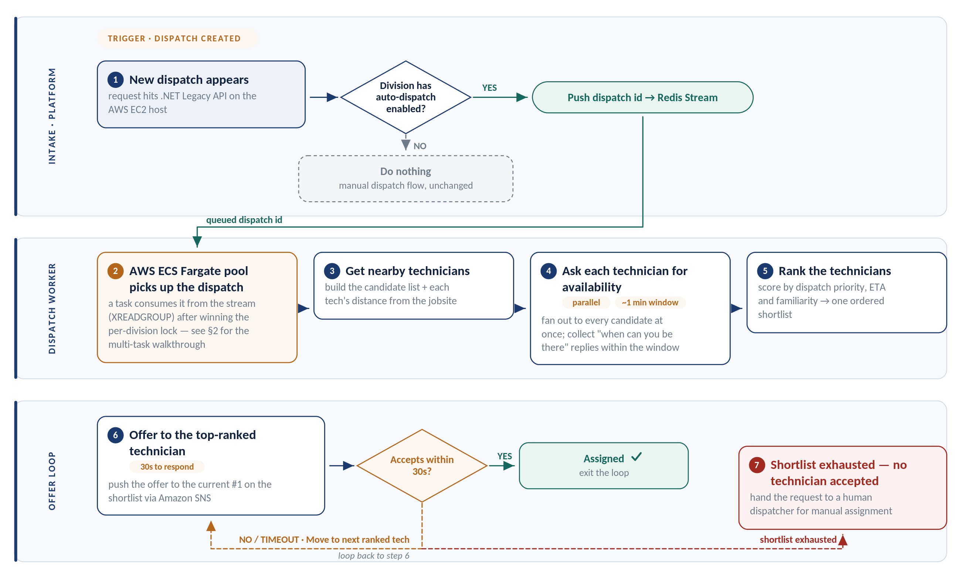
The ranked cascade with a 30-second offer window per technician and escalation to a human dispatcher when the shortlist is exhausted. Steps are written out below. Live version: stream1-unified-architecture.html.

Assignment sequence · trigger to outcome
# | Step | What happens
1 | New dispatch appears | request hits .NET Legacy API on the AWS EC2 host
◇ | Division has auto-dispatch enabled? | NO → Do nothing (manual dispatch flow, unchanged) · YES → Push dispatch id → Redis Stream
2 | AWS ECS Fargate pool picks up the dispatch | a task consumes it from the stream (XREADGROUP) after winning the per-division lock — see §2 for the multi-task walkthrough
3 | Get nearby technicians | build the candidate list + each tech's distance from the jobsite
4 | Ask each technician for availability parallel ~1 min window | fan out to every candidate at once; collect "when can you be there" replies within the window
5 | Rank the technicians | score by dispatch priority, ETA and familiarity → one ordered shortlist
6 | Offer to the top-ranked technician 30s to respond | push the offer to the current #1 on the shortlist via Amazon SNS
◇ | Accepts within 30s? | NO / TIMEOUT → Move to next ranked tech (↻ loop back to step 6) · YES → Assigned ✓ (exit the loop)
7 | Shortlist exhausted — no technician accepted | hand the request to a human dispatcher for manual assignment

Timeout rule: the worker's reply-wait timeout has to stay below the division lock's TTL. On timeout the worker escalates to the next technician on the shortlist; the division lock is never lost mid-flight.

Amazon SNS round-trip

Operational Flows

Summarise & Review Loop
- Trigger: technician reaches the Review step in the mobile app
- App compiles the wizard payload and sends POST /api/v1/summarise through the .NET proxy with zero additional API calls
- Enrich step: parallel fail-soft reads fetch equipment specs, completed forms, and procedures
- Generate: LLM drafts the 12-section ticket and identifies any procedure compliance gaps
- Analyse: if critical gaps found, display remediation fields for inline fixes; re-analyse until clean
- Submit enabled: only after ticket passes validation checks

Persist & Learn Loop
- Trigger: technician taps Submit
- Job write-back: dispatch record, parts, time, and notes flow through the existing mobile-post path
- Persist AI output: the accepted summary is stored in the summaries collection; every LLM call already logged in llm_calls
- History refresh: closing a dispatch extends the SQL co-occurrence counts that future part suggestions read from, refreshed inline with the existing write-back
- Corrections as ground truth: any technician edits to AI-drafted sections land in summary_edits and feed the evaluation set
The flywheel: every clean ticket submitted not only ends that visit—it also sharpens the history and suggestion data the next technician's ticket draws from, making the next closeout a little better.
The mechanics behind step 6's push — fire-and-forget out, a different path back in. Component-level diagram: §2 · Use Case A · step 3.
# | Step | What happens
1 | Worker publishes the offer | The winning ECS Fargate worker calls the Amazon SNS Publish API with the technician's platform endpoint ARN and the offer payload {dispatchId, techId, job}.
2 | Push is delivered | Amazon SNS fans the message out to the platform application endpoint through APNs (iOS) or FCM (Android) straight to the technician's phone.
3 | Technician responds | Tapping Accept/Reject in the FieldJetX app POSTs the reply to the AWS EC2 API, which de-dupes with SETNX resp:done and LPUSH es it onto a per-technician Redis reply list.
4 | Worker wakes instantly | The same worker that sent the offer is already blocked on BLPOP for that key — no polling, no delay.
5 | Rank & assign | On Accept the worker writes the assignment to SQL Server, releases the division lock, and XACK s the stream message — closing the loop.

B Job Summarisation — Technician Flow
The same close-out visit, shown twice: the manual process technicians use today, and the same steps with the copilot layered on top — plus the background flywheel that turns every clean ticket into better history for the next technician.
Figure 5
Use Case B — the close-out visit today, without AI
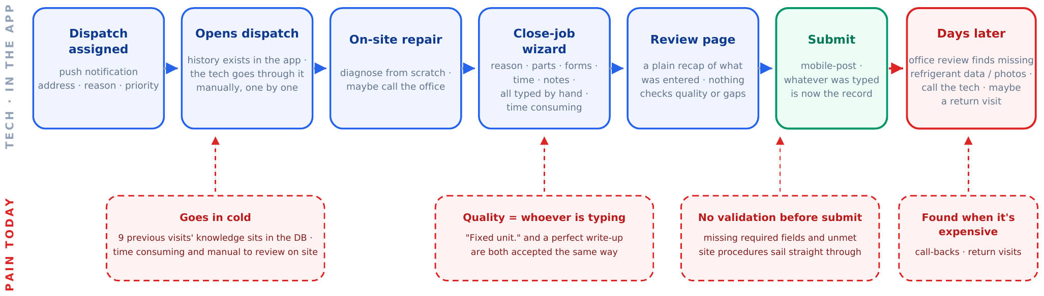
Left column = technician steps in the app; right column = where cost arises today (goes in cold, quality varies by typist, no validation before submit, problems found when expensive). Live version: stream1-unified-architecture.html.
Figure 6
Use Case B — the same visit with the AI Copilot
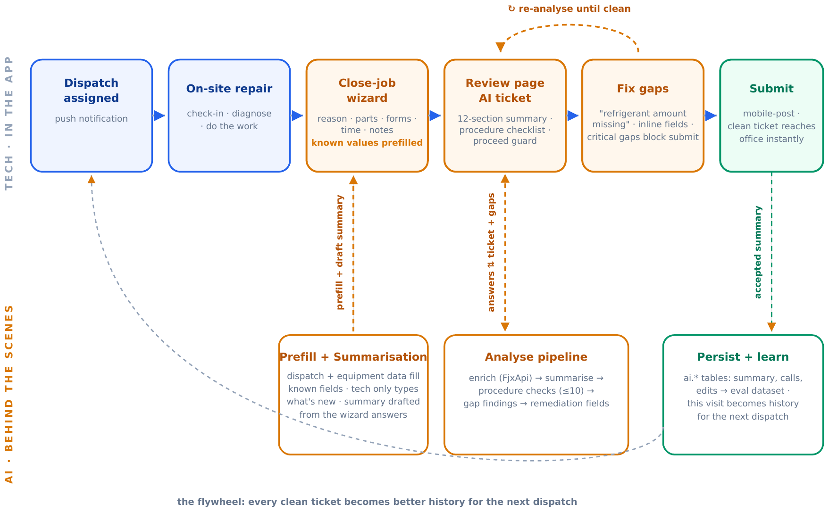
Left column = technician actions (unchanged journey); right column = AI work behind the scenes (briefing builder, prefill + summarisation, analyse pipeline, persist + learn). Blue = technician action; amber = AI-assisted step. Live version: stream1-unified-architecture.html.

C Parts Finder — Find & Allocate
For every part the technician needs, the app gathers every place it can be collected and orders them so the closest free stock comes first — the technician's own truck (on hand, zero distance), then other technicians' vans and branch warehouses (own stock, nearest first), and finally the United Refrigeration vendor. The needed quantity is then split greedily down that list: each source contributes what it has until the quantity is met.
Figure 7
Use Case C — four-source find and greedy allocate
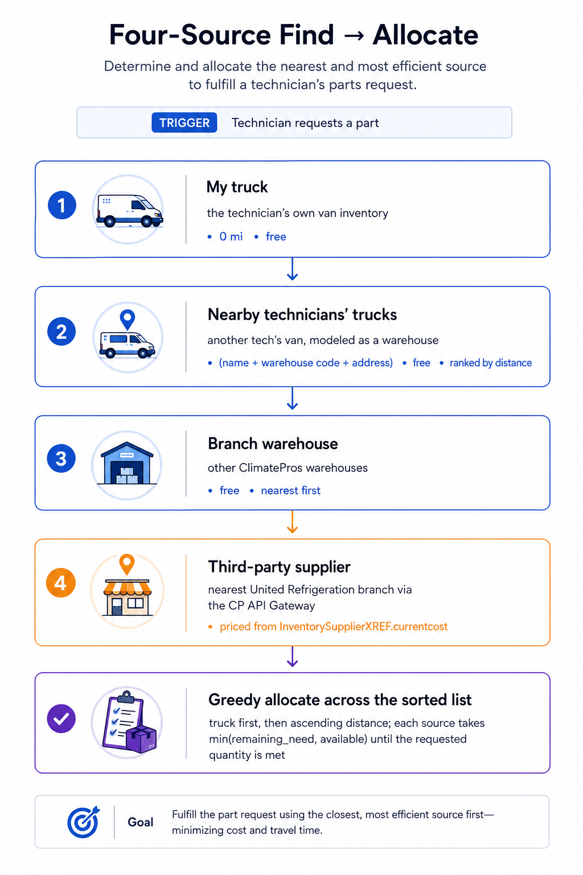
Truck → nearby technicians' trucks → branch warehouse → third-party supplier, then greedy allocation down the sorted list. Steps are written out above.
A van is a warehouse. Per operations, there is no separate "nearby technician" tier — another tech's van is modelled as a warehouse, which keeps the sourcing model to three underlying data tiers (truck / warehouse / vendor) while the technician-facing flow above still reads as four distinct sources.

Vendor lookup fails → drop the tier, not the request. If the United Refrigeration lookup fails, the vendor tier is dropped rather than failing the whole request — the technician still sees every own-stock option (truck + warehouse). See §11 Onboarding & Fault Tolerance.

06 Core Logic (per use case)
The algorithms and pipelines behind the flows in §5, lifted at full fidelity — every formula, weight, table and worked example intact, not condensed: how A ranks a shortlist of technicians, how B turns wizard answers into a 12-section ticket (plus the deterministic retrieval and measured baseline it stands on), and how C predicts parts by retrieval and sources them across three tiers.

A Auto-Dispatch — Ranking Algorithm
This is the detail behind step 3 (“Rank the technicians”) of the assignment loop in §5. It turns each candidate's availability, distance, and visit history into a single ordered shortlist. One formula covers every case — its behavior is tuned by a single weight w chosen from the job's dispatch type.

Inputs
● free i — minutes until technician i is available (time left on current job)
● dist i — miles from technician i to the jobsite
● visits i — prior visits by technician i to this customer (familiarity)
● AVG_SPEED — average truck speed in mph, a configurable constant
dispatchType — Emergency · High Priority · Medium Priority
↓

Step A — unify availability + distance into one ETA
Distance can't be compared to wait-time directly. Convert distance to travel time using the average truck speed, then add the wait, so every technician collapses to one number: minutes-until-on-site. Lower is better.
travel_i = (dist_i / AVG_SPEED) * 60 # miles -> minutes
eta_i = free_i + travel_i # total minutes until tech is on site

↓

Step B — weighted score
Blend ETA and visit count into one score. Both must be on a 0–1 scale where higher is better, so min-max normalize each across this candidate set, then weight by w (the speed share). A pure ranking is just an endpoint: w=1 sorts by ETA only, w=0 by visits only — no separate sort needed.
speed_score_i = (eta_max - eta_i) / (eta_max - eta_min) # lowest eta -> 1.0
fam_score_i = (visits_i - visits_min)/ (visits_max - visits_min) # most visits -> 1.0

score_i = w * speed_score_i + (1 - w) * fam_score_i # w = speed weight
# sort score_i descending -> rank 1 = offer target

Edge cases: a single candidate is rank 1 by default; if all ETAs tie the speed term is flat and familiarity breaks the tie (and vice-versa).
↓

Step C — pick w from the dispatch type
Emergency and Medium are just the two ends (w=1, w=0) of the same combined formula — so one code path serves all three.
Dispatch Type | Strategy | w (speed) | Result
Emergency | Speed-Based (locked) | 1.0 | Pure ETA; familiarity ignored — lowest combined time wins
High Priority | Combined | 0.2 (Speed 20 / Fam 80) | Weighted blend; weight configurable per strategy
Medium Priority | Familiarity-Based | 0.0 | Pure visit count — most familiar tech wins

One formula, three behaviors: the dispatch type only sets w. Emergency (w=1) reduces to pure speed, Medium (w=0) to pure familiarity, High blends them — no separate ranking code per type. The resulting ordered shortlist feeds directly into step 4 (offer to the top-ranked technician) in §5.
Future factor — skill gate: when technician skill data is available (1 ≤ skill i ≤ 5) and a job carries a minimum required skill, it enters as a hard gate, not a score term. Filter it in step 1 when building the candidate list — keep technician i only if skill i ≥ job.minSkill — so under-skilled technicians never reach ranking. The speed/familiarity scoring is untouched; only the candidate set shrinks.
Need | Mechanism
Same-site history (briefing) | Keyed SQL query: past visit digests for the same customer and site, most recent first.
Similar past issues (briefing) | Deterministic lookup: 2–3 recent dispatches with the same equipment type and problem code are pulled and handed to the LLM as context. No embeddings, no similarity index.
Part suggestions | SQL co-occurrence: a frequency table keyed on (equipment manufacturer type × problem code) → most-used parts, with fallback to equipment type alone, then global top parts. One SQL aggregation, fully explainable.
Compliance procedures | Always fetched live from the source system, never cached or embedded: they are compliance-critical and change.
Suggestions shown (k) | Hit rate
Top 1 | 18.6%
Top 3 | 31.8%
Top 5 | 39.9%
Top 10 | 52.1%
Question | Answer
Is it part of this architecture? | No. Decided 2026-07-07: it added infrastructure cost and operational surface without validated benefit.
When would we add it? | Only if evals show deterministic retrieval misses relevant history that semantic search over the free-text fields would find, and the gain beats the baseline by enough to pay for the pipeline.
How would it slot in? | Behind the existing retrieval abstraction: the briefing builder swaps its SQL lookup for a filtered similarity query; nothing else in the architecture changes. Embeddings can run on the private gateway's nomic-embed model, keeping data in client infrastructure.
Structure | Key | Purpose
STREAM | dispatch:stream | Durable buffer of incoming dispatch requests between the .NET Legacy API on AWS EC2 and the ECS Fargate workers. Consumed via a consumer group (XREADGROUP) — all N workers compete; each message goes to exactly one worker.
MUTEX | lock:tech:{techId} | Per-technician distributed lock. A request acquires locks on its candidate technicians before offering, in a fixed order (e.g. ascending techId) to avoid deadlock between overlapping requests. Requests with disjoint candidates run in parallel — even in the same division; requests sharing a technician serialize on that lock, so a tech is never double-offered. TTL self-releases on a crashed worker.
LIST | resp:{dispatchId}:{techId} | Per-technician reply channel. The AWS EC2 API LPUSH es the Accept/Reject; the worker BLPOP s it — instant wake, no polling. EXPIRE 60s self-cleans.

Core Logic: Summarise Pipeline & Retrieval
Inputs to the summarisation pipeline:
- wizard_answers: reason, parts, time, notes, completed forms from the mobile app
- context: equipment specs, completed forms, procedures read live from existing APIs
- ticket_standard.md: versioned prompt template defining the 12-section ticket structure
- history: SQL co-occurrence table (equipment type × problem code → most-used parts)
Pipeline stages:
- Compile & forward: mobile app → .NET proxy (validates auth) → FastAPI, one POST /api/v1/summarise call
- Enrich, prompt, generate: context reads run in parallel, fail-soft → merged into prompt from ticket_standard.md → one LLM call (~6–7s) → draft ticket + procedure checks as structured data
- Normalize & submit: draft mapped to fixed 12-section structure → deterministic rules override known sections → technician fixes gaps inline → submit writes through existing path

Retrieval Mechanism
Field | Type / notes
_id | ObjectId · primary key
dispatchId | int · reference to the SQL Server dispatch, carried in the request payload — not a database foreign key
sections | array · the 12 sections
procedureResults | array
status | draft / accepted
acceptedAt | date
embedding | array<double> · optional, stage 1
Field | Type / notes
_id | ObjectId · primary key
dispatchId | int
provider / model | gateway · qwen3-vl
tokensIn / tokensOut | int
latencyMs | int
outcome | ok / parse_fail / error
Field | Type / notes
_id | ObjectId · primary key
summaryId | reference → summaries._id
section | which of the 12
beforeText / afterText | the correction
editedBy / editedAt | who · when

Data & Schema

Storage Model
All AI output persists in the AI service's own MongoDB on Azure (Azure Cosmos DB for MongoDB, vCore)—a datastore owned entirely by the FastAPI AI service with no connection to the AWS SQL Server system of record. This separation ensures zero coupling with business tables and keeps the AI footprint auditable, independently backed up, and dropable without risk to operational data.

MongoDB Collections
Open items: collection and index design sign-off with the client DBA, and definition of the dispatch-completion trigger mechanism.

C Parts Finder — Data Model
Two stores cooperate. The existing SQL Server system of record (FieldJetX) owns the business data the Parts Finder reads — dispatches, the inventory catalogue, and stock by location — and the AI service only ever reads it, never writes to it. A separate vector index holds the semantic search index used for prediction, and the AI service's own MongoDB holds the data it writes: the parts a technician commits, acceptance signals, and indexing bookkeeping.
The relational database stays the single source of truth. Nothing in the existing business tables changes, and the vector index is derived and rebuildable.

08 API Reference
The full HTTP surface across all three use cases, lifted at full fidelity from each source design — every endpoint, parameter, and response shape kept intact. Only the caller-facing compute labels are updated to match this document's Azure-first infrastructure (§2 – §4) and the service renames already established there. Nothing in the request/response bodies themselves changes.

A Auto-Dispatch — API Reference
New endpoints introduced for Auto-Dispatch. Two callers: the admin dashboard (control plane — toggle & config) and the technician mobile app (data plane — push registration & replies). All existing endpoints (dispatch ingestion, dispatch status, technician location) are unchanged and out of scope here.
Method | Path | Caller | Purpose
POST | /divisions/{id}/toggle | Dashboard → AWS EC2 | Turn auto-dispatch ON/OFF for one division. Body { enabled: bool }. On enable: pull pending requests into the stream and scale the ECS Fargate pool up; on disable: drain and scale to zero (idle = $0).
PUT | /divisions/{id}/config | Dashboard → AWS EC2 | Update per-division ranking weights — distance, familiarity, priority, availability window. Body { weights: {...} }. Applied to the next assignment loop; no restart needed.
GET | /divisions/{id}/config | Dashboard → AWS EC2 | Read current toggle state + weights so the admin UI can render the switch position and weight sliders. Paired read for the two writes above.
POST | /devices/register | Mobile → AWS EC2 | Register/refresh a device push token. Body { techId, platform: ios|android, token }. AWS EC2 registers the device with Amazon SNS and stores techId → endpointArn. Re-posted whenever the OS rotates the token, so pushes never silently die.
POST | /technicians/{id}/availability | Mobile → AWS EC2 | Technician reports when they will be free. Body { availableAt }. Not tied to any dispatch — it updates the technician's general availability state, which the ranking loop reads for whichever request is being processed.
POST | /dispatches/{id}/respond | Mobile → AWS EC2 | Technician accepts/rejects a specific offer. Body { accept: bool }. Deduped via SETNX, then LPUSH ed to resp:{dispatchId}:{techId}; the worker's BLPOP wakes instantly.

Authentication
No new auth mechanism is introduced. Every endpoint sits behind the platform's existing auth middleware, by caller:
● Control plane (POST /divisions/{id}/toggle, PUT /divisions/{id}/config, GET /divisions/{id}/config) — behind the admin Dashboard auth, identical to the existing Dashboard endpoints. Only authenticated admins can toggle or reconfigure a division.
● Data plane (POST /devices/register, POST /technicians/{id}/availability, POST /dispatches/{id}/respond) — behind the technician mobile-app auth, identical to the existing technician endpoints. The authenticated technician identity must match the techId /technician in the path or body.

Error contract
All endpoints return the platform's standard error envelope so a client can handle failures uniformly:
{ "code": "string",
// stable machine code, e.g. DIVISION_NOT_FOUND

"message": "string",
// human-readable

"requestId": "string" }
// correlation id for tracing

Global status codes apply across all endpoints:
● 400 — malformed body / invalid field (e.g. weight out of range, unknown platform).
● 401 — missing/invalid credentials · 403 — authenticated but not permitted (e.g. non-admin hitting a control-plane route, technician acting for another techId).
● 404 — division / dispatch / technician not found.
● 409 — duplicate reply on /dispatches/{id}/respond (the SETNX dedupe already rejected it); the first reply stands.
● 500 — unexpected server error (correlate via requestId).

Two response types — two separate endpoints
The technician's two replies live at different paths because they have different scope:
● Availability — POST /technicians/{id}/availability. Tech-scoped, no dispatchId. A general "I'm free at …" answer to the availability poll during the ~1 min ranking window; updates the technician's availability record that ranking reads.
● Decision — POST /dispatches/{id}/respond. Dispatch-scoped. Accept/reject one specific offer; drives the offer loop, and a reject (or timeout) moves to the next ranked technician. This is the reply the worker is blocked on (BLPOP).
Method | Route | Purpose | Typical latency
POST | /api/v1/summarise | Wizard payload → 12-section ticket + procedure check results | ~6–7s (LLM-bound)
POST | /api/v1/analyse | Ticket → gap findings + inline remediation fields; re-run until clean | ~6–7s
GET | /api/v1/suggestions | Dispatch context (equipment type + problem code) → top-k part suggestions from the co-occurrence tables; deterministic, no LLM call | <200ms
GET | /admin/dashboard | Observability dashboard: edit-rate per section, latency, cost, parse failures, read from the AI MongoDB collections. Served by the same FastAPI container; no separate web app. | <500ms
GET | /health | Liveness probe for the Container Apps health check | <50ms

API Reference

Endpoints
All endpoints are REST with Pydantic models. The service is reachable only through the .NET proxy; there is no public endpoint.

Authentication & Error Contract
- Auth model: No client calls these routes directly. The .NET proxy is the only caller, authenticated by internal API key plus network trust (private Azure VNet). The dashboard is exposed through a .NET-proxied route with an admin-role check on the existing Entra token.
- Error codes: 400 validation · 401 missing/invalid credentials · 403 not permitted · 404 dispatch not found · 502 upstream failure · 503 prediction unavailable · 500 unexpected error
- Idempotency: /summarise and /analyse are read-only, side-effect free, and safe to retry

C Technician Parts Finder — API Reference
The FastAPI AI Server exposes a deliberately small HTTP surface, reached by FJX 2.2 through the .NET Microservices API's AI proxy route — the mobile app never calls the AI layer directly, and the proxy forwards exactly the two control endpoints (/parts/predict, /parts/source).
Endpoint | Purpose
GET /health | Liveness / deploy probe (load-balancer + Container Apps health checks; not proxied to clients).
POST /parts/predict | RAG-predicted parts for a dispatch — via the AI proxy route.
POST /parts/source | All sources per part — via the AI proxy route.

Scope: everything else the flow touches stays where it already lives: dispatch list/detail and the manual-add inventory tabs / catalog search are served by the existing .NET APIs, unchanged. The AI server does not serve or duplicate them — it reads the dispatch reason and stock context from the Legacy API, and calls the United CP Gateway server-side for the supplier tier.

POST /parts/predict
// request

{
"dispatchId"
:
"..."
}

// response → PredictedPart[]

[ {

"inventoryId"
:
"C066"
,

"name"
:
"Condenser Fan Motor 1/4 HP"
,

"partNumber"
:
"C066"
,

"confidence"
: 88,
// 20–95

"selected"
: true,
// pre-selected when confidence ≥ 60

"timesUsed"
: 3
} ]

Returns 503 when the prediction subsystem (embedding model / vector store) is unavailable — the client falls back to manual add. 502 on an upstream failure during prediction.

POST /parts/source
// request

{
"inventoryIds"
: [
"C066"
,
"24708"
],
"dispatchId"
:
"..."
,
"priority"
:
"Normal"
}

// response → SourcedPart[]

[ {

"inventoryId"
:
"C066"
,

"name"
:
"Condenser Fan Motor 1/4 HP"
,

"partNumber"
:
"C066"
,

"qtyNeeded"
: 1,

"sources"
: [ {

"tier"
:
"truck"
,
// truck | warehouse | vendor

"label"
:
"Your Truck — IL01 WH V1885"
,

"detail"
:
"Bin C2"
,

"distanceMi"
: 0.0,

"qtyAvailable"
: 2,

"price"
: null
// null for own stock; $ for vendor

} ]
} ]

Supplier integration — United CP Gateway (server-side, outbound)
For the vendor tier of /parts/source, the AI server calls the ClimatePros API Gateway for United Refrigeration from the backend — the contract below is the gateway's own shape, so the integration is a drop-in and the subscription key never leaves the server:
// request

{
"item"
:
"C066"
,
"coordinates"
: {
"latitude"
: 21.30,
"longitude"
: -157.85 },

"qty"
: 1,
"miles"
: 50,
"branchesIn"
: [],
"limit"
: 1 }

// response

{
"code"
: 100,
"success"
: true,
"response"
:
"OK"
,
"errors"
: [],

"inventory"
: [ {
"branchNo"
,
"address1"
,
"city"
,
"state"
,
"zipcd"
,

"phone"
,
"miles"
,
"workingHours"
,
"item"
,
"qtyAvail"
} ] }

Contract notes
Concern | Behavior
Auth | Bearer token from the FJX 2.2 session, validated at the .NET Microservices API before the AI proxy route forwards the call; the AI server is reachable only from inside the VNet. Supplier gateway calls use a subscription key held server-side (see §12 Non-goals & PII).
Errors | 400 validation · 404 dispatch not found · 502 upstream failure · 503 prediction unavailable.
CORS | Restricted to the FJX 2.2 mobile origin / native client in production.
Idempotency | Predict and source are read-only and side-effect free; safe to retry.

09 Observability & Evals
Two different concerns share this section. Observability is operational and unified: one tracing/logging layer, introduced fresh by this project (§3 Technology Stack, §4 Infrastructure), watches all three use cases the same way. Evals are about AI output quality and only apply where a model is in the loop — Auto-Dispatch (A) is a deterministic ranking formula (§6 Core Logic) with nothing to eval; Job Summarisation (B) already has a working, production-grounded eval loop, lifted at full fidelity below; Parts Finder (C) today only validates retrieval quality on a held-out set of recent dispatches and does not yet have B's correction-based feedback loop — closing that gap is future work, not part of this architecture.

Unified Observability — OpenTelemetry Tracing + CloudWatch / Azure Monitor Logs
Every service in Stream 1 — the AWS EC2 host running both .NET APIs, the AWS ECS Fargate dispatch-worker pool (A), the Azure Container Apps FastAPI AI server (B, C), the Redis-fed worker loop, and every vector-store call — emits OpenTelemetry traces and structured logs. AWS-side services report into CloudWatch; the Azure AI stack reports into an Azure Monitor workspace, and trace context is propagated across the single AWS→Azure hop so one dispatch is one trace (§3, §4). This was an abstract, “not yet designed” placeholder in the source design; here it is the one piece of infrastructure every use case shares, so it is specified once instead of three times.

Distributed traces
One trace per request, spanning every hop it takes — .NET proxy → Container Apps → AI server → LiteLLM → model, or .NET → Redis Stream → worker → SQL Server. The cross-cloud hop to AWS SQL Server (§4) is a span like any other, so the added round-trip is visible, not hidden.

Structured logs
Every service logs to Azure Monitor in one schema. Each entry carries the same requestId issued in the error envelope (§8 API Reference), so a failed call traces from the client-visible error code back through every hop it touched.

Correlation
requestId is the join key across traces, logs, and the AI-specific tables in §7 Data & Schema (the llm_calls collection, the summary_edits collection) — so a slow trace, a log line, and an eval finding for the same request all resolve to one id.
P95 targets — open item: §4 Infrastructure flags that cross-cloud AWS SQL Server round-trips must be budgeted into per-flow P95 targets, especially the Auto-Dispatch worker's per-request SQL calls. No formal SLOs exist yet in any of the three source designs; the inputs this document already establishes are the ~1 min technician-availability window and BLPOP reply-wait timeout (A, §5 Operational Flows), the ~6–7s LLM-bound /summarise / /analyse calls (B, §8), and the <200ms / <50ms deterministic endpoints (B/C, §8). Setting numeric P95 targets per flow, inclusive of the cross-cloud SQL leg, is follow-up work once Azure Monitor is live and has real traffic to baseline against — not something any source design specified.

B Evals — the Feedback Loop
Every AI interaction is persisted in the client's own database, so quality is measured from production reality, not vibes.

The feedback loop
Log everything → corrections become ground truth → changes must beat the eval set.
● the llm_calls collection records provider, model, tokens, latency, and outcome for every call: cost and reliability are queryable at any time.
● the summary_edits collection records every human correction to an AI section: this is labelled ground truth generated by normal usage.
● Eval set is built from those corrected rows and re-run before any prompt, ticket-standard, or provider/model change ships.
● Headline metric: edit-rate per section: which of the 12 sections the AI gets right, tracked over time and per customer.
Traceability: because prompts are built from a versioned ticket_standard.md and every call is logged with its model id, any ticket in production can be traced back to exactly which standard version and model produced it.
How we view it: a lightweight dashboard page (GET /admin/dashboard, §8 API Reference) is served by the same FastAPI container and reads straight from the AI MongoDB collections: no separate web app, no new hosting. Access is proxied through the .NET backend with an admin-role check on the existing Entra token, the same pattern as every other AI route, so the service stays fully private and no new login surface is created. Eval runs themselves are offline jobs over the summary_edits collection, not a hosted service.
The eval set inherits weak labels, not clean ones: the same audit that shaped the retrieval baseline (§6 Core Logic · B · Label-quality reality) found the structured outcome codes are mostly dead signal — root-cause/failure codes unused since 2021, problem code OTHER at 38%, summary code SERVICE for 88% of filled rows. The real predictive signal is free text (DispatchReason, technician notes). the summary_edits collection works around this because it labels the model's actual output, not the weak structured codes — but it also means the eval set is only as good as what technicians bother to correct, not an independently audited ground truth.

10 Cost Projection
One shared infra bill across A/B/C — same compute tiers, same fixed floor. A use case only shows up as a load driver (dispatch hours-on, B+C call volume), not a separate section.
Figures below are for one environment only (e.g. prod). Dev/Staging add cost on top — each environment duplicates this bill.
Pending re-pricing: Azure lines (Container Apps, vector store, Monitor) below use carried-over AWS rate-card estimates, not real Azure prices yet. Cosmos DB (Mongo vCore) is a real Azure quote, unverified for region/tier.

Compute Sizing
New tiers scale horizontally (more replicas), not vertically (bigger box). Baseline 0.5 vCPU / 1 GB handles 60+ concurrent dispatches per instance.
Component | Instance size | Scaling | Notes
Dispatch workers (ECS Fargate) — AWS | 0.5 vCPU / 1 GB | Scale 0–1 on Auto-Dispatch toggle | 60+ concurrent dispatches/instance
AI server (FastAPI) — Azure | 0.5 vCPU / 1 GB | Scale 1–N on request concurrency | Shared B & C; min 1 replica, no cold-start
ElastiCache for Redis — AWS | Managed tier | Fixed; sized to queue depth | No-eviction, persistence on
Vector store — Azure | Managed, serverless/free-tier scale | 3-4K embeddings — small, flat | Parts index (C); optional similar-incident index (B)
MongoDB (Cosmos DB for MongoDB vCore) — Azure | M10 tier (2 vCore / 8 GB) | Fixed tier; step up manually, not autoscale | AI stack's own store — summaries, part results, llm_calls, evals; no SQL Server coupling

Cost Formulas

AWS Fargate — dispatch workers
per_task_hour = (vCPU x rate_vcpu) + (GB x rate_mem)
monthly_cost = N x H x 30 x per_task_hour

vCPU = 0.5, rate_vcpu = $0.04048/hr
GB = 1, rate_mem = $0.004445/hr
-> per_task_hour = $0.024685

N = tasks (0 or 1 — scale-to-zero)
H = hours ON per day

Fixed / near-fixed lines
ElastiCache Redis = $0.032/hr x 730 hr = ~$23.36/mo (fixed, no-eviction)
SNS push = 500 dispatches/day x 5 techs x 30 = 75,000 pushes/mo
= 75,000 x $0.50/1,000,000 = ~$0.04/mo
Container Apps (AI) = $20 - $40/mo (1-2 replicas, 0.5 vCPU / 1 GB)
Vector store = ~$5/mo flat (3-4K embeddings, serverless/free-tier scale)
Azure Monitor + OTel= $15 - $30/mo
Cosmos DB Mongo(vCore) M10 = $0.129/hr x 730 hr = ~$94/mo flat

Unified Monthly Cost by Scenario
Total/mo | ~$159  Light (2h/day) | ~$182 – $185  Typical (8h/day) | ~$220 – $235  Heavy (24×7)

Component | Light (2h/day) | Typical (8h/day) | Heavy (24×7)
Dispatch workers — Fargate | ~$1.48 | ~$5.92 | ~$17.77
AI server — Container Apps | ~$20 | ~$30 | ~$40
Redis (fixed) | ~$23.36 | ~$23.36 | ~$23.36
SNS push | ~$0.04 | ~$0.04 | ~$0.04
Vector store (flat) | ~$5 | ~$5 | ~$5
Monitor + OTel | ~$15 | ~$22 | ~$30
MongoDB — Cosmos DB vCore (flat) | ~$94 | ~$94 | ~$94
Variable — per B+C call | < $1 | ~$2 – $5 | ~$10 – $25
Total/mo (est.) | ~$159 | ~$182 – $185 | ~$220 – $235

Fixed floor (Redis + vector store + Mongo + Monitor) ≈ $137–$152/mo regardless of traffic; only Fargate + Container Apps + variable calls scale down toward zero.

Database & Cross-Cloud Egress
SQL Server stays on AWS, unchanged — no incremental cost. Only cross-cloud line: the AWS→Azure AI request/response (B/C egress).
Component | Cloud | ~ Monthly
AWS SQL Server | AWS | Existing, sunk — no incremental cost
Cross-cloud egress (AWS → Azure AI calls) | AWS egress | TBD — needs a traffic estimate; get an AWS Data Transfer OUT quote once real volume is known

11 Onboarding & Fault Tolerance
Two questions per use case: how it gets from an empty production environment to live technician traffic, and how it behaves when something it depends on fails. The rollout shape is identical for all three — only the contents of each phase differ.
Deployment follows the existing FieldJetX development team's process. Their pipelines, their staging → production promotion, their release windows, their rollback. Stream 1 adds no new deployment tooling: the dispatch worker image and the .NET proxy route ride the client's established pipeline on the shared EC2 host, and any client-owned code change is scheduled with their team rather than ours.

How every rollout runs
Phase | Purpose | Gate before the next phase
0 · Provision | Stand up the infrastructure the feature cannot start without — network, hosting, queues, stores, credentials. | Every dependency reachable and health-checked
1 · Seed | Load the data the logic reads on its very first request: config, schema, indexes, history. | Nothing is empty at first call — no cold start
2 · Roll out | Ship the client experience behind a flag or app-version gate, to a pilot cohort only. | Pilot cohort live; everyone else unchanged
3 · Go live | Monitoring first, then one division/branch, then expand. | Pilot clean on its own metrics before widening

Each environment is fully isolated — separate queues, databases, indexes and keys — so a staging run can never touch live technician or customer data.

A Auto-Dispatch

Onboarding
Phase | What Auto-Dispatch needs | Cleared when
0 · Provision | ElastiCache for Redis cluster up with the consumer group created (XGROUP CREATE dispatch:stream) — workers cannot read the stream before it exists. Worker image in ECR, ECS Fargate task definition, scale 0↔N policy. Amazon SNS platform applications for APNs (Apple .p8) and FCM. IAM: SNS publish, ECS scale control, ElastiCache access. | Workers consume the stream, and /devices/register has live push credentials behind it
1 · Seed per division | Ranking weights — distance, familiarity, priority, availability window — written into SQL Server. Toggle defaults OFF for every division. Escalation target (the human dispatcher queue) defined. Technician records carry division, location source and skills. | Config and an escalation target exist for every division; nothing auto-dispatches yet
2 · Roll out push | Push-enabled app build with a minimum-version gate. New technicians register at sign-up; existing ones register on first open of the updated build. The app re-registers on OS token rotation and a periodic refresh, upserting on (techId, token). | Push-adoption % climbing per division
3 · Go live | Monitoring first — push adoption, stream lag, lock-hold time, BLPOP timeout rate. Pilot one division, validate exactly-once assignment and escalation end to end, then expand division by division. | Pilot clean; manual fallback retired as adoption nears 100%

The one cohort with a gap: a technician who has not yet opened the push-enabled build has no installation id, so Amazon SNS cannot ring them. They are skipped to manual assignment — never offered a job they cannot receive — and rejoin automatically on their next token refresh. No migration job and no per-technician provisioning.

New personal data: the push token and its SNS endpointArn (techId → endpointArn) are the only new PII this project stores — encrypted at rest, limited to the dispatch backend, overwritten on rotation and cleaned up when dead. Technician location is read from the platform's existing system, not newly stored.

Fault Tolerance
A dispatch is handed to exactly one worker, and the queue tracks it as handed out but not finished until that worker marks it done.
Failure | Behaviour | Why it is safe
Worker dies mid-dispatch | The request stays flagged unfinished; after the visibility timeout another worker claims and completes it | Nothing is lost — the request is recovered without an operator
Worker is slow, not dead | It still holds the per-technician claim, so the worker attempting takeover is blocked | No double offer — the same job never reaches two technicians
Worker truly crashed | Its claim releases automatically after a short hold, and a healthy worker takes over | The claim is the arbiter: still held means stay out, released means go ahead
No technician accepts | The 30-second offer window cascades down the shortlist, then escalates to a human dispatcher | A job is never silently dropped

Net effect — exactly-once: every request is processed even if a worker dies, and no request is processed twice even if a worker is slow.

B Job Summarisation

Onboarding
Phase | What the copilot needs | Cleared when
0 · Provision | Private subnet and internal load balancer (idle timeout ≥ 120 s) — the AI service gets no public URL. FastAPI image in the registry, always-on at min 2 instances on Azure Container Apps (the shared service that also serves C). Network path and key for the client's private model gateway. Secrets — gateway key, internal proxy key, FJX_API_TOKEN — in Azure Key Vault, never in code or images. The .NET proxy route is client-owned code, so it is scheduled with their team. | AI service reachable privately; models answer; no secret outside the vault
1 · Seed | DBA sign-off on the read-only SQL Server account, then the AI MongoDB database and its collections (summaries, llm_calls, summary_edits) with indexes on Azure Cosmos DB for MongoDB. ticket_standard.md v1 agreed and frozen — every prompt and eval references a version. Co-occurrence tables seeded by one idempotent SQL aggregation over 12 months of dispatch/parts history. Pilot customers' compliance procedures verified current. | Schema, standard and history in place — gap checks have something to check against
2 · Roll out | Copilot build plus min-version gate for the pilot cohort. Older app versions keep today's manual review page and simply never call the AI route. Assignment trigger decided (poll vs .NET hook — open client item). Pilot cohort briefed: the AI drafts, they review, edit and submit. | Pilot branch live; every other branch unchanged
3 · Go live | Monitoring first — LLM latency and error rate, parse-failure rate, proxy timeout rate, edit-rate dashboard, all from llm_calls / summary_edits. Pilot one customer/branch on real dispatches, capture the edit-rate and call-back baseline, then expand branch by branch. | Baseline captured; any later prompt or model change passes the eval set first

Editing is contributing, not correcting. Technician edits feed the eval set (§9), so the pilot cohort is briefed that they stay accountable for the ticket — the copilot drafts, they sign off.

Fault Tolerance
Failure | Behaviour | Why it is safe
An enrichment read fails | Pipeline continues without that block (fail-soft) | The ticket is built from what is available; missing context costs quality, not availability
Private gateway outage | AI features degrade to the manual experience — plain recap, briefings and suggestions skipped; submission never blocked | The gateway is the single model dependency and AI is an overlay, so losing it loses assistance, not function
Gateway saturated | Calls queue with a timeout; throughput drops from 30–35 tok/s single-call to ~11 tok/s at 4 concurrent, and calls past the timeout fall back to the manual recap | Latency degrades gracefully; the ~10% pilot keeps concurrency low and capacity is watched in llm_calls
Malformed model output | Parser falls back to regex extraction, then MISSING placeholders | The app always receives exactly 12 sections — a bad generation cannot break the review page
A Container Apps instance dies | The load balancer routes to the remaining instance and Container Apps replaces the replica | Minimum 2 always-on instances, so no cold-start window
AI tier unreachable | Review page falls back to today's manual recap; submission never blocked | Worst case is the pre-copilot experience

System of record: AWS SQL Server stays the single source of truth. The AI tier writes only to its own MongoDB collections and never to SQL Server; job write-back rides the existing mobile-post path, so an AI failure cannot corrupt or block business data.

C Parts Finder

Onboarding
Phase | What the parts finder needs | Cleared when
0 · Provision | Azure Container Apps service on the private VNet with an internal load balancer, image built in CI. Azure-hosted vector store and index created; connectivity to the customer-hosted embedding model and LLM health-checked. Read-only path to AWS SQL Server plus connectivity to its own MongoDB, the .NET Legacy API and the United CP Gateway. MongoDB collections and indexes on Azure Cosmos DB; AI proxy route deployed on the same shared .NET route B uses. | All four sources and both models reachable
1 · Seed the index | Batch-embed historical completed dispatches on the self-hosted embedding model, idempotent upsert by dispatchNo. Validate retrieval quality on a held-out set of recent dispatches. | The index is never empty at go-live — the cold-start gap is closed from the platform's own history
2 · Roll out | Ship "Add Parts with AI" behind a feature flag, enabled per branch/division. Pilot a small technician cohort, watching acceptance rate and source mix (truck / warehouse / vendor, §6). | Flag on for the pilot cohort only
3 · Go live | Expand the flag division by division. Wire the on-completion re-embed pipeline so the index grows as dispatches close. | The self-learning loop runs without a separate retraining job

Fault Tolerance
Failure | Behaviour | Why it is safe
Models or vector store unavailable | /parts/predict returns 503; the client falls back to manual inventory add | The flow continues — prediction is an accelerator, not a gate
Supplier (United) outage or timeout | That vendor tier is dropped from the part's sources; own-stock truck and warehouse options still return | The request does not fail — a United outage cannot block a technician who only needed own stock
Model throttling or slowness | Retry with backoff and batched pacing at index time; request-time timeouts bound prediction latency | Transient throttling cannot corrupt the index
Duplicate or repeated indexing | Idempotent upsert keyed by dispatchNo | Re-running indexing never double-counts a dispatch
SQL Server slow or unavailable | Read replicas plus brief caching for hot stock lookups; sourcing surfaces last-known availability where safe | Degrades to slightly stale stock rather than no answer
Container Apps replica crash | Stateless replicas behind the load balancer; Container Apps replaces unhealthy ones (health-checked via /health) | No single replica is load-bearing

The vendor lookup is the only call in C that leaves the client's own infrastructure, which is why it is the one tier dropped independently rather than failing the whole /parts/source request.

Environments
Use case | Isolated per environment | Shared
A Auto-Dispatch | Own ElastiCache for Redis, own SQL Server database, own ECS Fargate service | Existing EC2 application host
B Job Summarisation | Own Container Apps service, own MongoDB database | Private model gateway, .NET proxy route
C Parts Finder | Own vector index, supplier gateway on a test key in staging and a production key in production | Container Apps service and AI proxy route shared with B

12 Non-goals & PII
Two boundaries, drawn once for all three use cases instead of three times: what each use case deliberately does not do, and what personal data this project touches. C's source design carries the only dedicated PII inventory of the three — lifted at full fidelity below — and A's one new piece of personal data (the device push token) was already catalogued in full where it is introduced, §11 Onboarding & Fault Tolerance.

Non-goals

A Auto-Dispatch
● Not route optimization — closest-available-responder, like a 911 dispatch. It ranks who answers next, not the most efficient multi-stop route.
● Deterministic, no LLM — a weighted-sum over stated inputs with configured (not learned) weights, so every assignment is explainable and repeatable.
● The existing manual dispatch flow is untouched — a division with the toggle OFF behaves exactly as today.
● No UI change beyond the toggle and its configuration (task count N).
● No change to the SQL Server system-of-record schema beyond dispatch status fields.

Onboarding & Fault Tolerance

Onboarding Phases

Phase 0: Infrastructure & Baseline
- Deploy FastAPI AI server to Azure Container Apps with health checks
- Provision Azure-hosted vector store (serverless, pay-per-use)
- Set up Azure Monitor workspace and OpenTelemetry collection
- Create MongoDB collections (summaries, llm_calls, summary_edits) with agreed indexes
- Establish .NET proxy routes to /api/v1/summarise and /api/v1/analyse

Phase 1: Staging & Validation
- Load historical dispatches into MongoDB for testing
- Run eval set against baseline ticket_standard.md and model
- Validate prompt, retrieval, and ticket normalization in staging
- Confirm Azure Monitor tracing and correlation across .NET → FastAPI → model
- Load test /api/v1/summarise and /api/v1/analyse under expected volume

Phase 2: Early Adopter Rollout
- Enable for one small team or branch; monitor edit-rate per section
- Collect summary_edits as ground truth from real technician corrections
- Re-run eval set weekly against growing correction set
- Tune ticket_standard.md or model based on observed corrections
- Build dashboard (GET /admin/dashboard) and verify observability

Phase 3: General Availability
- Roll out to all divisions; monitor latency, cost, and error rates
- Run eval set before any prompt, ticket-standard, or model change ships
- Establish SLO for /api/v1/summarise latency (target: p95 < 8s)
- Track edit-rate per section as KPI; set baseline from early-adopter data

Fault Tolerance

Context read fails (equipment specs, procedures, forms):
Fail-soft: skip the missing context and continue. The prompt is still built from available context + wizard answers, just less enriched. This may reduce ticket quality but does not block the technician.

LLM call fails or times out:
Fall back to manual entry. The technician proceeds without copilot assistance and types the ticket normally. The failure is logged (llm_calls with outcome: error) and alerted for investigation.

Vector store or embedding service unavailable:
Prediction is skipped; technician uses manual part entry. The /api/v1/suggestions endpoint returns 503; the client falls back to manual-add and catalog-search tabs.

MongoDB collection unavailable:
Do not block ticket submission. Log the failure and queue a retry asynchronously. The ticket is accepted by the technician and written back through the existing path; AI-side logging happens best-effort in the background.

.NET proxy to FastAPI connection fails:
Technician gets a graceful "Copilot unavailable" message and falls back to manual entry. The .NET proxy logs the failure and retries with exponential backoff (max 3 attempts, timeout 10s per attempt) before giving up.

C Parts Finder
● No price ranking, no ordering. The tech decides where to pick a part up — the system shows the part, the place and the distance, and stops there.
● One supplier for the POC (United, via the existing CP API Gateway); more suppliers is future work, not this scope.
● Not replacing technician judgment — predictions are suggestions the tech can add, swap or ignore, never auto-committed.
● No automatic purchasing or PO creation from the vendor, and no warehouse/inventory management — stock levels stay owned by the system of record.

PII inventory & data handling

C PII inventory & security controls
AWS-specific terms are reconciled to their Azure equivalents per §3 / §4 (private Azure VNet in place of AWS VPC, Azure Key Vault in place of AWS Secrets Manager/SSM Parameter Store); AWS SQL Server and the self-hosted embedding/LLM layer are unchanged.
Area | Control
Client → service auth | Bearer token from the FJX 2.2 session, validated at the .NET Microservices API before the AI proxy route forwards the call; CORS restricted to the mobile client.
Network isolation | The AI layer runs in a private Azure VNet — the FastAPI AI Server is not internet-reachable; only the .NET proxy route (and the VNet paths to SQL Server, the vector store, and the customer-hosted models) can reach it.
Model hosting | Embedding and LLM inference run on client-provided, self-hosted models on customer hardware — dispatch text and parts history are never sent to a third-party AI provider.
Supplier gateway | United calls carry the Ocp-Apim-Subscription-Key header; the key is held server-side only and never reaches the mobile client (§8 API Reference · Contract notes).
Secrets management | All credentials (gateway key, DB, model endpoints) resolved from a secret store — Azure Key Vault — with rotation. No secrets in source or images.
Data store access | Least-privilege SQL Server account: read-scoped on inventory and dispatch tables with no write grant at all; every AI write goes to its own MongoDB. Network-restricted to the service subnet.
Transport | TLS on all hops (client, proxy, gateway, model endpoints, internal service calls).

● Dispatch & customer detail (name, address, phone) — served to the authenticated technician only; excluded from log bodies (§9 Observability & Evals).
● Van / warehouse locations — used transiently for distance ordering; not persisted beyond short-lived caching.
● The vector store holds no direct customer PII — only dispatch reason text and used part numbers — reducing the sensitivity of the derived index (§7 Data & Schema).
Derived and rebuildable: because the Azure-hosted vector store is derived from SQL Server rather than an independent source of truth, it can be re-seeded at any time — supporting deletion and data-retention requests handled at the SQL Server layer.

A Device push token — see §11
Auto-Dispatch's one new piece of personal data — the push token and its Amazon SNS endpointArn (techId → endpointArn) — is catalogued in full where it is introduced: encrypted at rest, access-limited to the dispatch backend, retained only while the device is active. See the Device token / installation id = PII callout in §11 Onboarding & Fault Tolerance · Phase 2. Technician location itself is not newly stored by this project — distance/ETA reads the platform's existing location system, unchanged and out of scope here.

B C The history B and C learn from
ClimatePros has 10–12 years of operational data — 200,000+ jobs in the last six months alone, and 16.3 million note records across the full span. It is messy by the client's own admission: ~40% of notes are ≤40 characters, and the single most common note in the database is literally “checked history.” That is the problem B and C are solving, so it is also the data both inherit — B's eval set (§9) and C's retrieval index (§6, §7) are both built on it.
10–12 yrs  operational history | 200,000+  jobs, last 6 months | 16.3M  note records, full span | ~40%  notes ≤40 chars

Not trained on the raw dump. The corpus is de-duplicated down to unique cases first, and personally identifiable information is stripped before anything reaches a model — whether that model is B's summarisation/copilot pipeline or C's embedding index. This is a data-preparation step upstream of both §6 Core Logic pipelines, not a per-request runtime control like the table above.

Appendix A — Corrections applied during conversion
The source section fragments had drifted apart: §2a, §3 and §4 had been updated to the confirmed cloud placement while §5 and §7–§12 still carried an earlier Azure-first model. Every correction below applies one rule — AI-specific components on Azure, everything else on AWS — together with the AI-datastore decision (MongoDB on Azure, not an ai.* schema on SQL Server). No other source content was altered, and no figures, formulas or API parameters were changed.
Terminology replaced throughout
Was | Now | Sections | Occurrences
Azure Cache for Redis | Amazon ElastiCache for Redis | §7, §10, §11 | 10
Azure Notification Hubs | Amazon SNS | §5, §10, §11 | 4
Azure VM | AWS EC2 | §2, §5, §7, §8, §9, §10, §11 | 17
Notification Hubs | Amazon SNS | §2, §5, §8, §10, §11, §12 | 15
ai.* tables | the AI MongoDB collections | §5 | 1
ai.llm_calls | the llm_calls collection | §5, §7, §9, §11 | 6
ai.summaries | the summaries collection | §5, §6, §7 | 4
ai.summary_edits | the summary_edits collection | §5, §7, §9, §11 | 7
device installation id | platform endpoint ARN | §5 | 1
deviceInstallationId | endpointArn | §8, §11, §12 | 6

Statements rewritten (each corrected a claim that contradicted the cloud rule or the MongoDB decision)
Correction | Section
intro — Azure relabelling premise removed; A prices as AWS | §10
callout — re-pricing scoped to the Azure AI lines | §10
A — variable cost is the Fargate pool | §10
A — rate provenance now matches the services bought | §10
heading — Fargate formula is the live formula | §10
Fargate task rate — flagged sizing conflict with §4 | §10
code — ElastiCache line and real instance class | §10
code — SNS push line | §10
scenario table header — AWS service names | §10
table footnote — provenance and cache instance class | §10
scale-to-zero note — Fargate | §10
scale-to-zero note — ElastiCache floor | §10
vector store line — flagged for Azure re-pricing | §10
formula legend — ECS Fargate tasks | §10
egress heading & intro — the seam is the AI request, not the database | §10
egress table — rows rescoped to the AI-request hop | §10
egress note — A stays in AWS; only B/C requests cross | §10
A Phase 0 — ECS Fargate + ECR, sizing conflict flagged | §11
A Phase 0 — IAM instead of Azure RBAC | §11
A environments — per-env Fargate service | §11
B Phase 1 — MongoDB collections replace the SQL ai.* schema | §11
B environments — per-env MongoDB database | §11
B fault tolerance — AI writes are MongoDB-only | §11
C Phase 0 — read-only SQL access, writes to MongoDB | §11
C Phase 0 — MongoDB provisioning replaces SQL migration | §11
data-store access — SQL account is read-only | §12
2b Use Case A caption — cloud placement corrected | §2
2b B&C caption — stale "no AWS managed service" claim removed | §2
AI datastore — ai.* on SQL Server → MongoDB on Azure | §2
2b A summary line — ECS Fargate worker | §2
Database row — AI output goes to MongoDB, not a SQL ai.* schema | §3
A step 1 — dispatch workers are ECS Fargate, not Container Apps | §5
push round-trip step 1 — SNS Publish, ECS Fargate worker | §5
push round-trip step 2 — SNS platform application wording | §5
intro — ECS Fargate task walkthroughs | §5
briefing builder — cached in MongoDB | §5
intro — AI output store is MongoDB, not an ai.* SQL schema | §7
A heading body — Container Apps pool → ECS Fargate pool | §7
STREAM row — producer/consumer are EC2 and ECS Fargate | §7
B — relational ai.* schema rewritten as MongoDB collections | §7
C intro — AI writes go to MongoDB, not a SQL ai.* schema | §7
C — ai.* schema section rewritten as MongoDB + learning-loop trigger stated | §7
/admin/dashboard — reads MongoDB collections | §8
/divisions/{id}/toggle — scales the ECS Fargate pool | §8
heading — both clouds’ log sinks named | §9
scope sentence — A is not an AI tier; split CloudWatch / Azure Monitor | §9
dashboard — reads MongoDB collections | §9

Appendix B — Open items
Carried from the source sections plus the two conflicts surfaced by this conversion. Each needs a ClimatePros owner before this document can move from draft to agreed.
# | Open item | Where | Why it matters
1 | Dispatch-worker task size: §4 Compute sizing specifies 0.5 vCPU / 1 GB; §10 Cost Projection and §11 Phase 0 both assume 1 vCPU / 2 GB. | §4, §10, §11 | The cost formula and the ECS task definition are built from this number; the two figures give different monthly totals.
2 | Azure re-pricing for the AI lines — Container Apps, the chosen vector store, and Azure Monitor. | §10 | Those figures are still AWS-sourced rates. Use Case A’s AWS figures now stand as-is.
3 | Vector store selection: §4 lists Azure AI Search / Pinecone as candidates; §3 marks the store experimental; §6 B states the index is out of scope pending evals, while §6 C actively searches it. | §3, §4, §6 | C needs a store at go-live; B only if evals justify it. The selection and the C-only scope should be stated explicitly.
4 | Learning-loop trigger for C: the AI server has no SQL Server connection, so dispatch completion must be pushed to it by the .NET side rather than polled. | §6 C, §7 C | Without a confirmed trigger the self-learning index never updates.
5 | MongoDB collection and index design sign-off with the client DBA (replaces the earlier ai.* DDL approval). | §7 B | Determines query performance for briefing retrieval and the eval dashboards.
6 | Dispatch-assignment trigger mechanism for the B briefing builder. | §5 B, §7 B | The briefing must start building at assignment time to be warm when the technician opens the job.
7 | Per-division lock model: the §2 diagram still shows a per-division lock (lock:div:*); the implemented model locks per candidate technician. Diagram redraw pending. | §2, §7 A | The diagram and the implementation disagree on concurrency behaviour.
8 | Cross-cloud network path: site-to-site VPN or VPC-to-VNet peering is the target state; the interim fallback is a public HTTPS endpoint with IP allow-listing / mTLS. | §4 | Security review and the P95 latency budget in §9 both depend on which one ships.
9 | Push token / endpoint ARN is the one new piece of personal data this project stores. | §11, §12 | Needs to be reflected in the PII inventory and retention policy.
10 | CLAUDE.md in the source repository still describes the older Azure-first model (“Azure except the AWS SQL Server database”) and names Azure Notification Hubs and Azure Cache for Redis. | repository | Future edits made from that guidance would reintroduce the mismatches corrected here.

