Magic Lantern Workbench: Kitsu and Keycloak integration, architecture overview
Kitsu fork, branch magiclantern. File: doc/MLW_Integration.docx

1. Summary
Kitsu users and their roles come from a Keycloak server. People still sign in with the standard Kitsu login form. Kitsu itself needed no code change: the work is in Zou, the API behind Kitsu, which checks the password with Keycloak and maps Keycloak roles to Kitsu roles.

1.1 Documents
Document | Repository and branch | Covers
This document | kitsu, magiclantern (https://github.com/magic-lantern-workbench/kitsu/blob/magiclantern/doc/MLW_Integration.docx) | Architecture, flows, diagrams, status.
Zou: Keycloak authentication with role mapping | zou, magiclantern (https://github.com/magic-lantern-workbench/zou/blob/magiclantern/doc/MLW_Integration.docx) | How the auth strategy and the role mapping work, settings, errors, tests.
mlw-zou-docker: Keycloak settings | mlw-zou-docker, main (https://github.com/magic-lantern-workbench/mlw-zou-docker/blob/main/doc/MLW_Integration.docx) | How the settings reach Zou in Docker, how to turn it on, how to check it.

2. Components
Component | Repository | Role in the integration
Kitsu (this repository) | kitsu, branch magiclantern | Web front end. Posts the login form to /api/auth/login. Unchanged for this feature.
Zou | zou, branch magiclantern | REST API. The auth_remote_keycloak strategy checks credentials with Keycloak and creates or updates the person and its role.
Docker packaging | mlw-zou-docker, main | Builds Zou from the magiclantern branch and starts it with PostgreSQL, Redis and Meilisearch. Passes the KEYCLOAK_* settings.
Keycloak | external, port 8180 | Realm mlw, client mlw-kitsu (public, direct access grants on), realm role mlw-kitsu-user.

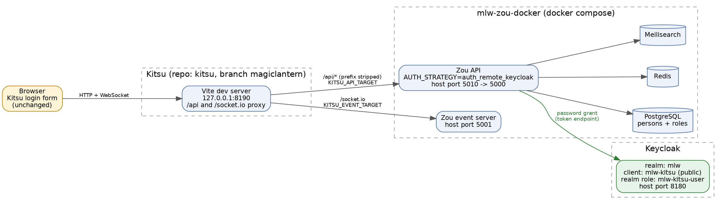
Figure 1. Components and connections
The Kitsu dev server proxies /api to Zou (KITSU_API_TARGET, stripping the /api prefix) and /socket.io to the event server (KITSU_EVENT_TARGET). The browser never talks to Keycloak.

3. Login flow
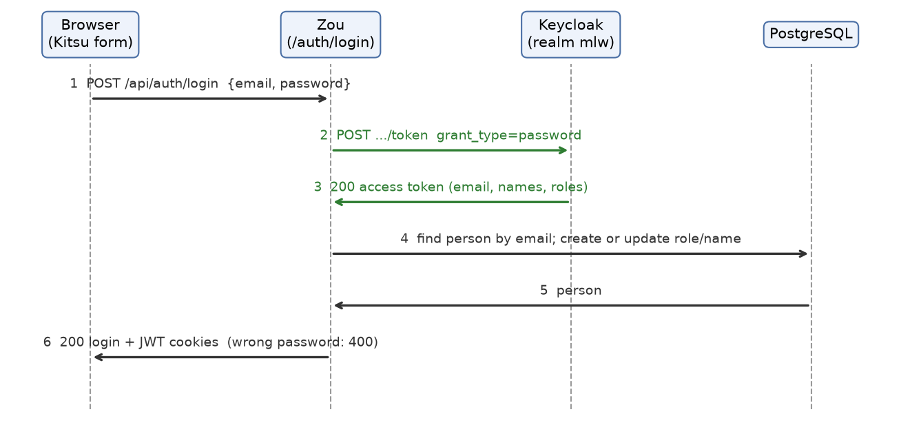
Figure 2. Login sequence
- The user types an email (or the Keycloak username) and a password in the normal Kitsu login form.
- Kitsu posts them to /api/auth/login, which the proxy forwards to Zou's /auth/login.
- Zou sends a password grant to Keycloak's token endpoint for realm mlw and client mlw-kitsu.
- Keycloak answers with an access token holding the email, the names and the roles, or refuses the credentials.
- Zou creates the Kitsu person on the first login, or updates the name and role, then issues its usual session cookies.
What the user sees is the same as before: a login form, then the Kitsu home page. A wrong password shows the standard "Wrong email or password" message.

4. Users and roles
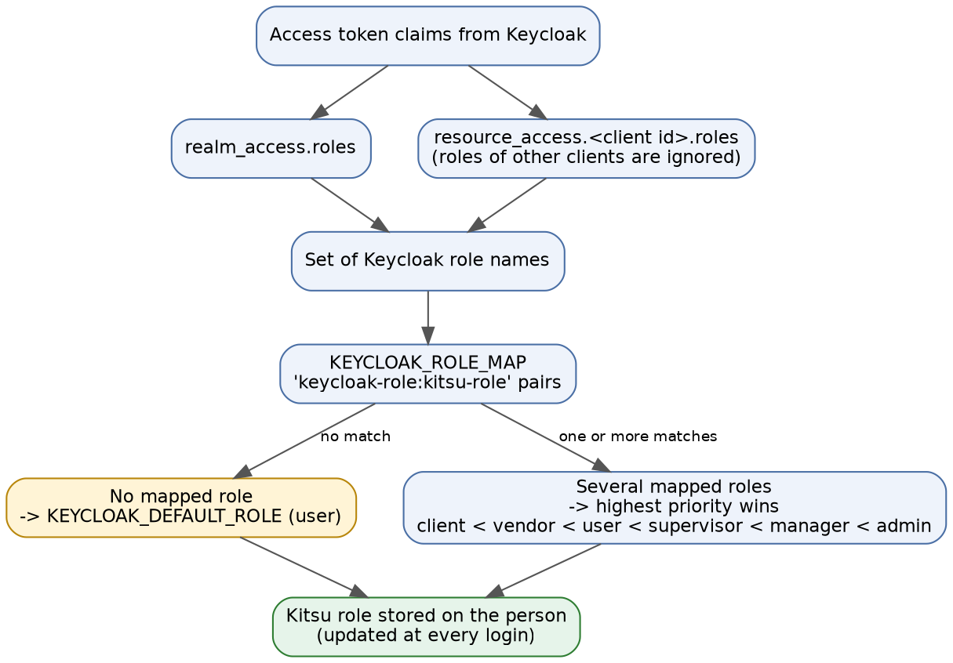
Figure 3. From Keycloak roles to a Kitsu role
Kitsu has six roles: client, vendor, user (Artist), supervisor, manager and admin (Studio Manager). KEYCLOAK_ROLE_MAP pairs Keycloak role names with them, the most privileged match wins, and KEYCLOAK_DEFAULT_ROLE applies when nothing matches. Details and examples are in the Zou document (https://github.com/magic-lantern-workbench/zou/blob/magiclantern/doc/MLW_Integration.docx).
Keycloak | Kitsu
User in realm mlw | Person, created at the first login, matched by email
email, given_name, family_name claims | Email, first name, last name
Realm role mlw-kitsu-user | Role user (Artist), with KEYCLOAK_ROLE_MAP=mlw-kitsu-user:user
Password | Never stored in Kitsu: the person gets a random local password nobody knows

5. What stays in Kitsu
- The login page. Its single sign-on buttons for SAML and OIDC show only when Zou reports those as enabled, which they are not here, so the original form is all the user sees.
- Everything about projects, tasks and permissions: Kitsu still decides what a person can do from their role.
- The local administrator account. Addresses in Zou's PROTECTED_ACCOUNTS skip Keycloak and keep a local password.

6. Running it
Zou with the Keycloak settings (see the mlw-zou-docker document, https://github.com/magic-lantern-workbench/mlw-zou-docker/blob/main/doc/MLW_Integration.docx), then the Kitsu dev server:
KITSU_API_TARGET=http://localhost:5010 KITSU_EVENT_TARGET=http://localhost:5001 \
npm run dev -- --port 8190 --strictPort

Open http://127.0.0.1:8190/. Port 8080 is the default in vite.config.js; 8190 is used here because 8080 is taken.

7. Status and limits
Item | State
Zou strategy and role mapping | Done and pushed. Tests pass. Checked against the real mlw realm: login by email and by username, wrong password, person creation.
Docker settings | Done and pushed. docker compose config accepts the file.
Zou in the container against Keycloak | Not yet checked. Needs a shared network between the containers (see the mlw-zou-docker document).
Login from the Kitsu page in a browser | Not yet checked. Expected to work: the page posts the same request that was tested.
Removing or disabling a user in Keycloak | The user can no longer sign in, but the Kitsu person stays active. A periodic sync is not built.
Password change screen in Kitsu | Still visible, but changing the password has no effect on login for Keycloak users.
Keycloak 2FA | Cannot run with the password grant. Zou's own 2FA can still be used.

