TACTIC Docker Architecture
TACTIC on Docker (mlw-TACTIC-docker)
Table of Contents
Overview 2
Details 3
Request flow 3
Proxy (proxy) 3
Application (tactic) 3
Image build 3
Process model 4
Startup sequence 4
Database (db) 4
Storage 5
Configuration 5
Security and hardening 5
Operations 5
Known limitations 6

Overview
The deployment is three containers on a private compose network. Only the proxy publishes ports to the host.
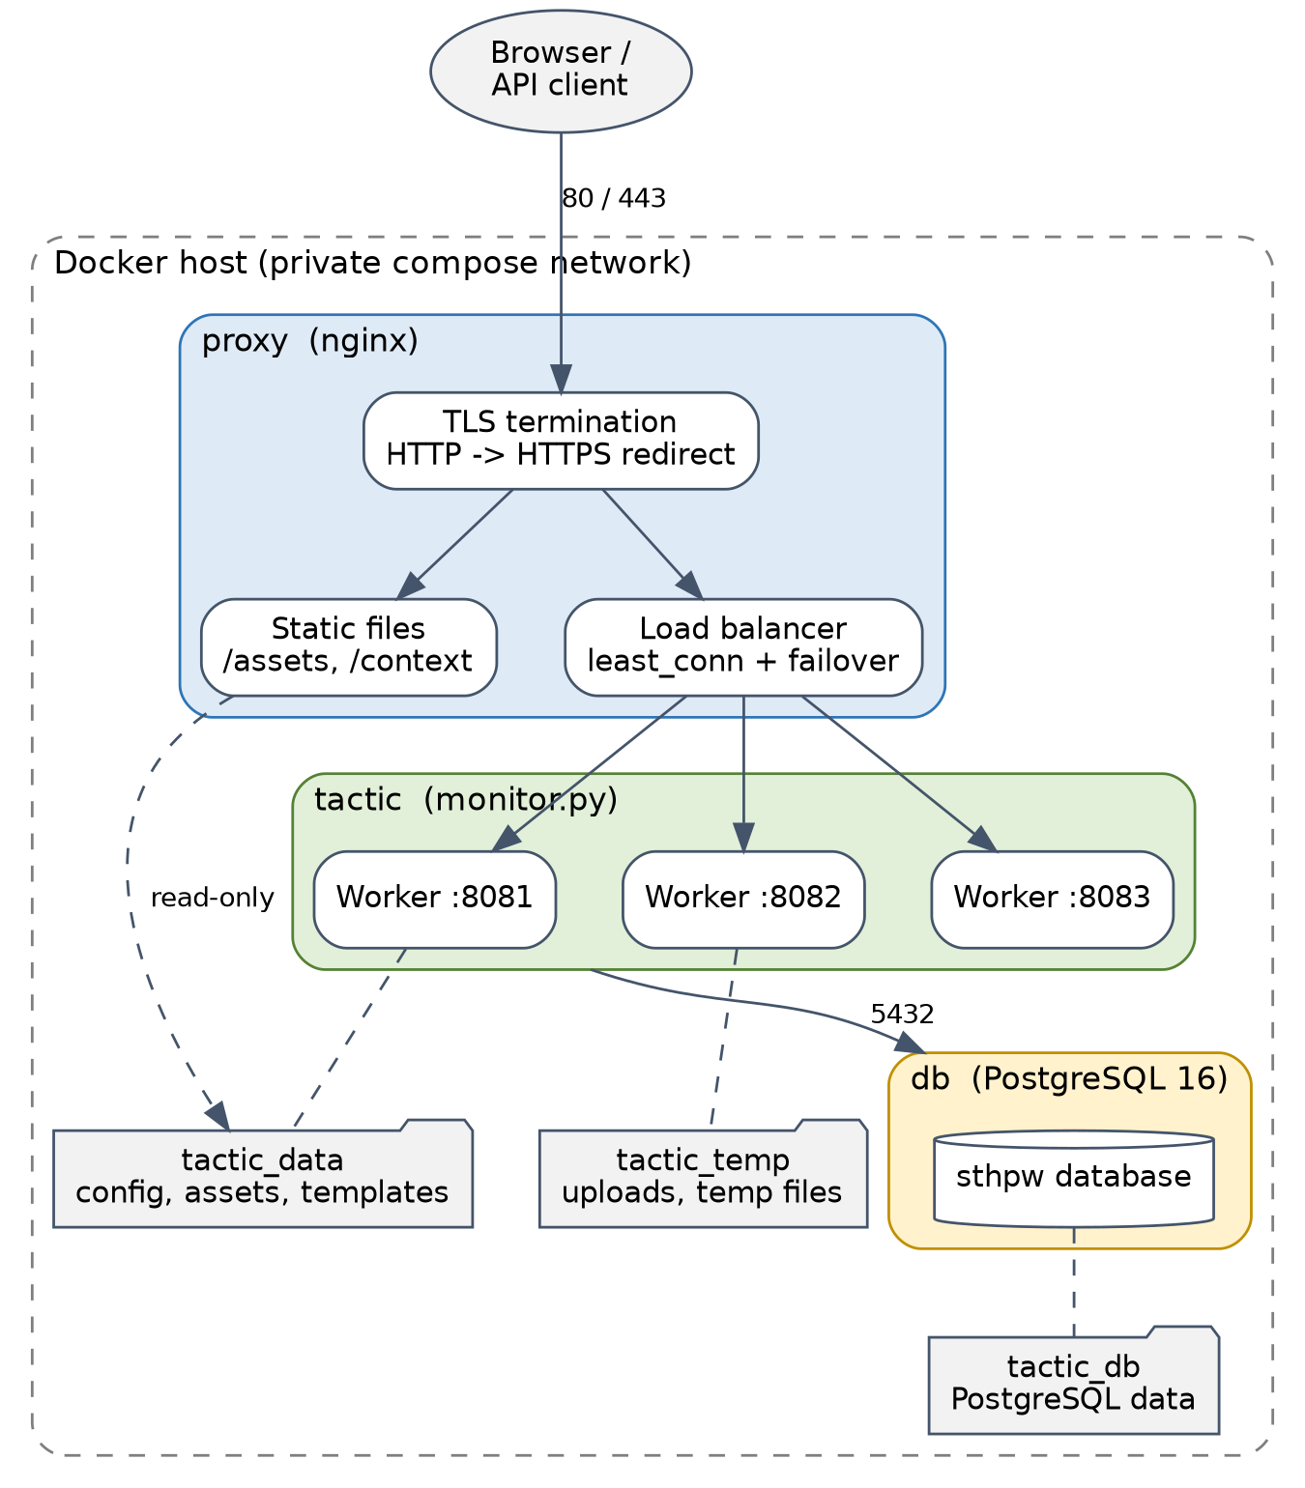
Figure 1. Main components and traffic flow
Component | Image | Role
proxy | nginx:stable-alpine | Terminates TLS, serves static files, balances requests across the TACTIC workers
tactic | python:3.11-slim (built here) | Runs TACTIC's monitor.py, which supervises three CherryPy worker processes
db | postgres:16 | Stores the sthpw database and all project data

Details

Request flow
- The client connects to the proxy on port 80 or 443. When a certificate is present, port 80 redirects to HTTPS.
- Requests under /assets/ and /context/ are answered by nginx directly, from the tactic_data volume (mounted read-only) and from a copy of TACTIC's src/context baked into the proxy image. These never reach Python.
- Everything else is proxied to the tactic_workers upstream: tactic:8081, 8082 and 8083. nginx uses least_conn, passes Host, X-Forwarded-For and X-Forwarded-Proto, and keeps connections alive to the workers.
- A worker that fails three times within 10 seconds is skipped by nginx (max_fails=3 fail_timeout=10s), so one dead worker does not cause errors.
- Workers query PostgreSQL over the compose network at db:5432.

Proxy (proxy)
Built from the proxy target of the Dockerfile. Configuration lives in docker/nginx/:
File | Purpose
tactic-upstream.inc | Worker upstream. Its ports must match TACTIC_PORTS in docker-compose.yml
tactic-common.inc | Static locations, gzip, proxy headers, long timeouts, unlimited upload size (TACTIC enforces its own limits)
tactic-http.conf | Plain HTTP server on port 80
tactic-tls.conf | HTTPS server on 443 (TLS 1.2/1.3, HSTS) plus the port 80 redirect
10-select-config.sh | Container start hook. Installs the TLS config when /etc/nginx/certs/tls.crt and tls.key both exist, otherwise the HTTP config

Certificates come from TLS_CERT_DIR (default ./certs), mounted read-only.

Application (tactic)

Image build
The Dockerfile has three stages:
- build: clones TACTIC at TACTIC_REPO/TACTIC_REF, records the commit in /opt/tactic/REVISION, builds a virtualenv with the requirements, CherryPy and pycryptodomex, and installs the tacticenv module that upstream's installer would normally copy into site-packages. It also patches startup.py so the bind address comes from TACTIC_BIND_HOST. Compilers exist only in this stage.
- tactic: the runtime image. It copies the virtualenv and TACTIC from the build stage and adds tini, postgresql-client, gettext-base (for envsubst), ImageMagick and ffmpeg.
- proxy: the nginx image, with TACTIC's static context files copied in.
pycryptodomex is needed because TACTIC's license check imports Cryptodome, while the crypto requirement installs a conflicting Crypto package.

Process model
The container runs as the unprivileged tactic user, with tini as PID 1, then entrypoint.sh, then python monitor.py. monitor.py starts one worker per port in TACTIC_PORTS (8081|8082|8083), watches each one's /test endpoint, and restarts any that stop responding. The container also has a Docker health check against 127.0.0.1:8081/test.
Workers bind to 0.0.0.0 through TACTIC_BIND_HOST. Upstream derives the bind address from <install><hostname>, which is also TACTIC's public base URL, so the two could not be set independently without the patch.

Startup sequence
docker/entrypoint.sh runs on every container start:
- Applies defaults for the DB_*, TACTIC_HOSTNAME and TACTIC_PROTOCOL variables.
- Creates the directories in tactic_data and copies the project templates and license file there if they are missing.
- Renders config/tactic-conf.xml from docker/tactic-conf.xml.template with envsubst, only if the file does not exist. Later edits to the file in the volume are preserved, and later changes to .env do not apply to it.
- Waits for PostgreSQL using pg_isready.
- Runs docker/bootstrap_db.py, which does nothing if the sthpw database already exists. Otherwise it creates the database, imports the schema and default data, adds the admin user and group and the default notifications, and runs the schema upgrade for the installed version.
- Replaces itself with the command (monitor.py).

Database (db)
Stock postgres:16 with shared_buffers, effective_cache_size and max_connections set from .env. It publishes no host port and is reachable only by the tactic service. Its health check gates the start of tactic. The password is fixed when the tactic_db volume is first initialised.

Storage
Volume | Mounted in | Contents
tactic_data | tactic (read-write), proxy (read-only) | config/, assets/ (check-ins served by nginx), templates/, dist/
tactic_temp | tactic | Upload, download, cache and temp files
tactic_db | db | PostgreSQL data directory

Configuration
Runtime settings come from .env, passed through docker-compose.yml. The TACTIC config template maps them as follows:
Variable | Used for
DB_HOST, DB_PORT, DB_USER, DB_PASSWORD | <database> section
TACTIC_HOSTNAME | <install><hostname>, the public base URL
TACTIC_PROTOCOL | <security><protocol>, http or https
TACTIC_PORTS | Worker ports read by monitor.py
TACTIC_BIND_HOST | Worker bind address, set in the image

Build-time settings are TACTIC_REPO and TACTIC_REF.

Security and hardening
- Only the proxy is exposed. The database and workers are reachable only on the compose network.
- DB_PASSWORD has no default; compose refuses to start without it.
- tactic runs as a non-root user with all capabilities dropped. no-new-privileges is set on every service.
- nginx hides its version (server_tokens off) and sends HSTS when TLS is enabled.
- TACTIC's default admin / tactic login is public and must be changed after first login.
- Root filesystems are writable. Read-only mode has not been tried.

Operations
- Restart policy: all services use restart: always.
- Logs: json-file driver, 10 MB per file, 5 files per service.
- Resources: the app container is limited by TACTIC_MEM_LIMIT (default 4 GB).
- Scaling workers: change TACTIC_PORTS in docker-compose.yml and the server lines in docker/nginx/tactic-upstream.inc, then rebuild the proxy.
- Backups: pg_dump for the database and an archive of the tactic_data volume. See the README for commands.

Known limitations
- The workers share one container and one memory limit. A runaway worker can affect the others.
- Each worker logs "Starting Scheduler" at start-up; TACTIC's optional job queue and watch-folder services are not enabled.
- Upstream is at version 5.0.0.a02 (alpha), so behaviour may change between builds of the 5.0 branch. Pin TACTIC_REF to a tag for repeatable deployments.

