Constant Maturity Event Futures
Milestone 1 Report: Data, Index Construction, and Contract Design
ECE473 | Palmer Mann, Jay Crowther, Ariel Perczek | October 27, 2026

1. Summary
Kalshi lists a separate Fed decision ladder for every FOMC meeting, and each ladder expires at its meeting. This milestone builds the inputs for a continuous product on top of those ladders. We (i) assemble a daily panel of every Kalshi Fed funds contract since July 2021, aligned to the FOMC calendar; (ii) construct a 90-day constant-maturity probability index by interpolating between the two meetings that bracket the 90-day horizon; (iii) backtest a daily-rebalanced portfolio of event contracts that tracks the index at mid prices; and (iv) draft a fully collateralized futures contract on the index, with an argument that the index is continuous between announcements.
- The panel covers 41 settled meetings and 660 contracts (100,885 contract-days). The main sample begins 17 March 2022, the first day off the zero lower bound.
- The index (CUT90) is available on 95.8% of days in the main sample. It ranges from 0.5% to 97.6% and follows the policy cycle.
- On non-announcement days the tracking portfolio has 0.99 correlation with index changes and 0.32 probability points (pp) of daily tracking error. The residual is a deterministic roll term equal to the slope of the term structure between the bracketing meetings, about 26 basis points of probability per day on average.
- Most tracking error occurs on announcement days (2.04 pp daily including them), when the index's reference rate resets.

2. Data

2.1 Contracts
For each FOMC meeting Kalshi lists a ladder of binary contracts of the form "Will the upper bound of the federal funds target range be above K% after the meeting?" A contract pays $1 if true and $0 otherwise, so its dollar price reads as a probability. Strikes are spaced 25 basis points apart. The series ticker changed from FED to KXFED in January 2026; we treat both as one series. Contract wording also evolved: 2021 contracts referenced the target rate on a fixed expiration date, and contracts from mid-2022 onward reference the upper bound after the meeting. With 25 bp strike spacing the two definitions coincide.

2.2 Sources
Contract metadata and daily candlesticks come from Kalshi's public REST API: the historical endpoints for markets settled before 28 August 2026 and the live endpoints afterward. Each daily candle reports the best bid and ask at the close, the last trade, the volume-weighted trade price, volume, and open interest. Candles close at midnight Eastern Time, so our daily snapshot is 00:00 ET at the end of each calendar day. Trading halts five minutes before the 2:00 pm ET policy statement.
Polymarket is deferred to Milestone 2. We retrieved metadata for its 24 Fed decision events (May 2024 onward). Polymarket lists outcome buckets (for example "25 bps decrease" or "no change") rather than a strike ladder, and its public price history gives one price per day with no bid or ask, so it serves only as a cross-check.

2.3 FOMC calendar
The calendar contains the 53 scheduled meetings from July 2021 through January 2028, with the decision timestamp set to 2:00 pm ET on the final day. It matches the decision dates Kalshi publishes for all 41 events that carry one. There were no unscheduled meetings in the sample. Kalshi listed no contract for the 3 November 2021 meeting; the target range was unchanged at that meeting.

2.4 Cleaning rules
- A quote with a bid-ask spread above $0.10 is treated as missing.
- Candles are absent on some contract-days. Quotes differ before and after 65% of these gaps, so a missing candle is missing data rather than an unchanged order book. We carry the last valid mid forward for at most 10 days and flag carried values.
- Candles that close after the 2:00 pm ET announcement and the current, incomplete day are excluded.
Table 1. Kalshi panel by period (pre-announcement contract-days).
Period | Contract-days | Contracts | Two-sided share | Median spread ($) | Volume (contracts)
Jul 2021 to Mar 2022 | 1,838 | 43 | 0.97 | 0.02 | 0.78M
Mar 2022 to Jan 2023 | 13,912 | 191 | 0.67 | 0.03 | 5.90M
Feb 2023 to Dec 2024 | 24,060 | 252 | 0.81 | 0.06 | 17.5M
Jan 2025 to Oct 2026 | 60,665 | 399 | 0.67 | 0.06 | 33.0M
Two-sided: bid above $0 and ask below $1. Contracts are counted in each period in which they trade, so counts sum to more than 660.

2.5 Sample choice
The proposal specifies data since July 2021. We keep the full panel but start the main analysis on 17 March 2022, for two reasons. First, until the 16 March 2022 hike the upper bound was 0.25%, so a cut was impossible and the cut index is identically zero by construction. Second, through January 2022 each meeting had a single strike and the listed meetings rarely spanned 90 days: two meetings bracket the 90-day horizon on only 5% of days in 2021, versus at least 97% in every year from 2022 onward. As a robustness check we repeat all results from 2 February 2023, after which every ladder has at least seven strikes (Figure 1, panel B).
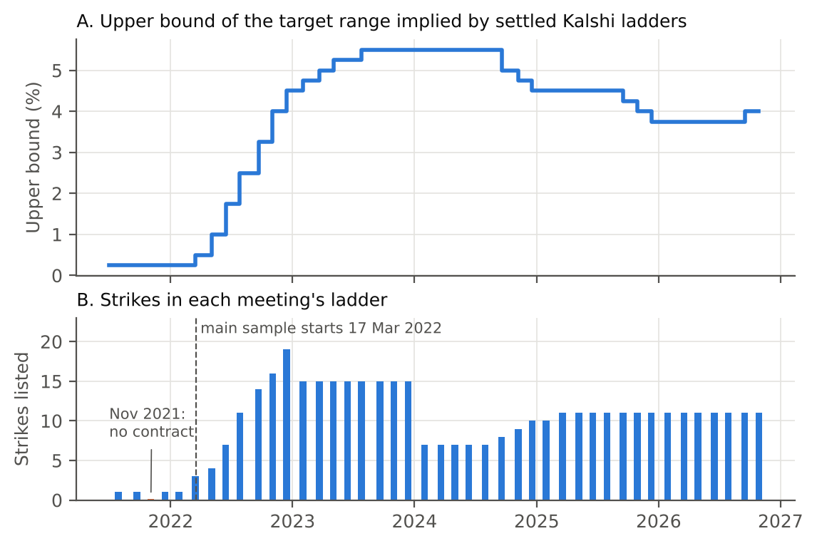
Figure 1. Panel A: upper bound of the target range implied by settled ladders (the lowest strike that settled NO). The path includes the 2022 to 2023 hiking cycle, cuts from September 2024 to December 2025, and a 25 bp increase on 16 September 2026. Panel B: number of strikes listed per meeting.

3. Constant-Maturity Index

3.1 Definition
Let U_{t} be the upper bound in effect at snapshot t, and let Y_{m}(K, t) be the mid price of the YES side of meeting m's contract with strike K. The probability that the upper bound after meeting m is below today's level, a net cut by meeting m, is one minus the price of the contract struck 25 bp below U_{t}:
C_{m}(t) = 1 − Y_{m}(U_{t} − 0.25, t) (1)
Set the target date T = t + 90 days. Let m₁ be the last meeting with decision date d₁ ≤ T and m₂ the first with d₂ > T. The index interpolates linearly in calendar time:
w_{t} = (d₂ − T) / (d₂ − d₁), CUT90_{t} = w_{t} C_{m1}(t) + (1 − w_{t}) C_{m2}(t) (2)
This mirrors the VIX, which interpolates two option expiries to a fixed 30-day horizon. Because the inputs are cumulative, CUT90 measures a net cut by the horizon; a cut followed by a hike does not count. The bracketing contracts are always 35 to 146 days from their decision, so the index never references a contract about to expire. CUT90 is the headline index from the proposal. Because the sample contains two hiking cycles, we also report HIKE90, defined identically with H_{m}(t) = Y_{m}(U_{t}, t), the probability of a net hike.

3.2 Example
On 15 July 2024 the upper bound was 5.50% and T fell halfway between the September and November meetings (w = 0.50). The market priced an 84.5% chance of a cut by September and 91.0% by November, so CUT90 = 87.8% (Figure 2). The Fed cut by 50 bp on 18 September 2024.
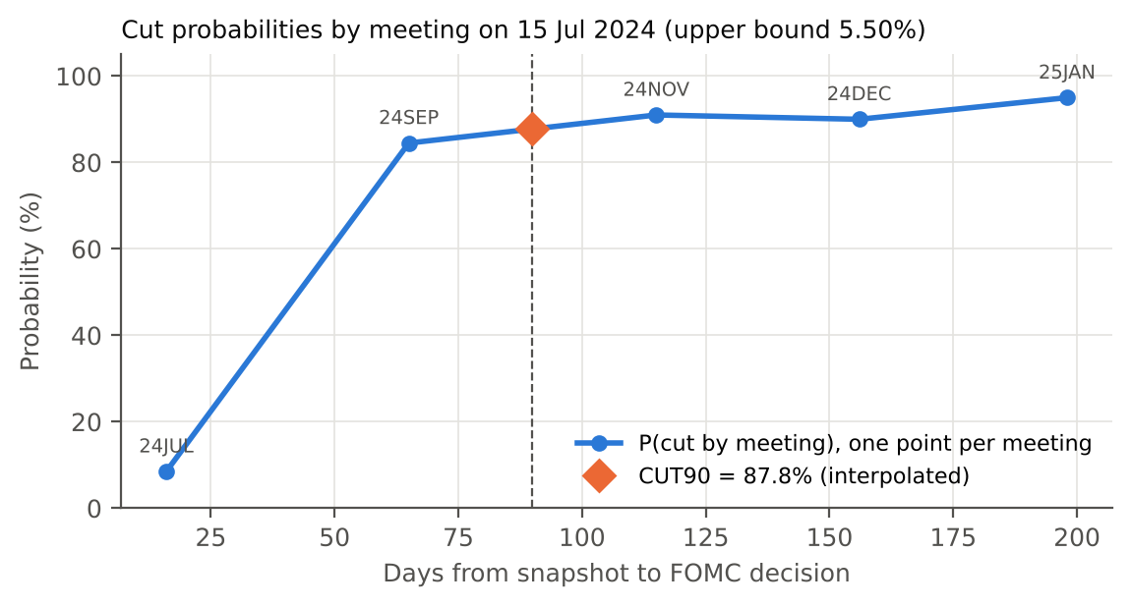
Figure 2. Term structure of cut probabilities on 15 July 2024 and the interpolated 90-day point.

3.3 The series
CUT90 stayed near 2% through 2022, rose during 2023 as markets priced an end to hikes, and averaged 67% in 2024 and 66% in 2025, the years in which the Fed cut. It fell in 2026 as expectations turned toward tightening. On 26 October 2026, the last complete day, CUT90 was 5.9% and HIKE90 was 94.4%.
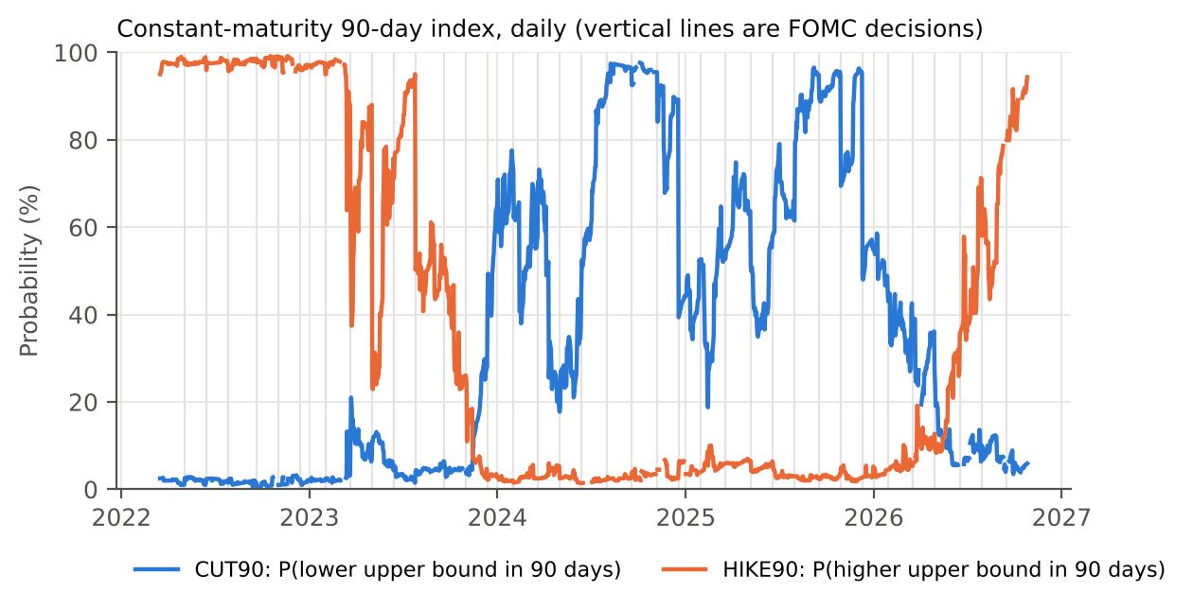
Figure 3. CUT90 and HIKE90, daily, 17 March 2022 to 26 October 2026. Gaps are days on which a leg has no valid quote.
Table 2. Index levels by year (probability, main sample).
Year | Days | CUT90 mean | CUT90 s.d. | CUT90 range | HIKE90 mean | HIKE90 s.d. | HIKE90 range
2022 | 276 | 0.018 | 0.006 | 0.005 to 0.032 | 0.977 | 0.008 | 0.950 to 0.992
2023 | 343 | 0.090 | 0.117 | 0.015 to 0.647 | 0.565 | 0.320 | 0.022 to 0.984
2024 | 353 | 0.669 | 0.250 | 0.177 to 0.976 | 0.030 | 0.012 | 0.014 to 0.067
2025 | 365 | 0.656 | 0.201 | 0.188 to 0.965 | 0.040 | 0.016 | 0.018 to 0.100
2026 | 278 | 0.207 | 0.159 | 0.035 to 0.586 | 0.321 | 0.291 | 0.028 to 0.944
Days counts CUT90 observations; HIKE90 counts differ slightly. 2022 starts 17 March; 2026 ends 26 October.

4. Tracking Backtest

4.1 Portfolio
At each snapshot the portfolio holds w_{t} units of the meeting-m₁ cut position and 1 − w_{t} units of the meeting-m₂ position, where a cut position is the NO side of the contract struck at U_{t} − 0.25 (price C_{m}). Its value therefore equals CUT90_{t}. The position is held to the next snapshot and then rebalanced to the new weights, strike, and bracket. Trades execute at mid with no fees or spread. Each unit is fully collateralized, as on Kalshi, so no leverage enters. Daily P&L is
π_{t+1} = w_{t} ΔC_{m1} + (1 − w_{t}) ΔC_{m2} (3)

4.2 A built-in roll term
On a day with no announcement and no change of bracket, the weight falls by 1/(d₂ − d₁) as the target date advances. Differencing equation (2) gives
ΔCUT90_{t+1} − π_{t+1} = [C_{m2}(t+1) − C_{m1}(t+1)] / (d₂ − d₁) ≈ s_{t} (4)
where s_{t} is the slope of the term structure per day. Even if every contract price were a martingale (expected change zero), the index itself would drift by s_{t} per day, and no portfolio of the underlying contracts could earn that drift. VIX futures show the same gap relative to spot VIX. This term is mechanical, and it is one of the components the proposal aims to separate from genuine returns.

4.3 Results
Table 3. Tracking statistics, main sample (17 March 2022 to 26 October 2026).
Index | Days | Corr(π, ΔI) | Daily TE (pp) | Mean ΔI − π (bp/day) | Mean slope s (bp/day)
CUT90, all days | 1,599 | 0.743 | 2.04 | 17.7 | 26.2
CUT90, ex announcements | 1,567 | 0.991 | 0.32 | 26.2 | 26.2
HIKE90, all days | 1,583 | 0.722 | 2.13 | −4.7 | 4.2
HIKE90, ex announcements | 1,550 | 0.998 | 0.12 | 4.3 | 4.2
TE: standard deviation of ΔI − π. Days require valid quotes on both legs at t and t+1. 32 (CUT90) and 33 (HIKE90) announcement days fall in the sample.
Away from announcements the portfolio tracks the index closely, and the mean tracking difference equals the average slope, as equation (4) predicts. Announcement days dominate tracking error. On those days the upper bound can change, which moves the reference strike and re-anchors the index even when beliefs about future meetings are unchanged.
Over the main sample one unit of the tracking portfolio lost 274 probability points ($2.74 per $1 of notional, before costs) while the daily changes in CUT90 over the same days summed to +9 points (Figure 4). The losses concentrate in 2024 and 2026, when priced cuts failed to occur on the expected schedule. We do not attribute this to the settlement discount, a risk premium, or forecast error here; that decomposition is a Milestone 2 deliverable.
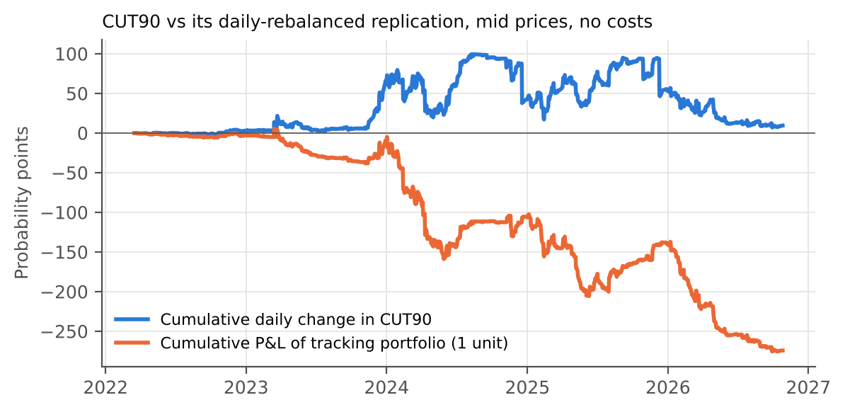
Figure 4. Cumulative daily change in CUT90 and cumulative P&L of one unit of the tracking portfolio, all backtest days, mid prices, no costs.

4.4 Robustness
Table 4. CUT90 tracking under alternative cleaning rules and samples (non-announcement days).
Specification | Index coverage | Days | Daily TE (pp) | Mean ΔI − π (bp/day) | Mean slope (bp/day)
Baseline: fill ≤ 10 days, spread ≤ $0.10 | 0.958 | 1,567 | 0.32 | 26.2 | 26.2
Fill ≤ 5 days | 0.890 | 1,438 | 0.32 | 27.3 | 27.3
Fill ≤ 30 days | 0.997 | 1,644 | 0.31 | 25.5 | 25.5
Spread ≤ $0.05 | 0.789 | 1,277 | 0.33 | 26.8 | 26.6
Spread ≤ $0.20 | 0.976 | 1,602 | 0.31 | 25.9 | 25.9
Sample from 2 Feb 2023 | n/a | 1,270 | 0.32 | 32.0 | 32.0
Tracking error and the roll identity are stable across specifications. Cumulative P&L is more sensitive to the fill and spread rules and is not reported as a result.

5. Futures Specification (Draft)
The contract below is a first design, to be refined in Milestone 2. Because CUT90 is bounded between 0 and 1, the future can be fully collateralized in the same way as the binaries beneath it: neither side can lose more than it posts, so there are no margin calls and no liquidations.
Table 5. Draft terms of the CUT90 future.
Term | Specification
Underlying | CUT90 index, quoted in points from 0 to 100
Contract unit | Pays $1 per index point at expiry ($100 at CUT90 = 1)
Collateral | At a trade price F, the long locks F and the short locks 100 − F; both are held in a stablecoin escrow until settlement
Payoff at expiry | Long receives the settlement value S; short receives 100 − S
Expiry | Monthly, last Friday of the month; moved to the prior Friday if within one business day of an FOMC decision
Settlement value | Mean of the daily CUT90 snapshots over the five calendar days ending on expiry, to limit manipulation of a single quote
Index inputs | Kalshi mid quotes under the Section 2.4 rules; the upper bound from the Federal Reserve's published target range
Oracle | An index publisher posts each daily value on-chain, followed by a dispute window before escrow is released
Fallback | Days without a valid index value drop out of the average; if all five are missing, settlement waits for the next valid value
Two design issues remain open. First, collateral in this contract is itself locked until settlement, so by the argument of Gebele and Matthes (2026) the future carries its own settlement discount unless escrowed collateral earns interest. Second, the five-day averaging window trades manipulation resistance against tracking error near expiry. Both are quantified in Milestone 2.

6. Continuity Between Announcements
Proposition 1. Let a_{k} < a_{k+1} be consecutive FOMC announcement times. Suppose (i) U_{t} is constant on [a_{k}, a_{k+1}), (ii) each price Y_{m}(K, t) is continuous in t, and (iii) consecutive meetings are less than 90 days apart. Then CUT90_{t} is continuous on (a_{k}, a_{k+1}).
Proof sketch. By (iii), a bracketing pair exists at every t and d₁ > t, so no bracketing contract resolves inside the interval. Between roll times the pair is fixed, w_{t} is linear in t, and by (i) and (ii) each C_{m} is continuous; CUT90 is a sum of products of continuous functions. A roll occurs at the time τ when τ + 90 days = d₂. As t approaches τ from below, w_{t} → 0 and CUT90 → C_{m2}(τ). At τ the pair becomes (m₂, m₃) with weight (d₃ − d₂)/(d₃ − d₂) = 1 on m₂, so CUT90_{τ} = C_{m2}(τ). The one-sided limits agree. The same argument applies to HIKE90. ∎
Condition (iii) holds throughout the calendar: meetings are 41 to 56 days apart. At an announcement, condition (i) fails because a change in the upper bound moves the reference strike, so the index can jump there even with no change in beliefs about later meetings. The construction therefore confines mechanical discontinuities to scheduled dates; news can still move prices on any day.
Daily data cannot prove continuity, but they are consistent with it. The mean absolute daily change in CUT90 is 1.01 pp on ordinary days, 1.42 pp on the 33 roll days, and 7.55 pp on the 32 announcement days. Roll days look like ordinary days; announcement days do not. The largest move on a non-announcement day (26.5 pp) reflects news, not the construction.

7. Limitations and Next Steps
Three limitations apply. First, 35% of index days use at least one carried-forward quote. Second, the midnight snapshot cannot separate intraday reactions. Third, the results use Kalshi alone. Milestone 2 will address the following:
- Roll cost from spreads and the Kalshi fee schedule, and capital requirements of the tracking portfolio.
- An event study of the index around each FOMC meeting.
- Estimation of the settlement discount D(τ) and decomposition of returns into belief change, discount drift, and jumps at resolution.
- A static no-arbitrage check of the strike ladder: YES prices should not increase with the strike.
- Comparison with Polymarket and with probabilities implied by fed funds futures.
- Optionally, Kalshi's separate cut, hold, and hike decision contracts as an alternative input to the index.

References
Cboe Global Markets. Cboe Volatility Index (VIX) White Paper. Chicago: Cboe.
Gebele and Matthes (2026). [Full citation to be added.]
Gürkaynak, R. S., and Wolfers, J. (2006). Macroeconomic derivatives: An initial analysis of market-based macro forecasts, uncertainty, and risk. NBER International Seminar on Macroeconomics 2005, 11 to 50.
Kalshi. Trade API v2 documentation, historical data. https://docs.kalshi.com/getting_started/historical_data
Page, L., and Clemen, R. T. (2013). Do prediction markets produce well-calibrated probability forecasts? Economic Journal, 123(568), 491 to 513.
Wolfers, J., and Zitzewitz, E. (2004). Prediction markets. Journal of Economic Perspectives, 18(2), 107 to 126.

Appendix A. Data Files
File | Contents
fomc_calendar.csv | 53 meetings, decision timestamps, matching Kalshi event
kalshi_markets.csv | 660 contracts: meeting, strike, listing and close times, settlement
kalshi_daily.csv / .parquet | 100,885 contract-days: bid, ask, mid, spread, trades, volume, open interest, flags
realized_upper_bound.csv | Upper bound after each meeting, inferred from settled ladders
index_daily.csv | Daily CUT90, HIKE90, bracketing meetings, weights, leg prices, stale flags
backtest_cut90.csv, backtest_hike90.csv | Daily portfolio P&L, index change, roll slope, announcement and roll flags
build_dataset.py, build_index.py, make_figures.py | Rebuild every file and figure from the raw API pulls

