Indoor and Outdoor Test Locations for the June 2010 Site Visit
University of Pennsylvania Team
MAGIC 2010 Competition

Our team has designated specific areas for conducting the June 2010 site visit at the University of Pennsylvania campus. Figure 1 shows an overhead map of our engineering complex and the adjacent field where the outdoor tests will be performed. Marked by the dark blue boundaries, an area with sufficient dimensions (36 by 72 meters) has been selected in order to accommodate the required outdoor set up.
The indoor tests will take place inside the Levine Hall, located at 3330 Walnut Street / Philadelphia, PA 19104-6309. This building is marked in red on Figure 1. The map of one of the floors of this engineering building is shown in Figure 2. This environment is suitable for standard small-scale autonomous exploration tasks and has similar geometrical complexity to the example in the information packet.

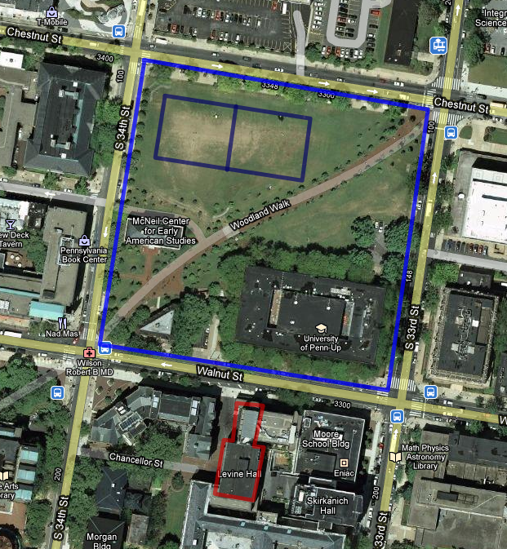
Figure 1. Site visit location. Outdoor test site is marked in dark blue,
indoor test site is marked in red
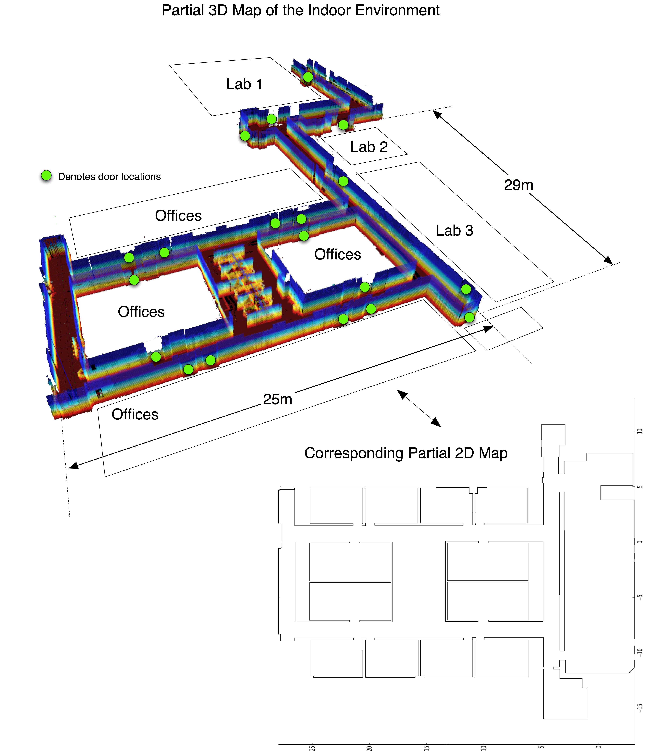

Figure 2. Maps of the indoor test environment. Partial 3D map constructed by a robot (top) and floor plan of the main area (bottom).

