

DuraSpeed3.0

Introduction & Usage

BA17C-CGD-V1.01 EN

V1.01

2019

Confidential

Doc No:

Version:

Release date:

Classification:

© 2008 - 2019 MediaTek Inc.

This document contains information that is proprietary to MediaTek Inc.

Unauthorized reproduction or disclosure of this information in whole or in part is strictly prohibited.

Specifications are subject to change without notice.

Keywords

DuraSpeed3.0

***MediaTek Inc.***

Postal address

No. 1, Dusing 1st Rd. , Hsinchu Science Park, Hsinchu City, Taiwan 30078

MTK support office address

No. 1, Dusing 1st Rd. , Hsinchu Science Park, Hsinchu City, Taiwan 30078

Internet

http://www.mediatek.com/

Document Revision History

|  |  |  |  |
| --- | --- | --- | --- |
| **Revision** | **Date** | **Author** | **Description** |
| V1.0 | 2018-7-27 | Chang Yang | Initial Release |
| V1.01 | 2019-11-20 | Jingen Yu | Documentation optimize |
|  |  |  |  |
|  |  |  |  |
|  |  |  |  |
|  |  |  |  |
|  |  |  |  |

Table of Contents

Document Revision History 3

Table of Contents 4

Lists of Tables 5

Lists of Figures 6

1 Introduction 7

1.1 Purpose 7

1.2 Scope 7

1.3 Who Should Read This Document 7

1.4 How to Use This Manual 7

2 References 9

3 Definitions 10

4 Abbreviations 11

5 Benefit of Duraspeed 12

5.1 Resolve performance issue caused by high CPU loading 12

5.2 Resolved performance issue caused by low memory 12

5.3 Keep important apps in background 13

5.4 Check duraspeed version 13

6 Duraspeed Design Introducation 14

7 Configure Whitelist 15

8 Configuration Customization 17

Lists of Tables

Table 1-2. Chapter Overview 7

Table 4-1. Abbreviations 11

Lists of Figures

Figure 5‑1. DuraSpeed High Cpu Trigger Flow 12

Figure 5‑2. DuraSpeed Low Memory Trigger Flow 13

Figure 6‑1. DuraSpeed Architecture 14

Figure 7‑1. Configure WhiteList Flow 15

Figure 7‑2. Configure Whitelist In DuraSpeed APP 16

Figure 7‑3. Configure Hidden-list In DuraSpeed APP 16

Figure 7‑4. Configure Whitelist In Platform 16

Figure 8‑1. Customization Comment 17

# Introduction

## Purpose

This document provides the usage guidelines for the DuraSpeed and associated modules. It describes how to use DuraSpeed3.0 on the Android platform. This manual also elaborates the mechanism required to use DuraSpeed3.0. This document provides.

1. Benefit of DuraSpeed
2. DuraSpeed Design Introducation
3. Configure Whitelist
4. Configuration Customization

## Scope

The document provide the usage details of the DuraSpeed3.0. DuraSpeed3.0 is applying on P0/Q0 version with specific MTK platform.

## Who Should Read This Document

This document is primarily intended for:

* Customers who want to enable DuraSpeed feature
* Customers who want to use DuraSpeed function for customization
* Customers who want to have a feature that can save power and keep app running smoothly with durable user experience.

## How to Use This Manual

This segment explains how information is distributed in this document, and presents some cues and examples to simplify finding and understanding information in this document. Table 1-2 presents an overview of the chapters and appendices in this document.

Table 1-2. Chapter Overview

| **#** | **Chapter** | **Contents** |
| --- | --- | --- |
| 1 | Introduction | Describes the scope and layout of this document. |
| 2 | References | Some reference documents information |
| 3 | Definitions | terms and definitions |
| 4 | Abbreviations | abbreviations and their explanations |
| 5 | Benefit of Duraspeed | DuraSpeed benefit introducation |
| 6 | Duraspeed Design Introducation | DuraSpeed architecture introducation |
| 7 | Configure Whitelist | Configure whitelist in DuraSpeed APP and platform |
| 9 | Configuration customization | DuraSpeed switcher configuration |

# References

The following documents contain provisions which, through reference in this text, constitute provisions of the present document.

# Definitions

For the purposes of the present document, the following terms and definitions apply:

**Android** is a mobile operating system developed by Google, based on the Linux kernel and designed primarily for touchscreen mobile devices such as smartphones and tablets.

**AOSP** (Android Open Source Project): Android has an active community of developers and enthusiasts who use the Android Open Source Project (AOSP) source code to develop and distribute their own modified versions of the operating system.

**DuraSpeed** (Durable Speed) : It’s a feature that can durable user experience and keep app running smoothly.

# Abbreviations

Please note the abbreviations and their explanations provided in Table 4-1. They are used in many fundamental definitions and explanations in this document and are specific to the information that this document contains.

Table 4-1. Abbreviations

| **Abbreviations** | **Explanation** |
| --- | --- |
| MTK | MediaTek, Asia’s largest fabless IC design company. |
| AOSP | Android Open Source Project |
| AMS | Activity Manager Service |
| APP | Application |

# Benefit of Duraspeed

DuraSpeed contains DuraSpeed framework and DuraSpeed APP. The target of DuraSpeed is to resolve the device performance issue caused by CPU loading is too higher or memory is too lower, or other case from system level. Below is the introduction of benefit brought by DuraSpeed, contains three points.

## Resolve performance issue caused by high CPU loading

DuraSpeed Framework will monitor the device CPU loading at any time, if the CPU loading is reached to high level, DuraSpeed will trigger to kill or suppress the background processes that occupy more CPU usaging to release enough CPU usaging for good performance. this is can be triggered at any time, not only when back to launcher. Below is the schematic diagram, “CPU Monitor” and “Process Module” in below diagram is not really class, just used to explain flow.



Background APPs

kill

suppress

keep



High CPU loading

DuraSpeed FWK

CPU Monitor

Process

Module

Figure 5‑1. DuraSpeed High Cpu Trigger Flow

## Resolved performance issue caused by low memory

DuraSpeed framework will monitor the device memory usaging at any time, when the available memory is reached to low level, DuraSpeed will trigger to kill or suppress background processes that occupy more memory to release enough memory for good performance. Below is the schematic diagram, “Memory Monitor” and “Process Module” in below diagram is not really class, just used to explain flow.



Background APPs

kill

suppress

keep



low memory

DuraSpeed FWK

Memory  
Monitor

Process

Module

Figure 5‑2. DuraSpeed Low Memory Trigger Flow

## Keep important apps in background

Some apps running in the background need to be protected and don’t to be killed when system resource is busy. The apps like playing is music in background, navigating in background and so on.

## Check duraspeed verison

We can find duraspeed version in Appinfo of settings: Settings -> Apps & notifications -> App info -> Show system -> Duraspeed -> Advanced

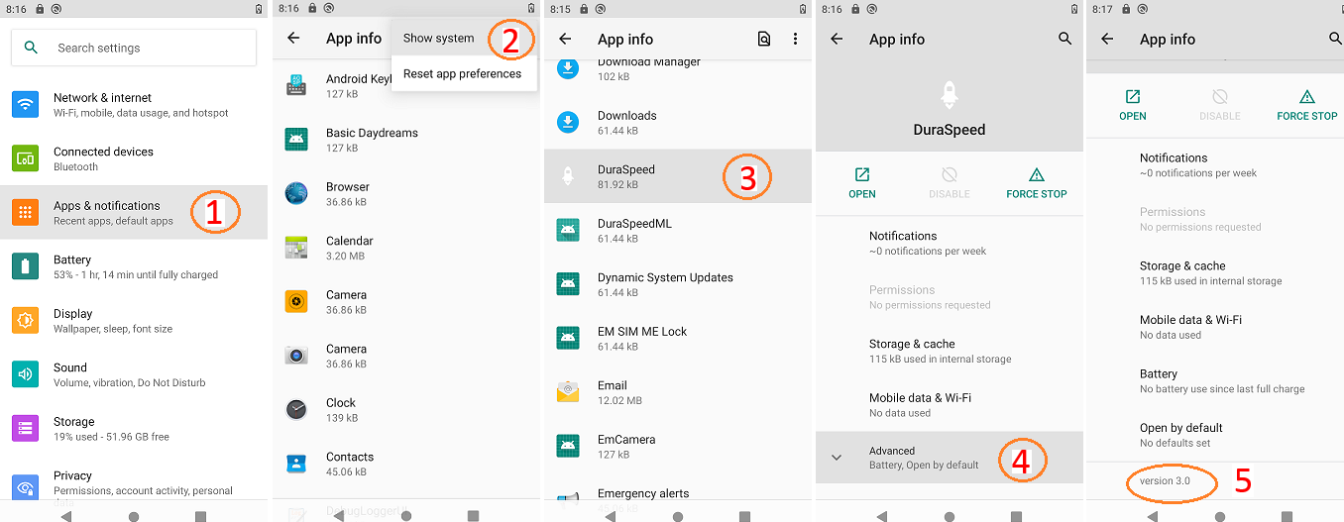

# Duraspeed Design Introducation

DuraSpeed APP part is used for end user to configure whitelist APPs that protected in background by DuraSpeed, these APPs in the whitelist will be applied to DuraSpeed framework by DuraSpeed APP.

DuraSpeed framework is placed in mediatek-services.jar, it contains a DuraSpeed service running in system server process. DuraSpeed APP part get the service instance from ServiceManager class and communicate with DuraSpeed framework throught it. Below is DuraSpeed architecture.

APPLICATIONS

DuraSpeed APP

**DuraSpeed Framework**

APPLICATIONS FRAMEWORK

mediatek framework

android framework

AMS

PackageManager

AudioManager

NotificationManager

…

Figure 6‑1. DuraSpeed Architecture

**DuraSpeed APP** : It is a system APP that prebuild in on platform.

* + APK Source : /vendor/mediatek/proprietary/packages/apps/DuraSpeed/
  + APK output: /system/priv-app/DuraSpeed/DuraSpeed.apk

**DuraSpeed Framework :** It is a system service. It provides API for system APP to manage the restriction policy and collect the applications information to decide if they can run in background or not.

* + Service Binary : /vendor/mediatek/proprietary/frameworks/opt/duraspeed/
  + Service Output : /system/framework/mediatek-services.jar

# Configure Whitelist

DuraSpeed APP is used to configure APPs whitelist to DuraSpeed framework, this part provide UI for end user to set. Below show how to configure whitelist on UI.

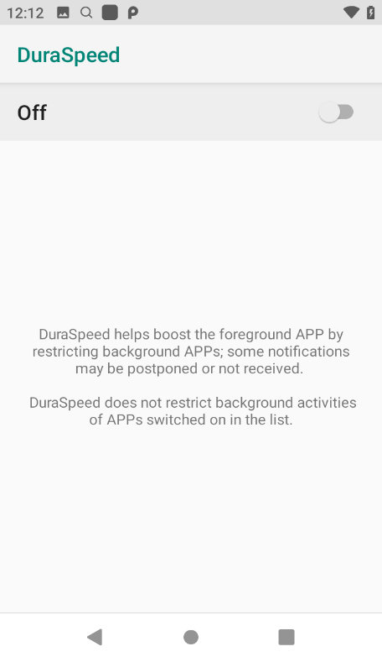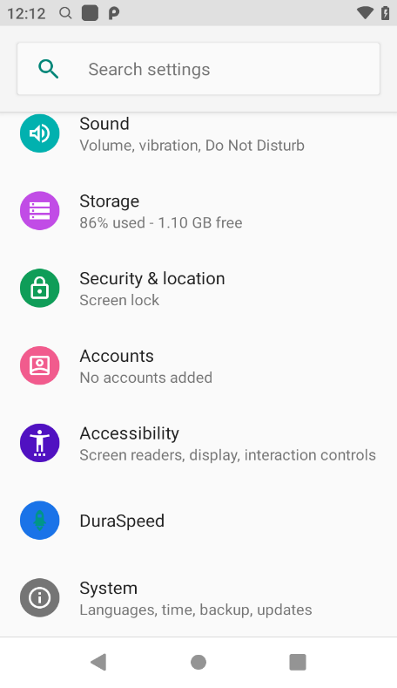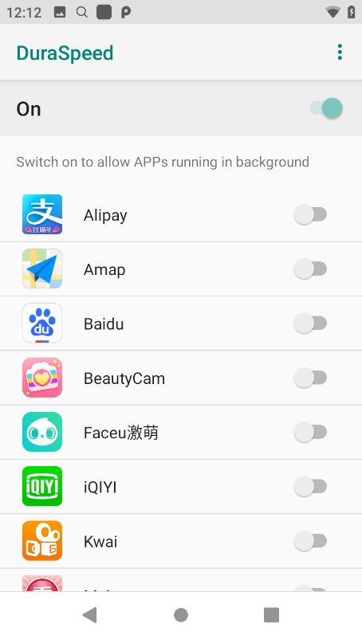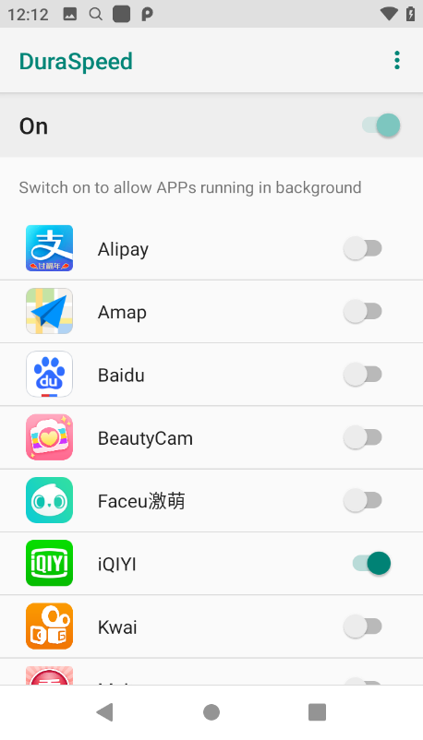

Open DuraSpeed Setting

Turn DuraSpeed On

Put iQIYI in whitelist

Figure 7‑1. Configure WhiteList Flow

For developer, you can configure whitelist APPs in codes. One way is to configure whitelist Apps in /vendor/mediatek/proprietary/packages/apps/DuraSpeed/res/values/config.xml file.

For example:

***vendor/mediatek/proprietary/packages/apps/DuraSpeed/res/values/config.xml***

<string-array name=”app_whitelist” translatable=”false”>

<item>com.tencent.mm</item>

<item>com.tencent.mobileqq</item>

</string-array>

Figure 7‑2. Configure Whitelist In DuraSpeed APP

Also, you can configure hidden-list Apps in this file, it is same with whitelist and they are not shown in whitelist UI, so end user can’t remove it from whitelist.

***vendor/mediatek/proprietary/packages/apps/DuraSpeed/res/values/config.xml***

<string-array name=”app_hidelist” translatable=”false”>

<item>com.tencent.mm</item>

<item>com.tencent.mobileqq</item>

</string-array>

Figure 7‑3. Configure Hidden-list In DuraSpeed APP

Another way, developer can configure whitelist in platform which is used by DuraSpeed framework, you must put the configure file in the path:”/system/ect/duraspeed/configuration.xml” in device.

***/system/ect/duraspeed/configuration.xml***

<?xml version="1.0" encoding="utf-8"?>

<configuration>

<PlatformWhitelist>

<App1>com.tencent.mm</App1>

<App2>com.tencent.mobile</App2>

</PlatformWhitelist>

</configuration>

Figure 7‑4. Configure Whitelist In Platform

Here is the example configuration file.

# Configuration Customization

There are 2 feature options for DuraSpeed, they are defined in ProjectConfig.mk

Enable / Disable DuraSpeed feature support : **MTK_DURASPEED_SUPPORT** = yes / no. If you turn it to “no”, there is no DuraSpeed item on Settings menu and DuraSpeed Framework don’t work.

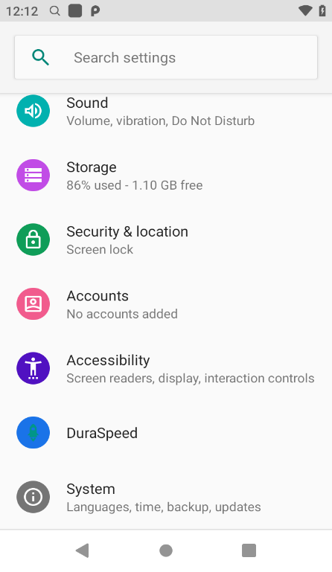

MTK_DURASPEED_SUPPORT=yes

DuraSpeed will be a build-in on device

And show on Settings Menu

MTK_DURASPEED_SUPPORT=no

DuraSpeed isn’t be supported on this

Device and there is no DuraSpeed item

On Settings Menu, Also there is no

DuraSpeed framework.

Figure 8‑1. Customization Comment

On / Off DuraSpeed UI switch ( default = no) : **MTK_DURASPEED_DEFAULT_ON** = yes / no. On the DuraSpeed supported platform(**MTK_DURASPEED_SUPPORT=yes**), if you set **MTK_DURASPEED_DEFAULT_ON**=yes, DuraSpeed will be activated automatically with default settings of restriction list. Otherwise, DuraSpeed don’t work default, if you want it work, you must turn it on in Settings by yourself.

You can configure some parameters in Configuration.xml to affect DuraSpeed manager background App. Current you can change below parameters.

***/system/ect/duraspeed/configuration.xml***

<?xml version="1.0" encoding="utf-8"?>

<configuration>

<PlatformWhitelist>

<App1>com.tencent.mm</App1>

<App2>com.tencent.mobile</App2>

</PlatformWhitelist>

<CpuThreshold>85<CpuThreshold/>

<CpuTarget>70<CpuTarget/>

<PolicyLevel>6<PolicyLevel/>

</configuration>

* PlatformWhitelist is used to add whitelist app to avoid killed by DuraSpeed which has introduced before.
* CpuThreshold is used to set threshold which DuraSpeed is triggered when whole CPU loading is higher than this value. Value is bigger means DuraSpeed is later to be trigged in CPU High loding case.
* CpuTarget means DuraSpeed should release CPU loading to this value when DuraSpeed is triggered by high CPU loading. Value is smaller means DuraSpeed need to kill more App to release more CPU resource.
* PolicyLevel DuraSpeed has policy level from 1 to 6, Default is level 6, values is smaller means Policy is more strict, means more App will be killed.
* MusicDelayTime means When the app have stopped playing music, this parameter decide when Duraspeed can kill or suppress it.

At present, DuraSpeed don’t provide parameters to adjust memory threshold or memory target.