**Assignment 2**

**CS 521**

**Information structures with python**

**Purpose :**

To deliver the code for getting the percentage of which the student response was correct

**Structure of assignment**

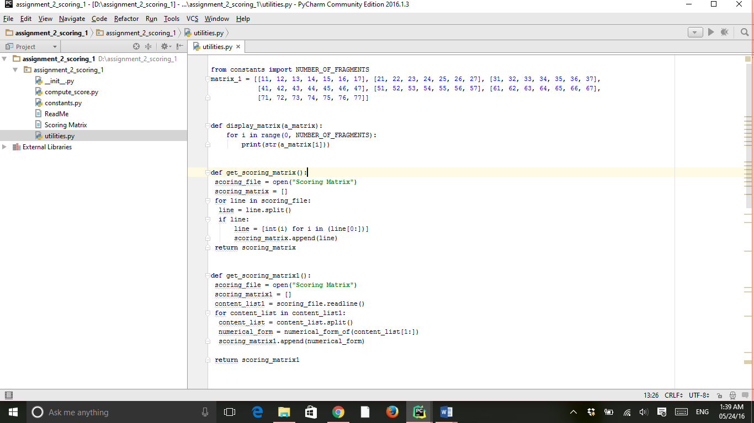

**Code for utilities.py and compute_score is attached as .zip file**

**utilities.py**

**from** constants **import** NUMBER_OF_FRAGMENTS *###importing the variable from other file  
  
##### Code for creating function display_matrix ##########***def** display_matrix(a_matrix):  
 **for** i **in** range(0, NUMBER_OF_FRAGMENTS): *#### for 0 to number of fragments* **print**(str(a_matrix[i])) *#### display the corresponding matrix*

***I did not used the code given corresponding to get_scoring _matrix ,I used different variable and function***  
*##### Code for creating function get_scoring_matrix ##########***def** get_scoring_matrix():  
 scoring_matrix = []  
 scoring_file = open(**"Scoring Matrix"**)*###opening the socinr matrix the read file line by line* i=0  
 **while**( i<=NUMBER_OF_FRAGMENTS):  
 content_of_line = scoring_file.readline()  
 content_list = content_of_line.split(**' '**)*##for blankspaces* numerical_form = numerical_form_of(content_list[1:])  
 scoring_matrix.append(numerical_form)  
 i += 1  
 **del** scoring_matrix[0]  
 **return** scoring_matrix

*##### Code for creating function numerical_form_of ##########***def** numerical_form_of(a_list):  
 **return** [int(a_list[i]) **for** i **in** range(len(a_list))] *#### return the list with the corresponding integers*

*##### Code for creating function pointwise_product ##########***def** pointwise_product(a_matrix, a_second_matrix): *### define function* m = [[0 **for** _ **in** range(7)] **for** _ **in** range(7)]*## intializing the matrix to null value* **for** i **in** range(0, NUMBER_OF_FRAGMENTS): *## for every i(row) starting from 0 to number_fragments* **for** j **in** range(0, NUMBER_OF_FRAGMENTS): *##for every i(column) starting from 0 to number_fragments* m[i][j] = (a_matrix[i][j] * a_second_matrix[i][j]) *## m[i][j]= multiplication of two matrix (a_matrix and a_second_matrix)* **return** m

*########### Code for creating function list_as_precedence_matrix (student response is calculated)#########***def** list_as_precedence_matrix(a_response): *### define function* return_matrix = [[0 **for** row **in** range(NUMBER_OF_FRAGMENTS)] *## intializing the matrix to null value* **for** column **in** range(NUMBER_OF_FRAGMENTS)]  
  
 **for** index_of_first **in** range(len(a_response) - 1): *### for loop index_of_first till length of (a_response-1)* **for** index_of_second **in** range(index_of_first + 1, len(a_response)):  
 value1, value2 = int(a_response[index_of_first]), int(a_response[index_of_second])  
 **if** value1 < value2: *## if the value1 < value 2 fro eg value1=3 and value2=4* return_matrix[value1 - 1][value2 - 1] = 1 *##return_matrix (the index of (value1 -1)(value2 -1)) will be initilaize to 1* **return** return_matrix *###then return return_matrix*

*############ Code for creating function sum_of _upper_triangle ##############***def** sum_of_upper_triangle(a_matrix):  
 sum_returned = 0 *##### initializing to zero so that it doesnot any garabage value* **for** row **in** range(NUMBER_OF_FRAGMENTS): *### for loop for getting into row from 0 to number of fragments* **for** column **in** range(row + 1, NUMBER_OF_FRAGMENTS): *### for loop for getting into column starting row+1 to number_of fragments* sum_returned += a_matrix[row][column] *####### sum of a_matrix is assign to sum_returned variable* **return** (sum_returned) *### return the value*

**compute_score.py**

**from** constants **import** NUMBER_OF_FRAGMENTS  
**from** utilities **import** display_matrix,numerical_form_of,\  
 get_scoring_matrix, pointwise_product, list_as_precedence_matrix,\  
 sum_of_upper_triangle  
  
  
  
**'''  
User was queried for response to scrambling test of size NUMBER_OF_FRAGMENTS,  
then student gave response, then evaluation matrix was shown, then  
student's score was shown as a percentage.  
'''***# (Entry): Student queried for response to scrambling test  
# of size NUMBER_OF_FRAGMENTS, then student gave response response_list***print**(**"\n\nStudent response in {0} integers, separated by commas: "**.  
 format(NUMBER_OF_FRAGMENTS))  
response_ = raw_input()*######taking response as input*response_list = response_.split(**','**)*###skip the blank  
  
# (Score): The student's score is on the console, rounded to 1 decimal*student_response_matrix = list_as_precedence_matrix(response_list) *### intializing the function to other variable*scoring_matrix = get_scoring_matrix() *### intializing the function to other variable*student_score_matrix = pointwise_product(student_response_matrix, scoring_matrix) *## usingthe function pointwise_product function to compute the matrix multiplication of student_response_matrix andscoring_matrix*student_score = 100 * (sum_of_upper_triangle(student_score_matrix)) / (sum_of_upper_triangle(scoring_matrix)) *###then compute the percentage by the calculating the value is matrix***print**(**"Your score is {0}%"**.format(str(round(student_score, 1))))*#####display the result*

**output:**

the input I give was 1,2,3,4,5,7,6

when we run the file it asked for the student response :

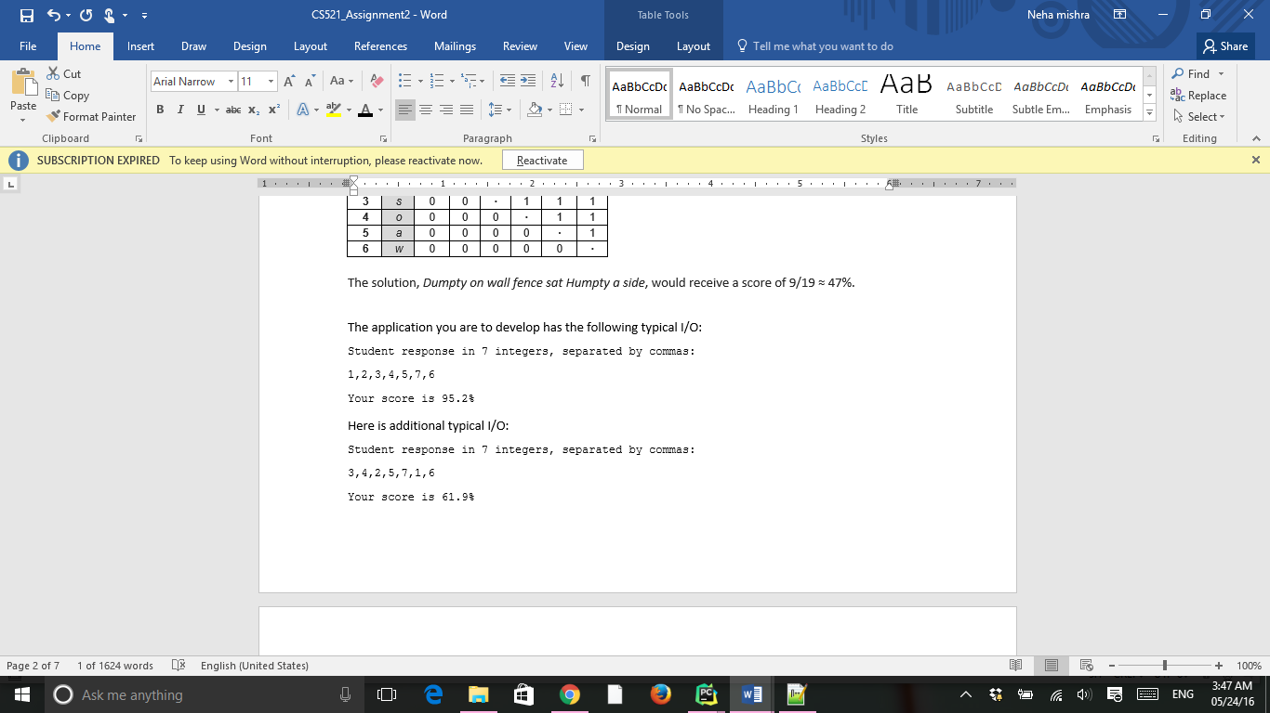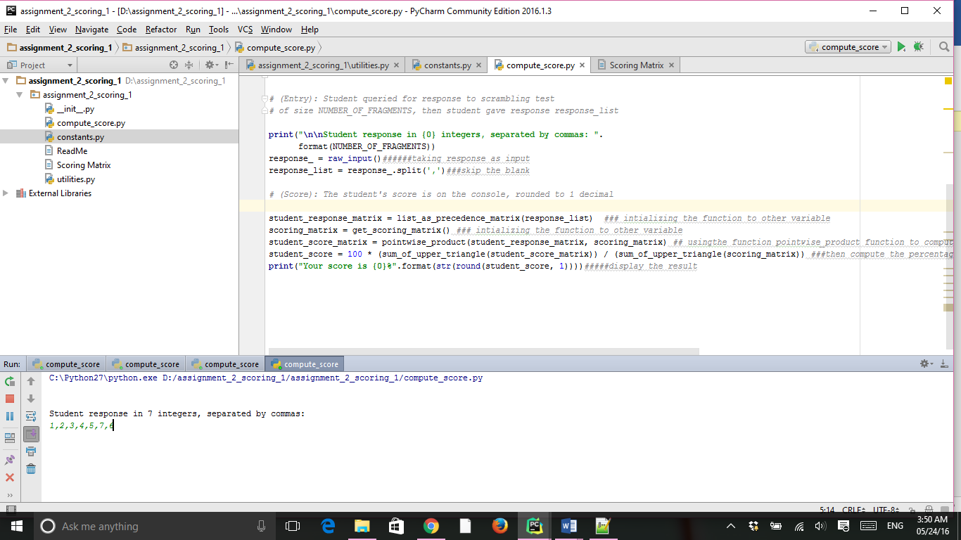

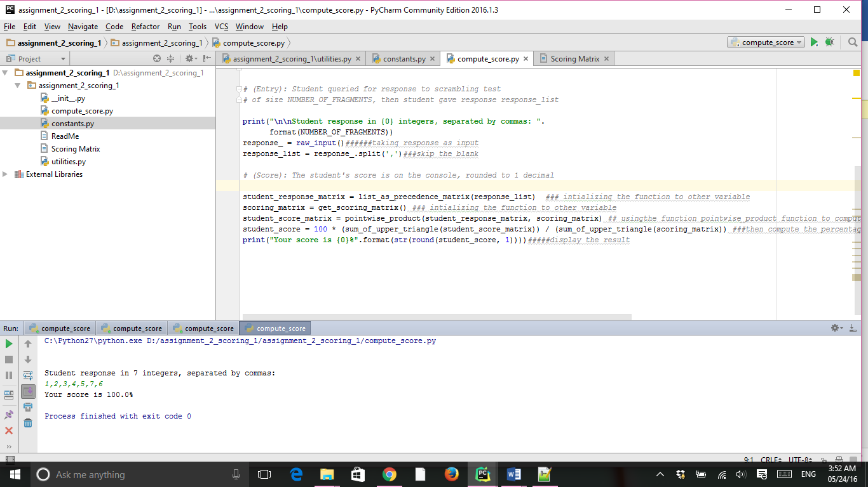

When I give input 3,4,2,5,7,1,6

The output was

