**Lab 5**

**Information structures with python**

**Deliverables:**

In the lab we created a combo box with four values printing, so whenever user clicks any value, the output shows the user clicked “ ”value.

**Code :**

**import** Tkinter  
**import** ttk  
  
  
  
**class** ComboBoxDemo:  
  
 **def** __init__(self, parent):  
 self.parent = parent  
 self.box = ttk.Combobox()  
 self.display_combo() *# work delegated* **def** display_combo(self):  
 *# A Combobox with values 'First value', 'Second value', 'Third value' ,'Fourth value' is on the console # Combobox inherits from Sequence--on which indexing is allowed* self.box[**'values'**] = (**'First value'**, **'Second value'**, **'Third value'**,**'Fourth value'**)  
 self.box.grid(column=0, row=0) *# position of display \** self.box.current(0) *# index of value showing (as default) in the single line window* **def** echo_to_console(an_event):  
 **print**(**'User clicked '**+self.box.get())  
 self.box.bind(**'<<ComboboxSelected>>'**, echo_to_console)  
  
**if** __name__ == **'__main__'**:  
 root = Tkinter.Tk()  
 app = ComboBoxDemo(root)  
 root.mainloop()

**Output : The combo box Created**

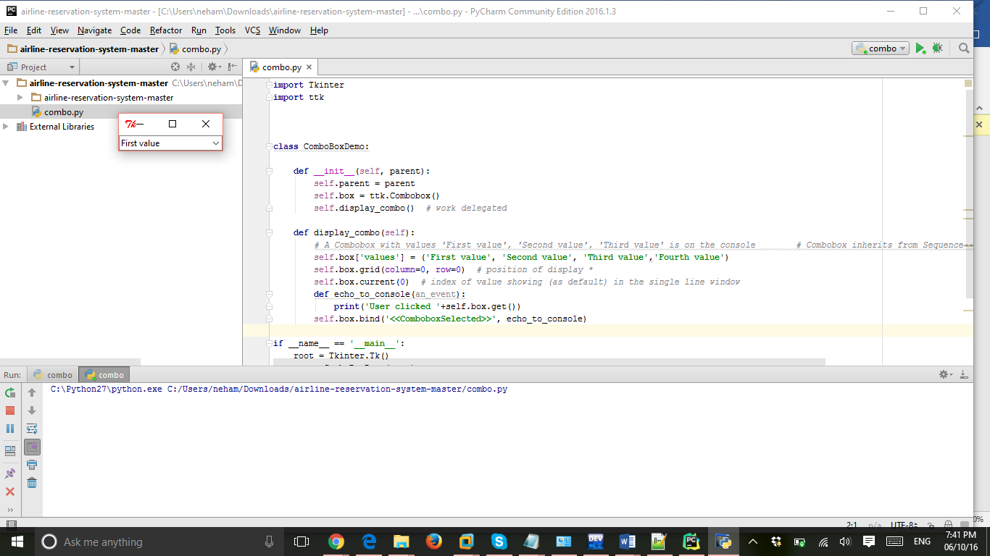

**When click on fourth option:**

