**METCS 521**

**Information Structures with Python**

**Lab 1**

**Part 1**

**PURPOSE:**

To get your environment set up and to get a Python program running.

**Deliverables:**

I first downloaded the Python GUI from JETBRAINS.COM

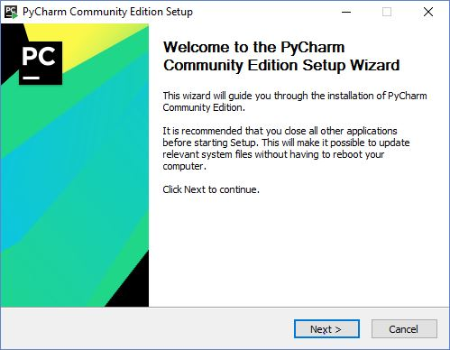Then started installing on my laptop, as you can see below

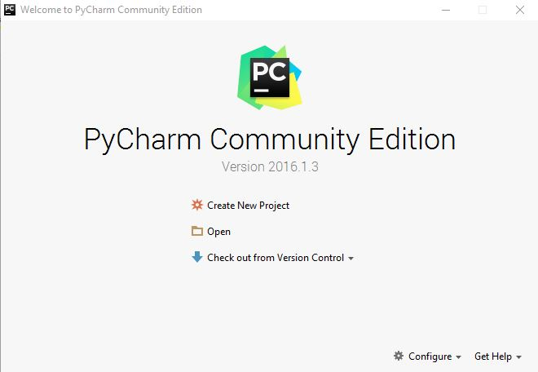Started working on Pycharm Community Edition

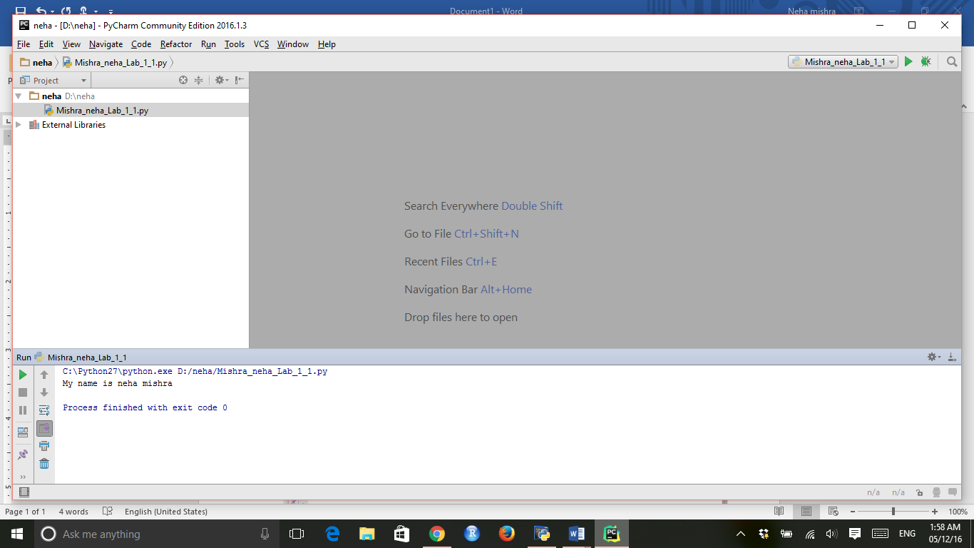First program building

**Starts with the first program of simply printing name and addition**

For that we can one file name =”Mishra_neha_Lab_1_1.py”

Then we write code for printing name

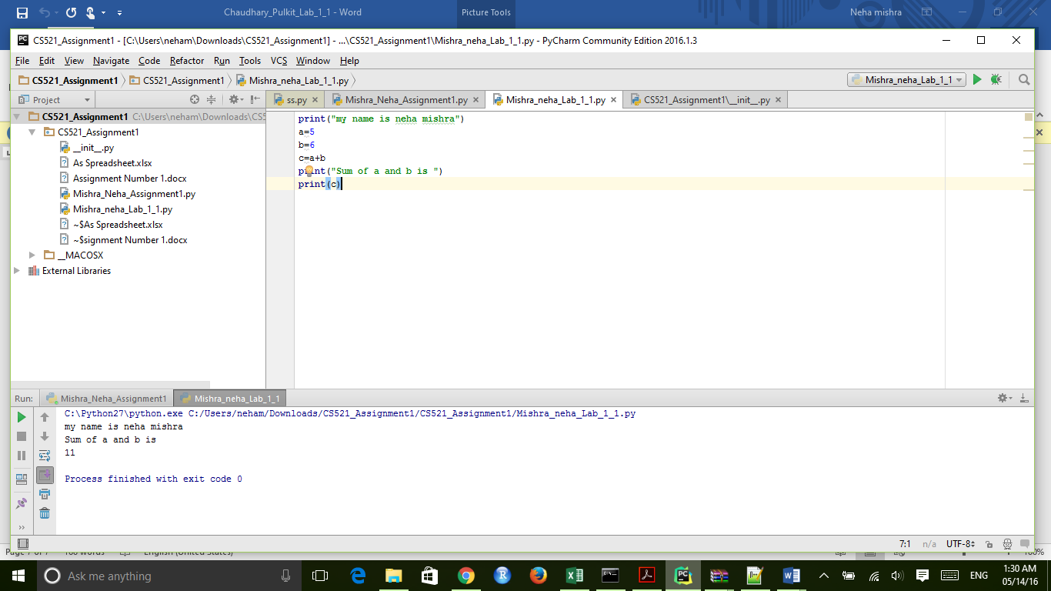

The result is displayed as :

