**Assignment 3**

**Information structures with python**

**Deliverables:**

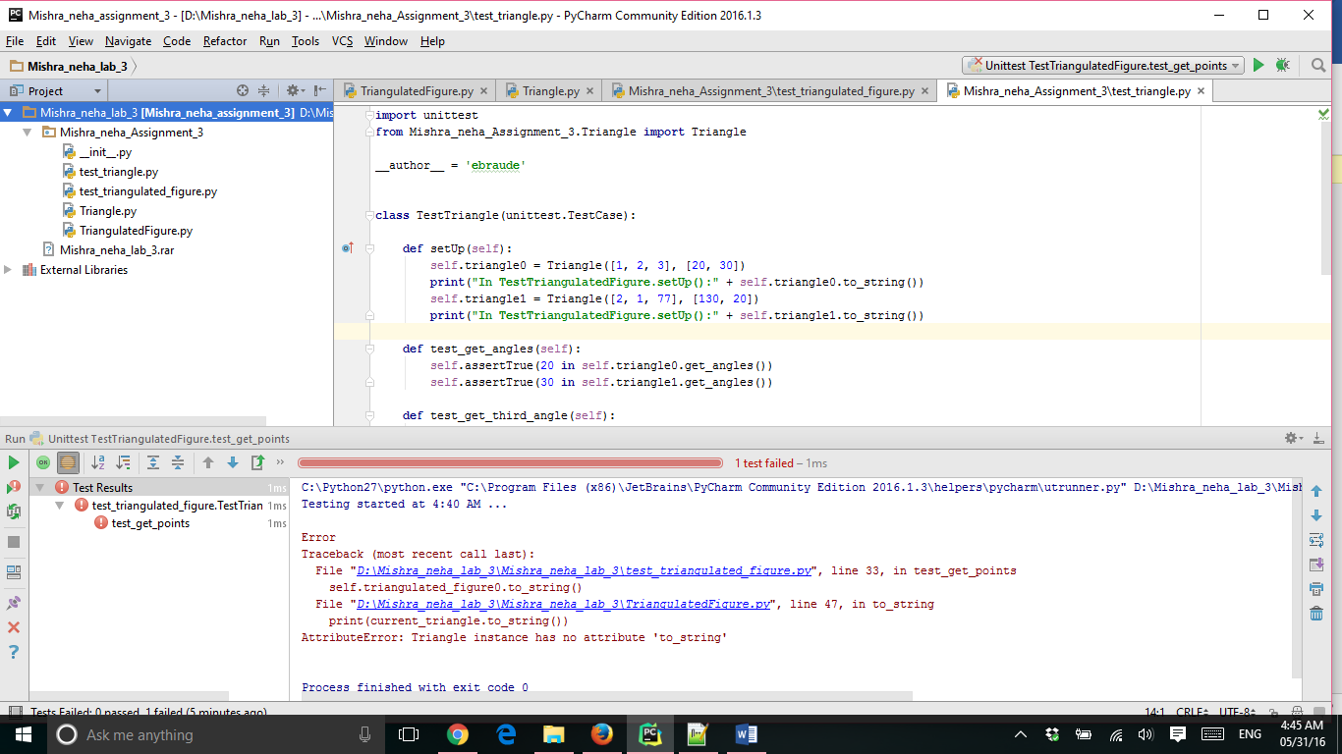

The code is attached in the .zip file

**from** triangle **import** Triangle  
  
  
**class** TriangulatedFigure:  
 *# Class Invariant 1: Every triangle in self.triangles has  
 # a unique set of vertices [Note 1 (at end)]  
  
 # Class Invariant 2: len(self.triangles) < 2 --XOR--  
 # Every Triangle in self.triangles shares two get_points with another* **def** __init__(self):  
  
  
 self.triangles = [] *# the Triangle objects that make up self* **def** add(self, a_triangle):  
 *# Precondition 1: a_triangle is a Triangle instance  
 # Precondition 2: len(self.triangles) < 2  
 # --XOR--  
 # a_triangle ... is not in self.triangles AND  
 # ... shares two vertices with a Triangle in old(self.triangles)  
 # Postcondition: a_triangle is in self.triangles* **if** (len(self.triangles) < 2 **or** (a_triangle **not in** self.triangles) **and not** (  
 len(self.triangles) < 2 **and** (a_triangle **not in** self.triangles))):  
 *## satisfying the condition first* self.triangles.append(a_triangle)*## adding the value to the list* **def** get_points(self):  
 triangles_points = []  
 **for** triangle **in** self.triangles:  
 triangles_points.extend(triangle.get_points())*## attaching by extending the value to traingles.points* **return** set(triangles_points)  
  
  
  
 **def** to_string(self):  
 **for** current_triangle **in** self.triangles:  
 **print**(current_triangle.to_string())  
  
 **def** triangles_with_vertex(self, a_point):  
 *# Precondition: At least one triangle in self.triangles contains a_point  
 # Returns the (contiguous) list of self.triangles containing a_point  
 # in clockwise order  
 # Example: URL1 (see at end)  
  
 # [Collected]: triangles_with_a_point =  
 # the triangles in self.triangles containing a_point [Note 3]* triangles_with_a_point = []  
  
 **for** triangles_ **in** self.triangles:  
 **if** a_point **in** triangles_.get_points():  
 triangles_with_a_point.append(triangles_)  
 triangles_in_order=[triangles_with_a_point[0]]  
 *#triangles_remaining=triangles_with_a_point[1:].copy()* **return** triangles_with_a_point

output :

only one test case runs and the output is :

