**Lab 4**

**Information structures with python**

**Deliverables:**

Exception.py file

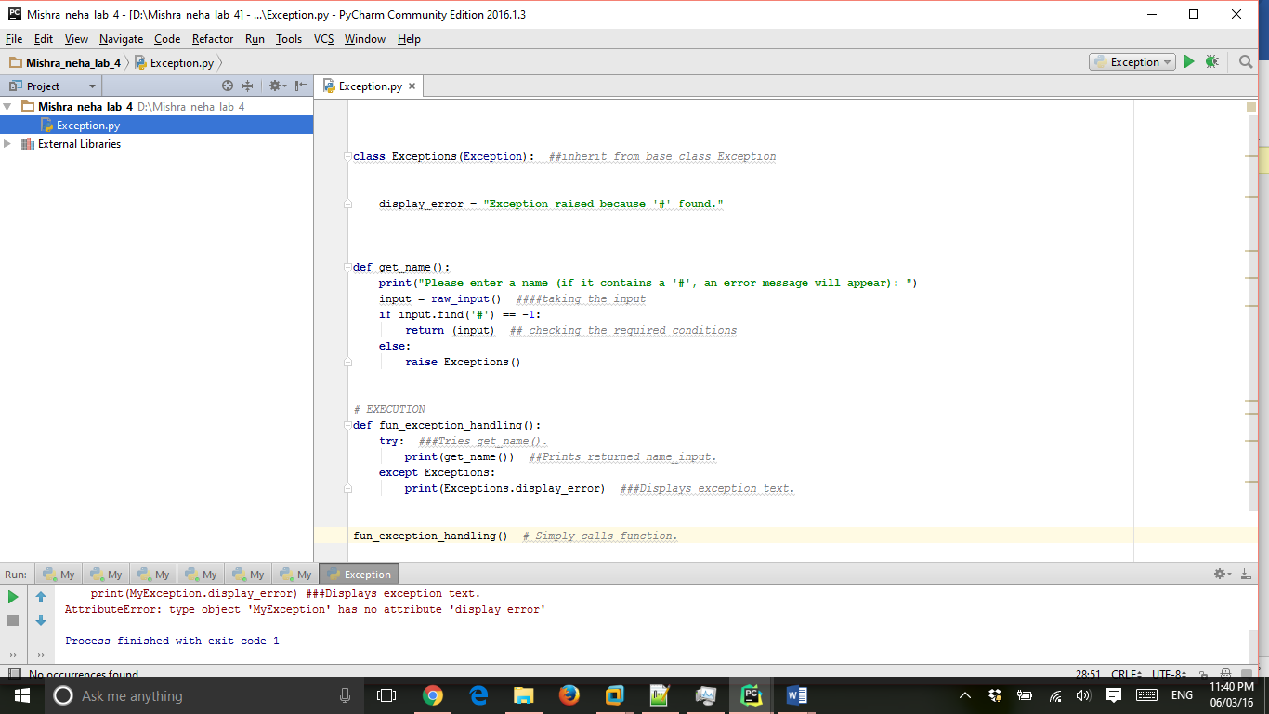

**class** Exceptions(Exception): *##inherit from base class Exception* display_error = **"Exception raised because '#' found."**

**def** get_name():  
 **print**(**"Please enter a name (if it contains a '#', an error message will appear): "**)  
 input = raw_input() *####taking the input* **if** input.find(**'#'**) == -1:  
 **return** (input) *## checking the required conditions* **else**:  
 **raise** Exceptions()  
  
  
*# EXECUTION***def** fun_exception_handling():  
 **try**: *###Tries get_name().* **print**(get_name()) *##Prints returned name_input.* **except** Exceptions:  
 **print**(Exceptions.display_error) *###Displays exception text.*fun_exception_handling() *# Simply calls function.*

**Output:**

First output in which we are passing the string with # so the output is display as :

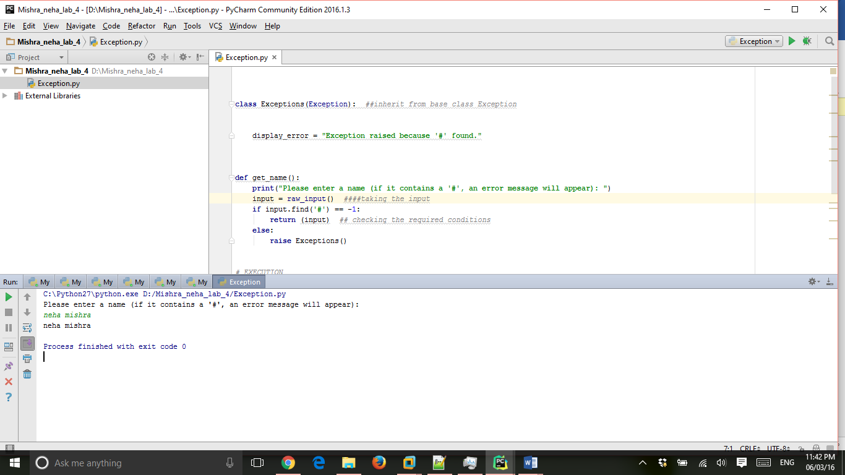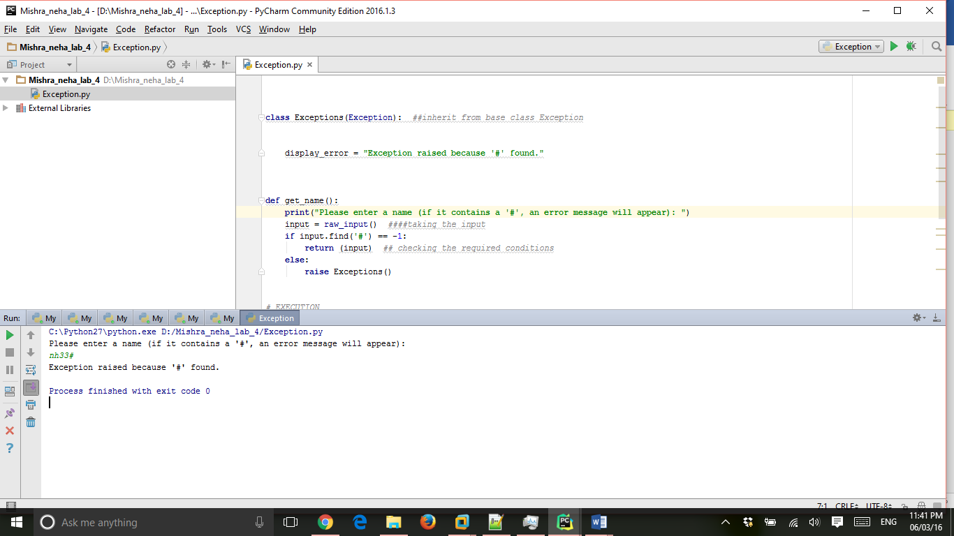

second output in which we are passing the simple string without # so the output is display as :