**Screen Recording and sharing the recorded video via youtube**

The following steps are to help you to record a video of your computer’s screen and then to share the recorded video with your professor/grader via youtube.

We will use a program its name is icecream screen recorder to record a video of any session that takes place at your computer’s screen. There is no obligation of using this program. If you want to use other program, feel free to do so.

Part A. recording a session on a computer screen.

Stop 1: installing icecream screen recorder program.

Download icecream screen recorder program from this link. http://icecreamapps.com/Screen-Recorder/ . The free version is enough for the requirements of our tasks. Once you finish downloading the program, please install it. When you run the program, its interface should be as the following photo.

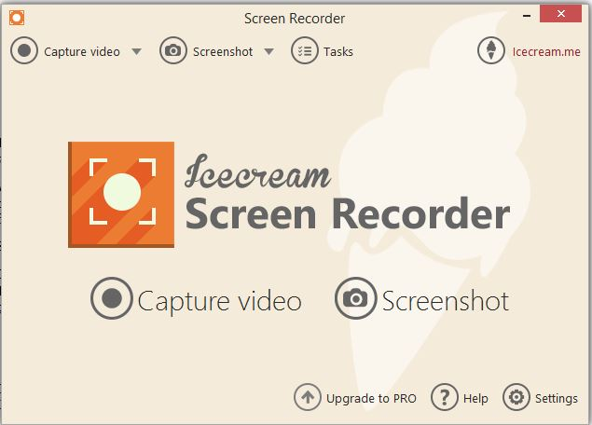

Step 2: configuring icecream screen recorder.

Click on settings in bottom-right corner to configure some settings in the program.

In **save** **to** option, you can change the directory where to save the recorded videos.

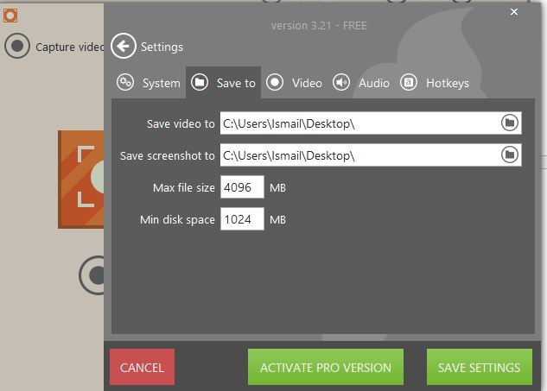

In **audio** option, you can enable/disable record audio (what is being played on the computer’s speakers) and record microphone. Disable record audio and enable record microphone so your oral explanation while you record your session is saved too.

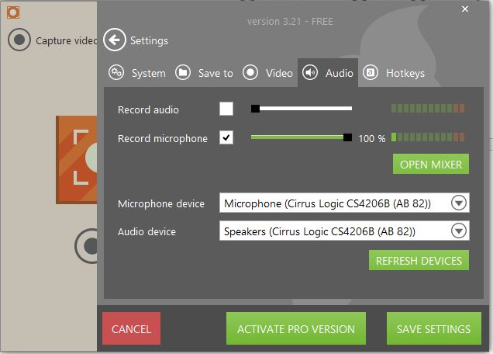

Click on save settings to save the changes you had made and to go back to the main menu.

Step 3: record by icecream screen recorder.

Maximize your PyCharm in your screen and then click on icecream screen recorder icon in the task bar, the result should be as the following photo.

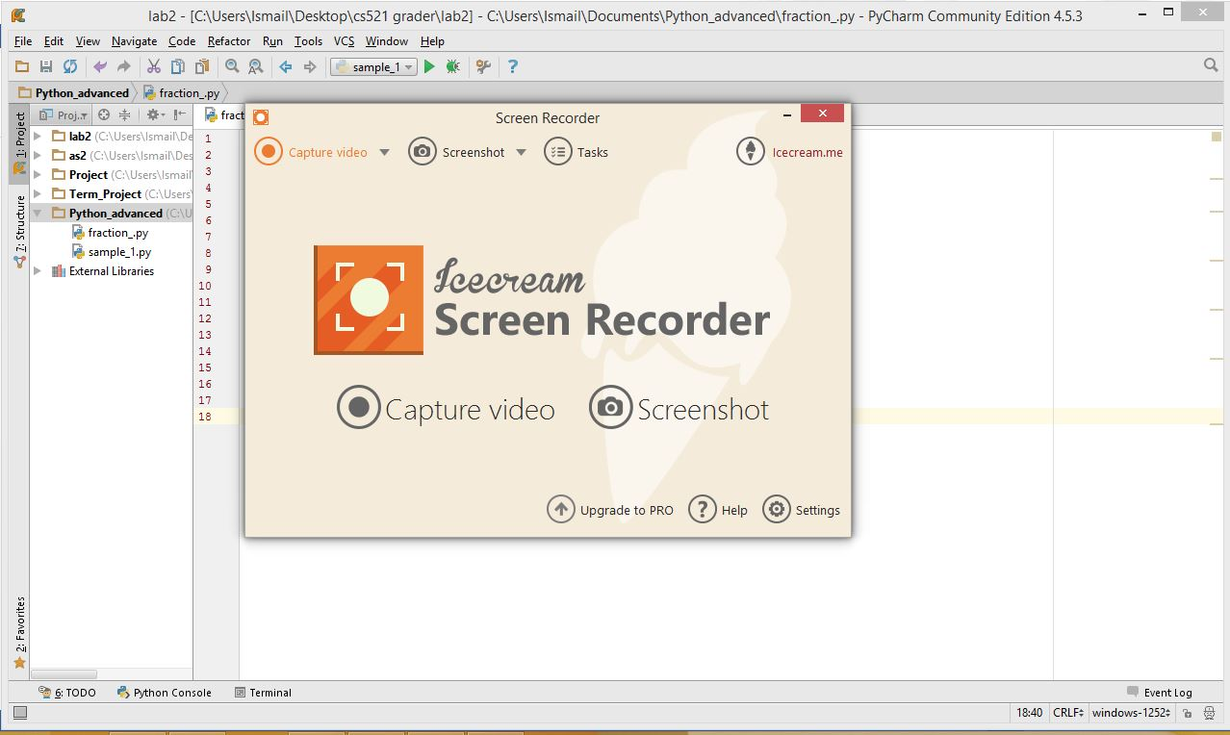

Click on **capture video** to start recording your session. Once you click on capture video, the program will ask you to select the recorded area. By left click on the mouse and drag the cursor and drop it, you will create a small area on your screen that will be recorded.

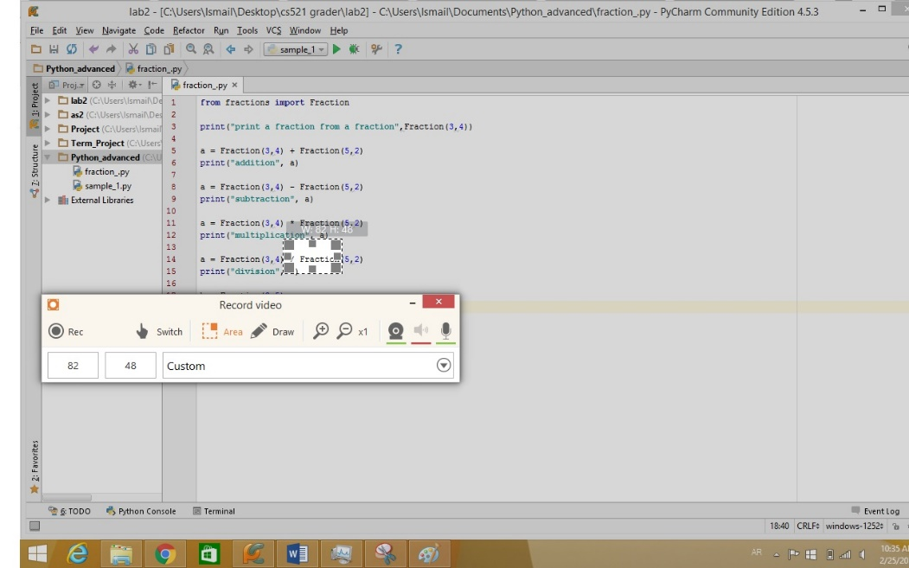

If you want to record the whole area of your screen, change the setting from **custom** to **full screen** in the dropdown list-box. If you want to record your PyCharm window only, leave the setting on **custom** and expand the area that you created until you cover the whole window of PyCharm.

Click on **Rec** to start recording. The program will record anything on the selected area, you can change from PyCharm to other program and the other program will be recorded too. Once you finish recording, click on the program icon on the task bar to restore it on the window and click **stop**.

The video will be saved in the directory that you specified in the step 2.

Part B: - Uploading the recorded session on Youtube and share it with your professor/grader.

Step 1: - log-in in youtube, this should be automatic if you are logged in by your gmail account within the same browser.

Step 2: - on the upper-right corner, click on upload. Create a channel.

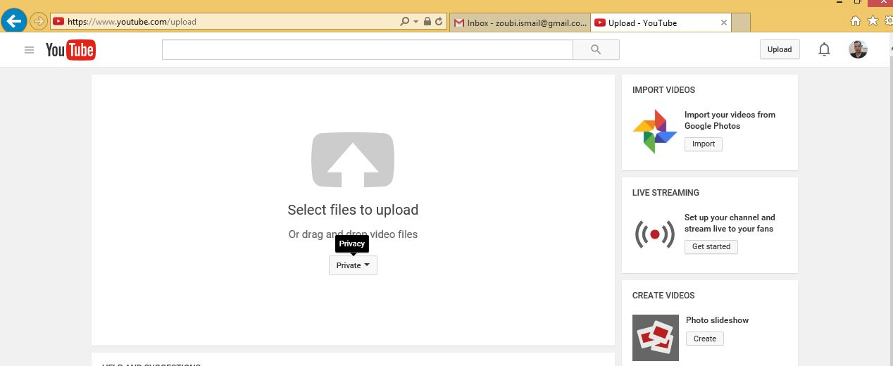Step 3: - in a dropdown list-box, there are three options of privacy, select private.

Step 4: upload the recorded video either by dragging it from where you saved it and dropping it above the area where you selected the privacy mode. Or you can select it from the directory by clicking on the big-gray arrow.

Step 5: in case you forgot to change the name of your video, you can change it here, for example, I changed the name of this video to **running term project iteration 2**.

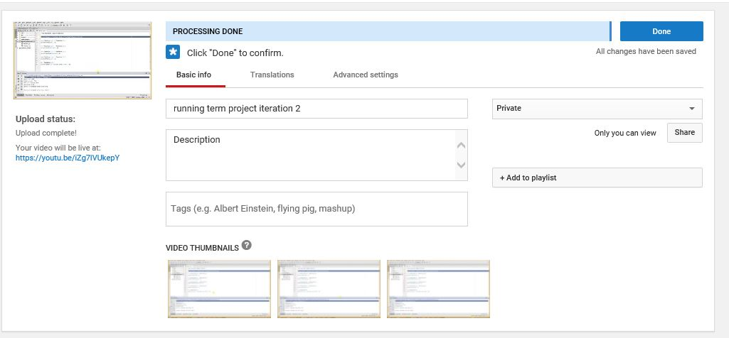

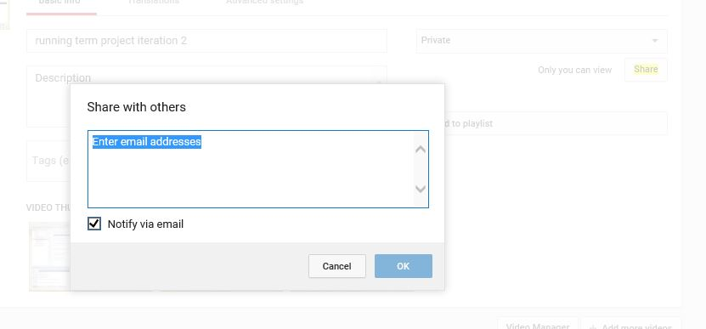Step 6: beneath the privacy dropdown list-box, click on **share**.

Insert the email address of your professor/grader, and then click OK. Your professor/grader should receive an email notifying them of the uploaded video once you click on **Done** button that is placed right of the uploading bar**.**

If you have any question regarding these steps, please, feel free to contact me on izoubi@bu.edu.

The url of my project is [https://youtu.be/-m7rIM3TWvs](https://youtu.be/-m7rIM3TWvs" \t "_blank)