**Assignment 4**

**Information structures with python**

**Deliverables**

**Part 1—Overall Project Description:**

In this project I am creating editor, some of the functionalities I have added in assignment 4 , other remaining will be added in assignment 5.

As we know that Notepad is used for writing text, opening a file ,editing a file and some functions like that .

In this Assignment I have included functions like creating new file , editing text like cut,paste ,copy , using python GUI and Tkinter .

**Part 2 –Structure of directory is**

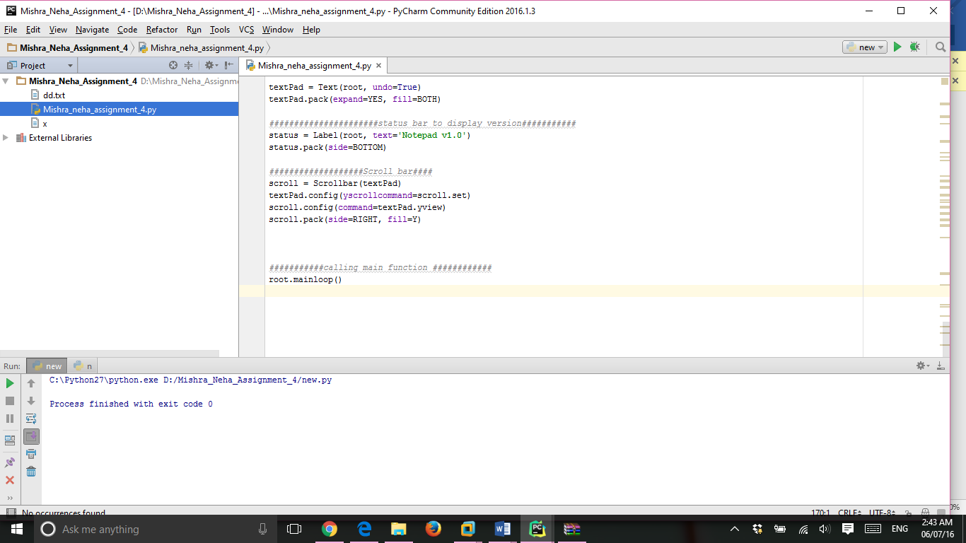

**Part 3 Sample feature implemented is for eg.**

Create a newfile xx.txt , save it and then open it edit it and saveas gf.py

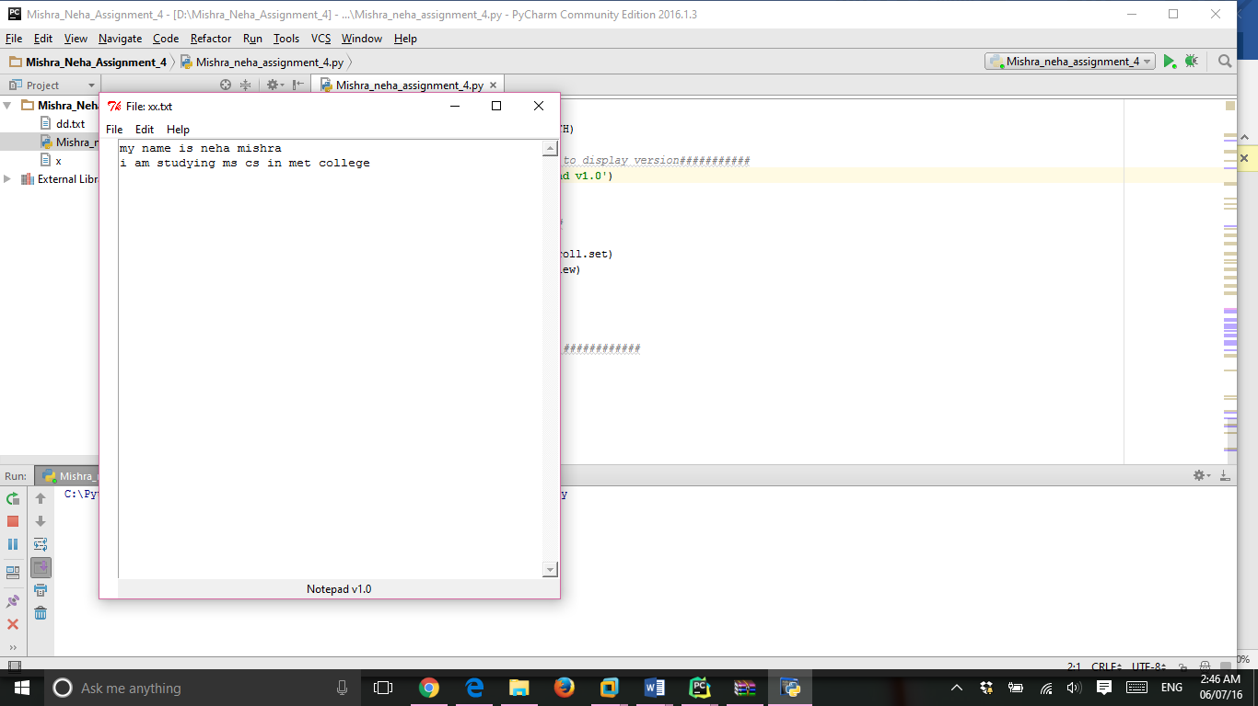

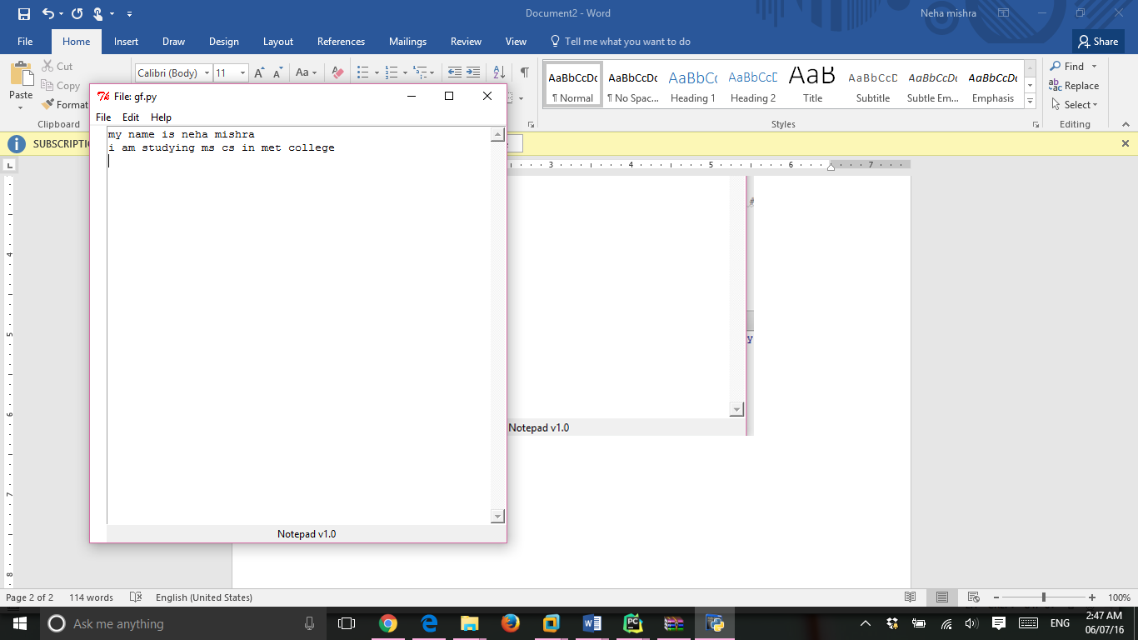

**Part 4 Features added :**

*#####################Creating File menu bar##########*file = Menu(menubar)  
file.add_command(label=**'New'**, accelerator=**'Ctrl + N'**, command=newfile)

*#########################line label##################*label = Label(root, width=2, bg=**'white'**)  
label.pack(side=LEFT, fill=Y)  
  
 *################Textpad#########*textPad = Text(root, undo=True)  
textPad.pack(expand=YES, fill=BOTH)  
  
*######################status bar to display version###########*statusbar = Label(root, text=**'Notepad v1.0'**,bg=**'light blue'**)  
statusbar.pack(side=BOTTOM)  
  
*###################Scroll bar####*scroll = Scrollbar(textPad)  
textPad.config(yscrollcommand=scroll.set)

**Part 5 :**

**For my best code I would say it**

In this function , I used predefined function of tk ,called asksaveas file in which ,new file or already created file can be save as the name we give to it.

The code is given below :

**def** saveas(event=None):  
 f = asksaveasfile(initialfile=**'newfile.txt'**, defaultextension=**'.txt'**)

################ new file to save as file and default extension saved is .txt###############  
 **global** filename  
 **try**:  
 filename = f.name  
 ofile = open(filename, **'w'**)  
 message = textPad.get(1.0, END)  
 ofile.write(message)  
 ofile.close()  
 root.title(**'File: '** + os.path.basename(filename))  
 **except**:  
 **pass**

**Output**

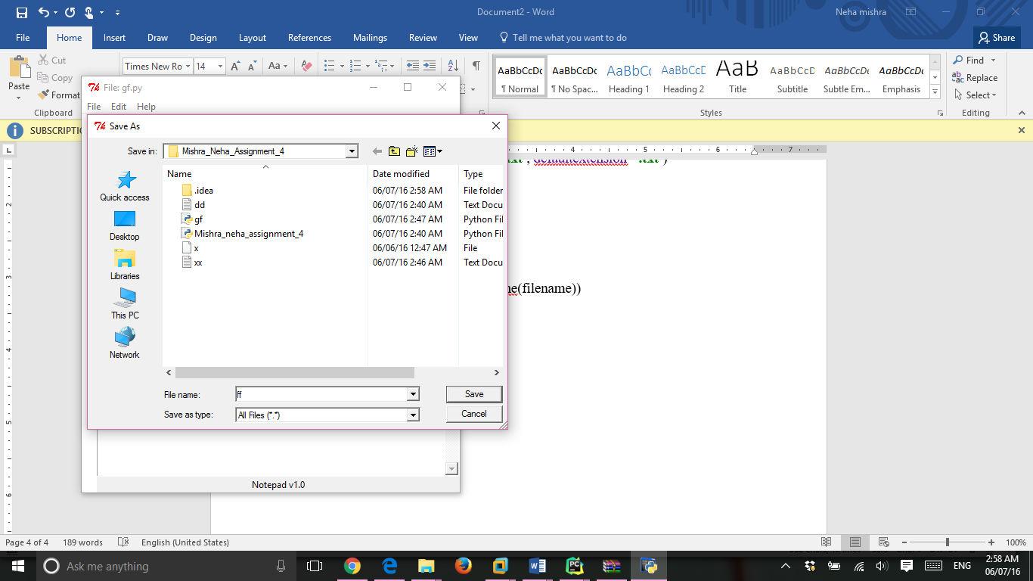

Note : The entire code is attached in a zip file :