# Prerequisites for running the deep learning markdowns

1. Go to add/remove programs and uninstall all previous versions of Python
2. Python installation required – 64 bit versions of 3.6 to 3.8 only!
   * Tested for v 3.8.6 – Download 64 bit version for windows/macOS:
     + “[Windows x86-64 executable installer](https://www.python.org/ftp/python/3.8.6/python-3.8.6-amd64.exe) / [macOS 64-bit installer](https://www.python.org/ftp/python/3.8.6/python-3.8.6-macosx10.9.pkg)”
   * Please uninstall older/newer versions!
3. Add/Check if the folder path where Python is installed has been added to PATH under system environment in Windows:
   * Search for ‘env’ in Windows search
   * Open “Edit the System environment variables”
   * Click on “Environment Variables”
   * Under the “System variables” list at the bottom, click on “Path” Variable & then click “Edit” at the bottom of the list.
   * Check if the Python installation folder & the Scripts folder within that folder appear among the paths in the list
     + For a Python 3.8.6 installation they should appear as the following in Windows
       - C:\Users\rbapna\AppData\Local\Programs\Python\Python38
       - C:\Users\rbapna\AppData\Local\Programs\Python\Python38\Scripts
     + **Note:** The AppData folder is normally hidden in Windows. There is no need to unhide it as such. Just typing the above path (after changing ‘rbapna’ to your system name!) in the address bar of File Explorer should take you to the location of your python installation
   * If they are not present, click on “New” and add the paths, save & exit
   * Example of correct file paths added into PATH:

1. Install TensorFlow library through ‘pip’:
   * Go to the folder where Python has been installed
     + As mentioned previously it should be - **C:\Users\”your system name”\AppData\Local\Programs\Python\**
     + Again, you don’t need to unhide AppData folder. Just typing the above path in the address bar should work!
     + Example:

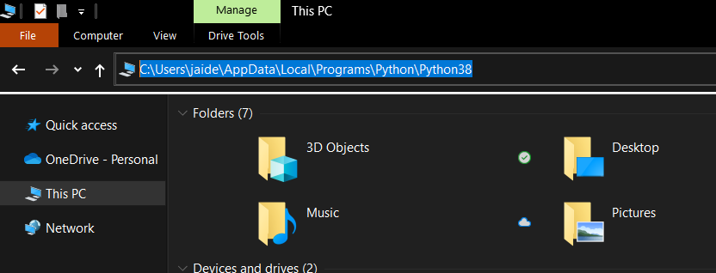

* + Run ‘cmd’ in that folder (you can type ‘cmd’ where the folder path appears at the top in the address bar & press enter) A screenshot of a computer

    Description automatically generated with medium confidence

* + Type **pip3 install --user --upgrade tensorflow**
    - Ignore error messages with the word ‘cuda’ as they are related to installation on a GPU

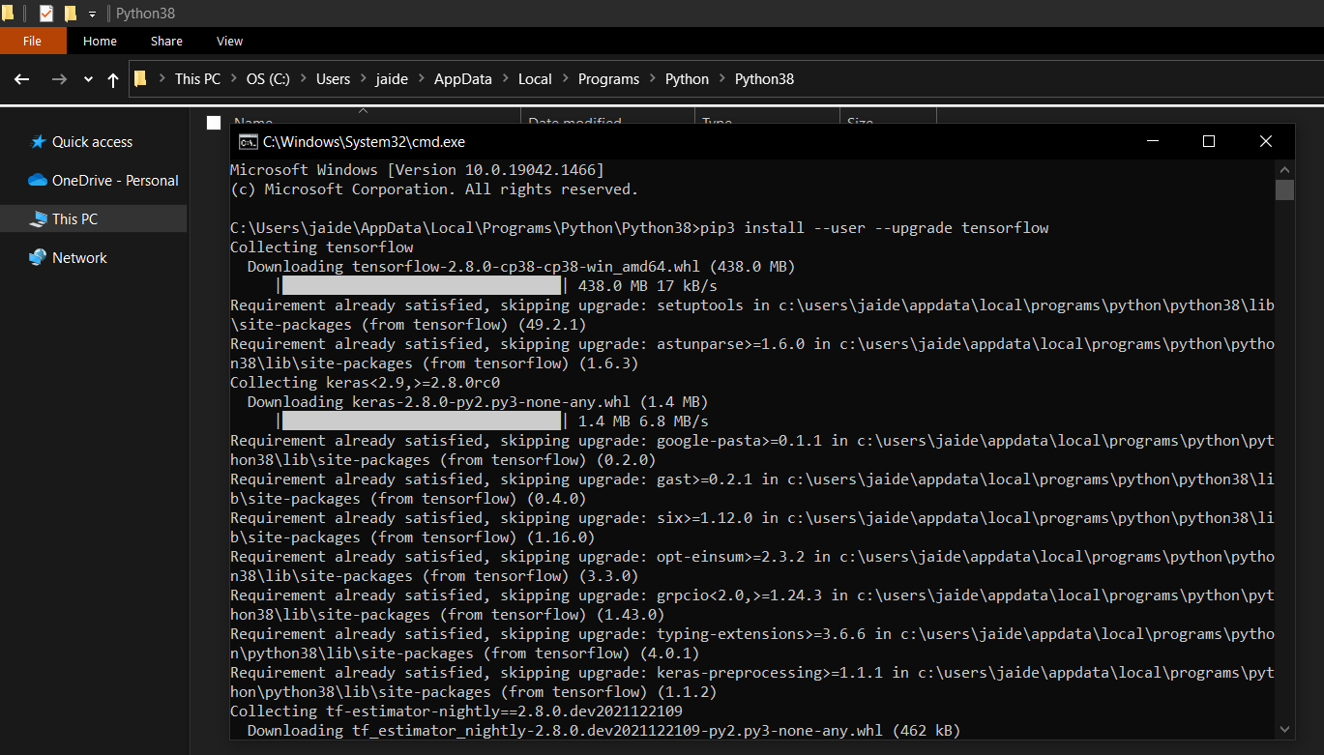

* + After installation has finished, verify installation by typing **python -c "import tensorflow as tf; print(tf.reduce_sum(tf.random.normal([1000, 1000])))"**
    - If a tensor is returned, you've installed TensorFlow successfully

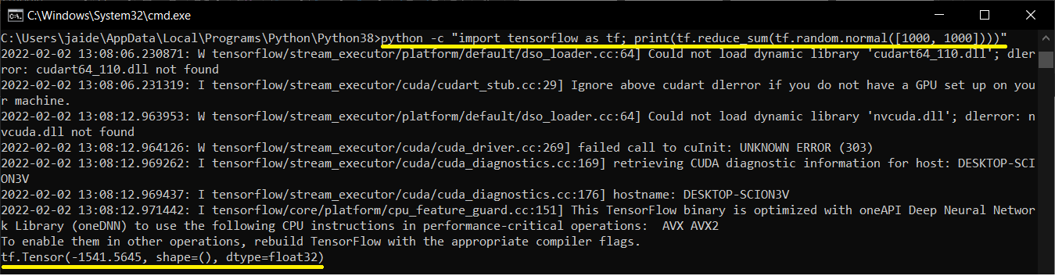

1. Restart your R session incase its already open
   * R version used for testing - 4.1.2 (2021-11-01)
   * R studio version used for testing - Version 1.4.1717
   * **Note:** R and R studio version is mentioned here for reference only. As long as you are not using very old versions everything should work fine!
2. Before running the markdowns, run **install.packages('keras')** in the console within R
3. For some of the markdowns, the following Python libraries are needed – Pillow & SciPy. Install them the same way as before through pip in cmd opened from the location of your Python installation:
   * pip install Pillow
   * pip install SciPy