Lab 1
CS 650
Jae Lee

Part 1: Edge Detection

1. Gradient magnitude image seems to be quite functional for edge detecting even if it is hard to find a fine thin edge. When I adjusted my global threshold too high, it missed a lot of edges. On the other hand, with low global threshold, the image becomes more susceptible to noise with thicker edges. Personally, I found the optimal threshold to be 70 which catches most of edges with little noise for the blocks image.

magnitude_threshold_box   | magnitude_threshold_blocks(threshold=70)  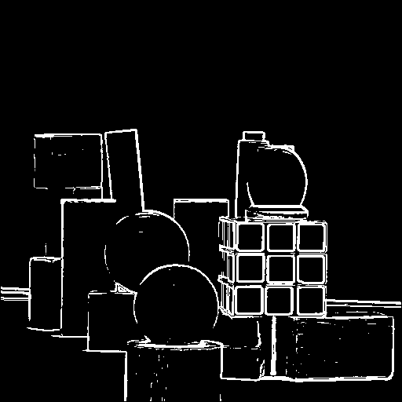

2. I used atan2 in C++ to find the gradient orientation. For encoding, I divided into 4 directions: Quadrant I, Quadrant II, Quadrant III, Quadrant IV. If the orientation stays in 1st quadrant(0 to 90 degree), the encoding pixel color was 255 which is white. 90 to 180 degree, 180 to 270, 270 to 360 was encoded as light gray, dark gray, black respectively.

orientation_box  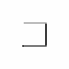  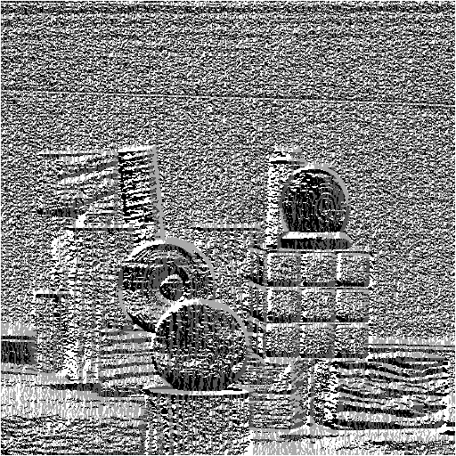 | orientation_blocks

3. Laplacian was actually one of my favorite image to look at because it detected edge with relatively simple algorithm and the detected edge was already thin enough. However, when I applied zero-crossing, the image became funny looking although it still kept edges.

laplacian_box  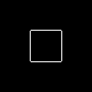 | 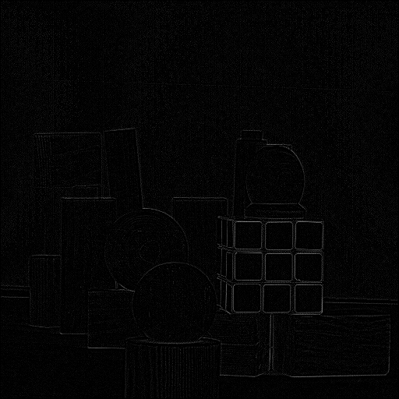  laplacian_blocks
zerocrossing_box   | zerocrossing_blocks  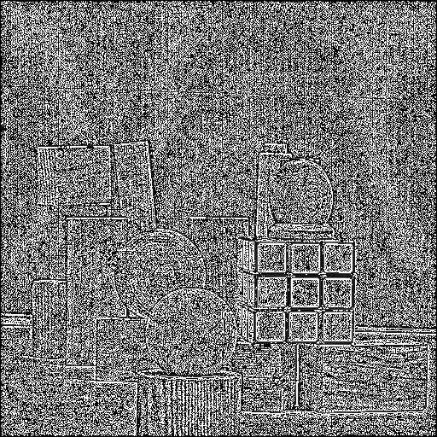

4. When I joined the gradient magnitude image and zero-crossing together, I was content with my image. This method thinned out edges from the gradient magnitude image while keeping almost all of the edges. After done with this part, I was ready to move onto the actual Hough transform. As shown below, the joint image seems more refined than just gradient magnitude.

joint_blocks

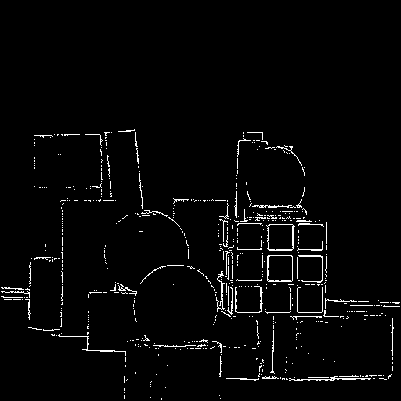

Part2: Hough Transform

Getting Hough transform working was easy task for the simple circle image. I didn't have much trouble to detect edge, accumulate, and vote. The following images are the accumulator image, a center of the circle, and the circle detected by Hough.

houghspace_simple  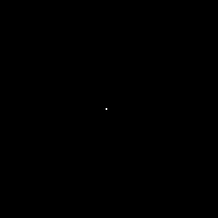  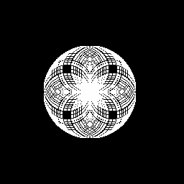 | center_simple |   hough_simple

At first, my regular edge detection for the more complicated circles didn't quite produce the best result. It turns out that applying a smoothing filter worked well. As shown below, applying filter helped a lot to reduce the noise.

joint_circles1  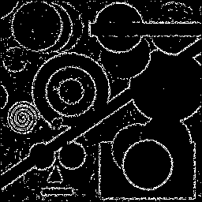 | joint_circles2  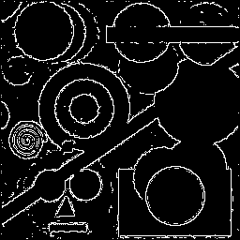

My algorithm for Hough transform can be summarized in the following.
1. Iterate through the image and find a white pixel.
2. If white pixel, points on the circles with the white pixel as its center with different sizes get votes. The votes are stored in different Hough space.
3. Thresholding and finding local maxima method are applied to find the actual centers of the circles on the original image.
4. With the found centers, draw circles with different radius in its Hough space.
5. Combine these 3 Hough spaces.

These are the center points for circles.
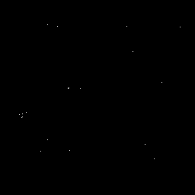
center_circles

Although my Hough transform is not perfect such as the inability to detect circular shapes at the corners of image or producing some false positives, it has been improved by applying the optimal threshold and the local maxima method. Also, thinning the circle helped to make the result look nicer.

hough_circles1  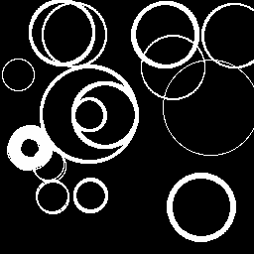 | 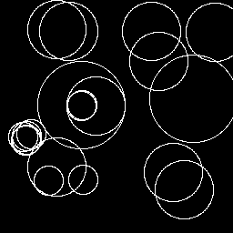  hough_circles2

Limitation – without OpenCV or Matlab's nice built-functions, it was difficult and very time-consuming to complete the project. For the upcoming labs, taking advantage of OpenCV seems to be compelling option which will save me a ton of time.

Here is my final result of detecting circles.
joint_circles2 | hough_circles2

Thank you !

