Lab 0
CS 650
Jae Lee

Part 1: Binarization
I implemented the assignment in C++ and it was little harder than I thought it would be for interacting with .pgm image file. In my program, I stored the entire pixel data from .pgm file in a 2d array first and applied the Otsu method later.

I went through the entire range of the possible threshold, in my case 0 – 255, and calculated the between-class variance. Then, I stored the between-class variance in an array to find the maximum value. The index of this maximum value gave me the optimal threshold value.
At first, I thought my program would run slow because of the very large array being accessed and manipulated, it was not a problem with my modern laptop.

I spent much time on trying to figure out how to read bytes from .pgm file and write to .pgm file. The solution to my problem was that when I read, I had to read as char and cast into integer for image processing. For writing to .pgm file, I actually wrote pixel data in integer data type and changed the .pgm file type to P2 instead of P5, which means data of the files are understood in ASCII instead of byte.

The Otsu method might not be the smartest algorithm to find the optimal threshold, but it does its job. The Niblack algorithm also seems to take a lot of computation, so Otsu is not the only one that is expensive in processing. However, since Otsu is global thresholding, this is not the best algorithm to binarize the image if the original image has widely varying background.

Binarization is very useful when I want to see the outlining figure of the object without any color information. Thus, like the examples below, it is useful for old-written documents or news papers for character restoration.

Here are some results of the Otsu method. As clearly shown, there is no more gray area. All pixel is either white or black.

Before:
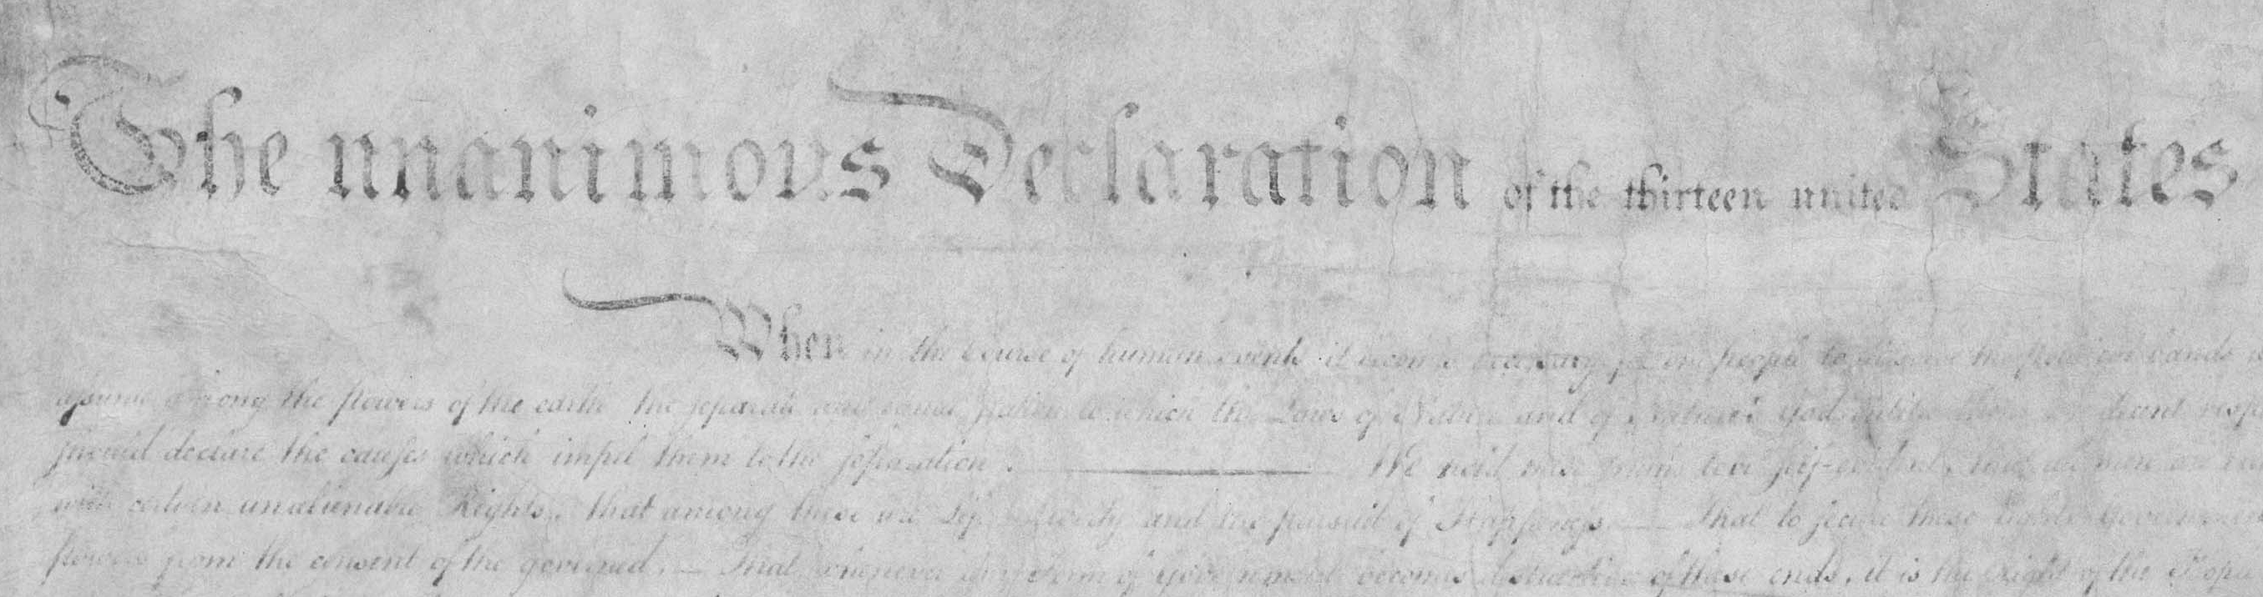
After:
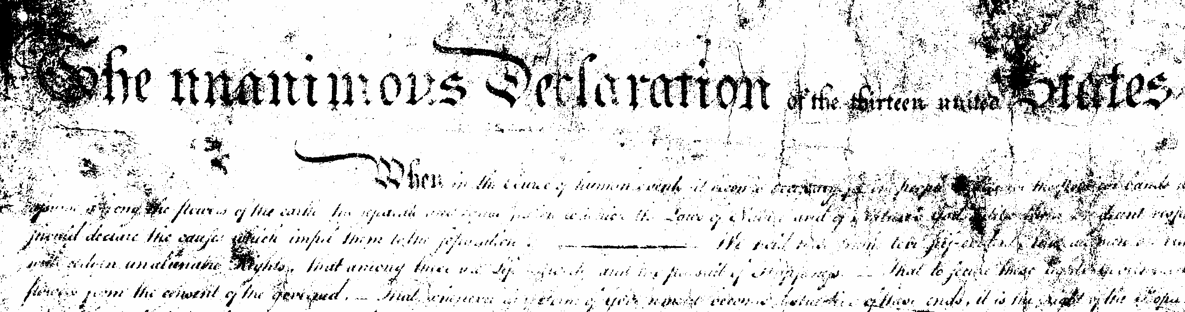

Before:  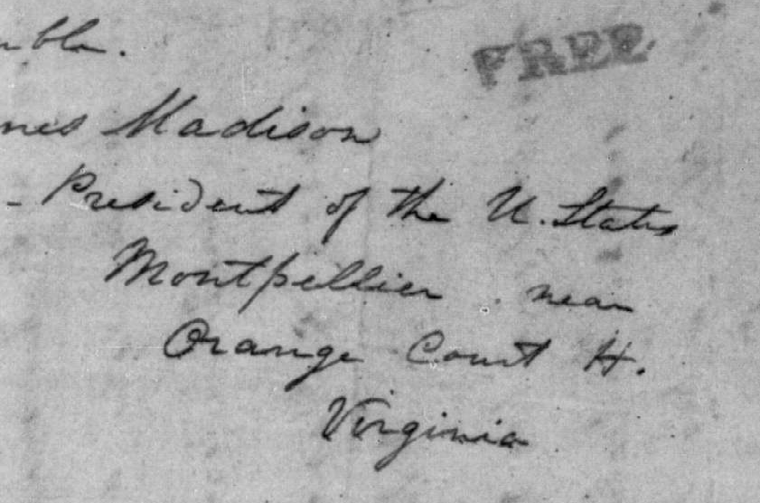 | After:  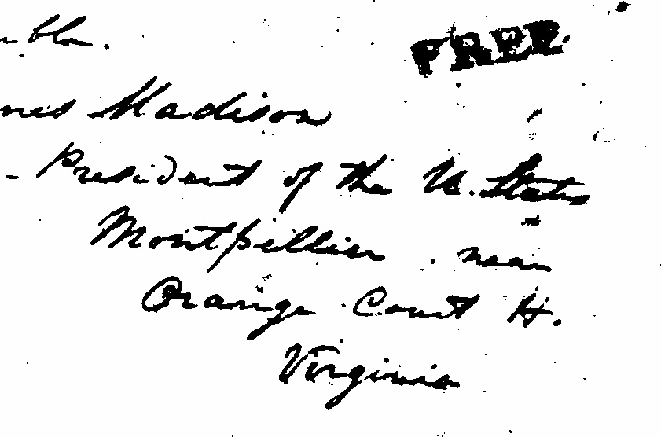

Part 2: Morphology
After I finished the binarization, morphological process was too troublesome. It would have been harder if the structuring elements had to be able to be modified. However, for our purpose, the structuring elements was fixed in size, 3x3. Because the structuring elements were 3x3, I put some padding around the pixel data array because otherwise I had to use a series of if-else statements for corner cases of the array. After I process the pixel data, I ignored the padding around the array when a .pgm file was being written.

My algorithm basically selects each pixel data of the image and if ANY surrounding pixel is set to 1, the selected pixel data becomes 1 for dilating, or if ALL surrounding pixel is set to 1, the selected pixel data becomes 1 for eroding. I had to make a copy of the pixel data array to avoid dilating on a being dilated array and eroding from a being eroded array.

In fact, I was able to see the effect of Open and Close operators with the examples that I made. As I expected, Open operator got rid of noise of the image and Close operator filled some gaps that were supposed to be filled. I observed that the open operator made the entire image look more clean and neat while the close operator made the character more legible.

Here are some results.
Open  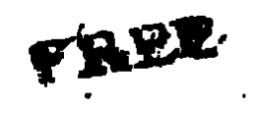 | Original  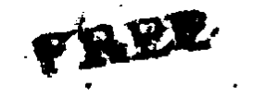 | Close  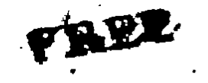
As shown above, gaps are more filled from open to close, while the number of noise pixels are more reduced from close to open.

Open  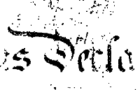 | Original  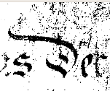 | Close  

