Lab 2 – Graph Cut
CS 650
Jae Lee

Preparation
I studied the 'Lazy Snapping' paper to learn how to calculate the likelihood for nodes(pixels) and prior energy for edges(connections of nodes). Likelihood and prior energy are essentially T-link and N-link. For this lab, I decided to use OpenCV for the first time in my life because OpenCV has many convenient tools that I wanted to use. Specifically, for this lab, I used OpenCV to display the image, to handle with the mouse interface, and to use K-mean clustering.

Foreground / background color estimation
I select foreground pixels by dragging the mouse with the left-button clicked. I do the same procedure to select background, but with middle-button. After this, I put foreground pixels and background pixels into K-mean clustering function to find the mean values for each cluster of foreground and background. For example, the figure below shows that there were 14 foreground pixels selected and 19 for background pixels. 4 clusters for each foreground and background. A row represent mean R, G, B values for a cluster.

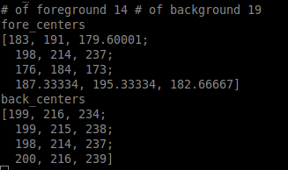

T-link / N-link weights
After foreground and background color estimation, T-link can be calculated. The Lazy snapping method finds the minimum color distance(difference) between foreground and background clusters and each pixel, and then T-link weights are set for the pixel after some algebraic manipulation.
I set 8-connected node as surroundings of a pixel for N-link. Thus, a pixel will hold 8 weights for its neighbors which are calculated based on RGB color difference of two pixels.

Result

I applied my graph-cut algorithm to simple twitter image. As shown below, twitter is almost just two colors except for some noise around the bird shape. It was not difficult to segment object out from this kind of images.

Original   | Foreground and Background selected  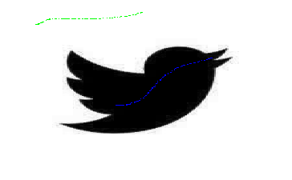 | Graph-cut result

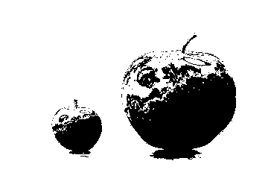
This is little more complex image than the twitter image above. I am using this image to see some of the effect of parameters such as foreground and background selection, the number of clusters, and the importance weight(lambda) on likelihood or prior energy.
Parameters used: # of clusters = 4, lambda = 3(which puts more importance on likelihood than prior energy)

Original  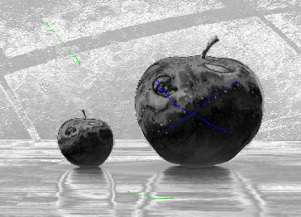   | Fore/Background | Result
I changed the number of clusters to 20 and the performance of graph-cut improved because it was better at sorting the foreground pixels which came from the part of the apple reflecting the light.
Parameters used: # of clusters = 20, lambda = 3

Original | 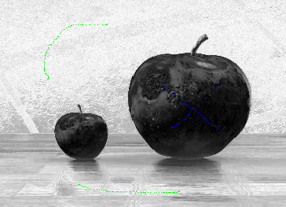  Fore/Background | 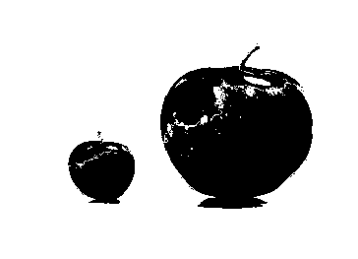  Result

It was interesting to see that the weight between likelihood and prior energy actually matters for the quality of segmentation. It seems like the likelihood has to have more weights on than prior energy.
Parameters used: # of clusters = 20, lambda = 1

Original | 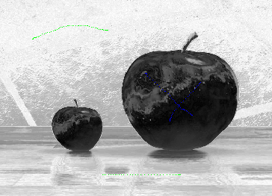  Fore/Background | 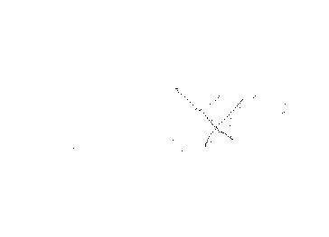  Result

The image below is the most complicated image that I used because there are a lot of similar colors in both foreground and background.
Parameters used: # of clusters = 20, lambda = 5

Original  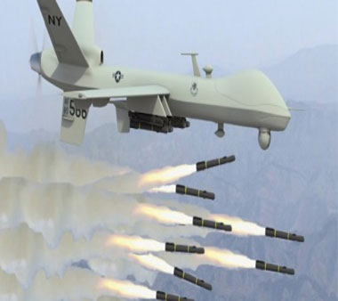 | 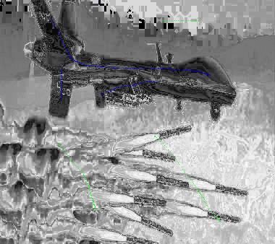  Fore/Background | 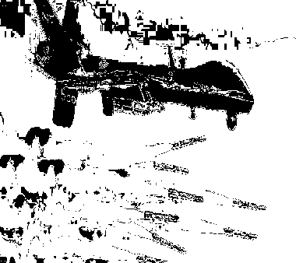  Result

Some improvement by increasing the number of clusters.
Parameters used: # of clusters = 50, lambda = 5

Original | 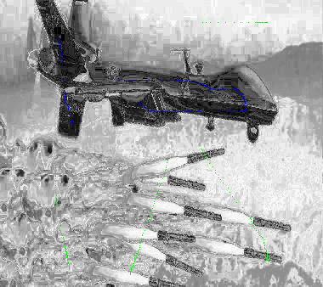  Fore/Background | 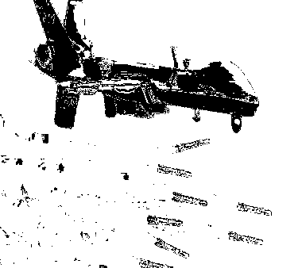  Result

Conclusion
It was a fun lab to see the result of graph-cut. I also learned to use some OpenCV functions which will help for my research as well. As shown above, graph-cut works well on the images with distinct colors between foreground and background. However, it struggles with the images like similar colors are used for both foreground and background.

