**Lab1 - Breadboard**

09/10/2013

ECEN 220

Jaehun Lee

**Preparation Work**

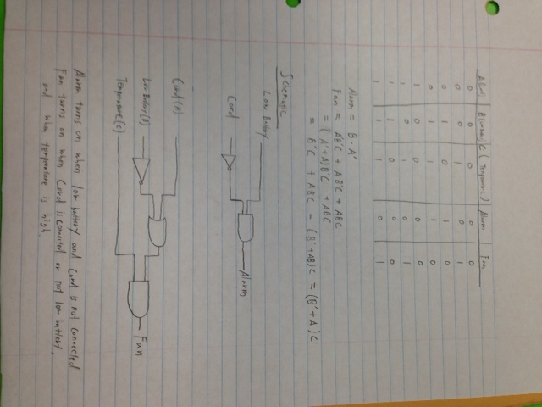

**Schematic of the circuit**

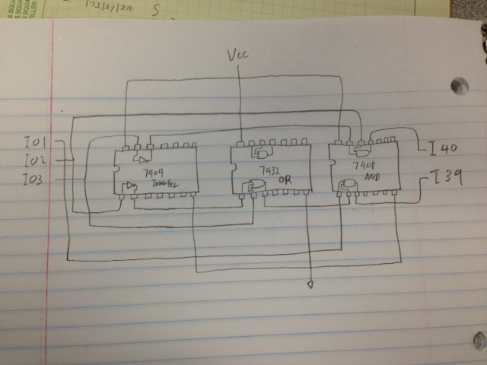

I used 5 gates, but 3 chips. I used 7408(AND gate), 7404(Inverter), and 7432(OR gate).

**Result of the circuit**

|  |  |  |  |  |
| --- | --- | --- | --- | --- |
| A(Cord) | B(Low Battery) | C(Temperature) | Alarm | Fan |
| 0 | 0 | 0 | 0 | 0 |
| 0 | 0 | 1 | 0 | 1 |
| 0 | 1 | 0 | 1 | 0 |
| 0 | 1 | 1 | 1 | 0 |
| 1 | 0 | 0 | 0 | 0 |
| 1 | 0 | 1 | 0 | 1 |
| 1 | 1 | 0 | 0 | 0 |
| 1 | 1 | 1 | 0 | 1 |

**Anomalies**

I didn’t have any bugs.