ECEN 220

Jae Lee

Lab 12 – LC3 Full simulation

12/11/2013

**State Machine Diagram (6pt)**

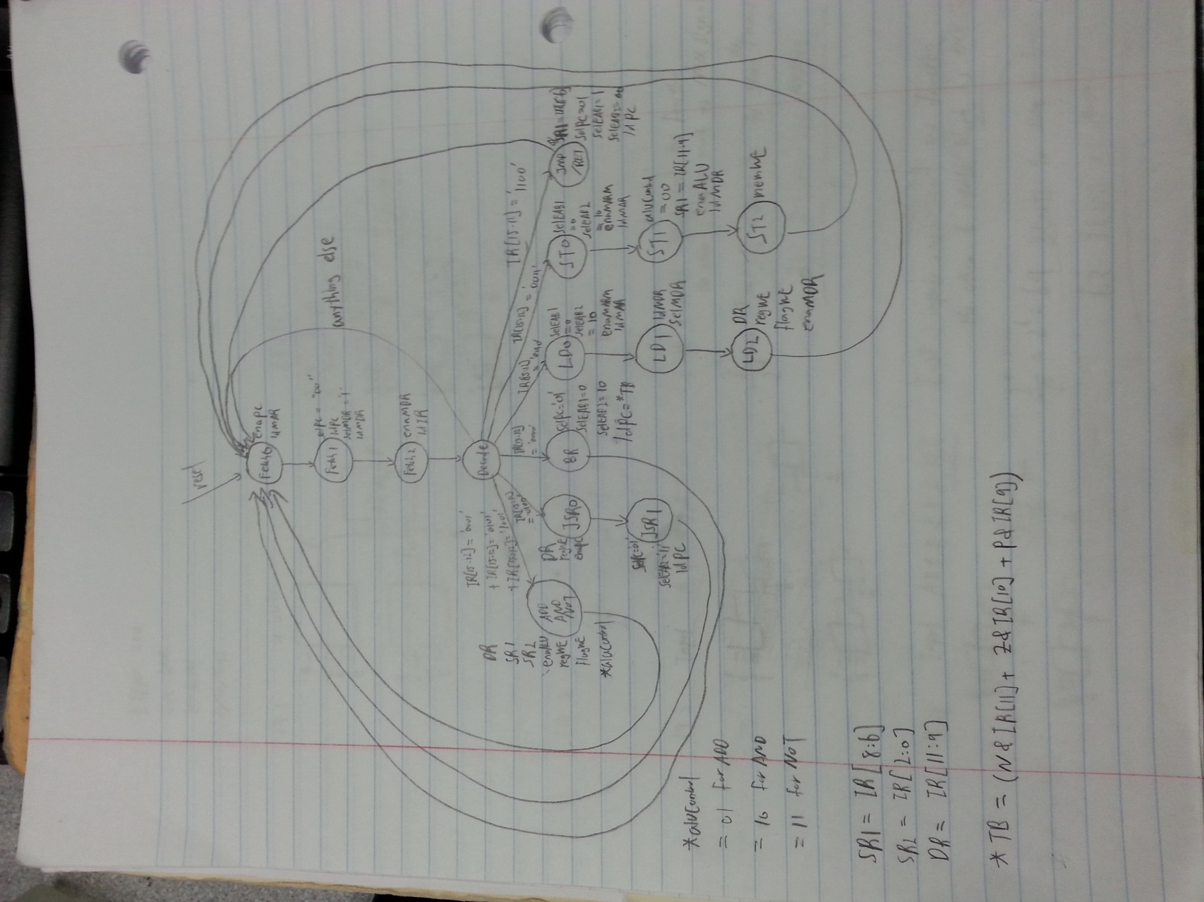

**Controller Verilog file (7pt)**

|  |
| --- |
| module LC3_Control(IR,N,Z,P,aluControl,SR1,SR2,DR,selPC,selEAB1,selEAB2,  enaALU,regWE,flagWE,enaMARM,selMAR,enaPC,ldPC,ldIR,ldMAR,ldMDR,selMDR,memWE,enaMDR,reset,clk);    input reset,clk;  input[15:0] IR;  input N,Z,P;  output reg[1:0] aluControl,selPC,selEAB2;  output reg[2:0] SR1,SR2,DR;  output reg selEAB1,enaALU,regWE,flagWE,enaMARM,selMAR,enaPC,ldPC,ldIR,ldMAR,ldMDR,selMDR,memWE,enaMDR;    reg[14:0] CS;  reg[3:0] OPcode;    parameter fetch0 = 15'h0001;  parameter fetch1 = 15'h0002;  parameter fetch2 = 15'h0004;  parameter decode = 15'h0008;  parameter AAN = 15'h0010;  parameter JSR0 = 15'h0020;  parameter JSR1 = 15'h0040;  parameter BR = 15'h0080;  parameter LD0 = 15'h0100;  parameter LD1 = 15'h0200;  parameter LD2 = 15'h0400;  parameter ST0 = 15'h0800;  parameter ST1 = 15'h1000;  parameter ST2 = 15'h2000;  parameter JMRE = 15'h4000;    always @(posedge clk)  begin  if(reset)  CS <= fetch0;    else  case(CS)  fetch0:  CS = fetch1;  fetch1:  CS = fetch2;  fetch2:  CS = decode;  decode:  begin  OPcode = IR[15:12];  if(OPcode == 4'b0001 || OPcode == 4'b0101 || OPcode == 4'b1001)  CS = AAN;  else if(OPcode == 4'b0100)  CS = JSR0;  else if(OPcode == 4'b0000)  CS = BR;  else if(OPcode == 4'b0010)  CS = LD0;  else if(OPcode == 4'b0011)  CS = ST0;  else if(OPcode == 4'b1100)  CS = JMRE;  else  CS = fetch0;  end  AAN:  CS = fetch0;  JSR0:  CS = JSR1;  JSR1:  CS = fetch0;  BR:  CS = fetch0;  LD0:  CS = LD1;  LD1:  CS = LD2;  LD2:  CS = fetch0;  ST0:  CS = ST1;  ST1:  CS = ST2;  ST2:  CS = fetch0;  JMRE:  CS = fetch0;  endcase  end  always @(CS)  begin  enaALU = 1'b0;  enaMARM = 1'b0;  enaPC = 1'b0;  enaMDR = 1'b0;  ldIR = 1'b0;  ldPC = 1'b0;  ldMAR = 1'b0;  ldMDR = 1'b0;  regWE = 1'b0;  memWE = 1'b0;  flagWE = 1'b0;  case(CS)    fetch0://fetch0  begin  enaPC = 1'b1;  ldMAR = 1'b1;  end    fetch1://fetch1  begin  ldPC = 1'b1;  selPC = 2'b00;  ldMDR = 1'b1;  selMDR = 1'b1;  end    fetch2://fetch2  begin  ldIR = 1'b1;  enaMDR = 1'b1;  end    AAN://add,and,not  begin  enaALU = 1'b1;  regWE = 1'b1;  flagWE = 1'b1;  aluControl = (IR[15:12] == 4'b0001)? 2'b01:  (IR[15:12] == 4'b0101)? 2'b10:  2'b11;  SR1 = IR[8:6];  SR2 = IR[2:0];  DR = IR[11:9];  end    JSR0://JSR0  begin  DR = 3'b111;  regWE = 1'b1;  enaPC = 1'b1;  end    JSR1://JSR1  begin  selPC = 2'b01;  selEAB1 = 1'b0;  selEAB2 = 2'b11;  ldPC = 1'b1;  end    BR://BR  begin  selPC = 2'b01;  selEAB1 = 1'b0;  selEAB2 = 2'b10;  ldPC = ((N & IR[11]) | (Z & IR[10]) | (P & IR[9]));  end    LD0://LD0  begin  selEAB1 = 1'b0;  selEAB2 = 2'b10;  enaMARM = 1'b1;  selMAR = 1'b0;  ldMAR = 1'b1;  end    LD1://LD1  begin  ldMDR = 1'b1;  selMDR = 1'b1;  end    LD2://LD2  begin  DR = IR[11:9];  regWE = 1'b1;  flagWE = 1'b1;  enaMDR = 1'b1;  end  ST0://ST0  begin  selEAB1 = 1'b0;  selEAB2 = 2'b10;  enaMARM = 1'b1;  selMAR = 1'b0;  ldMAR = 1'b1;  end    ST1://ST1  begin  aluControl = 2'b00;  SR1 = IR[11:9];  enaALU = 1'b1;  ldMAR = 1'b1;  end    ST2://ST2  begin  memWE = 1'b1;  end    JMRE://JMP,RET  begin  SR1 = IR[8:6];  selPC = 2'b01;  selEAB1 = 1'b1;  selEAB2 = 2'b00;  ldPC = 1'b1;  end  endcase  end    endmodule |

**Full LC3 Verilog file (7pt)**

|  |
| --- |
| module LC3(reset, clk);  input reset, clk;    wire[15:0] IR;  wire N,Z,P;    wire[1:0] aluControl,selPC,selEAB2;  wire[2:0] SR1,SR2,DR;  wire selEAB1,enaALU,regWE,flagWE,enaMARM,selMAR,enaPC,ldPC,ldIR,ldMAR,ldMDR,selMDR,memWE,enaMDR;    LC3_Control LC3_C(IR,N,Z,P,aluControl,SR1,SR2,DR,selPC,selEAB1,selEAB2,  enaALU,regWE,flagWE,enaMARM,selMAR,enaPC,ldPC,ldIR,ldMAR,ldMDR,selMDR,memWE,enaMDR,reset,clk);  Datapath DP(reset, clk, IR, N, Z, P, aluControl, SR1, SR2, DR, selPC, selEAB2, enaALU,  regWE, enaMARM, selMAR, selEAB1, enaPC, ldPC, ldIR, ldMAR, ldMDR, selMDR, memWE, enaMDR, flagWE);    endmodule |

**Master TCL file (2pt)**

|  |
| --- |
| wave add /DP/IR -radix hex  wave add /DP/N -radix hex  wave add /DP/Z -radix hex  wave add /DP/P -radix hex  wave add /DP/reg0/r0 -radix hex  wave add /DP/reg0/r1 -radix hex  wave add /DP/reg0/r2 -radix hex  wave add /DP/reg0/r3 -radix hex  wave add /DP/reg0/r4 -radix hex  wave add /DP/reg0/r5 -radix hex  wave add /DP/reg0/r6 -radix hex  wave add /DP/reg0/r7 -radix hex  wave add /DP/PC -radix hex  isim force add clk 0 -time 0 -value 1 -time 5ns -repeat 10ns  isim force add reset 1 -time 0 -value 0 -time 8ns  run 2000ns |

**All Simulation waveforms(18pt)**

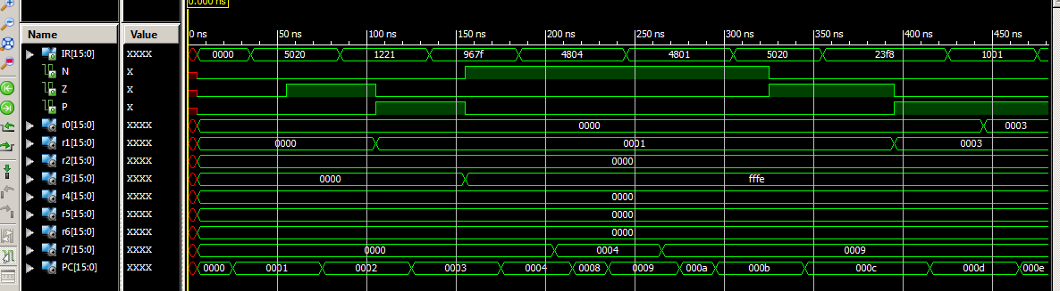

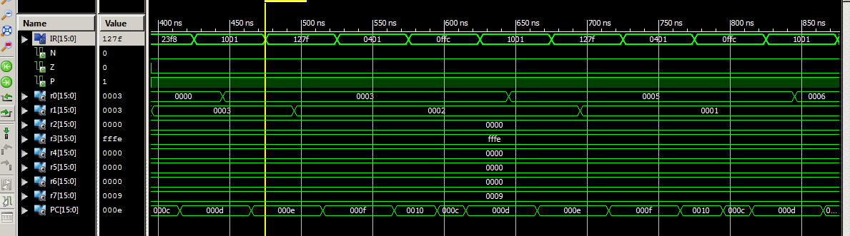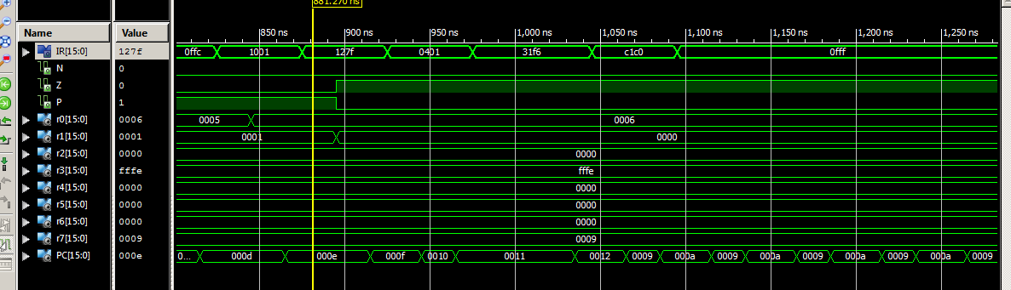

**Anomalies**

My lab partner and I had a hard time to make LC3 control Verilog code because we were not familiar with the Behavioral Verilog. However, we found a good Verilog example of putting a state machine into a Verilog code. Once things started rolling, everything fell into the place.

**TA evaluation**

All of you guys are great. I really learned a lot from you guys. Thank you for your help on home works and labs. I don’t have any suggestion for individual person, but in general, sometimes I had to wait so long to get help while doing lab.