Jae Lee

ECEN 220

Lab #2 – CAD: Schematic Entry and Simulation

09/17/2013

Car Alarm Schematic

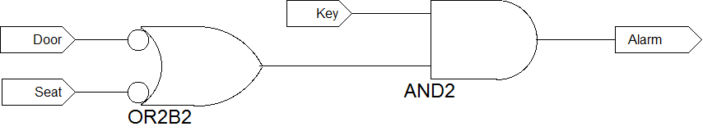

Car Alarm simulation waveform

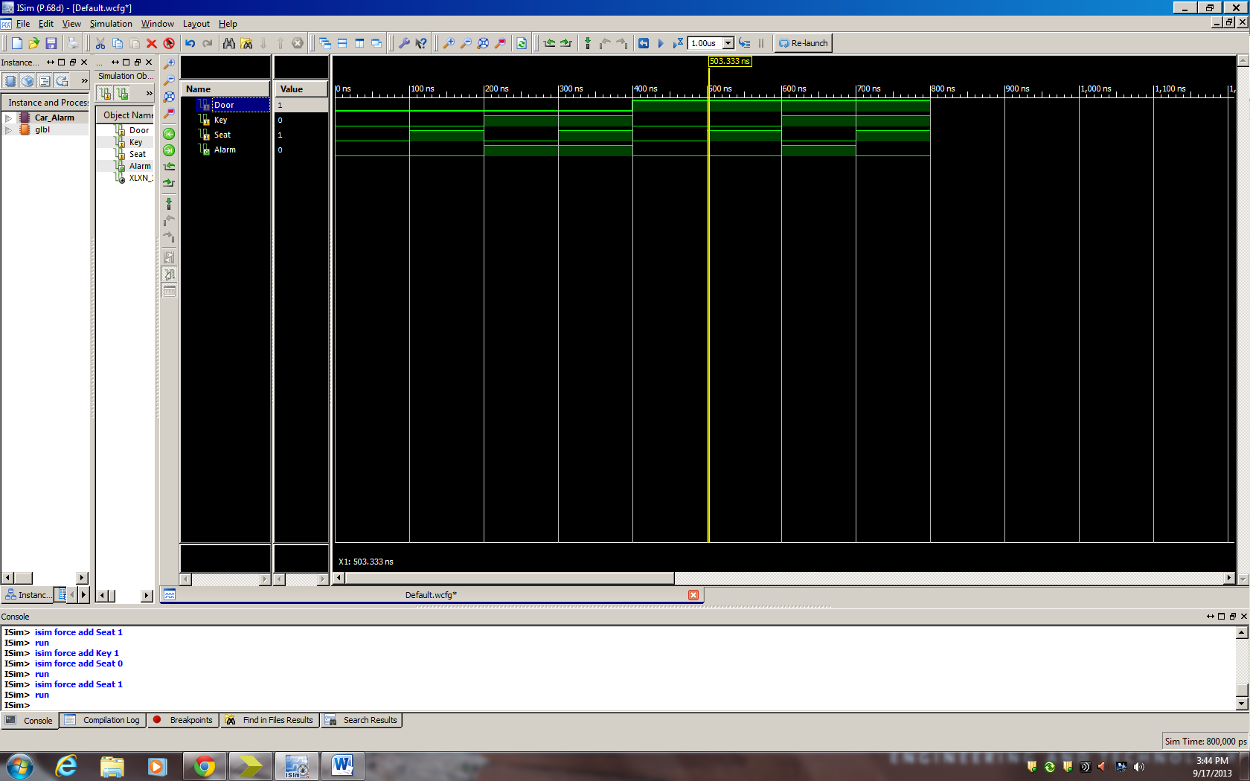

Alarm Fan schematic

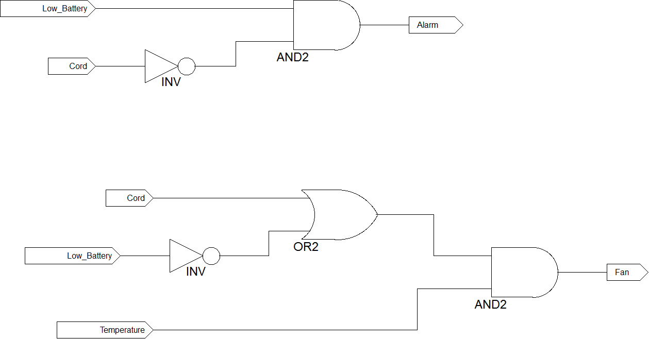

Alarm Fan Simulation waveform

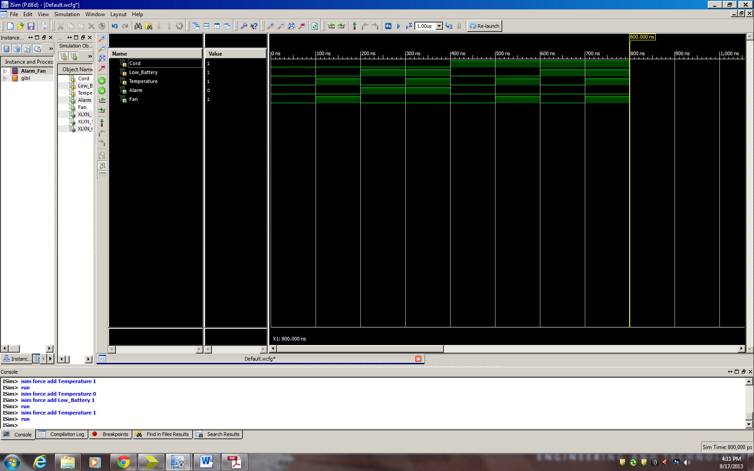

**Problem 2.1**

Original schematic (Top) & Simplified schematic (Bottom)

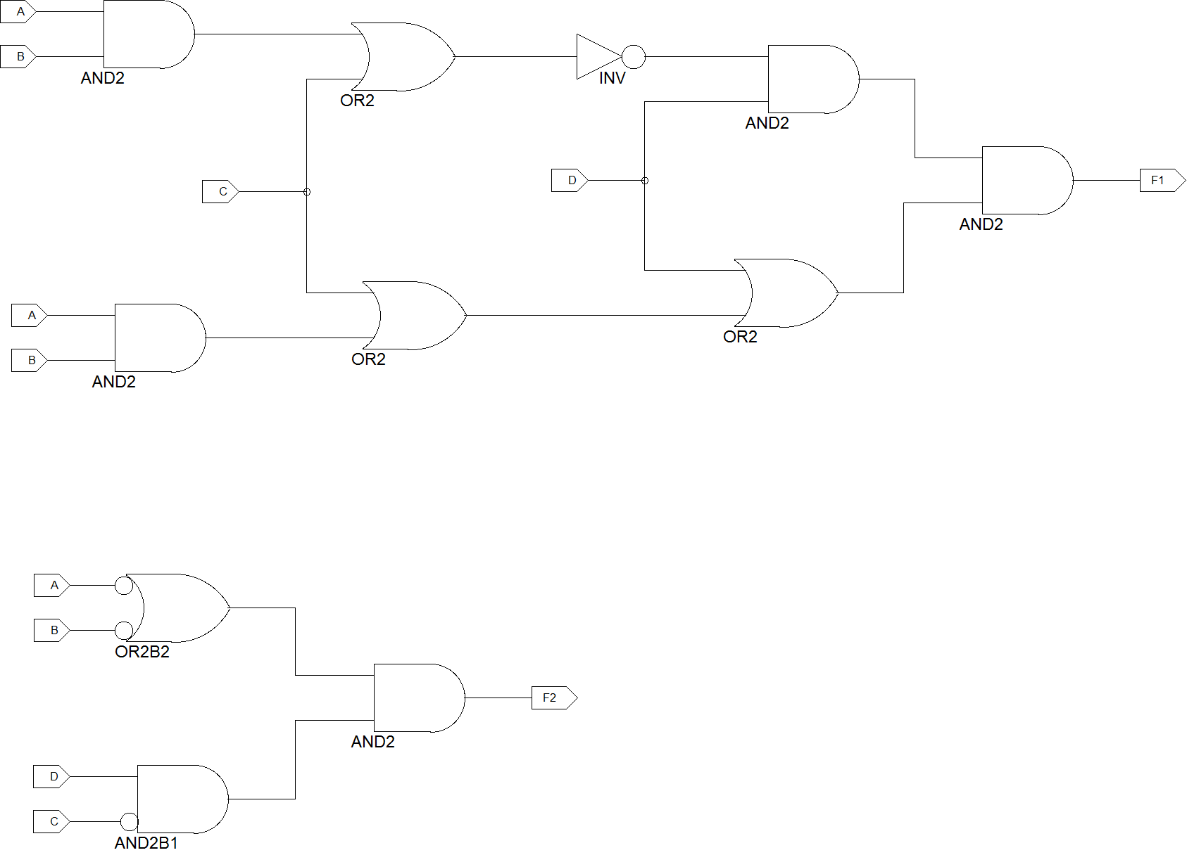

Original Wave form (F1) & Simplified Wave form (F2)

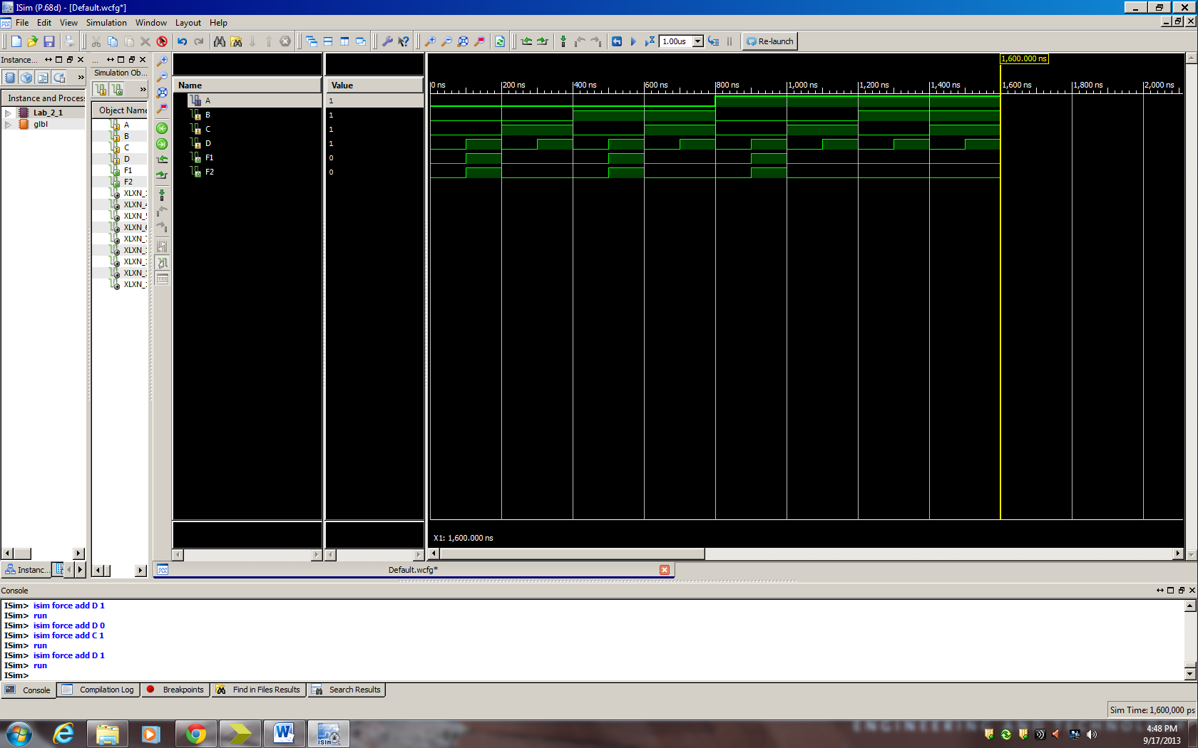

Truth table

|  |  |  |  |  |  |  |
| --- | --- | --- | --- | --- | --- | --- |
| A | B | C | D | A’+B’ | C’D | (A’+B’)C’D |
| 0 | 0 | 0 | 0 | 1 | 0 | 0 |
| 0 | 0 | 0 | 1 | 1 | 1 | 1 |
| 0 | 0 | 1 | 0 | 1 | 0 | 0 |
| 0 | 0 | 1 | 1 | 1 | 0 | 0 |
| 0 | 1 | 0 | 0 | 1 | 0 | 0 |
| 0 | 1 | 0 | 1 | 1 | 1 | 1 |
| 0 | 1 | 1 | 0 | 1 | 0 | 0 |
| 0 | 1 | 1 | 1 | 1 | 0 | 0 |
| 1 | 0 | 0 | 0 | 1 | 0 | 0 |
| 1 | 0 | 0 | 1 | 1 | 1 | 1 |
| 1 | 0 | 1 | 0 | 1 | 0 | 0 |
| 1 | 0 | 1 | 1 | 1 | 0 | 0 |
| 1 | 1 | 0 | 0 | 0 | 0 | 0 |
| 1 | 1 | 0 | 1 | 0 | 1 | 0 |
| 1 | 1 | 1 | 0 | 0 | 0 | 0 |
| 1 | 1 | 1 | 1 | 0 | 0 | 0 |

Minimization work

F1 = (AB+C)’D(AB+C+D) = (A’+B’)C’D(AB+C+D) = (A’+B’)C’(ABD+CD+D) = (A’+B’)(ABC’D+C’D)

= (A’+B’)(C’D)

**Problem 2.2**

Original schematic (Left) & Simplified schematic (Right)

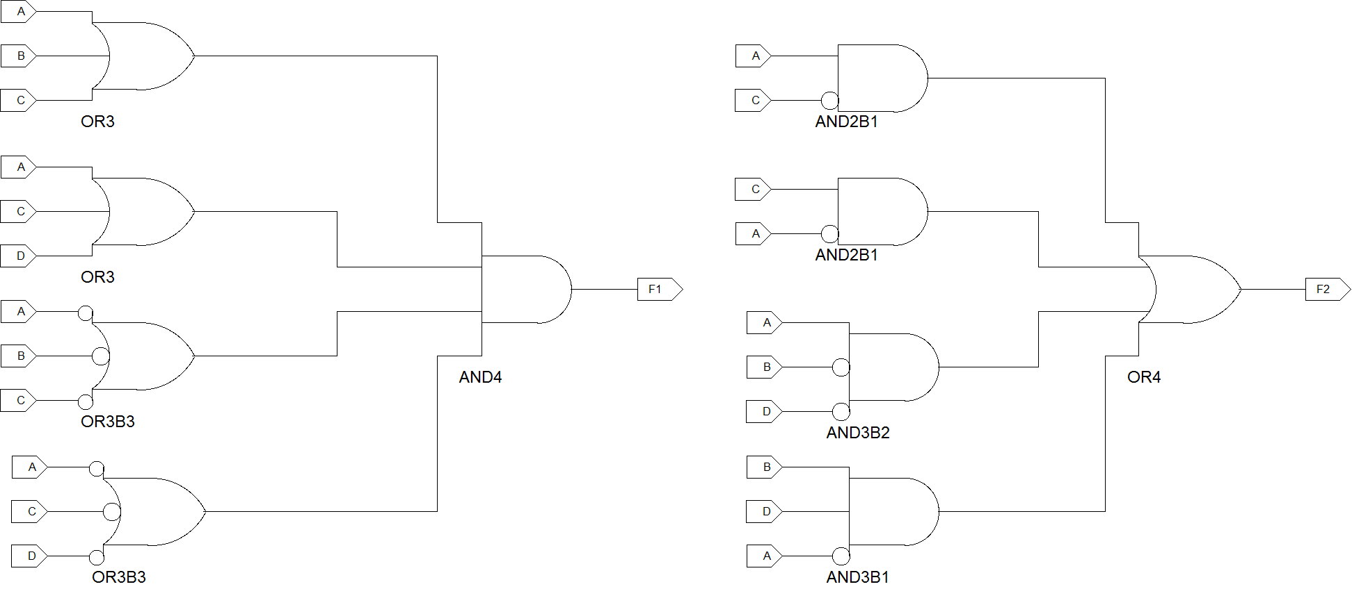

Original Wave form (F1) & Simplified Wave form (F2)

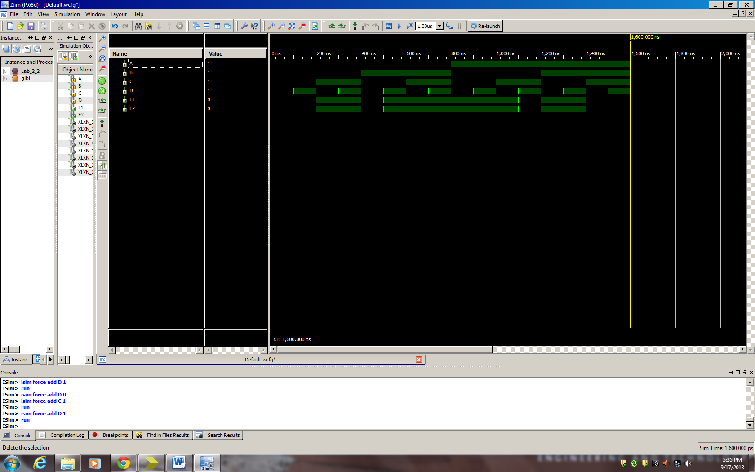

Truth Table

|  |  |  |  |  |  |  |  |  |
| --- | --- | --- | --- | --- | --- | --- | --- | --- |
| A | B | C | D | AC’ | A’C | AB’D’ | A’BD | F |
| 0 | 0 | 0 | 0 | 0 | 0 | 0 | 0 | 0 |
| 0 | 0 | 0 | 1 | 0 | 0 | 0 | 0 | 0 |
| 0 | 0 | 1 | 0 | 0 | 1 | 0 | 0 | 1 |
| 0 | 0 | 1 | 1 | 0 | 1 | 0 | 0 | 1 |
| 0 | 1 | 0 | 0 | 0 | 0 | 0 | 0 | 0 |
| 0 | 1 | 0 | 1 | 0 | 0 | 0 | 1 | 1 |
| 0 | 1 | 1 | 0 | 0 | 1 | 0 | 0 | 1 |
| 0 | 1 | 1 | 1 | 0 | 1 | 0 | 1 | 1 |
| 1 | 0 | 0 | 0 | 1 | 0 | 1 | 0 | 1 |
| 1 | 0 | 0 | 1 | 1 | 0 | 0 | 0 | 1 |
| 1 | 0 | 1 | 0 | 0 | 0 | 1 | 0 | 1 |
| 1 | 0 | 1 | 1 | 0 | 0 | 0 | 0 | 0 |
| 1 | 1 | 0 | 0 | 1 | 0 | 0 | 0 | 1 |
| 1 | 1 | 0 | 1 | 1 | 0 | 0 | 0 | 1 |
| 1 | 1 | 1 | 0 | 0 | 0 | 0 | 0 | 0 |
| 1 | 1 | 1 | 1 | 0 | 0 | 0 | 0 | 0 |

Minimization work

F = (A+B+C)(A+C+D)(A’+B’+C’)(A’+C’+D’) = (A+(B+C)(C+D))(A’+(B’+C’)(C’+D’))

= (A+C+BD)(A’+C’+B’D’) = AC’+A’C+AB’D’+A’BD+B’CD’+BC’D (the last two terms are redundant)

**Anomalies**

Things went pretty smooth. I just had a hard time to simplify problem 2.2. Using CAD was cool thing to do. I really enjoyed doing this lab.