Jae Lee

ECEN 220

Lab #7

10/22/2013

**1-bit Register Verilog code**

module reg_one(dout, din, write, clr, clk);

output dout;

input din, write, clr, clk;

wire temp1;

feff f1(dout, clk, temp1, clr);

mux21 m1(temp1, write, dout, din);

endmodule

**1-bit Register TCL file**

wave add / -radix hex

isim force add din 1 -time 0 -value 0 -time 26ns

isim force add write 0 -time 0 -value 1 -time 18ns

isim force add clk 0 -time 0 -value 1 -time 5ns -repeat 10ns

isim force add clr 1 -time 0 -value 0 -time 18ns

run 40ns

**1-bit Register simulation waveform**

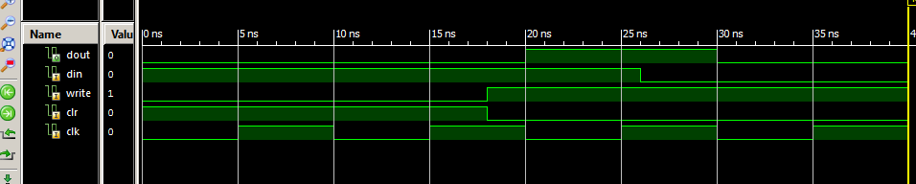

**4-bit Register Verilog code**

module reg_four(dout, din, write, clr, clk);

output[3:0] dout;

input[3:0] din;

input write, clr, clk;

reg_one r0(dout[0], din[0], write, clr, clk);

reg_one r1(dout[1], din[1], write, clr, clk);

reg_one r2(dout[2], din[2], write, clr, clk);

reg_one r3(dout[3], din[3], write, clr, clk);

endmodule

**4-bit Register TCL file**

wave add / -radix hex

isim force add write 0 -time 0 -value 1 -time 17ns

isim force add clk 0 -time 0 -value 1 -time 5ns -repeat 10ns

isim force add clr 1 -time 0 -value 0 -time 18ns

isim force add din 1111 -time 0 -value 1100 -time 30ns

run 40ns

**4-bit Register simulation waveform**

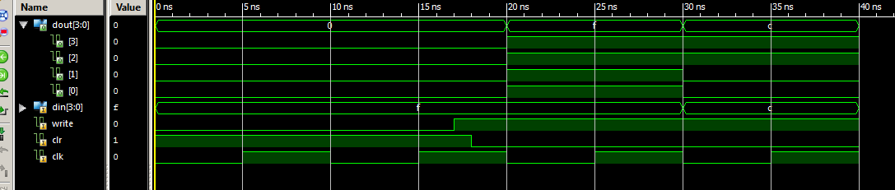

* 2 to 4 Decoder Verilog code (1)
* 2 to 4 Decoder TCL file (1)
* 2 to 4 Decoder simulation waveform (2)

**2 to 4 Decoder Verilog code**

module decorder24(q,a);

input[1:0] a;

output[3:0] q;

assign q = (4'b0001 << a);

endmodule

**2 to 4 Decoder TCL file**

wave add / -radix hex

isim force add a 00 -time 0 -value 01 -time 10ns -value 10 -time 20ns -value 11 -time 30ns

run 40ns

**2 to 4 Decoder simulation waveform**

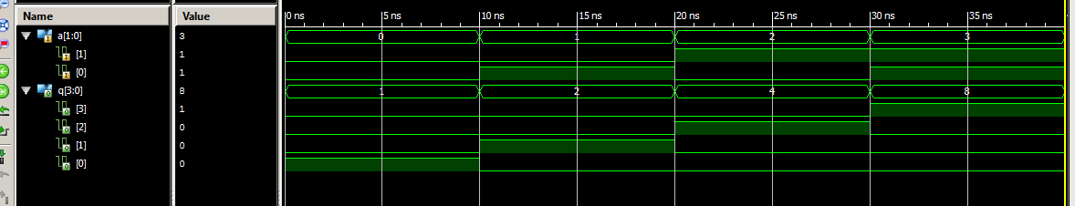

* 4-bit x 4-word Registers Verilog code (3)
* 4-bit x 4-word Registers TCL file (1)
* 4-bit x 4-word Registers simulation waveform (3)

**4-bit x 4-word Registers Verilog code**

module word_register(dout, addr, regWE, din, clk, clr);

output[15:0] dout;

input[1:0] addr;

input regWE, clk, clr;

input[3:0] din;

wire[3:0] sel;

wire temp0, temp1, temp2, temp3;

and(temp0, sel[0], regWE);

and(temp1, sel[1], regWE);

and(temp2, sel[2], regWE);

and(temp3, sel[3], regWE);

decorder24 d1(sel, addr);

reg_four r0(dout[3:0], din, temp0, clr, clk);

reg_four r1(dout[7:4], din, temp1, clr, clk);

reg_four r2(dout[11:8], din, temp2, clr, clk);

reg_four r3(dout[15:12], din, temp3, clr, clk);

endmodule

**4-bit x 4-word Registers TCL file**

wave add / -radix hex

isim force add clk 0 -time 0 -value 1 -time 5ns -repeat 10ns

isim force add clr 1 -time 0 -value 0 -time 18ns

isim force add din 1111 -time 0

isim force add addr 00 -time 0 -value 01 -time 9ns -value 10 -time 18ns -value 11 -time 28ns -repeat 35ns

isim force add regWE 0 -time 0 -value 1 -time 18ns -value 0 -time 62ns

run 80ns

**4-bit x 4-word Registers simulation waveform**

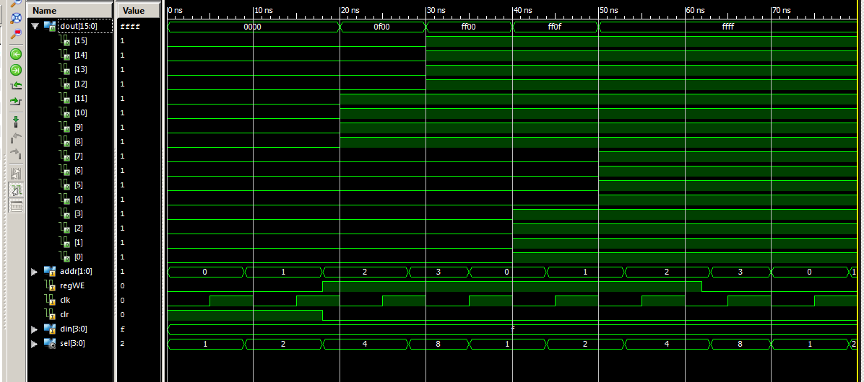

**4:1 4-bit MUX Verilog code**

module mux164(result, sel, din3, din2, din1, din0);

input[1:0] sel;

input[3:0] din3, din2, din1, din0;

output[3:0] result;

mux41 m0(result[0], sel[1:0],{din3[0],din2[0],din1[0],din0[0]});

mux41 m1(result[1], sel[1:0],{din3[1],din2[1],din1[1],din0[1]});

mux41 m2(result[2], sel[1:0],{din3[2],din2[2],din1[2],din0[2]});

mux41 m3(result[3], sel[1:0],{din3[3],din2[3],din1[3],din0[3]});

endmodule

**4:1 4-bit MUX TCL file**

wave add / -radix hex

isim force add din3 1111 -time 0

isim force add din2 0011 -time 0

isim force add din1 1010 -time 0

isim force add din0 0101 -time 0

isim force add sel 00 -time 0 -value 01 -time 20ns -value 10 -time 40ns -value 11 -time 60ns

run 80ns

**4:1 4-bit MUX simulation waveform**

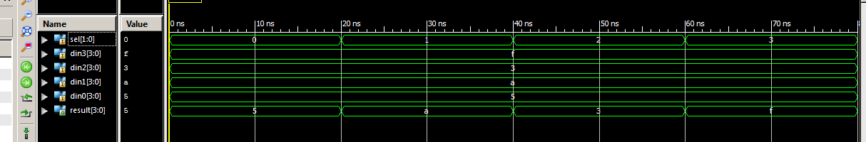

**Complete Register File Verilog code**

module complete(Reg_out, din, regWE, clr, clk, waddr, raddr);

output[3:0] Reg_out;

input[3:0] din;

input clr, clk, regWE;

input[1:0] waddr, raddr;

wire[15:0] dout;

word_register wr1(dout, waddr, regWE, din, clk, clr);

mux164 m1(Reg_out, raddr, dout[15:12], dout[11:8], dout[7:4], dout[3:0]);

endmodule

**TestBench Verilog code**

module testbench(Reg_out, Din_led3, Din_led2, Din_led1, Din_led0, din, regWE, clr, clk, waddr, raddr);

output[3:0] Reg_out;

output Din_led3, Din_led2, Din_led1, Din_led0;

input[3:0] din;

input clr, clk, regWE;

input[1:0] waddr, raddr;

wire[15:0] dout;

complete c1(Reg_out, din, regWE, clr, clk, waddr, raddr);

buf(Din_led3,din[3]);

buf(Din_led2,din[2]);

buf(Din_led1,din[1]);

buf(Din_led0,din[0]);

endmodule

**TestBench UCF file**

## clock pin for Nexys 2 Board

NET clk LOC = "B8"; # Bank = 0, Pin name = IP_L13P_0/GCLK8, Type = GCLK, Sch name = GCLK0

##NET "clk1" LOC = "U9"; # Bank = 2, Pin name = IO_L13P_2/D4/GCLK14, Type = DUAL/GCLK, Sch name = GCLK1

## Leds

NET Reg_out<0> LOC = "J14"; # Bank = 1, Pin name = IO_L14N_1/A3/RHCLK7, Type = RHCLK/DUAL, Sch name = JD10/LD0

NET Reg_out<1> LOC = "J15"; # Bank = 1, Pin name = IO_L14P_1/A4/RHCLK6, Type = RHCLK/DUAL, Sch name = JD9/LD1

NET Reg_out<2> LOC = "K15"; # Bank = 1, Pin name = IO_L12P_1/A8/RHCLK2, Type = RHCLK/DUAL, Sch name = JD8/LD2

NET Reg_out<3> LOC = "K14"; # Bank = 1, Pin name = IO_L12N_1/A7/RHCLK3/TRDY1, Type = RHCLK/DUAL, Sch name = JD7/LD3

NET Din_led0 LOC = "E17"; # Bank = 1, Pin name = IO, Type = I/O, Sch name = LD4

NET Din_led1 LOC = "P15"; # Bank = 1, Pin name = IO, Type = I/O, Sch name = LD5

NET Din_led2 LOC = "F4"; # Bank = 3, Pin name = IO, Type = I/O, Sch name = LD6

NET Din_led3 LOC = "R4"; # Bank = 3, Pin name = IO/VREF_3, Type = VREF, Sch name = LD7

## Switches

NET raddr<0> LOC = "G18"; # Bank = 1, Pin name = IP, Type = INPUT, Sch name = SW0

NET raddr<1> LOC = "H18"; # Bank = 1, Pin name = IP/VREF_1, Type = VREF, Sch name = SW1

NET waddr<0> LOC = "K18"; # Bank = 1, Pin name = IP, Type = INPUT, Sch name = SW2

NET waddr<1> LOC = "K17"; # Bank = 1, Pin name = IP, Type = INPUT, Sch name = SW3

NET din<0> LOC = "L14"; # Bank = 1, Pin name = IP, Type = INPUT, Sch name = SW4

NET din<1> LOC = "L13"; # Bank = 1, Pin name = IP, Type = INPUT, Sch name = SW5

NET din<2> LOC = "N17"; # Bank = 1, Pin name = IP, Type = INPUT, Sch name = SW6

NET din<3> LOC = "R17"; # Bank = 1, Pin name = IP, Type = INPUT, Sch name = SW7

## Buttons

NET clr LOC = "B18"; # Bank = 1, Pin name = IP, Type = INPUT, Sch name = BTN0

#NET "btn<1>" LOC = "D18"; # Bank = 1, Pin name = IP/VREF_1, Type = VREF, Sch name = BTN1

#NET C0<0> LOC = "E18"; # Bank = 1, Pin name = IP, Type = INPUT, Sch name = BTN2

NET regWE LOC = "H13"; # Bank = 1, Pin name = IP, Type = INPUT, Sch name = BTN3

**Anomalies**

This took pretty long to finish. I got confused because of many inheriting Verilog files. Input and output digits were pretty confusing to make straight forward. Writing Testbench is something that I still need to improve.