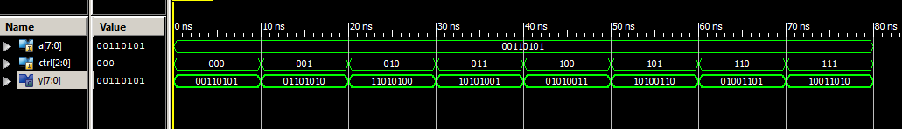
4.6
library ieee;
use ieee.std_logic_1164.all;
entity left_shift is
port(
a: in std_logic_vector(7 downto 0);
ctrl: in std_logic_vector(2 downto 0);
y: out std_logic_vector(7 downto 0)
);
end left_shift;

architecture shift_arch of left_shift is
begin
y <= a when(ctrl="000") else
a(6)&a(5)&a(4)&a(3)&a(2)&a(1)&a(0)&a(7) when(ctrl="001") else
a(5)&a(4)&a(3)&a(2)&a(1)&a(0)&a(7)&a(6) when(ctrl="010") else
a(4)&a(3)&a(2)&a(1)&a(0)&a(7)&a(6)&a(5) when(ctrl="011") else
a(3)&a(2)&a(1)&a(0)&a(7)&a(6)&a(5)&a(4) when(ctrl="100") else
a(2)&a(1)&a(0)&a(7)&a(6)&a(5)&a(4)&a(3) when(ctrl="101") else
a(1)&a(0)&a(7)&a(6)&a(5)&a(4)&a(3)&a(2) when(ctrl="110") else
a(0)&a(7)&a(6)&a(5)&a(4)&a(3)&a(2)&a(1);
end shift_arch;

5.3
architecture if_arch of decoder4 is
begin
process(s,en)
begin
if(s="00" and en="1") then
x <= "0001";
elsif(s="01" and en="1") then
x <= "0010";
elsif(s="10" and en="1") then
x <= "0100";
elsif(s="11" and en="1") then
x <= "1000";
else
x <= "0000";
end if;
end process;
end if_arch;

5.4
architecture case_arch of decoder4 is
signal ens <= en&s;
begin
process(ens)
begin
case ens is
when "000"|"001"|"010"|"011" =>
x <= "0000";
when "100" =>
x <= "0001";
when "101" =>
x <= "0010";
when "110" =>
x <= "0100";
when others =>
x <= "1000";
end case;
end process;
end case_arch;

