ECEn 324
Jaehun Lee
HW #1

2.61
A. return (!!x); // If x has 1 in any bit, !x will be 0, and !! x will give 1.

B. // If x has 0 in any bit meaning that ~x has 1 in any bit, and works same as part A.
int inverted = ~x;
return (!!inverted);

C. int temp = 0xFF;
int result = x & temp;
return (!!result);

D. int shift_val = (sizeof(int)-1)<<3;
int xright = x >> shift_val;
int inverted = ~(xright & 0xFF);
int combining = (0x000000FF & inverted);
return any_bit_one(combining);

Output
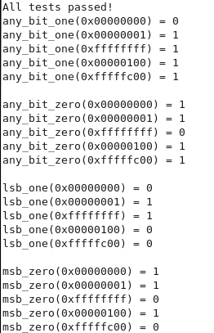

2.71
A. Because the original code didn't care about sign extension making all bytes 0 except for 0th bytes.

B. int result = (word >> (bytenum <<3)) & 0xFF;
result = result << 24;
result = result >> 24;
return result;

Output

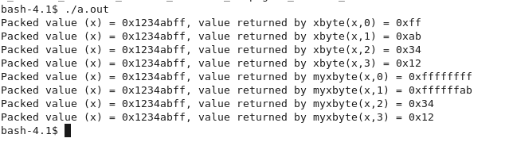

2.76
A. result1 = (x << 4) + x;

B. result1 = x - (x << 3);

C. result1 = (x << 6) - (x << 2);

D. result1 = (x << 4) - (x << 7);

Output
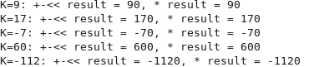

2.81
A. False, (x<y) == (-x>-y)
The expression is False, when x = TMINw, -x will be the same value as x.

B. True, ((x+y)<<4)+y-x == 17*y+15*x => ((x+y)<<4) == 16*y + 16*x
Left-shift by 4 does the same thing as multiplying by 16.

C. True, ~x+~y +1 == ~(x+y) => (-x-1) + (-y-1) +1 => -x-y+1 => -(x+y)+1
~x can be substituted to be -x-1.
D. True, (ux-uy) == -(unsigned)(y-x) => uy-ux == (unsigned)(y-x)
Casting 'unsigned' doesn't change the bit patterns.

E. True, ((x>>2) << 2) <= x
Left-shift by 2 and right-shift by 2 will make negative x more negative and make positive x more positive.

