ECEn 324
hw #10
Jae Lee

324-8
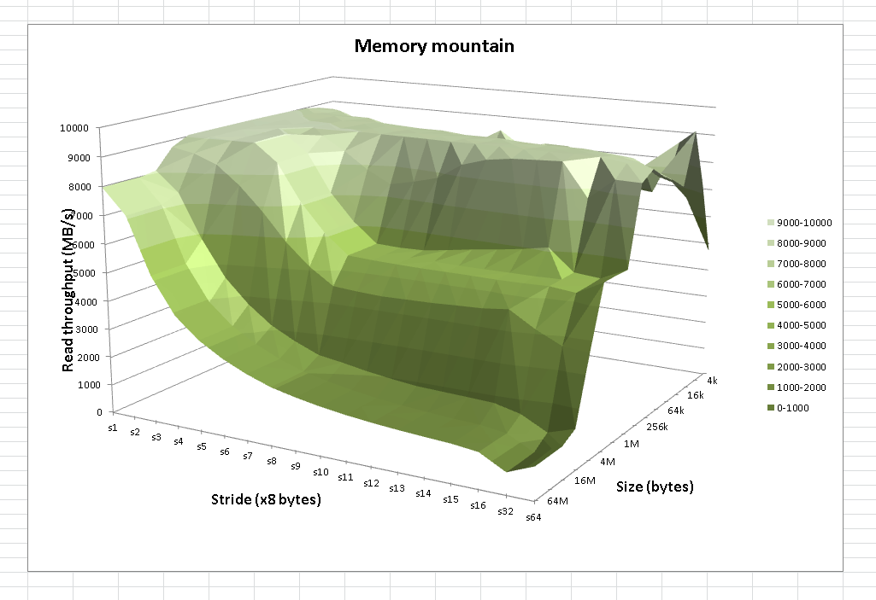
- Optimization level 1, 4 gave faster read throughput than optimization level 2, 3. What was interesting was that optimization level 1 was faster than level 2 and 3.
- It seems like overall read throuput measure of this(CAEDM spice acacia machine with optimization level3) is higher than the memory mountain in the text book. Overall shape is pretty similar to the one in the text book, but it has one less flat region along the mountain.
- Since there are only two flat regions along the mountain, we can deduce that there are 2 caches between CPU and main memory.

7.8
A. (a) REF(main.1) → DEF(main.1)
(b) REF(main.1) → DEF(main.1)
B. (a) UNKNOWN – two weak symbols
(b) UNKNOWN
C. (a) ERROR – two strong symbols
(b) ERROR

7.12
15 | 0x80483cb | 0x804945c
16 | 0x80483d0 | 0x8049458
18 | 0x80483d8 | 0x8049548
18 | 0x80483dc | 0x8049458
23 | 0x80483e7 | 0x8049548

324-9
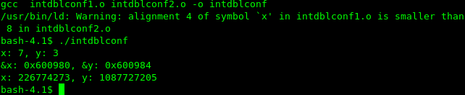
First of all, when I ran the original source code, I could see that variable int x and int y declared in initdblconf1.c were overwritten by double x in intdblconf2.c. And one good thing found here is that the linker gave me a Warning that indicates this problem.

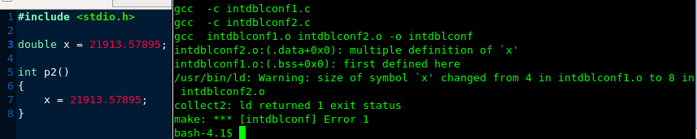
I tried to initialize double x in intdblconf2.c so that both of variable x in two different files are strong symbols. As I expected this threw an error message and the program was not allowed to operate.

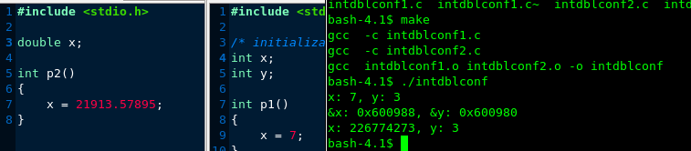
I also tried to uninitialize both x in the program making both of x weak symbols. As seen in the above screen shot, y is not overwritten by double x. This gives me the insight that double x was selected to put in the symbol table. This was definitely good choice made by the linker.

