ECEn 324
HW #11
Jae Lee

8.18
12, 02, 1, 0. we can sort these four numbers in any order.
Thus, A, C, E.
B and D can't be the answers because 2 always have to follow 0 or 1.

324-10
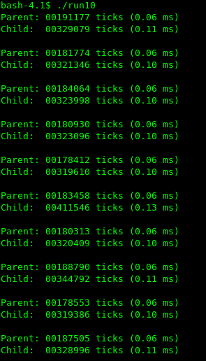 | Child processes always take longer time to finish their processings. It seems like when child processes are initiated, there are some extra time-consuming steps that they have to experience.  Parent processes had been running before child processes were placed. Thus, in this machine, parent processes were scheduled to be the first one to show up as a result of execution of the code provided.

324-11
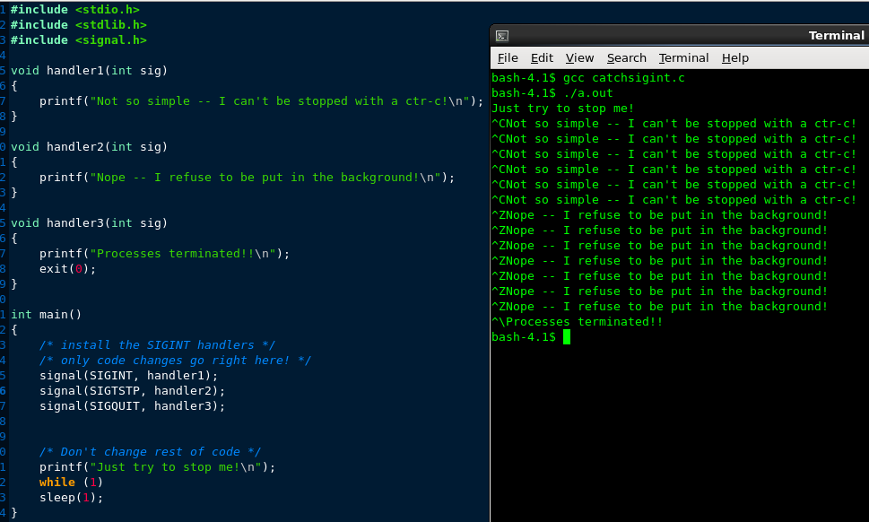
In order to actually kill the process, I installed an another handler that catches SIGQUIT signal. Through this handler, I was able to terminate the running process. I learned that some signals can be caught by appropriate handlers and handled in ways that programmer want. I imagine this would give much flexibility of things that the programmers do.

9.12
Virtual Address: 0x03a9
A. Virtual address format
0 0 0 0 1 1 1 0 1 0 1 0 0 1
B. Address translation
VPN 0x0E
TLB index 0x02
TLB tag 0x03
TLB hit? No
Page fault? No
PPN 0x11
C. Physical address format
0 1 0 0 0 1 1 0 1 0 0 1
D. Physical memory reference
Byte offset 0x1
Cache index 0xa
Cache tag 0x11
Cache hit? No
Cache byte returned -

9.14
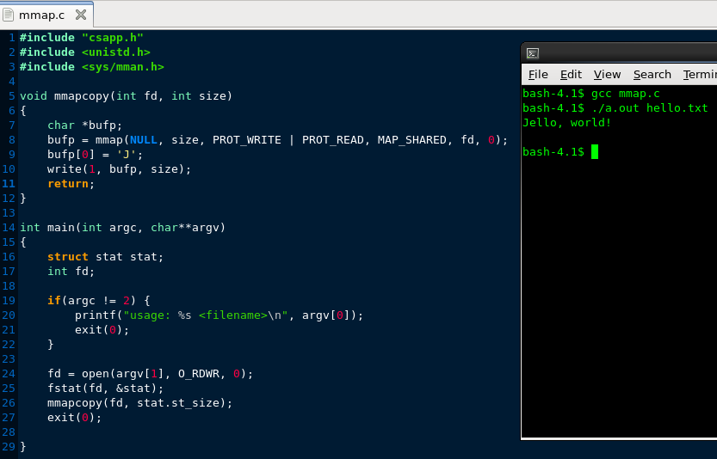

324-12
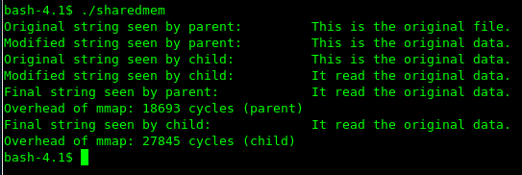

As can be seen, using mmap function, it is possible to share writable data. In this case, parent and child share shared.dat file and both were able to modify the contents in the file. The overhead of mmap() function seems to be higher than at least fork() function. I can interpret that the difference between the cycles of parent and the cycles of child are caused by fork() function which ranges between 6000 – 10000. However, even child process usually shows more than 16000 cycles. Therefore, the overhead of mmap() function itself seems to be already high.
Most of times, parent process executes before child process executes. Very rarely I saw a case that child process ran before parent process.

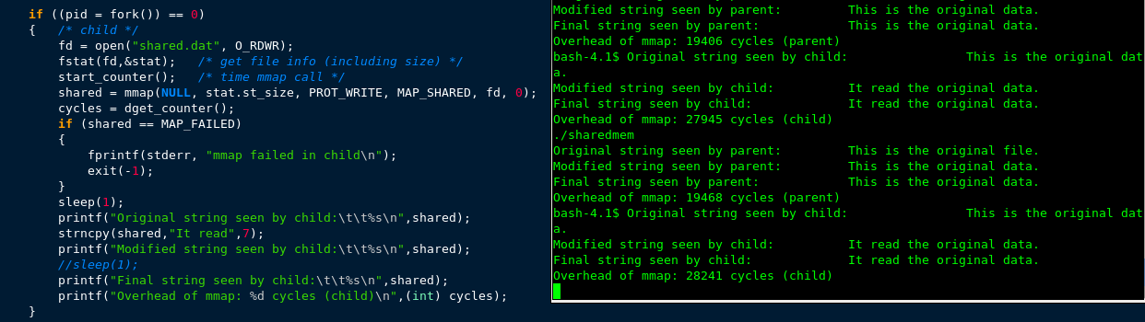
When I insert sleep(1) function in the child process before it prints out any values, I got the result that 100% consistently prints the output of the parent process first.

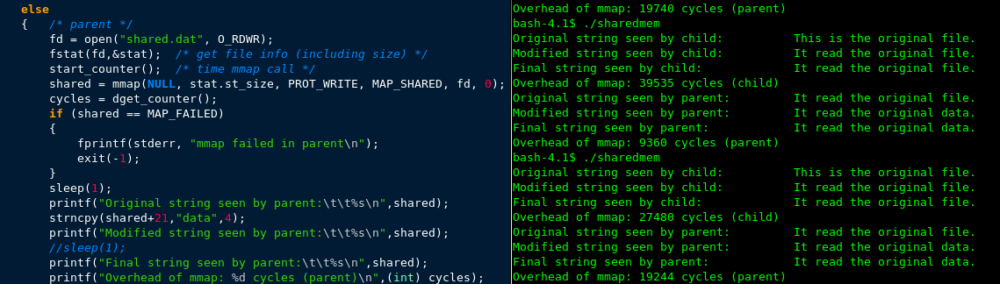
When I insert sleep(1) function in the child process before it prints out any values, I got the result that 100% consistently prints the output of the child process first.

