ECEn 324
HW 12
Jae Lee

324-13
  /* Read request line and headers */  Rio_readinitb(&rio, fd);  Rio_readlineb(&rio, buf, MAXLINE); //line:netp:doit:readrequest  sscanf(buf, "%s %s %s", method, uri, version); //line:netp:doit:parserequest  printf("<<<echo: %s>>>\n", buf); // prints out request line  if (strcasecmp(method, "GET")) { //line:netp:doit:beginrequesterr  void read_requesthdrs(rio_t *rp)  {  char buf[MAXLINE];  Rio_readlineb(rp, buf, MAXLINE);  printf("<<<echo: %s>>>\n", buf); // prints the request headers | 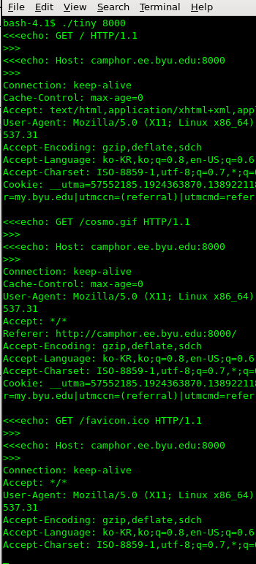

324-14
A. Multi-processes version calls other functions the most times and seems like the most complex way to run a program, definitely a lot more overbearing than multi-threads version of the program. I think it is because each process has to have its own private address space. Thus, it takes additional overhead for process control whereas multi-threads version share some code, data, and kernel context.

B. Shared data is very challengeous for the process-based designs because it requires interprocess communication mechanisms, such as Unix pipes, System V shared memory, or semaphores. However,
it is easy to share data structures between threads. So read-only and writeable shared data will cause many permission control mechanisms for the process-based deisgn, but not for the threads-based design.

C. I experimented on a spice machine called, 'camphor'. It uses a quad-core processor Intel(R) Core(TM) i5-2400 CPU @ 3.10GHz. Definitely, Parallel version is much faster. Expectedly, the multi-threads version is faster than the multi-processes version because the time to set up for the multi-threads takes less time than that of the multi-processes. Parallelizing sequential code seems very overbearing to do. If I had to choose one of two ways to parallelize some codes, I would choose the Multi-threads design.

Sequential version  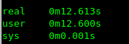 | Multi-processes version  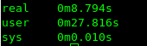 | Multi-threads version  

