ECEn 324
HW #2
Jae Lee

2.72
A. The reason why the conditional test always worked was because sizeof(val) returned an unsigned number which made the entire (maxbytes-sizeof(val)) be represented as an unsigned number. So the result of the equation above was always greater than or equal to 0.
B.
Buggy Code Correct Code
if (maxbytes-sizeof(val) >= 0) if (maxbytes-(int)sizeof(val) >= 0)
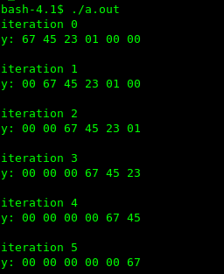
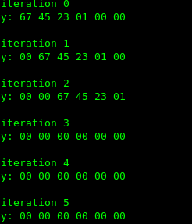

2.86
Description | Hex | M | E | V
-0 | 0x8000 | 0 | -62 | -
Smallest value >2 | 0x4001 | 257/256 | 1 | 257*2^-7
512 | 0x4800 | 1 | 9 | -
Largest denormalized | 0x00ff | 255/256 | -62 | 255*2^-70
-∞ | 0xff00 | - | - | -
0x3BB0 | - | 432/256 | -4 | 432*2^-12

2.92
float_bits float_absval(float_bits f) {
// Fill in your code here
unsigned result = (f<<1)>>1;
return result;
}
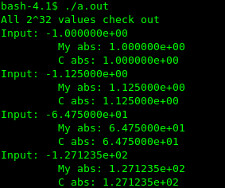

324-1
A. I thought the while loop will never terminate because the value is always not equal to g. No.
B. No, the loop actually terminates.
C. 16777216 = 2^24 times
16777216 = 0 10010111 00000000000000000000000 = 1*2^24*(1.0+.0) = 2^24
16777217 = 1*2^24*(1.0+2^-24) = 2^24 +1, but 2^-24 can't be represented precisely without rounding in 32-bit float expression.
D. Double type can represent up to 2^53 floating point numbers. It takes 2^29 more times than type float.
E. Because how float, double interpret and represent the bit patterns are way different from some integer types.

