ECEn 324
HW #5
Jae Lee

4.43
A. No, this code sequence doesn't describe the behavior of the instruction pushl %esp. From problem 4.6, we can see that the old %esp value(before decrementing %esp by -4) is being pushed because pushtest function always returns zero. This means that the value which is being pushed by pushl %esp instruction and the original %esp value are the same.
B. movl REG, -4(%esp)
subl $4, %esp

4.44
A. Just like the problem above, this code sequence is not correct because addl $4, %esp instruction will change the value of the top of the stack, but from problem 4.7 we saw that the value didn't change.
B. addl $4, %esp
movl -4(%esp), REG

324-2
A.
Running option default by gcc -m64 stacksize.c, if not told otherwise
#include <stdio.h>

#define N 20
#define XSIZE (0x01<<N)

#define M 10
#define MAXREC (0x01<<M)

double big_array(void)
{
int i, x[XSIZE];
double result = 0.0;
for (i = 0; i < XSIZE; i++)
x[i] = i;
for (i = 0; i < XSIZE; i++)
result += x[i];
return result;
}
double max_recursion(int val)
{
if (val <= 1)
return 1;
return val + max_recursion(val-1);
}
int main()
{
printf("Result returned by big_array() is %e\n", big_array());
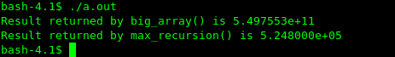
printf("Result returned by max_recursion() is %e\n", max_recursion(MAXREC));
}

The result shown =>

#define N 22 /* I changed this value ! */
#define M 10
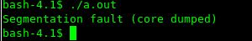

The result shown =>

Switching -m64 option to -m32 option or vice versa didn't change when overflowing occurs.
Default stack size = 10240 kbytes = 1024*10240 bytes = 10485760
So, the listed size agree with the result of my experiment because an int array size of 2^21 needs 8388608 bytes for allocation which is smaller than the stack size. However, an int array size of 2^22 needs 16777216 bytes for allocation which is larger than the stack size giving Segmentation fault.
I changed the stack size to be 5120 kbytes = 5120*1024 bytes = 5242880.
As I expected, an array size of 2^21 led to Segment fault, but 2^20 didn't.
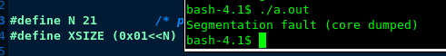

B.
Running option default by gcc -m64 stacksize.c, if not told otherwise
#define N 21
#define M 19 /* I changed this value! */
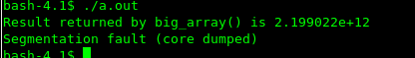

The result shown =>

Running option: gcc -m32 stacksize.c
#define N 21
#define M 18 /* I changed this value */
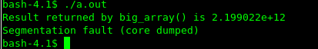

The result shown =>

For the maximum recursion depth, switching -m64 to -m32 changed when to overflow the depth of 19 to 18.
Default stack size = 10240 kbytes = 1024*10240 bytes = 10485760
I found that each function call allocates 24 bytes in the stack. So 2^18 times of function call will allocates 6291456 bytes which is allowable. However, if I call the same function 2^19 times, it gave me Segmentation Fault because 2^19*24 is 12582912 which is bigger than the entire stack size.
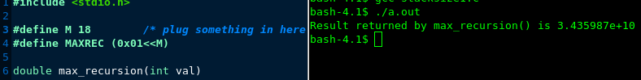
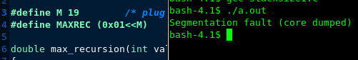

I also doubled the entire stack size and worked consistently and in the expected way.
For the stack size 20480*1024 = 20971520, 2^20 times of function call(2^20*24 = 25165824) gave me Segmentation Fault, whereas 2^19 times of function call(2^19*24 = 12582912) worked without Segmentation Fault.

Optimization level totally affected the size of stack. The higher level of optimization, the more efficient the compiler organizes the stack. Like shown below, optimization level 0 gave me Segmentation Fault for the stack size of 10240 kbytes, but optimization level 1 didn't give me Segmentation Fault.

