ECEn 324
Jae Lee
HW#6

4.45
A.  void bubble_p(int *data, int count) /* pointer version */  {  int i, last;  for(last = count-1; last > 0; last--) {  for(i = 0; i < last; i++) {  if(*(data+(i+1)) < *(data+i)) {  int t = *(data+(i+1));  *(data+(i+1)) = *(data+i);  *(data+i) = t;  }  }  }  } | bubble_a:  .LFB0:  .cfi_startproc  pushq %rbp  .cfi_def_cfa_offset 16  .cfi_offset 6, -16  movq %rsp, %rbp  .cfi_def_cfa_register 6  movq %rdi, -24(%rbp)  movl %esi, -28(%rbp)  movl -28(%rbp), %eax  subl $1, %eax  movl %eax, -8(%rbp)  jmp .L2  bubble_p:  .LFB1:  .cfi_startproc  pushq %rbp  .cfi_def_cfa_offset 16  .cfi_offset 6, -16  movq %rsp, %rbp  .cfi_def_cfa_register 6  movq %rdi, -24(%rbp)  movl %esi, -28(%rbp)  movl -28(%rbp), %eax  subl $1, %eax  movl %eax, -8(%rbp)  jmp .L9  They are equivalent !  Compiler option: gcc -m32 testbubble.c
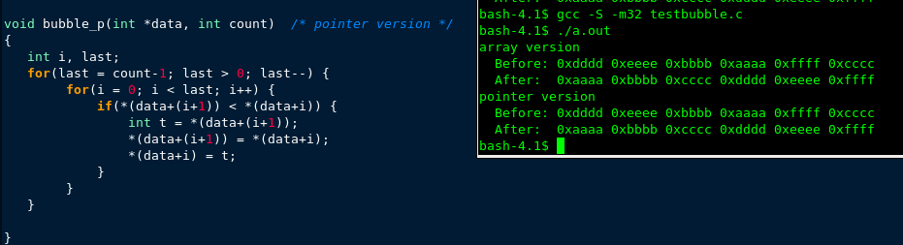

B.
# Execution begins at address 0
.pos 0
init: irmovl Stack,%esp # Set up stack pointer
irmovl Stack,%ebp # Set up base pointer
jmp Main # Execute main program

# Array of 7 elements
.align 4
array: .long 0xdddd # These values should get sorted
.long 0xeeee
.long 0xbbbb
.long 0xaaaa
.long 0xffff
.long 0xcccc
.long 0x0101 # This value should not change

Main: irmovl $6,%eax
pushl %eax # push array size
irmovl array,%edx
pushl %edx # push array address
call Bubble # Bubble(array,6)
halt

# void Bubble(int *data, int count)
Bubble:
# your handtranslated code goes here
pushl %ebp
rrmovl %esp, %ebp
irmovl $16, %esi
subl %esi, %esp
mrmovl 12(%ebp), %eax
irmovl $1, %esi
subl %esi, %eax
rmmovl %eax, -8(%ebp)
jmp L9
L13:
irmovl $0, %esi
rmmovl %esi, -12(%ebp)
jmp L10
L12:
mrmovl -12(%ebp), %eax
irmovl $1, %esi
addl %esi, %eax
addl %eax, %eax
addl %eax, %eax
mrmovl 8(%ebp), %edi
addl %edi, %eax
mrmovl (%eax), %edx
mrmovl -12(%ebp), %eax
addl %eax, %eax
addl %eax, %eax
mrmovl 8(%ebp), %edi
addl %edi, %eax
mrmovl (%eax), %eax
subl %eax, %edx
jge L11
mrmovl -12(%ebp), %eax
irmovl $1, %esi
addl %esi, %eax
addl %eax, %eax
addl %eax, %eax
mrmovl 8(%ebp), %edi
addl %edi, %eax
mrmovl (%eax), %eax
rmmovl %eax, -4(%ebp)
mrmovl -12(%ebp), %eax
irmovl $1, %esi
addl %esi, %eax
addl %eax, %eax
addl %eax, %eax
mrmovl 8(%ebp), %edi
addl %edi, %eax
mrmovl -12(%ebp), %edx
addl %edx, %edx
addl %edx, %edx
mrmovl 8(%ebp), %edi
addl %edi, %edx
mrmovl (%edx), %edx
rmmovl %edx, (%eax)
mrmovl -12(%ebp), %eax
addl %eax, %eax
addl %eax, %eax
mrmovl 8(%ebp), %edi
addl %edi, %eax
mrmovl -4(%ebp), %edx
rmmovl %edx, (%eax)
L11:
irmovl $1, %esi
mrmovl -12(%ebp), %edi
addl %esi, %edi
rmmovl %edi, -12(%ebp)
L10:
mrmovl -12(%ebp), %eax
mrmovl -8(%ebp), %edi
subl %edi, %eax
jl L12
irmovl $1, %esi
mrmovl -8(%ebp), %edi
subl %esi, %edi
rmmovl %edi, -8(%ebp)
L9:
irmovl $0, %esi
mrmovl -8(%ebp), %edi

subl %esi, %edi

jg L13
leave
ret

.pos 0x300
Stack: # Stack goes here, grows down

Result
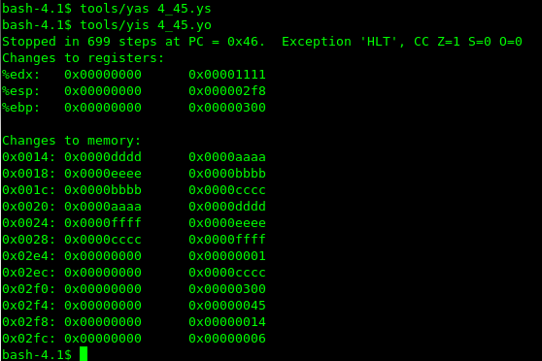

4.47
 | Iaddl V,rB
Fetch | Icode:ifun ← M1[PC]  rA:rB ← M1[PC+1]  valC ← M4[PC+2]  valP ← PC+6
Decode | ValB ← R[rB]
Execute | ValE ← valB+valC  Set CC
Memory
Write back | R[rB] ← valE
PC update | PC ← valP

