HW#8
Jae Lee

324-4
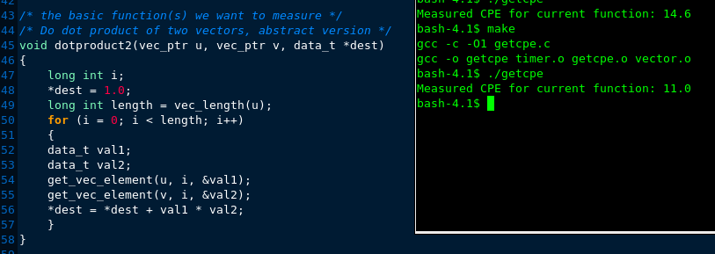
2. Move the call to vec_length out of the loop

3. Directly access the vector data
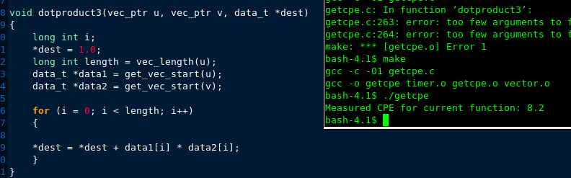
4. Accumulate results in a local variable
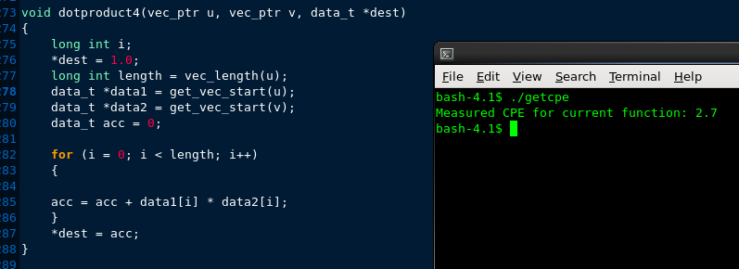
5. Unroll the loop by 2
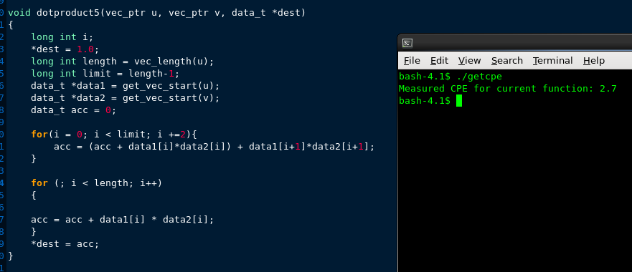
6. Unroll the loop by 2 with 2-way parallelism
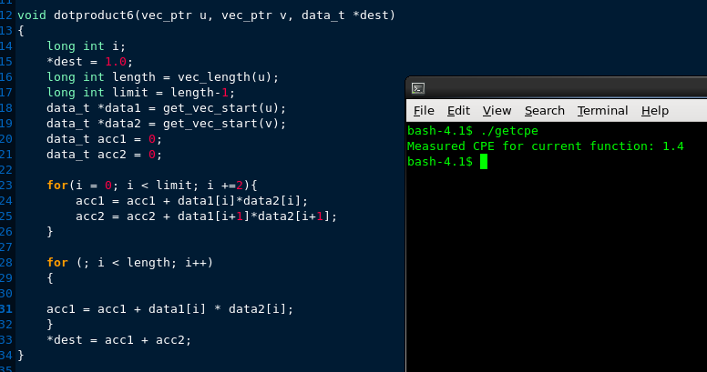
7. Unroll the loop by 2 and reassociate
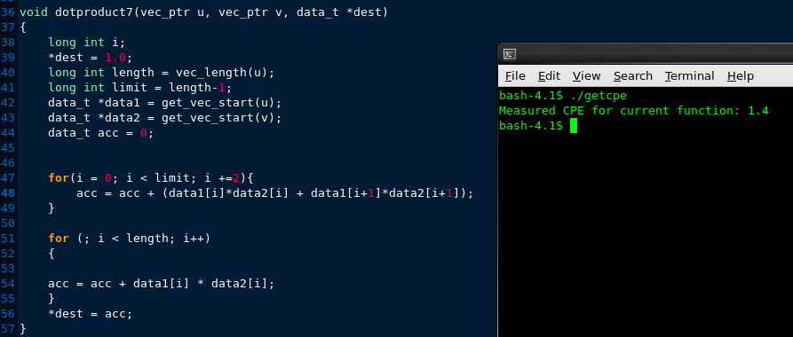
The results are pretty close what are in the text book. I verified that the optimization techniques are very effective and real. Latency bounds is 2.7 and throughput bounds is 1.00.

324-5

