324-6
Source Code

int main()
{
int i,j,len,refnum,addr,tag,index,indexmask,bshift,ishift,outcome;
int hitcount = 0;
int misscount = 0;
int numsets = CACHESIZE/(BLOCKSIZE*SETASSOC);

/* first, output information about the cache configuration we're
simulating: a sanity check */
printf("Simulating ");
if (SETASSOC == 1)
printf("Direct-mapped ");
else
printf("%d-way set-associative ", SETASSOC);
printf("cache\n Size: %d bytes, #Sets: %d, Blocks: %d bytes\n",
CACHESIZE, numsets, BLOCKSIZE);

/* clear cache: initialize all cache entries to invalid */
for (i = 0; i < numsets; i++)
for (j = 0; j < SETASSOC; j++)
cache[i][j].valid = INVALID;

/* determine values to process each address for this cache */
bshift = mylog2(BLOCKSIZE); // width in bits of block offset field
ishift = mylog2(numsets); // width in bits of set index field
indexmask = makemask(ishift); // mask to get shifted set index field
printf(" [variable values: bshift = %d, ishift = %d, indexmask = 0x%x]\n", bshift, ishift, indexmask);

/* now process reference sequence: assume machine is
* byte-addressable and that each request is for one byte. Use the
* variables bshift, ishift, and indexmask to interpret the bits
* in each address */
len = (int) sizeof(ref) / sizeof(int); // determine # references
for (refnum = 0; refnum < len; refnum++)
{
/* get the next address in sequence */
addr = ref[refnum];

/* strip out index and tag fields: compute index and tag
* values using addr, bshift, ishift, and indexmask */

// Your code goes here
// index = ?
// tag = ?
index = (addr>>bshift) & indexmask;
tag = addr>>(bshift+ishift);

/* now check set for matching tag. If no matching entry, set
* outcome to MISS. Otherwise, set outcome to HIT and update
* the reference field with current value of refnum. */

// Your code goes here
// remember to check all valid entries in set!
outcome = MISS;
for(i = 0; i < SETASSOC; i++)
{
if(cache[index][i].valid == VALID && cache[index][i].tag == tag)
{
outcome = HIT;
cache[index][i].reference = refnum;
}
}

/* if miss, insert entry in cache */
if (outcome == MISS)
{
/* pick replacement slot: first INVALID or oldest
reference value */
int min = -1;
for (i = 0; i < SETASSOC; i++)
{
if (cache[index][i].valid == INVALID)
{
min = i;
break;
}
}
if (min == -1)
{ // no INVALID slot found
min = 0;
for (i = 1; i < SETASSOC; i++) // compare with remaining slots
{
if (cache[index][i].reference < cache[index][min].reference)
min = i;
}
}

/* put block in slot that was identified */

// Your code goes here
cache[index][min].tag = tag;
cache[index][min].valid = VALID;
cache[index][min].reference = refnum;
}
#define SETASSOC 2 // 1 is direct mapped, etc.  #define CACHESIZE 128 // size in bytes  #define BLOCKSIZE 4 // size in bytes  int ref[] = { 0x00, 0x01, 0x80, 0xC0, 0x00, 0x80, 0xC0, 0x04, 0x05 } ; | 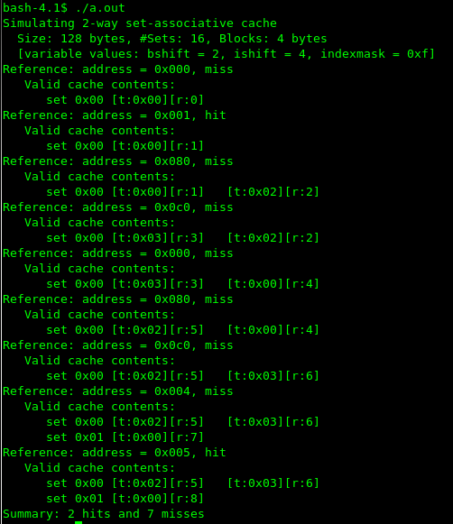
#define SETASSOC 1 // 1 is direct mapped, etc.  #define CACHESIZE 128 // size in bytes  #define BLOCKSIZE 4 // size in bytes  int ref[] = { 0x00, 0x01, 0x02, 0x03, 0x04, 0x05, 0x40, 0x42, 0x00 } ;  I chose this because I thought it would be fun to check how direct-mapped cache works. | 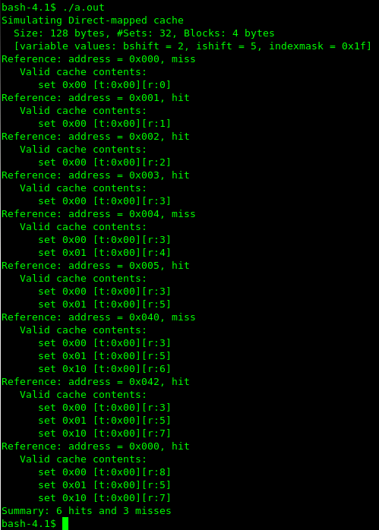
#define SETASSOC 2 // 1 is direct mapped, etc.  #define CACHESIZE 128 // size in bytes  #define BLOCKSIZE 2 // size in bytes  int ref[] = { 0x00, 0x01, 0x02, 0x03, 0x04, 0x05, 0x40, 0x42, 0x41 } ;  I changed blocksize to be 2 so that I could see more misses by changing addresses. | 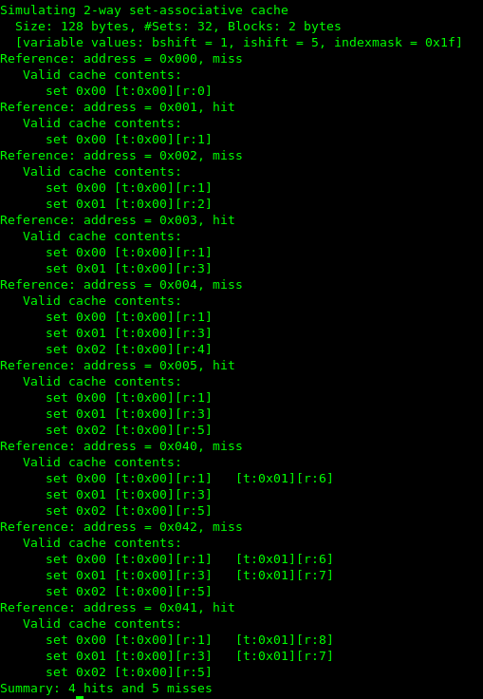

324-7
#define SQSIZE 16  Results were pretty consistent with Cold cache time, Warm cache time, Poor locality time with SQSIZE 16. | 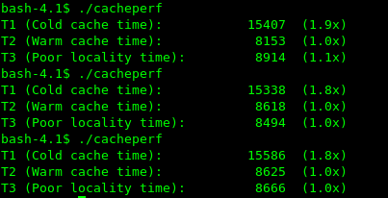
#define SQSIZE 16  Once in about every 8 tries, I saw an odd peak of 2.5 or 2.4 for Cold cache time. So this program is inconsistent. I believe this is real Cold cache time because other results were obtained at least one try which means that cache is already warmed up.  As far as difference between cold cache time and warm cache time goes, I didn't see any higher than 2.5. This value is high because when cache is cold, every time new lines or sets, cache misses occur. | 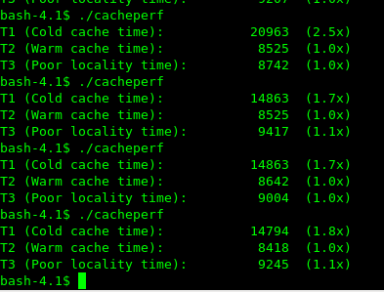
#define SQSIZE 2048  I found SQSIZE makes the poor locality time worst. I think the reason why this is the case is because poor locality and capacity miss happen at the same time. | 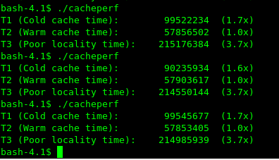
Optimization level -O3  #define SQSIZE 16  This is very odd. I don't know how to explain this. | 