- Print the plot of your estimated histogram of the binomial random variable found in the last section.
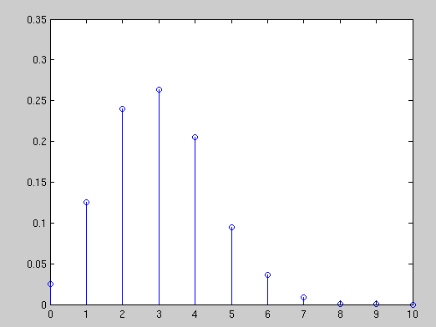
- Write the twentieth element of the Fibonacci sequence you generated starting from 0,1,1,2,..

4181

