HW4 Matlab
a)
each row indicates the number of burgers and each column indicates the number of fries
Burger Column | 1 | 2 | 3 | 4
1 | 0.0984 | 0.0201 | 0.0087 | 0.0095
2 | 0.0746 | 0.0729 | 0.0185 | 0.0189
3 | 0.0506 | 0.0769 | 0.0449 | 0.0293
4 | 0.0312 | 0.0621 | 0.0919 | 0.0383
5 | 0.0185 | 0.0199 | 0.0410 | 0.0815
6 | 0.0094 | 0.0113 | 0.0215 | 0.0501

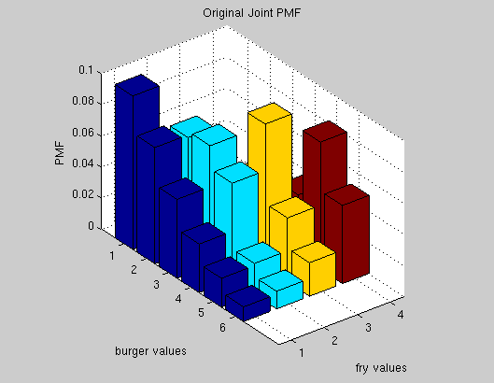

b) 0.0769

c) each column indicates the number of burgers
1 | 2 | 3 | 4 | 5 | 6
0.1367 | 0.1849 | 0.2017 | 0.2235 | 0.1609 | 0.0923

d) each column indicates the number of fries
1 | 2 | 3 | 4
0.2827 | 0.2632 | 0.2265 | 0.2276
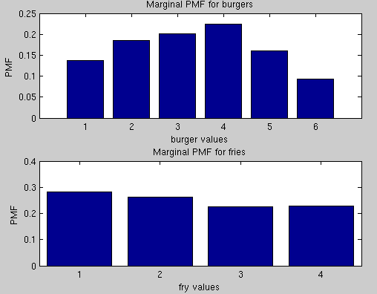
e) 3.3639

f) 2.3990

g) $ 9.127

h) each column indicates the number of burgers
1 | 2 | 3 | 4 | 5 | 6
0.0764 | 0.2770 | 0.2922 | 0.2359 | 0.0756 | 0.0429
