1.

|  |
| --- |
| % problem 1  clear;  close all;  clc;    p = 0.5;  q = 1-p;  n = 1000;  trials = 10000;  s = 0.1;    x = cumsum((rand(n,trials)<p).*2*s-s); % generate 10000 random walks. each column represent one random walk.    figure(1);  hold on;  plot(x((1:n),1),'r');  plot(x((1:n),2),'b');  plot(x((1:n),3),'g');  plot(x((1:n),4));  plot(x((1:n),5));  hold off;    mean_sim = mean(x(n,(1:trials)))  mean_est = n*(p-q)*s  var_sim = var(x(n,(1:trials)))  var_est = 4*n*p*q*s^2    mean_sim = -0.0465  mean_est = 0  var_sim = 10.1783  var_est = 10.0000 |

2.

|  |
| --- |
| % problem 2  clear;  close all;  clc;    p = 0.5;  q = 1-p;  n = 1000; % the number of steps in a random walk  T = 0.5; % each time step length  t = n*T;  trials = 10000;  s = 1;  alpha = s^2/T;    x = cumsum((rand(n,trials)<p).*2*s-s); % generate 10000 random walks. each column represent one random walk  y = cumsum((rand(n,trials)<p).*2*s-s);  x_est = x(n,1:trials); % end points of 10000 random walk  y_est = y(n,1:trials);  z_est = sqrt(x_est.^2+y_est.^2);    x_actual = 0:1:150;  z_actual = raylpdf(x_actual,sqrt(alpha*t)); % parameters: (x, std)    figure(1); hold on;  histogram(z_est,'normalization','pdf'); % estimated plot for z(rayleigh)  plot(z_actual);  legend('estimate','actual');  xlabel('z');  ylabel('pdf of z'); |

Analytical parts for 1,2

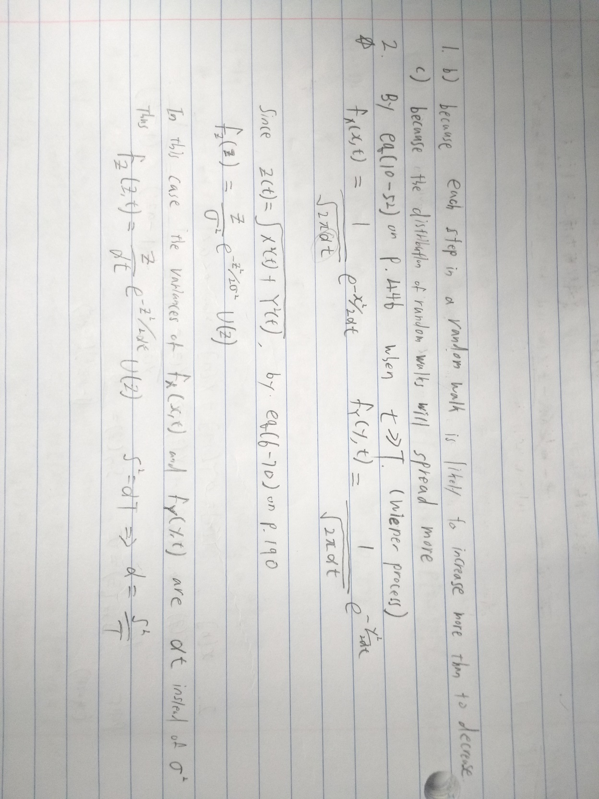

3.

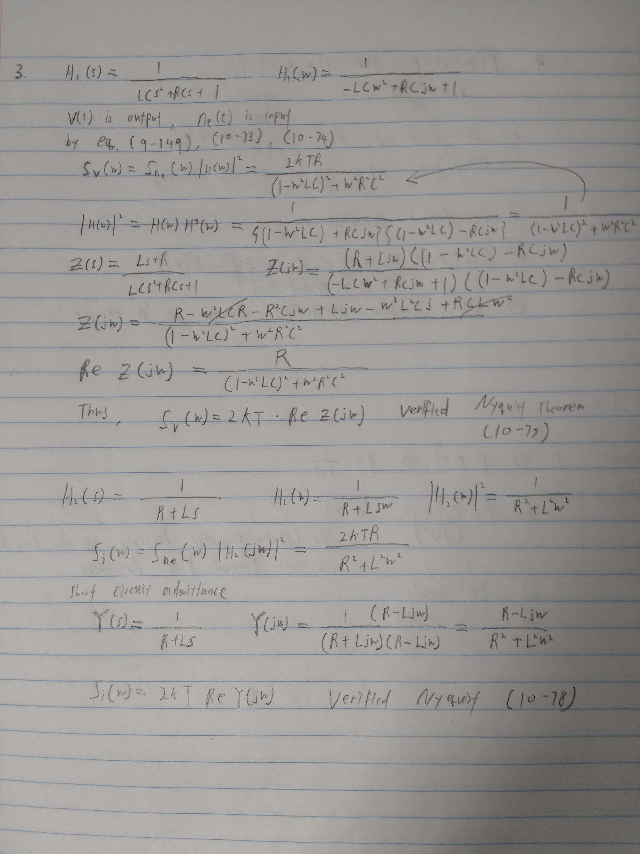

4.

